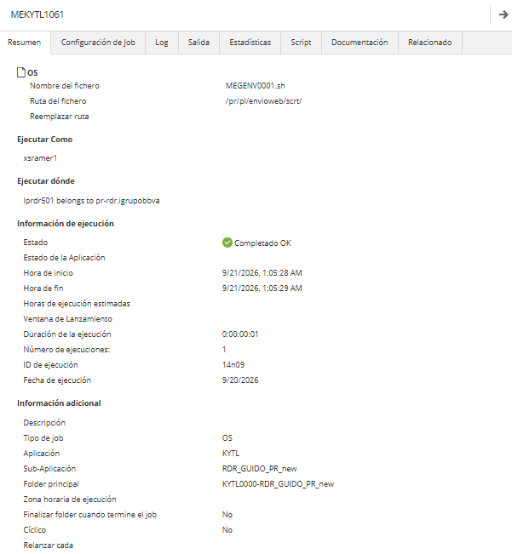
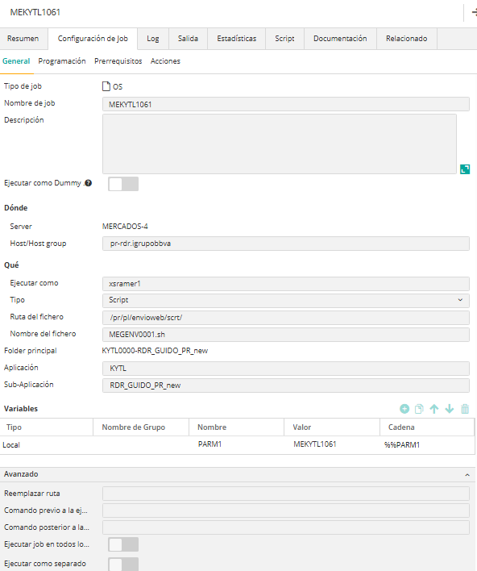
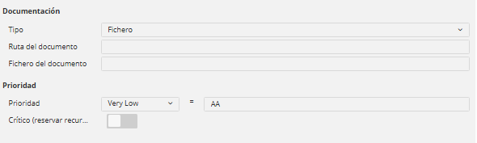
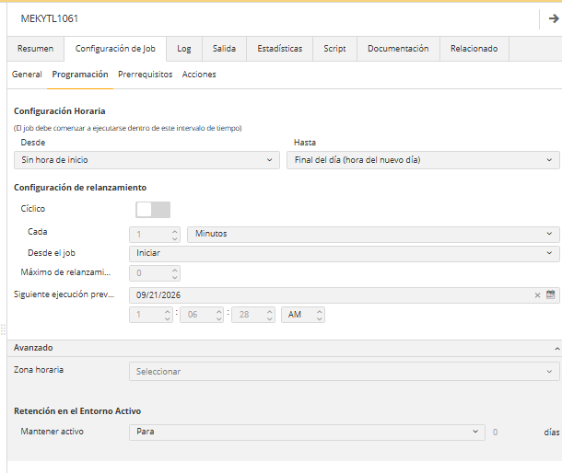
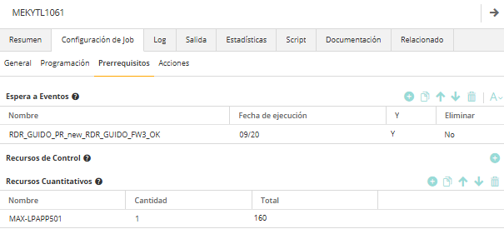
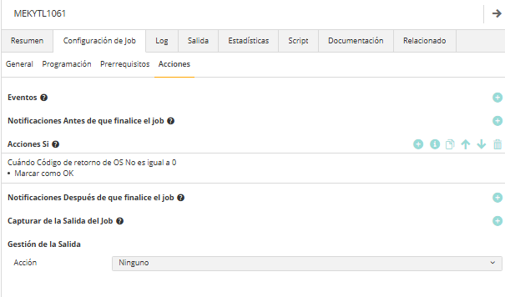
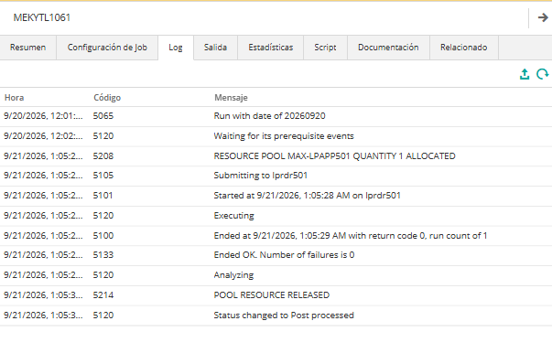
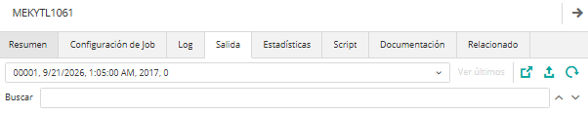

21/09/26 01:05:28 [WARNING] Fichero MEKYTL1061.idx no generado, se utiliza fichero de backup en maquina
ENVIO DE FICHEROS PARA CODIGO DE ENVIO : MEKYTL1061.
SERVIDOR LOCAL : lprdr501
RUTA LOCAL : /fichtemcomp/pr/descargas/kytl/users/
RUTA HISTORIFICACION: /fichtemcomp/pr/descargas/kytl/users/backup/
TIPO ENVIO : TIPO
PROTOCOLO ENVIO : CD
SENTIDO ENVIO : PUT
ACCION REMOTA : rpl
FORMATO ENVIO : BINARY
SERVIDOR REMOTO : lpnov503
RUTA REMOTA : /usr/local/pr/nova/landingzone/EINS/filesystempre/incoming/
USUARIO TRANSMISION : xtcibt1p
FICHEROS : OFP_ROLES_RDR.csv
**************************************************************
* *
* Licensed Materials - Property of IBM *
* *
* IBM(R) Connect:Direct(R) for UNIX 6.3.0.3_iFix017 *
* Build date: 10Oct2024 *
* *
* (C) Copyright IBM Corp. 1992, 2024 All Rights Reserved. *
* *
**************************************************************
Direct> Enter a ';' at the end of a command to submit it. Type 'quit;' to exit CLI.
Process Submitted, Process Number = 24955
Return code = 0
Message id = XSMG252I
Direct>
Connect:Direct CLI Terminated...
21/09/26 01:05:29 TRANSFERENCIA: lprdr501:/fichtemcomp/pr/descargas/kytl/users/OFP_ROLES_RDR.csv --> lpnov503:/usr/local/pr/nova/la\
ndingzone/EINS/filesystempre/incoming/OFP_ROLES_RDR_20260921.csv --> OK
21/09/26 01:05:29 HISTORIFICACION : mv /fichtemcomp/pr/descargas/kytl/users/OFP_ROLES_RDR.csv /fichtemcomp/pr/descargas/kytl/users/\
backup/OFP_ROLES_RDR.csv --- [CORRECTA].
21/09/26 01:05:29 [INFO] Ejecucion de Proceso MEGENV0001.sh finalizada correctamente a las [01:05:29]

