CMP6202
Artificial Intelligence and
Machine Learning Project
2026 – 2027
[Individual Report – 80%]

Predicting English Premier League Match Outcomes Using Pre-Match Tactical Metrics and Supervised Machine Learning

26174134

Table of Contents
1. Report Introduction 3
1.1. Dataset identification 3
1.2. Supervised learning task identification 3
1.3. Declaration of Generative AI Use 3
2. Exploratory Data Analysis 4
2.1. Question(s) identification 4
2.2. Splitting the dataset 4
2.3. Exploratory Data Analysis process and results 4
2.4. EDA conclusions 4
3. Experimental Design 4
3.1. Identification of your chosen supervised learning algorithm(s) 4
3.2. Identification of appropriate evaluation techniques 4
3.3. Data cleaning and pre-processing transformations 4
3.4. Limitations and Options 5
4. Predictive Modelling / Model Development 5
4.1. The predictive modelling process 5
4.2. Evaluation results on “seen” data 5
5. Evaluation and further modelling improvements 5
6. Conclusion 7
6.1. Summary of results 7
6.2. Reflection on Individual Learning 7
7. GitHub link 7
8. References 7

Report Introduction
This report is specifically tailored for a Head of Quantitative Sports Analytics and Technical Decision-Makers within a professional football club or sports forecasting consultancy. The tone maintains rigorous technical precision in statistical machine learning, while contextualising probabilistic predictions into actionable pre-game tactical preparation and risk management.

Dataset identification
The primary dataset investigated in this research is derived from the open-source Club Football Match Data (2000–2026)repository, constructed by Adam Gábor (2026) and hosted on Kaggle. The historical match data originates from official records aggregated by Football-Data.co.uk, while club-level quality ratings are integrated directly from ClubElo.
- Dataset Scope & Representation: The raw repository contains 238,858 global matches. To establish a rigorous, homogeneous, and computationally reproducible framework compliant with the assessment brief (minimum 3,000 rows), an 11-season historical cohort of the English Premier League (Division E0, covering the calendar years 2014 to 2024 inclusive) was extracted. This produces a dedicated dataset of 4,178 official matches, ensuring sufficient statistical power without introducing cross-league distributional shifts.
- Exact Usage License: The dataset is distributed under the MIT License. This license expressly permits unrestricted academic, commercial, and research utilisation, modification, and reproduction.
- Attribute Inventory & Data Types: To eliminate temporal data leakage, all post-match variables (such as in-game shots, fouls, corners, and cards) are strictly excluded from the feature space. The candidate pre-match attributes include:

- MatchDate (Datetime): Official date of the fixture, utilized for chronological splitting and temporal feature extraction.
- HomeTeam / AwayTeam (Categorical Nominal): Competing club entities.
- HomeElo / AwayElo (Numerical Continuous): Dynamic team strength ratings based on historical opponent-adjusted performance.
- Form3Home / Form3Away (Numerical Discrete): Cumulative points obtained over the preceding 3 league matches (range 0–9).
- Form5Home / Form5Away (Numerical Discrete): Cumulative points obtained over the preceding 5 league matches (range 0–15).
- OddHome / OddDraw / OddAway (Numerical Continuous): Market consensus decimal betting odds reflecting opening implied probabilities.
- HandiSize / HandiHome / HandiAway (Numerical Continuous): Asian handicap spreads and corresponding market lines.
- FTResult (Categorical Ground Truth): Observed full-time outcome (H: Home Win, D: Draw, A: Away Win).

Supervised learning task identification
Predictive Problem Definition:
The supervised objective is formulated as a binary classification task with probabilistic risk estimation. Specifically, the model aims to predict whether the host team will secure victory in a scheduled fixture ($P\left(\text{HomeWin}=1∣X\right)$), conditioned solely upon pre-match information available prior to kickoff. In competitive sports modelling, formulating the target as a binary problem (Home Win vs. Non-Home Win) is a standard industrial benchmark, as home advantage represents the single largest systematic bias in association football.
Target Variable ($y$ / Ground Truth):
The ground truth is established via the binary variable HomeWin, mapped directly from the verified full-time result (FTResult):
$$\text{HomeWin}=\left\{\begin{matrix}1 & \text{if FTResult}=\text{’H’ (Home Win)} \\ 0 & \text{if FTResult}∈\left\{\text{’D’} , \text{’A’}\right\}\text{ (}\text{Draw}\text{ or Away Win)}\end{matrix}\right.$$
Across the 4,178 matches analyzed, the empirical distribution exhibits 1,877 Home Wins (44.93%) and 2,301 Non-Home Wins (55.07%). This balanced, non-degenerate class proportion provides an ideal benchmark for comparing probabilistic linear and non-linear classifiers without requiring synthetic oversampling techniques.

Declaration of Generative AI Use
Generative AI (Google Gemini) was consulted as an assistive reference tool during this project.
- Why it was used: Primarily to assist with English academic proofreading (grammar, phrasing, and vocabulary refinement) and to troubleshoot Python environment setup and syntax errors.
- Specific tasks performed: Checking grammatical clarity of the written sections and helping resolve library installation issues in the local virtual environment.
- Which AI was used: Google Gemini.
- Verification of outputs: All code implementation, experimental choices, feature selection, and data analysis were designed, tested, and validated independently by the student in a local VS Code environment, ensuring authentic understanding and methodological ownership.

Exploratory Data Analysis

Question(s) identification
Prior to committing to model architectures, the exploratory data analysis aims to resolve four targeted analytical questions:
- Class Distribution: What is the empirical baseline probability of a Home Win in the Premier League, and is the target significantly imbalanced?
- Elo Differential: Does the historical rating discrepancy between host and visitor clubs (EloDiff = HomeElo - AwayElo) provide clear discriminative separation for match outcomes?
- Recent Form Impact: How strongly do short-term (3-game) and medium-term (5-game) form trajectories influence the likelihood of securing 3 points at home?
- Multicollinearity & Feature Leakage: Are opening bookmaker consensus odds highly collinear, and can we confirm that all retained features are strictly observable before match kickoff?

Splitting the dataset
To guarantee complete leakage-safe integrity, the dataset is partitioned prior to learning any preprocessing parameters(such as scaling factors or imputation medians).
The 4,178 matches are split into an 80% Training set (3,342 matches) and a 20% Test set (836 matches) using stratified sampling based on the target HomeWin (stratify=y) with a fixed seed (random_state=42). The test partition is strictly isolated and held out to serve as an unpolluted benchmark for final model evaluation only.

Exploratory Data Analysis process and results
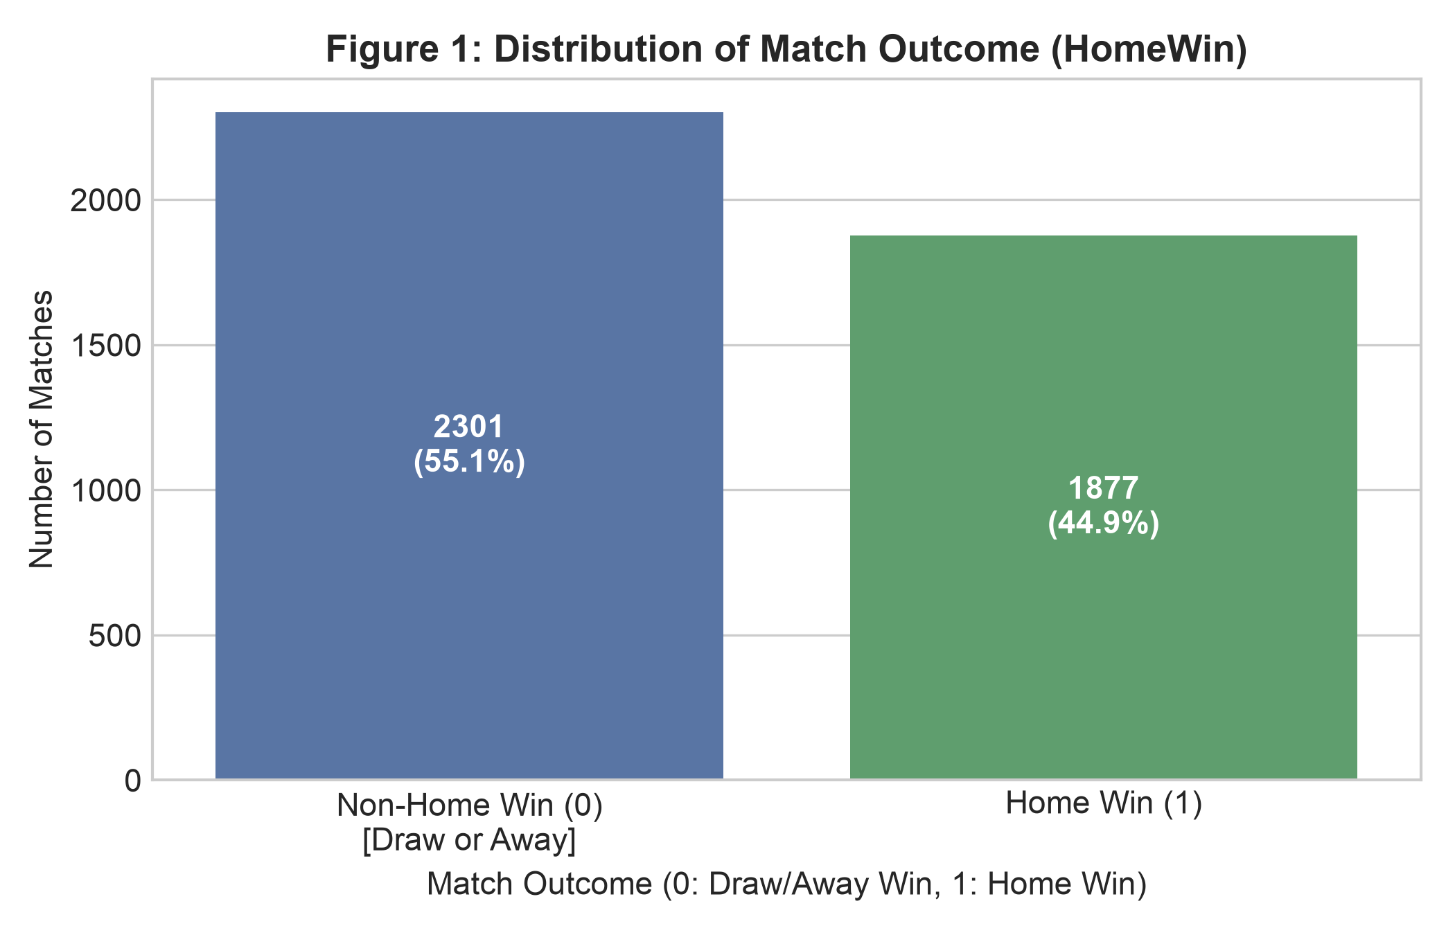
Figure 1: Distribution of Premier League Match Outcomes (HomeWin: 2014–2024)

Interpretation & Modelling Decision:
Figure 1 illustrates the empirical distribution of the binary target variable across the 4,178 Premier League matches. Non-Home Wins (Draws and Away Wins combined, labelled as 0) account for 2,301 fixtures (55.07%), while Home Wins (labelled as 1) account for 1,877 fixtures (44.93%).
This observation yields two critical modeling decisions:
- Baseline Specification: A naive majority-class classifier that blindly predicts '0' for all fixtures would achieve an accuracy of 55.07% while achieving a Recall of 0.00% for home victories. Consequently, 55.07% represents the benchmark to beat, and accuracy alone will be insufficient to evaluate model utility.
- Absence of Severe Imbalance: Because the positive class comprises nearly 45% of the total dataset, the distribution is naturally balanced. Consequently, synthetic oversampling techniques (such as SMOTE) or undersampling filters are unnecessary, preserving the true natural prior probability distribution of match outcomes.

Figure 2: Pre-Match Elo Differential Distribution by Observed Match Outcome
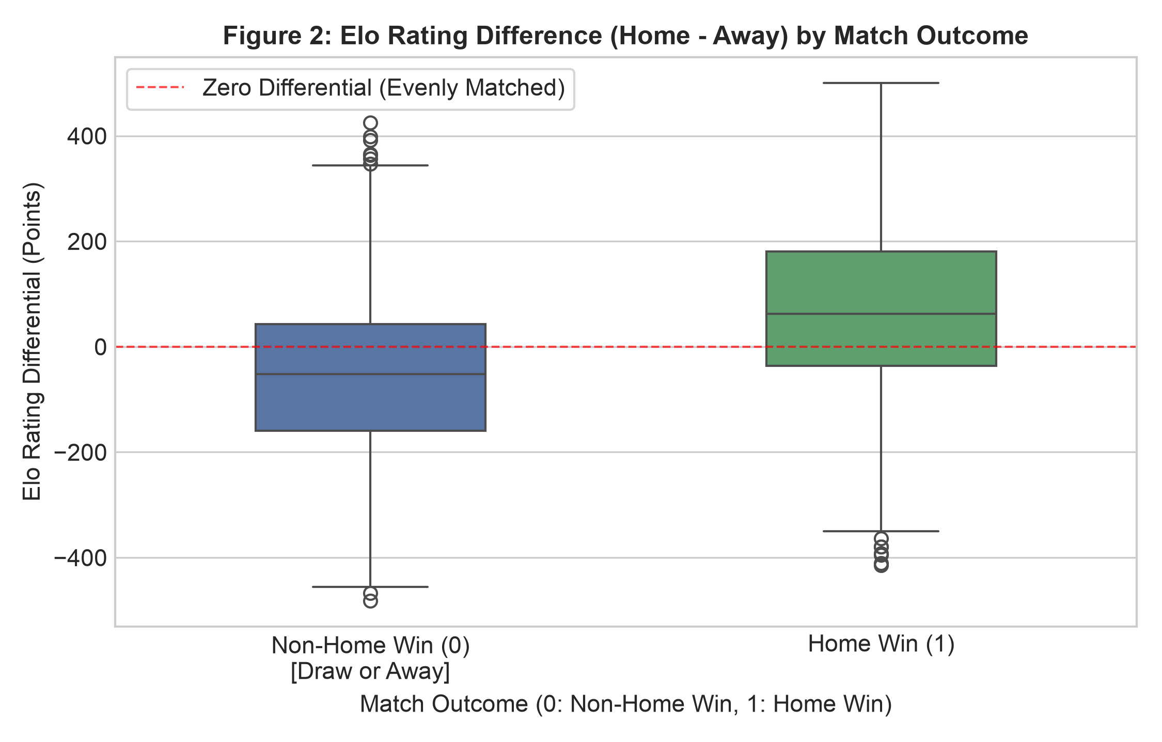

Figure 2 compares the distribution of the pre-match team strength discrepancy (EloDiff = HomeElo - AwayElo) conditioned on whether the match resulted in a home victory (HomeWin = 1) or not (HomeWin = 0).
The summary statistics demonstrate a clear shift in central tendency:
- For Non-Home Wins (0), the mean differential is -55.68 points (median: -51.52), showing that host teams failing to secure victory were, on average, lower-rated than their opponents.
- For Home Wins (1), the mean differential shifts to +68.11 points (median: +62.72), with the interquartile range situated predominantly above parity (zero line).
Modelling Decision:
The rating discrepancy provides strong discriminative signal. However, notable outliers exist in both distributions (upsets where underdogs overcame deficits of more than 300 Elo points). Consequently, EloDiff is retained as a primary predictive feature. Because distance-based models (such as k-NN and SVM) are sensitive to large ranges, feature scaling (StandardScaler) must be applied prior to training.

Figure 3: Pearson Correlation Heatmap for Pre-Match Features
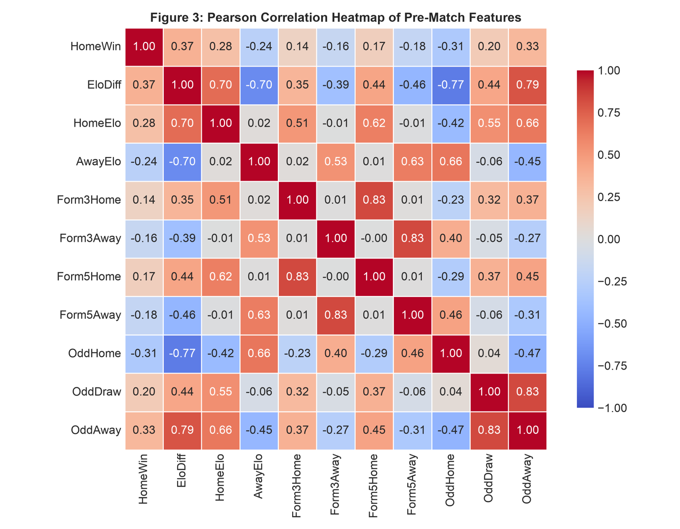

Figure 3 displays the pairwise linear correlations across the pre-match feature space and their association with the target variable HomeWin.
The empirical correlation ranking highlights the primary predictive signals:
- Primary Linear Associations: The engineered rating differential EloDiff demonstrates the highest positive linear correlation with a home victory ($r=+0.374$), followed closely by the away betting odd OddAway ($r=+0.333$). Conversely, the home odd OddHome displays a moderate negative correlation ($r=-0.311$), consistent with betting market theory where lower odds correspond to higher winning probabilities.
- Recent Form Trajectories: Rolling points gathered over the preceding 5 and 3 fixtures show consistent momentum signals. Home form metrics exhibit positive alignment ($r=+0.171$ for Form5Home; $r=+0.136$for Form3Home), whereas away form indicators reduce home victory chances ($r=-0.176$ for Form5Away).
- Multicollinearity: Strong collinearity is identified between short- and medium-term form indicators, specifically between Form3Home and Form5Home ($r=+0.83$) and between Form3Away and Form5Away ($r=+0.83$). Strong dependencies also exist between team Elo ratings and the composite EloDiff ($r=0.70$).
Modelling Decision:
High collinearity between form windows indicates redundant signals that could destabilise weight estimates in linear classifiers such as Logistic Regression. Feature selection will prioritize medium-term form (5 matches) over short-term noise (3 matches). In addition, non-linear ensemble models such as Random Forest and Gradient Boosting will be utilized to capture non-linear interactions between rating differentials and momentum that linear correlations cannot represent.

EDA conclusions
The exploratory data analysis of the 4,178 English Premier League fixtures establishes four core findings that guide our downstream experimental design:
- Target Distribution and Baseline Accuracy: The binary target variable HomeWin reveals a natural distribution of 44.93% home victories and 55.07% non-home outcomes (draws and away victories combined). This establishes a naive majority-class baseline of 55.07%. Because the minority class represents nearly 45% of total instances, the dataset does not suffer from acute class imbalance, rendering synthetic resampling methods (such as SMOTE) unnecessary.
- Discriminative Feature Signals: Pre-match team rating differentials (EloDiff) and opening market odds (OddHome, OddAway) display the strongest correlations with match outcomes. The clear separation between positive and negative differential medians verifies that historical team quality provides a robust discriminative signal prior to kickoff without inducing temporal data leakage.
- Multicollinearity and Redundancy: High pairwise collinearity between rolling form windows (Form3 and Form5, r = 0.83) demonstrates redundant momentum signals. Consequently, feature selection should consolidate form metrics to prevent variance inflation in linear models. Furthermore, the presence of non-linear dynamics between club ratings and match outcomes motivates the adoption of non-linear tree ensembles alongside linear baselines.
- Feature Magnitude and Transformation Strategy: Disparities across measurement scales—ranging from hundreds of Elo points to small decimal betting odds—make standardized scaling (StandardScaler) necessary for distance-based and margin-based classifiers (such as k-NN, Logistic Regression, and Support Vector Machines) to prevent larger magnitude features from dominating distance calculations.

Experimental Design

Identification of your chosen supervised learning algorithm(s)
Discuss how your chosen supervised learning algorithm(s) work and justify why you think it/why is/are appropriate for this learning task.

Identification of appropriate evaluation techniques
Discuss and justify the evaluation techniques that you have chosen.
- Which evaluation metrics have you chosen to use?
- How will each of these evaluation metrics contribute to giving us a clearer picture of the relative performance of your model(s)?

Data cleaning and pre-processing transformations
Do not just list steps. Justify why these steps were necessary for your specific dataset. If your dataset was 'clean' to begin with, demonstrate your understanding by explaining what issues you checked for (outliers, nulls, etc.) and why they did not require intervention.

Limitations and Options
You should aim to discuss the possible limitations of your approach based on the data available and the techniques applied.

Predictive Modelling / Model Development

The predictive modelling process
Discuss the process you undertook to train your model(s)
- How did you use the pre-processed data to produce the model?
- What algorithm parameters did you use when “fitting” your model – if you simply used the default parameters for that algorithm discuss what they were.
- Present relevant code snippets to focus your discussion for this process

Evaluation results on “seen” data
- Discuss the process of evaluating your model on previously “seen” data – e.g. the training set.
- Present relevant code snippets and visualisations to focus your discussion for this process.

Evaluation and further modelling improvements
Here are step-by-step instructions for this task, considering that you will work with machine learning model(s) for either regression or classification:
Step 1: Model Selection
Regression or Classification: First, decide whether your project involves regression or classification. Choose the appropriate problem type based on your dataset and project goals.
Step 2: Data Preparation
Data Preprocessing: Prepare your dataset by handling missing values, encoding categorical variables, and scaling/normalizing the features as needed. Ensure that the dataset is clean and well-structured.
Step 3: Model Development
- Select a Model: Choose a machine learning algorithm that is suitable for the selected problem type (e.g., Linear Regression for regression, or Logistic Regression for classification) at least two different models.
- Train-Test Split: Split your dataset into training and testing subsets (e.g., 70% for training, 30% for testing) to assess the model's performance.
- Model Training: Train the selected machine learning model on the training data. Ensure that you understand the model's hyperparameters and tuning options.
Step 4: Model Evaluation
- Performance Metrics: Use appropriate evaluation metrics for regression (e.g., Mean Absolute Error, Root Mean Squared Error, R-squared) or classification (e.g., Accuracy, Precision, Recall, F1) to assess the model's performance.
- Visualizations: Create visualizations such as scatter plots for regression or confusion matrices for classification to better understand the model's predictions.
- Interpretation: Interpret the model's results. Understand how the features impact the predictions (e.g., feature importance for decision trees).
Step 5: Model Improvement
- Hyperparameter Tuning: If needed, perform hyperparameter tuning to optimize your model's performance. Consider techniques like grid search.
- Feature Engineering: Explore feature engineering techniques that may improve your model, such as creating new features, transforming existing ones, or feature selection.
Step 6: Validation
- Cross-Validation: Validate your model using cross-validation techniques (e.g., k-fold cross-validation) to ensure robust performance assessment.
Step 7: Comparative Analysis of Multiple Algorithms
- Model Comparison: Compare the results of at least two different machine learning algorithms. You should clearly explain why you chose these specific algorithms and how they differ in terms of their approach (e.g., decision trees vs. logistic regression, or linear regression vs. support vector machines).
- Evaluate and compare the performance of the algorithms using the same evaluation metrics. Discuss how the algorithms perform relative to each other based on these metrics.
- Use visualizations such as bar charts or performance plots to present a clear comparative analysis of the models' results (e.g., comparison of accuracy, precision, recall, or regression errors).
- Reflect on the strengths and weaknesses of each algorithm. Explain why one algorithm may perform better or worse than another for your specific problem.

Conclusion

Summary of results
- Discuss the evaluation results for the final model.
- Summarise your current results from the model development process, including the problem, data, methodology, results, and insights.

Reflection on Individual Learning
- Reflect on your learning experience throughout the project.
- Discuss specific technical challenges faced, how you overcame them, and any resulting limitations (this demonstrates authentic learning).
- Certification evidence in AI and Machine Learning: Include evidence for each certification achieved during the project. This may be provided as screenshots of the certification/badge, certificate PDFs, or a public verification link (for example, a Credly.com badge URL). Evidence should clearly demonstrate successful completion and allow verification where applicable.

GitHub link
MANDATORY: Provide a link to a public GitHub repository. This repository must contain:
- Your complete, well-documented Python code (Notebooks or scripts).
- The raw dataset (or a link to the exact source if the file is too large).
- A 'README' file explaining how to run the code. Note: Only this Word document is submitted to Moodle; all technical files must reside at this link.

References
Use BCU Harvard style. More information on referencing is available here: https://www.bcu.ac.uk/library/services-and-support/referencing
Warning: Ensure all references are real and accessible. Use of 'hallucinated' or fake references generated by AI will be treated as academic misconduct.

