**1) Popup Titles overflowing**

Steps to reproduce:

Given I am a new user

When I see the onboarding popups

Then their titles are overflowing themselves and another blocks

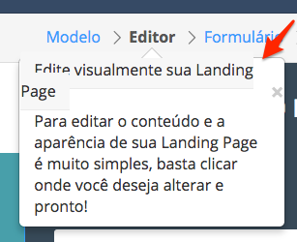

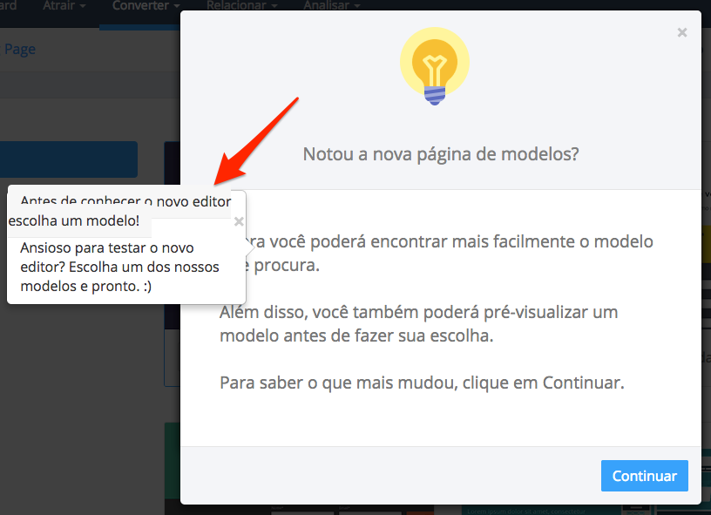

Severity: Cosmetic

Priority: Low

**2) Landing Page doesn’t show clearly what field have an error**

Given I am on a Landing Page

And I don’t fill the fields exactly

When I receive the validation messages

The fields aren’t clearly specified

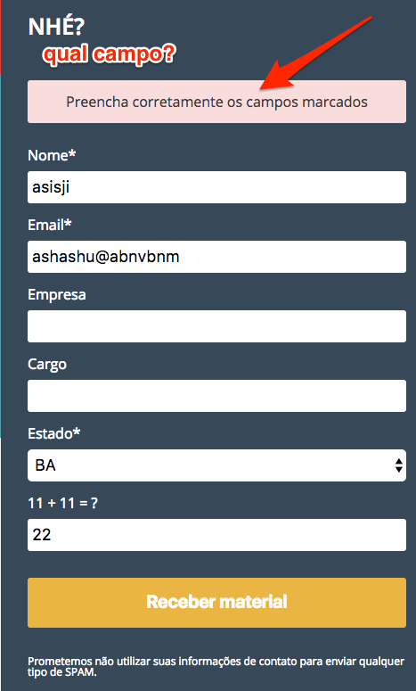

Severity: Cosmetic

Priority: Medium

**3) Click in “Confirmar” on the import leads workflow generates a lot of lists to be imported**

Steps to reproduce:

Given I am on the importacoes workflow

And I select my csv

If I click a lot of times on the “Confirmar” button

Then the same csv is listed a lot of times

Severity: Medium

Priority: Medium

**4) Form creation instructions in Spanish**

Given I am on the form creation workflow

And I am on the second step

Then the informations hints are in Spanish

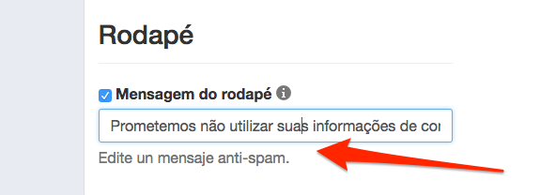

Severity: Cosmetic

Priority: Low

**5) Lead counter lost when merge leads**

Pre-requirements: Have three leads

Steps to reproduce:

Given I am on the leads list

And I choose one lead to merge

When I finish the merge

Then I see on the list two leads

But the message shows me that I only have one lead

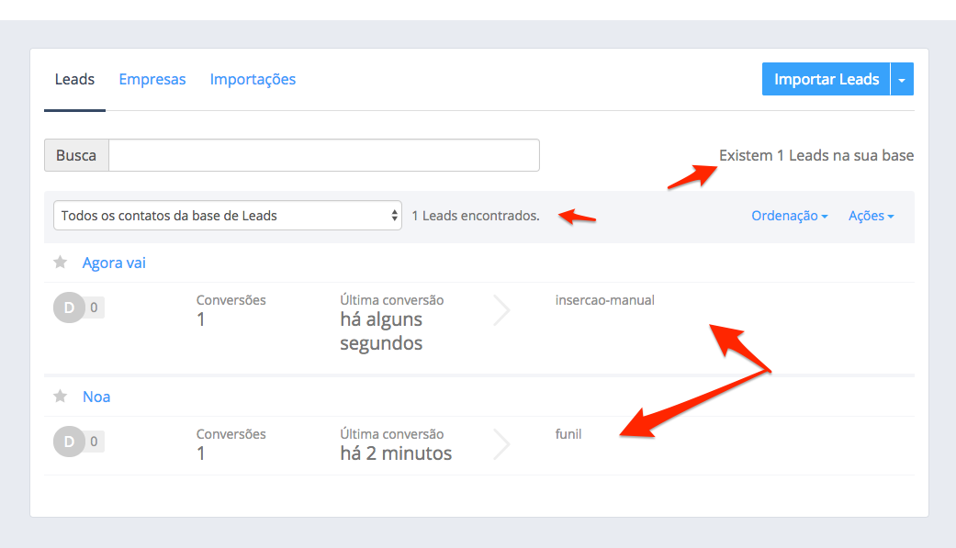

Severity: High

Priority: High

**6) Is possible to have -1 leads**

Pre-requirements: Had merged at least one lead, and deleted the visible leads by /leads endpoint

Given I am on the dashboard

And look into “Últimas conversões de Leads”

And click on the lead

And delete it

When I am redirected to /leads endpoint

And I click to import by csv

And choose the CSV

When I am on the disclaimer step

Then I could see that I have -1 leads

Severity: High

Priority: Medium

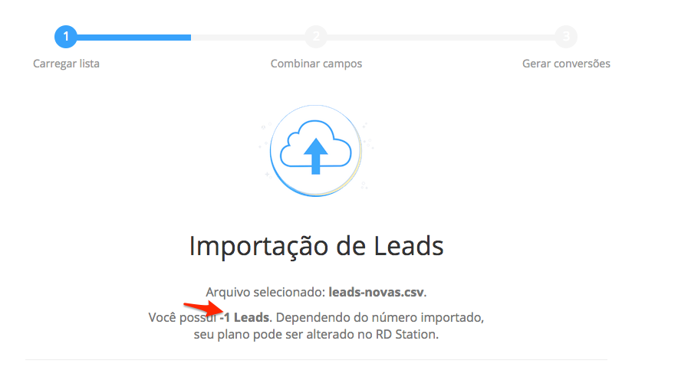

**7) Search only work when suggestions appears**

Steps to reproduce:

Given I am on the leads list

When I search for a name

And press enter before the suggestions box appears

Then the result of the doesn’t bring the lead

Severity: Medium

Prioritity: Medium