C1:
Cipher analysis:
IC – 0.043453842
IC does not match the distribution of english letters, therefore cannot be simple transposition (e.g.
http://practicalcryptography.com/cryptanalysis/stochastic-searching/cryptanalysis-vigenere-cipher/

C2:
Cipher analysis:
IC – 0.06656747
IC matches that of English, however the single letter frequency distribution doesn’t match English.
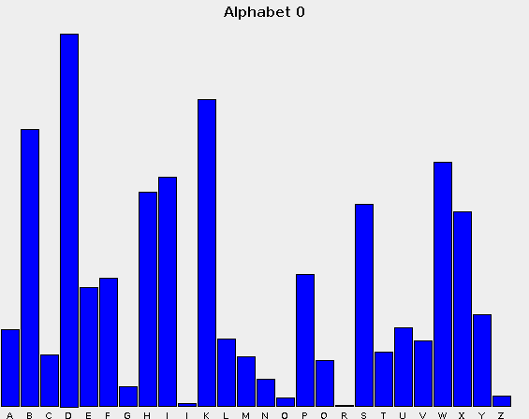
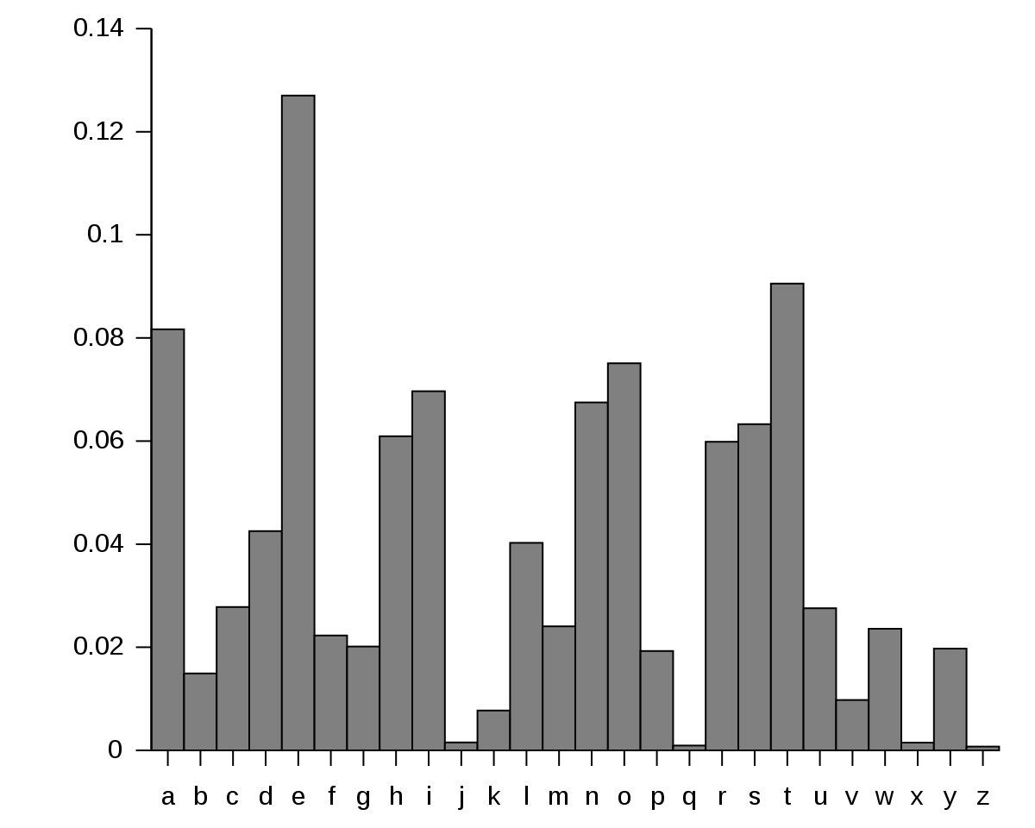
As the single letter frequencies in the ciphertext also do not seem to match the sequence of the frequencies on the right (i.e. each ciphertext letter is not shifted by a fixed amount), this is likely not a simple caesar cipher, but a monalphabetic subtitution cipher.

Using jkrypto, the relative letter frequencies of the ciphertext were found and compared to English:
(https://en.wikipedia.org/wiki/Letter_frequency#Relative_frequencies_of_letters_in_the_English_language)

C3:
Cipher analysis:
IC – 0.0652331
IC matches that of English, and the single letter frequency distribution is also very close to English.
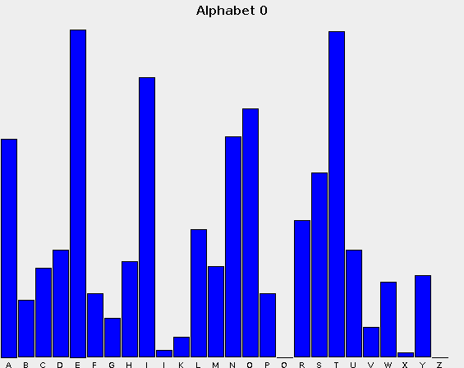

Therefore, this is likely a transposition cipher.

Output of Kasiski search for repeated strings of size 5:

aaimn: 2| 15
eipts: 2| 360
socnt: 2| 510
ocntd: 2| 510
cntdt: 2| 510
ntdtl: 2| 510
tdtla: 2| 510
dtlau: 2| 510
tlaur: 2| 510
laurt: 2| 510
aurtc: 2| 510
urtco: 2| 510
rtcoo: 2| 510
ocotd: 2| 155
styes: 2| 231
otiit: 2| 780
asrte: 2| 15
eyewh: 2| 30

Excluding one outlier “styes” with a period of 231, the GCD of the periods between the strings (15, 350, 510, 155, 780, 15, 30) was 5. So the period of the cipher is likely 5.

C4:
Cipher analysis:
IC – 0.0422036
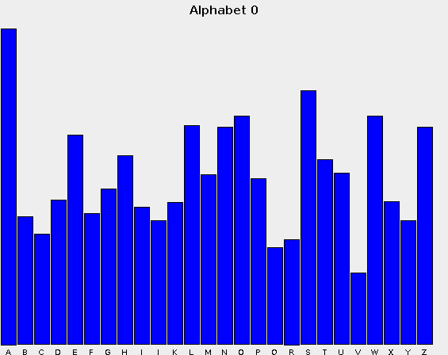
Single letter frequency distribution does not match English at all.

Output of Kasiski search for repeated strings of size 9.

ulnsadxdo: 2| 1584
iiymeafxq: 2| 312
iymeafxqa: 3| 312, 276
ymeafxqaw: 3| 312, 276
meafxqawd: 3| 312, 276
eafxqawdi: 3| 312, 276
vkpxsnkex: 2| 240
kpxsnkexd: 2| 240
pxsnkexdl: 2| 240
xsnkexdla: 2| 240
nzmlaadce: 2| 912
zmlaadces: 2| 912
mlaadcesd: 2| 912
laadcesdi: 2| 912

The GCD of the periods between the strings (1584, 312, 276, 240, 912) was 12. So the period of the cipher could be 12, 6, 4, 3 or 2. Given the IC of 0.0422 is closest to the average IC for a period of 3 (http://practicalcryptography.com/cryptanalysis/stochastic-searching/cryptanalysis-vigenere-cipher/), this is the most likely key length.

