

Functional Safety Concept Lane Assistance

**Document Version: 1.0**

**Template Version 1.0, Released on 2017-06-21**



# Document history

|  |  |  |  |
| --- | --- | --- | --- |
| Date | Version | Editor | Description |
| 04-14-2018 | 0.1 | Pablo | Purpose, Inputs |
| 04-21-2018 | 1.0 | Pablo | Finish document |
|  |  |  |  |
|  |  |  |  |
|  |  |  |  |

# Table of Contents

Document history

Table of Contents

Purpose of the Functional Safety Concept

Inputs to the Functional Safety Analysis

Safety goals from the Hazard Analysis and Risk Assessment

Preliminary Architecture

Description of architecture elements

Functional Safety Concept

Functional Safety Analysis

Functional Safety Requirements

Refinement of the System Architecture

Allocation of Functional Safety Requirements to Architecture Elements

Warning and Degradation Concept

# Purpose of the Functional Safety Concept

The purpose of the functional safety concept is to define the high level safety requirements and allocate them to the relevant parts of the system diagram, for the Lane Assistant system item.

# Inputs to the Functional Safety Concept

## Safety goals from the Hazard Analysis and Risk Assessment

|  |  |
| --- | --- |
| **ID** | **Safety Goal** |
| Safety_Goal_01 | The oscillating steering torque from the lane departure warning function shall be limited |
| Safety_Goal_02 | The lane keeping assistance function shall be time limited, and the additional steering torque shall end after a given time interval so that the driver cannot misuse the system for autonomous driving |

## Preliminary Architecture

Figure 1 shows the preliminary architeture for the lane assistance system.

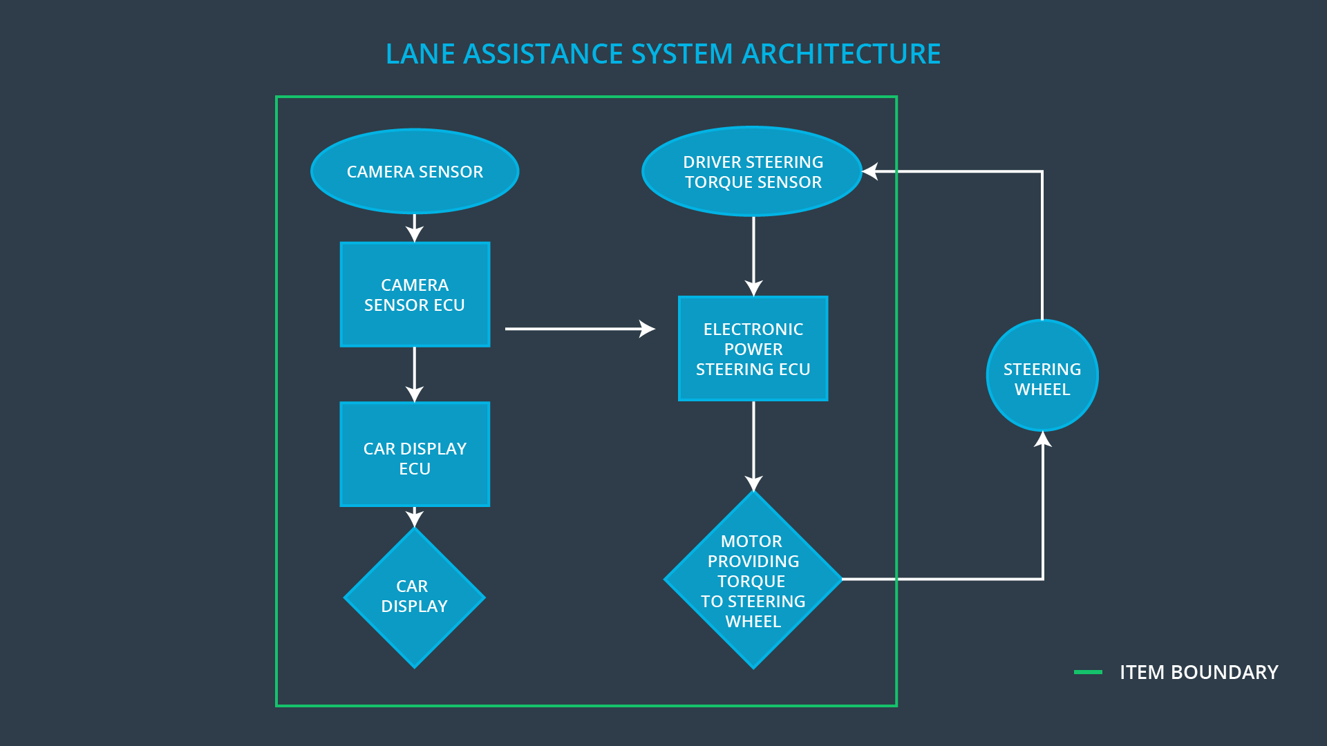  
Figure 1: Lane Assistance System Architecture

### Description of architecture elements

|  |  |
| --- | --- |
| **Element** | **Description** |
| Camera Sensor | Captures road images and transmits them to the Camera Sensor ECU |
| Camera Sensor ECU | Based on the received images, detects lane lines and determines when the vehicle leaves the lane by mistake. Sends departure warning signal to the Car Display ECU. Send estimated torque required to the Electronic Power Steering ECU. |
| Car Display | Displays warnings related to the Lane Departure Status. |
| Car Display ECU | Processes Lane Departure Warning signals from Camera Sensor ECU and transmits display signal and information to the Car Display. |
| Driver Steering Torque Sensor | Measures the torque applied to the steering wheel. Sends torque signal to the Electronic Power Steering ECU. |
| Electronic Power Steering ECU | Adjusts the torque required to correct the vehicle trajectory based on the driver steering torque sensor and the camera sensor ECU. |
| Motor | Applies the torque required by the Electronic Power Steering ECU to the steering wheel. |

# Functional Safety Concept

The functional safety concept consists of:

* Functional safety analysis
* Functional safety requirements
* Functional safety architecture
* Warning and degradation concept

## Functional Safety Analysis

|  |  |  |  |
| --- | --- | --- | --- |
| **Malfunction ID** | **Main Function of the Item Related to Safety Goal Violations** | **Guidewords (NO, WRONG, EARLY, LATE, MORE, LESS)** | **Resulting Malfunction** |
| Malfunction_01 | Lane Departure Warning (LDW) function shall apply an oscillating steering torque to provide the driver a haptic feedback | MORE | The lane departure warning function applies an oscillating torque with very high torque amplitude (above limit) |
| Malfunction_02 | Lane Departure Warning (LDW) function shall apply an oscillating steering torque to provide the driver a haptic feedback | MORE | The lane departure warning function applies an oscillating torque with very high torque frequency (above limit) |
| Malfunction_03 | Lane Keeping Assistance (LKA) function shall apply the steering torque when active in order to stay in ego lane | NO | The lane keeping assistance function is not limited in time duration which leads to misuse as an autonomous driving function. |

## Functional Safety Requirements

Lane Departure Warning (LDW) Requirements:

|  |  |  |  |  |
| --- | --- | --- | --- | --- |
| **ID** | **Functional Safety Requirement** | **ASIL** | **Fault Tolerant Time Interval** | **Safe State** |
| Functional  Safety  Requirement  01-01 | The lane keeping item shall ensure that the lane departure oscillating torque amplitude is below Max_Torque_Amplitude | C | 50 ms | Vibration torque is zero |
| Functional  Safety  Requirement  01-02 | The lane keeping item shall ensure that the lane departure oscillating torque is below Max_Torque_Frequency | C | 50 ms | Vibration torque is zero |

Lane Departure Warning (LDW) Verification and Validation Acceptance Criteria:

|  |  |  |
| --- | --- | --- |
| **ID** | **Validation Acceptance**  **Criteria and Method** | **Verification Acceptance**  **Criteria and Method** |
| Functional  Safety  Requirement  01-01 | Test and Validate that we chose a reasonable Max_Torque_Amplitude value for drivers | If Torque_Amplitude >= Max_Torque_Amplitude, the lane assistance output is set to zero within the 50 ms fault tolerant time interval |
| Functional  Safety  Requirement  01-02 | Test and Validate that we chose a reasonable Max_Torque_Frequency value for drivers | If Torque_Frequency >= Max_Torque_Frequency, the lane assistance output is set to zero within the 50 ms fault tolerant time interval |

Lane Keeping Assistance (LKA) Requirements:

|  |  |  |  |  |
| --- | --- | --- | --- | --- |
| **ID** | **Functional Safety Requirement** | **ASIL** | **Fault Tolerant Time Interval** | **Safe State** |
| Functional  Safety  Requirement  02-01 | The electronic power steering ECU shall ensure that the lane keeping assistance torque is applied for only Max_Duration | B | 500 ms | Lane Keeping Assistance torque is zero |

Lane Keeping Assistance (LKA) Verification and Validation Acceptance Criteria:

|  |  |  |
| --- | --- | --- |
| **ID** | **Validation Acceptance**  **Criteria and Method** | **Verification Acceptance**  **Criteria and Method** |
| Functional  Safety  Requirement  02-01 | Test and validate that the Max_Duration chosen really did dissuade drivers from taking their hands off the wheel. | The system does turn off if the lane keeping assistance exceeded Max_Duration |

## Refinement of the System Architecture

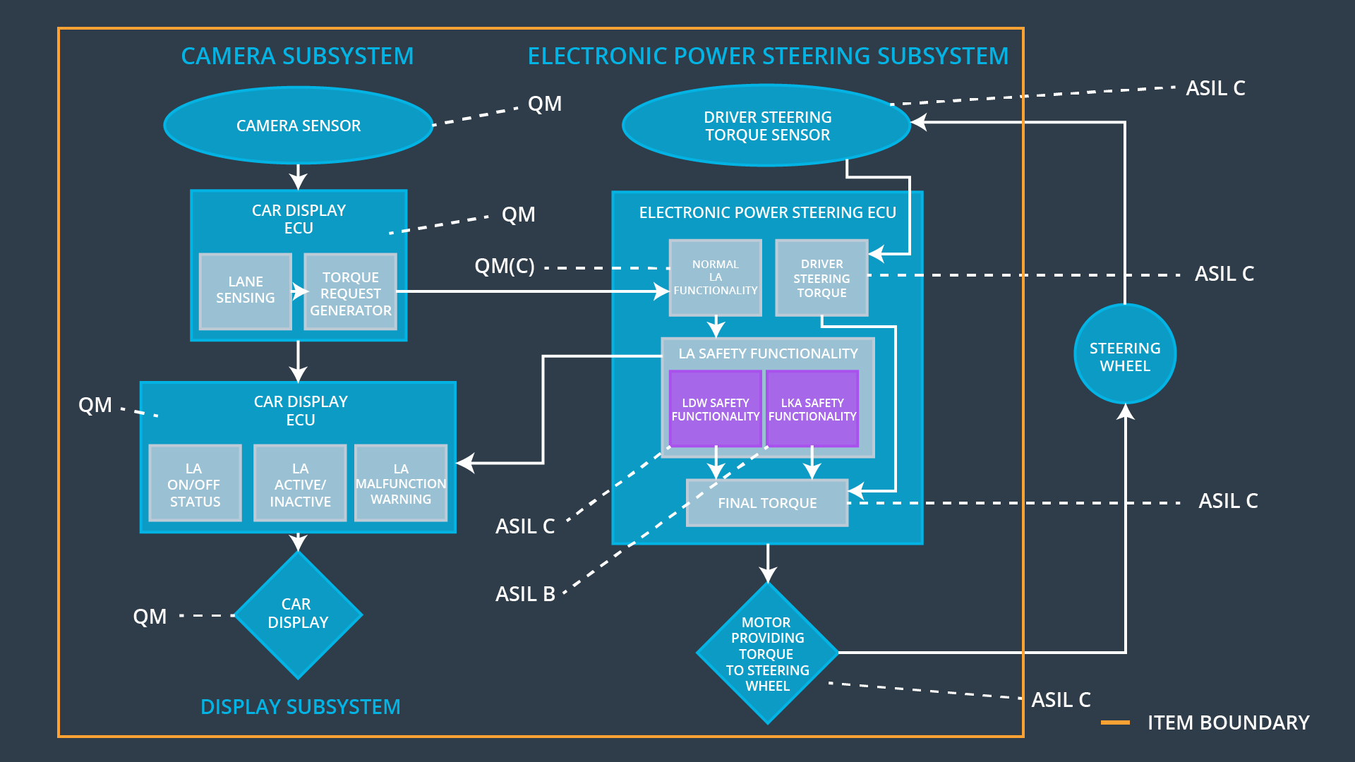  
*Figure 2: System ASIL Levels*

## Allocation of Functional Safety Requirements to Architecture Elements

|  |  |  |  |  |
| --- | --- | --- | --- | --- |
| **ID** | **Functional Safety Requirement** | **Electronic Power Steering ECU** | **Camera ECU** | **Car Display ECU** |
| Functional  Safety  Requirement  01-01 | The lane keeping item shall ensure that the lane departure oscillating torque amplitude is below Max_Torque_Amplitude | **X** |  |  |
| Functional  Safety  Requirement  01-02 | The lane keeping item shall ensure that the lane departure oscillating torque is below Max_Torque_Frequency | **X** |  |  |
| Functional  Safety  Requirement  02-01 | The electronic power steering ECU shall ensure that the lane keeping assistance torque is applied for only Max_Duration | **X** |  |  |

## Warning and Degradation Concept

|  |  |  |  |  |
| --- | --- | --- | --- | --- |
| **ID** | **Degradation Mode** | **Trigger for Degradation Mode** | **Safe State invoked?** | **Driver Warning** |
| WDC-01 | The torque request from the lane keeping assistance will be set to zero. | Malfunction_01, Malfunction_02 | Yes | Warning light on the dashboard when the system malfunctions |
| WDC-02 | The torque request from the lane keeping assistance will be set to zero. | Malfunction_03 | Yes | Warning light on the dashboard when the system malfunctions |