

Technical Safety Concept Lane Assistance

**Document Version: 1.0**



# Document history

|  |  |  |  |
| --- | --- | --- | --- |
| Date | Version | Editor | Description |
| 4-21-2018 | 1.0 | Pablo |  |
|  |  |  |  |
|  |  |  |  |
|  |  |  |  |
|  |  |  |  |

# 

# Table of Contents

Document history

Table of Contents

Purpose of the Technical Safety Concept

Inputs to the Technical Safety Concept

Functional Safety Requirements

Refined System Architecture from Functional Safety Concept

Functional overview of architecture elements

Technical Safety Concept

Technical Safety Requirements

Refinement of the System Architecture

Allocation of Technical Safety Requirements to Architecture Elements

Warning and Degradation Concept

# Purpose of the Technical Safety Concept

The purpose of the technical safety concept is to determine the safety requirements of each system that compose the lane keeping item. This involves determining the functional safety requirements of the lane keeping item.

The technical safety concept involves:

* Turning functional safety requirements into technical safety requirements
* Allocating technical safety requirements to the system architecture

# Inputs to the Technical Safety Concept

## Functional Safety Requirements

|  |  |  |  |  |
| --- | --- | --- | --- | --- |
| **ID** | **Functional Safety Requirement** | **ASIL** | **Fault Tolerant Time Interval** | **Safe State** |
| Functional  Safety  Requirement  01-01 | The lane keeping item shall ensure that the lane departure oscillating torque amplitude is below Max_Torque_Amplitude | C | 50 ms | Vibration torque is zero |
| Functional  Safety  Requirement  01-02 | The lane keeping item shall ensure that the lane departure oscillating torque is below Max_Torque_Frequency | C | 50 ms | Vibration torque is zero |
| Functional  Safety  Requirement  02-01 | The electronic power steering ECU shall ensure that the lane keeping assistance torque is applied for only Max_Duration | B | 500 ms | Lane Keeping Assistance torque is zero |

## Refined System Architecture from Functional Safety Concept

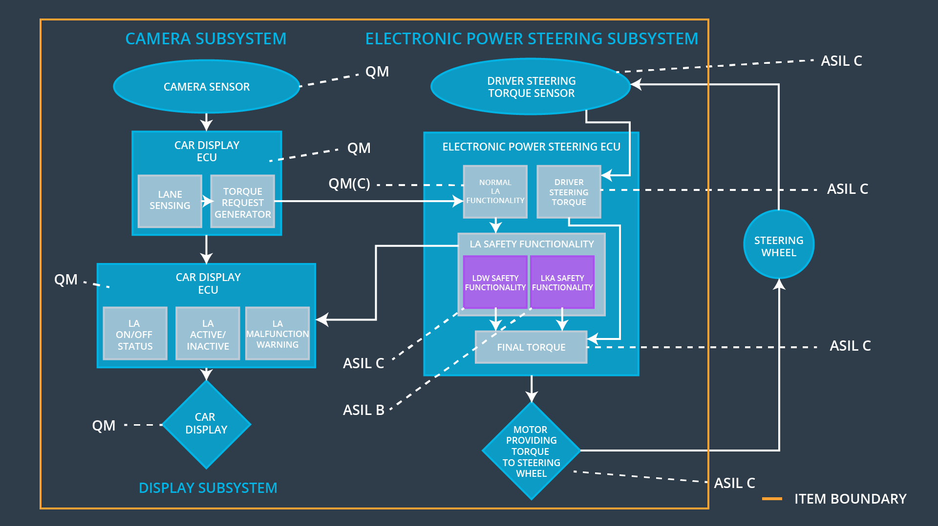  
Figure 1: Refined system architecture

### 

### Functional overview of architecture elements

|  |  |
| --- | --- |
| **Element** | **Description** |
| Camera Sensor | Captures road images and transmits them to the Camera Sensor ECU |
| Camera Sensor ECU - Lane Sensing | Based on the received images, detects lane lines and determines when the vehicle leaves the lane by mistake. Sends departure warning signal to the Car Display ECU. |
| Camera Sensor ECU - Torque request generator | Based on Lane Sensing result, sends estimated torque required to the Electronic Power Steering ECU. |
| Car Display | Displays warnings to the driver related to the Lane Keeping Assistance System. |
| Car Display ECU - Lane Assistance On/Off Status | Indicates warning related to the Lane Keeping Assistance System On/Off Status. |
| Car Display ECU - Lane Assistant Active/Inactive | Indicates warnings related to the Lane Keeping Assistance System Active/Inactive Status. |
| Car Display ECU - Lane Assistance malfunction warning | Indicates warnings related to the Lane Keeping Assistance System malfunction. |
| Driver Steering Torque Sensor | Measures the torque applied to the steering wheel. Sends torque signal to the Electronic Power Steering ECU. |
| Electronic Power Steering (EPS) ECU - Driver Steering Torque | Adjusts the torque required to correct the vehicle trajectory based on the driver steering torque sensor. |
| EPS ECU - Normal Lane Assistance Functionality | Adjusts the torque required to correct the vehicle trajectory based on the Torque Request Generator |
| EPS ECU - Lane Departure Warning Safety Functionality | Checks if output from Normal Lane Assistance Functionality is less than Max_Torque_Amplitude and Max_Torque_Frequency. If it is above them, sets torque to zero. |
| EPS ECU - Lane Keeping Assistant Safety Functionality | Checks if lane keeping assistance torque is applied for only Max_Duration. Of it is above it, sets torque to zero. |
| EPS ECU - Final Torque | Combines torques requested by LA Safety Functionality and Driver Steering Torque and sends it to the Motor. |
| Motor | Applies the torque required by the Electronic Power Steering ECU to the steering wheel. |

# Technical Safety Concept

## Technical Safety Requirements

**Lane Departure Warning (LDW) Requirements:**

Functional Safety Requirement 01-01 with its associated system elements

(derived in the functional safety concept)

|  |  |  |  |  |
| --- | --- | --- | --- | --- |
| **ID** | **Functional Safety Requirement** | **Electronic Power Steering ECU** | **Camera ECU** | **Car Display ECU** |
| Functional  Safety  Requirement  01-01 | The lane keeping item shall ensure that the lane departure oscillating torque amplitude is below Max_Torque_Amplitude | X |  |  |

Technical Safety Requirements related to Functional Safety Requirement 01-01 are:

|  |  |  |  |  |  |
| --- | --- | --- | --- | --- | --- |
| **ID** | **Technical Safety Requirement** | **ASIL** | **Fault Tolerant Time Interval** | **Architecture Allocation** | **Safe State** |
| Technical  Safety  Requirement  01 | The LDW safety component shall ensure that the amplitude of the 'LDW_Torque_Request' sent to the 'Final electronic power steering Torque' component is below 'Max_Torque_Amplitude’ | C | 50 ms | LDW Safety | LDW_Torque_Request = 0 |
| Technical  Safety  Requirement  02 | As soon as the LDW function deactivates the LDW feature, the 'LDW Safety' software block shall send a signal to the car display ECU to turn on a warning light | C | 50 ms | LDW Safety | LDW_Torque_Request = 0 |
| Technical  Safety  Requirement  03 | As soon as a failure is detected by the LDW function, it shall deactivate the LDW feature and the 'LDW_Torque_Request' shall be set to zero. | C | 50 ms | LDW Safety | LDW_Torque_Request = 0 |
| Technical  Safety  Requirement  04 | The validity and integrity of the data transmission for 'LDW_Torque_Request' signal shall be ensured. | C | 50 ms | Data transmission integrity check | LDW_Torque_Request = 0 |
| Technical  Safety  Requirement  05 | Memory test shall be conducted at start up of the EPS ECU to check for any faults in memory. | A | Ignition Cycle | Memory Test | LDW_Torque_Request = 0 |

Functional Safety Requirement 01-2 with its associated system elements

(derived in the functional safety concept)

|  |  |  |  |  |
| --- | --- | --- | --- | --- |
| **ID** | **Functional Safety Requirement** | **Electronic Power Steering ECU** | **Camera ECU** | **Car Display ECU** |
| Functional  Safety  Requirement  01-02 | The lane keeping item shall ensure that the lane departure oscillating torque frequency is below Max_Torque_Frequency | X |  |  |

Technical Safety Requirements related to Functional Safety Requirement 01-02 are:

|  |  |  |  |  |  |
| --- | --- | --- | --- | --- | --- |
| **ID** | **Technical Safety Requirement** | **ASIL** | **Fault Tolerant Time Interval** | **Architecture Allocation** | **Safe State** |
| Technical  Safety  Requirement  01 | The LDW safety component shall ensure that the amplitude of the 'LDW_Torque_Request' sent to the 'Final electronic power steering Torque' component is below 'Max_Torque_Frequency’ | C | 50 ms | LDW Safety | LDW_Torque_Request = 0 |
| Technical  Safety  Requirement  02 | As soon as the LDW function deactivates the LDW feature, the 'LDW Safety' software block shall send a signal to the car display ECU to turn on a warning light | C | 50 ms | LDW Safety | LDW_Torque_Request = 0 |
| Technical  Safety  Requirement  03 | As soon as a failure is detected by the LDW function, it shall deactivate the LDW feature and the 'LDW_Torque_Request' shall be set to zero. | C | 50 ms | LDW Safety | LDW_Torque_Request = 0 |
| Technical  Safety  Requirement  04 | The validity and integrity of the data transmission for 'LDW_Torque_Request' signal shall be ensured. | C | 50 ms | Data Transmission integrity Check | LDW_Torque_Request = 0 |
| Technical  Safety  Requirement  05 | Memory test shall be conducted at start up of the EPS ECU to check for any faults in memory. | A | Ignition Cycle | Memory Test | LDW_Torque_Request = 0 |

**Lane Keeping Assistance (LKA) Requirements:**

Functional Safety Requirement 02-1 with its associated system elements

(derived in the functional safety concept)

|  |  |  |  |  |
| --- | --- | --- | --- | --- |
| **ID** | **Functional Safety Requirement** | **Electronic Power Steering ECU** | **Camera ECU** | **Car Display ECU** |
| Functional  Safety  Requirement  02-01 | The lane keeping item shall ensure that the lane keeping assistance torque is applied for only Max_Duration | X |  |  |

Technical Safety Requirements related to Functional Safety Requirement 02-01 are:

|  |  |  |  |  |  |
| --- | --- | --- | --- | --- | --- |
| **ID** | **Technical Safety Requirement** | **ASIL** | **Fault Tolerant Time Interval** | **Allocation to Architecture** | **Safe State** |
| Technical  Safety  Requirement  01 | The LKA safety component shall ensure that the duration of the 'LKA_Torque_Request' sent to the 'Final electronic power steering Torque' component is below 'Max_Duration’ | B | 500 ms | LKA Safety | LKA_Torque_Request = 0 |
| Technical  Safety  Requirement  02 | As soon as the LKA function deactivates the LKA feature, the 'LKA Safety' software block shall send a signal to the car display ECU to turn on a warning light | B | 500 ms | LKA Safety | LKA_Torque_Request = 0 |
| Technical  Safety  Requirement  03 | As soon as a failure is detected by the LKA function, it shall deactivate the LKA feature and the 'LKA_Torque_Request' shall be set to zero. | B | 500 ms | LKA Safety | LKA_Torque_Request = 0 |
| Technical  Safety  Requirement  04 | The validity and integrity of the data transmission for 'LKA_Torque_Request' signal shall be ensured. | B | 500 ms | Data Transmission integrity Check | LKA_Torque_Request = 0 |
| Technical  Safety  Requirement  05 | Memory test shall be conducted at start up of the EPS ECU to check for any faults in memory. | A | Ignition Cycle | Memory Test | LKA_Torque_Request = 0 |

## Refinement of the System Architecture

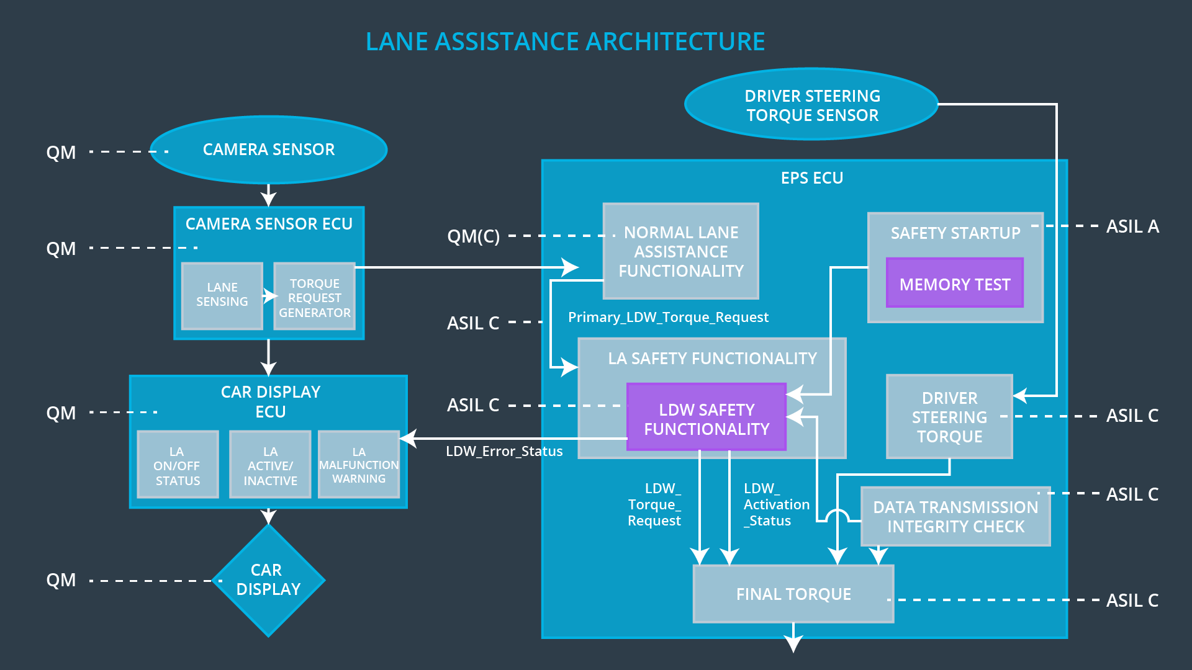  
Figure 2: Refinement of the System Architecture

## Allocation of Technical Safety Requirements to Architecture Elements

We already included the allocation as part of the technical requirement tables above. For this particular item, all technical safety requirements are allocated to the Electronic Power Steering ECU.

## Warning and Degradation Concept

|  |  |  |  |  |
| --- | --- | --- | --- | --- |
| **ID** | **Degradation Mode** | **Trigger for Degradation Mode** | **Safe State invoked?** | **Driver Warning** |
| WDC-01 | The torque request from the lane keeping assistance will be set to zero. | Malfunction_01, Malfunction_02 | Yes | Warning light on the dashboard when the system malfunctions |
| WDC-02 | The torque request from the lane keeping assistance will be set to zero. | Malfunction_03 | Yes | Warning light on the dashboard when the system malfunctions |