**Pablo Sepulveda**  
IT121 JavaScript 1  
Spring 2023  
Prof. Sarah North

GitHub repository:

<https://github.com/pablospanish9/IT121_Javascript_1/tree/main/week_2>

**Temperature converter:**

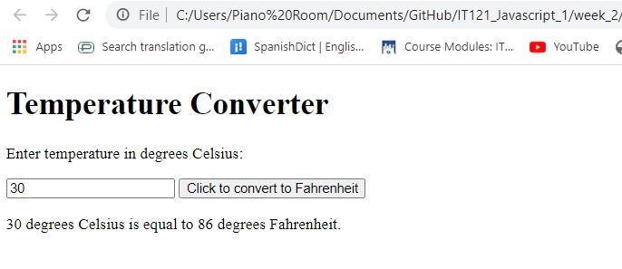

**Find type of:**

