**Pablo Sepulveda**  
IT121 JavaScript 1  
Spring 2023  
Prof. Sarah North

# Week_3 Assignment_1 Create an object using .js const

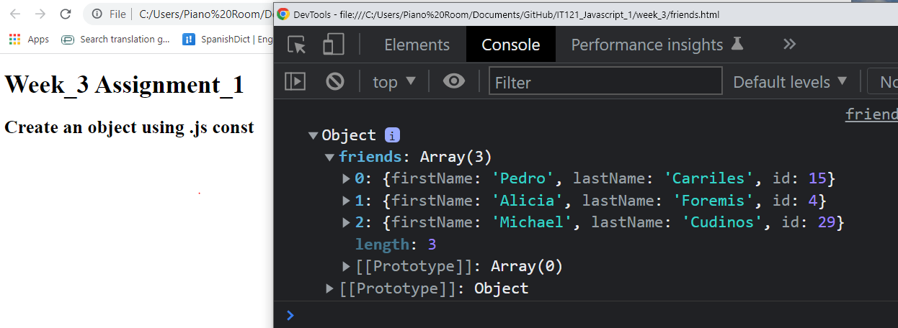

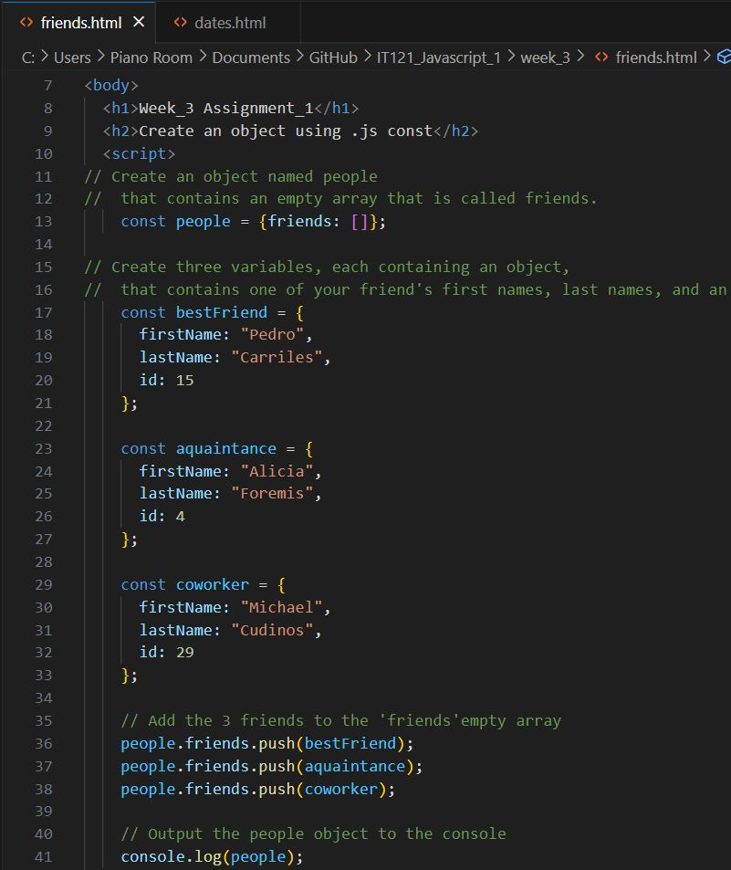

# Week_3 Assignment_2 Calculate the dateOne year from now

