**Pablo Sepulveda**  
IT121 JavaScript 1  
Spring 2023  
Prof. Sarah North

<https://github.com/pablospanish9/IT121_Javascript_1/tree/main/week_6>

<!DOCTYPE html>

<html>

<head>

  <title>Recursive Functions</title>

  <script>

    // The program defines a function called 'counter' which takes an integer argument 'i'.

    // It recursively calls itself with 'i + 1' until 'i' is equal to or greater than 10.

    // When 'i' is less than 10, it logs the current value of 'i' to the console.

    const counter = (i) => {

      console.log(i);

      if (i < 10) {

        return counter(i + 1);

      }

      return;

    };

    // The main function, when called with the initial value of 0, invokes the 'counter' function.

    // the numbers from 0 to 9 are logged to the console.

    const main = () => {

      counter(0);

    };

    // Define four additional functions: one, two, three, and four.

    const one = () => console.log('one');

    const two = () => console.log('two');

    // When the 'three' function is called, it logs the string 'three' to the console

    // and then calls the functions 'one' and 'two'.

    const three = () => {

      console.log('three');

      one();

      two();

    };

    // When the 'four' function is called, it logs the string 'four' to the console

    // and then schedules the execution of the function 'one' using setTimeout() with a delay of 0 milliseconds.

    // It then calls the 'three' function.

    const four = () => {

      console.log('four');

      setTimeout(one, 0);

      three();

    };

    // Invoke the 'main' function to start the recursive counting process.

    main();

    // Call the 'four' function which logs 'four' to the console,

    // schedules the execution of 'one' using setTimeout() with a delay of 0 milliseconds,

    // and calls the 'three' function.

    four();

  </script>

</head>

<body>

  <h1>Recursive Functions</h1>

</body>

</html>

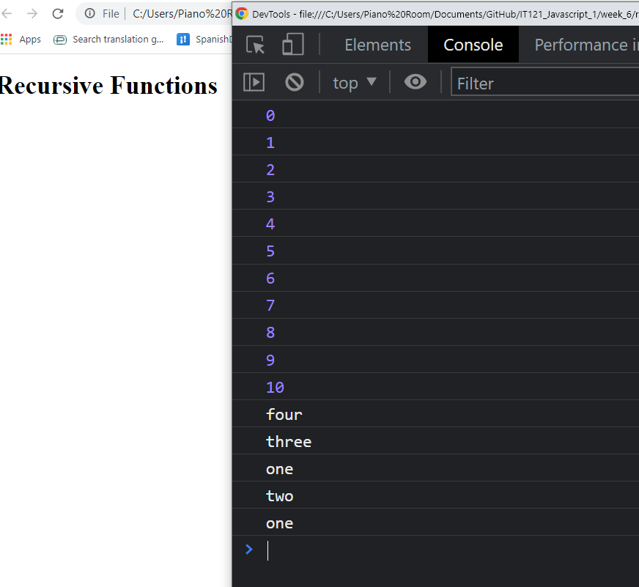

<!DOCTYPE html>

<html>

<head>

  <title>Recursive Functions</title>

  <script>

    // The program defines a function called 'counter' which takes an integer argument 'i'.

    // It recursively calls itself with 'i + 1' until 'i' is equal to or greater than 10.

    // When 'i' is less than 10, it logs the current value of 'i' to the console.

    const counter = (i) => {

      console.log(i);

      if (i < 10) {

        return counter(i + 1);

      }

      return;

    };

    // The main function, when called with the initial value of 0, invokes the 'counter' function.

    // the numbers from 0 to 9 are logged to the console.

    const main = () => {

      counter(0);

    };

    // Define four additional functions: one, two, three, and four.

    const one = () => console.log('one');

    const two = () => console.log('two');

    // When the 'three' function is called, it logs the string 'three' to the console

    // and then calls the functions 'one' and 'two'.

    const three = () => {

      console.log('three');

      one();

      two();

    };

    // When the 'four' function is called, it logs the string 'four' to the console

    // and then schedules the execution of the function 'one' using setTimeout() with a delay of 0 milliseconds.

    // It then calls the 'three' function.

    const four = () => {

      console.log('four');

      setTimeout(one, 0);

      three();

    };

    // Invoke the 'main' function to start the recursive counting process.

    main();

    // Call the 'four' function which logs 'four' to the console,

    // schedules the execution of 'one' using setTimeout() with a delay of 0 milliseconds,

    // and calls the 'three' function.

    four();

  </script>

</head>

<body>

  <h1>Recursive Functions</h1>

</body>

</html>