**Pablo Sepulveda**  
IT121 JavaScript 1  
Spring 2023  
Prof. Sarah North

<https://github.com/pablospanish9/IT121_Javascript_1/tree/main/week_7>

View page on server:

<https://pabsep2.dreamhosters.com/sites/it121/week7/flags.html>

[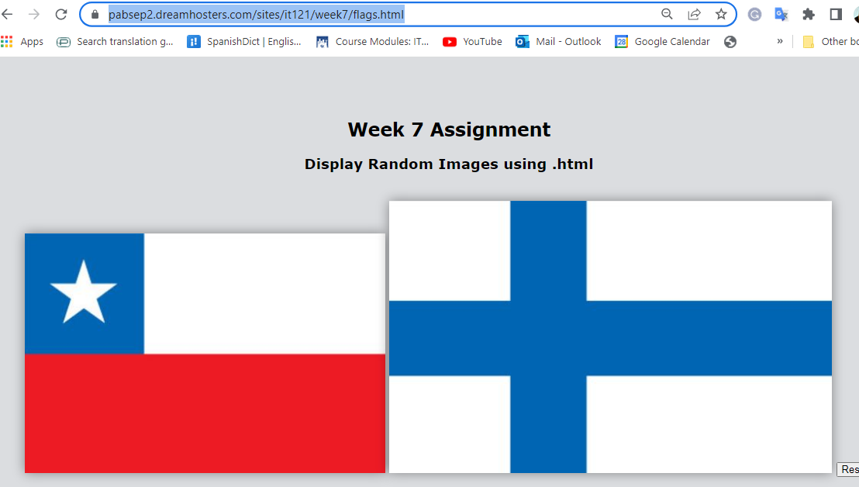](https://pabsep2.dreamhosters.com/sites/it121/week7/flags.html)

          <h2><br><br>

            Week 7 Assignment </h2>

          <h3>Display Random Images using .html</h3><br>

        <!-- Images of flags -->

        <!-- Pics change when clicked -->

        <!-- Specifies the JavaScript function changeImg(event) to be executed

        when the image is clicked. It passes the event object as an argument to the function. -->

        <img src="images/chile.JPG" alt="Flag of chile" onclick="changeImg(event)" />

        <img src="images/comoros.JPG" alt="Flag of Comoros" onclick="changeImg(event)" />

        <!-- button element that creates a clickable button. -->

        <button onclick="resetTable()">Reset</button>

        <script>

          // Page loads code and pictures not visible to the user.

          // Add an Event listener to the window object for the 'load' event.

          // The 'load' event is triggered when the web page finishes loading.

          window.addEventListener('load', function() {

            var images = ["images/chile.JPG", "images/comoros.JPG", "images/Ethiopia.JPG", "images/finland.JPG",

                       "images/lithuania.JPG", "images/armenia.JPG", "images/mozambique.JPG"];

            var imgs = document.querySelectorAll('img');

            // forEach() method to iterate over each <img> element in the imgs collection.

            // It executes the provided callback function for each element.

            imgs.forEach(function(img, index) {

              var randomIndex = Math.floor(Math.random() * images.length);

              img.src = images[randomIndex];

            });

          });

          // This function is called when one of the flag images is clicked.

          function changeImg(event) {

            var images = ["images/chile.JPG", "images/comoros.JPG", "images/Ethiopia.JPG",

               "images/finland.JPG", "images/armenia.JPG","images/lithuania.JPG", "images/mozambique.JPG"];

            var randomIndex = Math.floor(Math.random() * images.length);

            // This line updates the src attribute of the clicked image element.

            event.target.src = images[randomIndex];

          }

          // This function is called when the "Reset" button is clicked.

          function resetTable() {

            // This line selects all the <img> elements in the document and assigns them to the imgs variable.

            var imgs = document.querySelectorAll('img');

            imgs[0].src = 'images/chile.JPG'; // set the first image to 'chile' after reset

            imgs[1].src = 'images/finland.JPG'; // set the second image to 'finland' after reset

          }

        </script>