<https://pabsep2.dreamhosters.com/sites/it121/week8/movesquare.html>

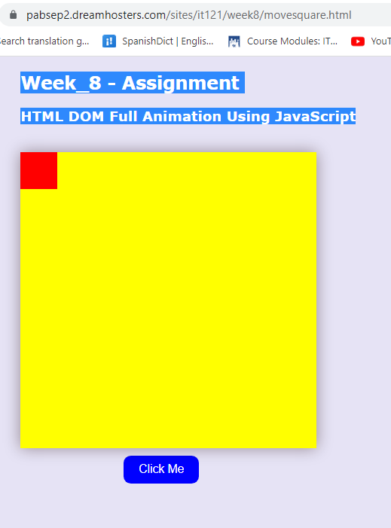

<style>

    /* CSS styles for the container */

         body {

      background-color: rgb(230, 227, 245);

      margin-left: 150px;

      font-family: Verdana, Sans-serif;

    }

    #container {

      width: 400px;

      height: 400px;

      position: relative;

      background: yellow;

      box-shadow: 0 0 20px rgba(30, 0, 0, 0.4); /* Add shadow to the element */

    }

    /* CSS styles for the animated element */

    #animate {

      width: 50px;

      height: 50px;

      position: absolute;

      background: red;

    }

        /* CSS styles for the button */

        button {

      display: block;

      margin-top: 10px;

      margin-left: 140px;

      padding: 10px 20px;

      font-size: 16px;

      background-color: blue;

      color: white;

      border: none;

      border-radius: 10px; /* Add border radius for rounded corners */

    }

  </style>

</head>

<body>

<!-- Heading -->

<h2>Week_8 - Assignment</h2>

<h3>HTML DOM Full Animation Using JavaScript</h3><br>

<!-- Container for the yellow square and animated element -->

<div id="container">

  <div id="animate"></div>

</div>

<!-- Button to trigger the animation -->

<button onclick="myMove()">Click Me</button>

<script>

  // JavaScript function for initiating the animation

  function myMove() {

    let id = null;  // Variable to store the animation interval ID

    const elem = document.getElementById("animate");  // Reference to the animated element

    let pos = 0;  // Variable to track the current position of the animated red square

                  // element as it moves

    // Clear any existing animation interval,

    // before starting a new animation

     clearInterval(id);

    // Start a new animation interval with a callback function "frame"

    // recurring timer that calls the frame function repeatedly every 7 milliseconds.

    id = setInterval(frame, 7);

    function frame() {

      if (pos == 350) {

        clearInterval(id);  // Stop the animation when the element reaches 350

        // this 'else' keeps the animation going, the variable is incremented by 1px using:

      } else {

        pos++;  // Increment the position

        elem.style.top = pos + 'px';  // Update the top position of the element

        elem.style.left = pos + 'px';  // Update the left position of the element

      }

    }

  }

</script>

</body>