**Pablo Sepulveda**  
IT121 JavaScript 1  
Spring 2023  
Prof. Sarah North

<https://github.com/pablospanish9/IT121_Javascript_1/tree/main/week_9>  
<https://github.com/pablospanish9/IT121_Javascript_1/blob/main/week_9/email.html>  
Web server: <https://pabsep2.dreamhosters.com/sites/it121/email.html>

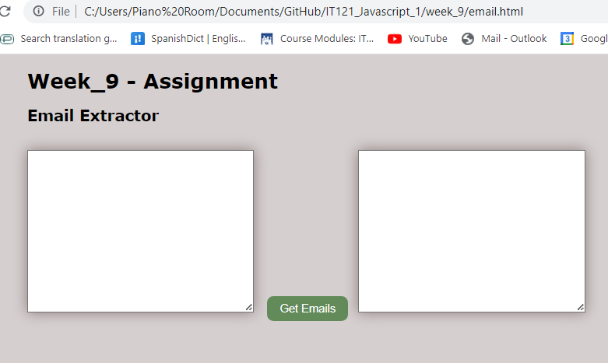

<!doctype html>

<html>

<head>

    <title>Complete JavaScript Course</title>

<style>

#inputArea, #outputArea {

  width: 350px;

  height: 250px;

  margin-top: 20px;

  margin-right: 5px;

  box-shadow: 0 0 20px rgba(30, 0, 0, 0.4); /* Add shadow to the element */

  /* margin-left: 10px; */

}

body {

      background-color: rgb(214, 207, 207);

      margin-left: 150px;

      font-family: Verdana, Sans-serif;

    }

    /* CSS styles for the button */

        button {

      /* display: block; */

      margin-top: 10px;

      margin-left: 10px;

      margin-right: 10px;

      padding: 10px 20px;

      font-size: 18px;

      background-color: rgb(99, 139, 90);

      color: white;

      border: none;

      border-radius: 10px; /* Add border radius for rounded corners */

    }

</style>

</head>

<h1>Week_9 - Assignment</h1>

<h2>Email Extractor</h2>

<body>

    <textarea id="inputArea" name="txtarea" rows="2" cols="50"></textarea>

    <!-- clickable button labeled "Get Emails". When the user clicks this button,

    it will trigger a JavaScript function that extracts email -->

    <button id="extractButton">Get Emails</button>

    <textarea id="outputArea" name="txtarea2" rows="2" cols="50"></textarea>

    <script>

        // Select the first textarea element with the name attribute set to 'txtarea' and store it in the variable 'firstArea'.

        var firstArea = document.querySelector('textarea[name="txtarea"]');

        // Select the second textarea element with the name attribute set to 'txtarea2' and store it in the variable 'secArea'.

        var secArea = document.querySelector('textarea[name="txtarea2"]');

        // Find the button element in the document and attach a click event listener to it, calling the 'lookUp' function when clicked.

        var button = document.querySelector('button');

        button.addEventListener('click', lookUp);

        // Declare a function named 'lookUp'.

        function lookUp() {

            // Get the value of the 'firstArea' text area and store it in the 'rawTxt' variable.

            // firstArea is a variable that holds a reference to the <textarea> element

            // .value is a property of the <textarea> element, to access the current value entered or set in the textarea.

            // firstArea.value retrieves the current value entered or set in the firstArea textarea element.

            // The retrieved value is then assigned to the variable rawTxt

            var rawTxt = firstArea.value;

            // Use a regular expression to match and extract email addresses from the 'rawTxt' string,

            // and store them in a variable called 'eData'. rawTxt is a variable that holds the text

            //  content retrieved from the firstArea textarea element,

            // .match() is a JavaScript string method used to search for a match between a regular expression and the given string.

            var eData = rawTxt.match(/[a-zA-Z0-9._%+-]+@[a-zA-Z0-9.-]+\.[a-zA-Z]{2,}/g);

            // Create an empty array named 'holder' to store unique email addresses.

            var holder = [];

            // Iterate through each element in the 'eData' array.

            eData.forEach(function(email) {

                // Check if the current email address is not already present in the 'holder' array.

                // This ensures that only unique email addresses are stored in the holder array.

                if (!holder.includes(email)) {

                    // Add the current email address to the 'holder' array.

                    holder.push(email);

                }

            });

            // Set the value of the 'secArea' text area to the joined string of unique email addresses.

            secArea.value = holder.join('\n');

        }

    </script>

</body>

</html>