# Notice to landlord of rented premises

***Residential Tenancies Act 1997* (the Act)**

**Note:** Enter text in spaces provided only. This form will be invalid if you remove or change any questions or other text.

**Use this form to give notice if you are a**:

* tenant of rented premises, or
* specialist disability accommodation (SDA) resident under a residential tenancy agreement. This form refers to you as the ‘tenant’ and an SDA provider as the ‘landlord’.

**Use this form to give notice to the landlord/agent that:**

* non-urgent repairs are required
* you have arranged and paid for urgent repairs and you require reimbursement
* you have paid utility charges that are not your responsibility and you require reimbursement
* you caused or became aware of damage to the premises
* you are terminating the tenancy agreement before moving in
* you are the legal representative or next of kin of the tenant who is deceased
* you intend to vacate because the premises have been destroyed or are unfit for human habitation
* you intend to vacate for other reasons.

**Note:** Do not use this form to request the landlord’s consent to keep a pet in the rented premises. You must use the ‘Pet request form’ available from the [Forms and publications section – Consumer Affairs Victoria website](https://www.consumer.vic.gov.au/forms) (consumer.vic.gov.au/forms).

## How to use this form

### 1. Identify your reason

Read the reasons for giving a notice on the back of this page and identify the correct reason for your circumstances.

The number beside each reason is the relevant section of the Act. You should consult the Act to make sure that you are entitled to give a notice.

### 2. Complete part 1 to 7

You must complete all boxes.

### 3. Sign at part 8 and write your name at part 9

### 4. Write your reason in part 10

In part 10, write the section number and the exact words given to you on the back of this page.

### 5. Attachments

For some reasons you must provide evidence or receipts. If you are providing them, attach them to the notice and tick the ‘yes’ box in part 11.

### 6. When the form is complete

Send a copy of the form to the landlord. For more information, see ‘How to serve this notice’ on page 2.

Keep copies of the form for your records. If the landlord does not comply, you can post one of these copies to Consumer Affairs Victoria to request an inspection or email the document to [renting@justice.vic.gov.au](mailto:renting@justice.vic.gov.au)

### Telephone Interpreter Service

If you have difficulty understanding English, contact the Translating and Interpreting Service (TIS) on 131 450 (for the cost of a local call) and ask to be put through to an Information Officer at Consumer Affairs Victoria on   
1300 55 81 81.



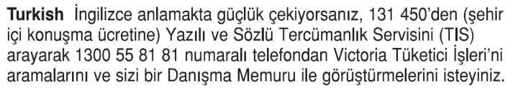





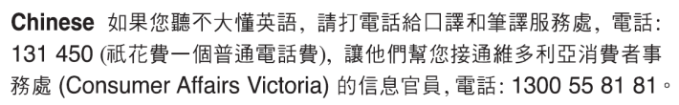

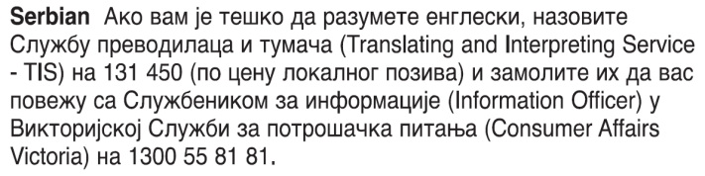







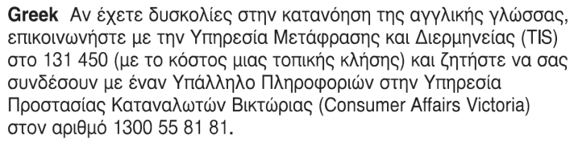

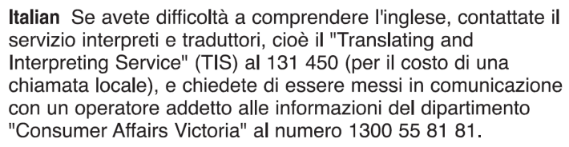Information about renting is available in other languages at [consumer.vic.gov.au/languages](https://www.consumer.vic.gov.au/languages).

# Notice to landlord of rented premises

## Reasons to use in question 10

### 72(2)(a)–urgent repairs *–* reimbursement

* *write this and complete description and $ amount*

I have arranged and paid for urgent repairs to the premises after taking reasonable steps to arrange for them to be carried out by you or your agent.

The urgent repairs were _ and cost $_ I require you to reimburse me $_ within 14 days.

* *Please note – the maximum amount for which the landlord may be liable is $1,800.*
* *attach detail, receipts, and any other evidence.*

### 74(1)(a)–non-urgent repairs

* *write this and complete the repair description*

I require you to carry out repairs to the premises within 14 days. The repairs needed are _

### 55(2)–utility charges

* *write the following and complete $ amount*

I have paid utility charges that are your responsibility.

I require you to reimburse me $_ within 28 days.

* *attach detail, receipts, and any other evidence.*

### 62–notice of damage

* *write the following and complete damage description*

I am notifying you of damage to the premises. The damage is _

### 226–termination before moving in

* *write this.*

I am terminating the tenancy agreement before I move in because the premises are _

* *select one of the following reasons and write it*
* not in good repair.
* unfit for human habitation.
* destroyed to such an extent that they are unsafe.
* not vacant.
* not legally available for use as a residence.
* unavailable for occupation for the following reason _

### 228–termination after death of sole tenant

* *write this.*

I am the legal representative or next of kin of your tenant who is deceased. The tenancy agreement will end in 28 days after you are given this notice.

* *Please note – you can agree with the landlord in writing on an earlier termination date.*

### 238(1)–premises destroyed or unfit

* *write this and complete the date which may be the date on which the notice is given or a later date*

I intend to vacate on _ / _ / _ because the premises are unfit for human habitation, or totally destroyed, or damaged so much that they are unsafe.

### 235(1)–intention to vacate (no specified reason)

* *write this and complete the date*\*

I am giving you at least 28 days notice that I intend to vacate the premises on _ / _ / _

* If there is a fixed term tenancy agreement, this date cannot be before the end date of the agreement.

### 237(1)–intention to vacate

* *write this and complete the date\**

I am giving you at least 14 days notice that I intend to vacate the premises on _ / _ / _ because _

* *select one of the following reasons and write it*
* you have given me notice to vacate under section 255 or 256 or 257 or 258 or 259 or 260 or 262 or 263.
* I require special or personal care and need to vacate the premises to obtain this care.
* I have received a written offer of public housing.
* I require temporary crisis accommodation and need to vacate the premises in order to obtain that accommodation.

* If there is a fixed term tenancy agreement, this date cannot be before the end date of the agreement.

### 237A(2)–long-term tenancy agreement is not in a prescribed form

* *write this and complete the date*

I am giving you at least 28 days notice that I intend to vacate the premises on _ / _ / _ because the long-term tenancy agreement is not in a prescribed standard form (Form 1 or Form 2).

### 239(1)–non compliance with Tribunal order

* *write this and complete the date*

I am giving you at least 14 days notice that I intend to vacate the premises on _ / _ / _ because you have failed to comply with a compensation or compliance order of the Victorian Civil and Administrative Tribunal (VCAT).

### 240(1)–successive breaches by landlord

* *write this and complete the date*

I am giving you at least 14 days notice that I intend to vacate the premises on _ / _ / _ because you are in breach of a duty owed under a duty provision within Part 5 of the Act for the third time. I have given you notice of breach of that duty under S208 on two previous occasions.

## How to serve this notice

**You can serve this notice by hand, by post, or by email (with consent).**

If you send this notice by post, you must take into account the extra days it takes for the notice to be delivered. Australia Post has three different speeds for ordinary mail delivery – express, priority and regular mail, which may take up to six days. Priority and regular delivery speeds also apply for registered post. You may wish to keep evidence of the mail delivery method you relied on to send this notice. For more information about Australia Post’s mail delivery options and times, visit the [Australia Post website](http://www.auspost.com.au/) (auspost.com.au).

You can only send this notice by email if you already have the landlord’s written consent to receive notices and other documents this way. The landlord may have given consent in the tenancy agreement or separately in writing. A consent form is available from the [Forms and publications section – Consumer Affairs Victoria website](https://www.consumer.vic.gov.au/forms) (consumer.vic.gov.au/forms).

If you send this notice by email, the provisions of the *Electronic Transactions (Victoria) Act 2000* apply. For legal purposes,   
the time when a notice is received is when it can be retrieved from the email address the recipient nominated.

To help calculate the total minimum days to allow, depending on the notice period required and the method of delivery,   
visit the [Giving notices – Residential Tenancies List page – Victorian Civil and Administrative Tribunal website](https://www.vcat.vic.gov.au/resources/giving-notices-residential-tenancies-list) (vcat.vic.gov.au/resources/giving-notices-residential-tenancies-list).

If you need help with this notice, visit the [Renting section – Consumer Affairs Victoria website](https://www.consumer.vic.gov.au/renting) (consumer.vic.gov.au/renting)   
or call the Consumer Affairs Victoria Helpline on 1300 55 81 81.

# Notice to landlord of rented premises Landlord’s copy

## From the tenant

### Landlord details

1. This notice is given to *(landlord/s names):*

|  |
| --- |
| Harry Potter |

1. Landlord’s address *(can be an agent’s):*

|  |
| --- |
| 1 Hogwarts Dr  Hogwarts VIC 3820 |

### Tenant details

1. Tenant/s name/s:

|  |
| --- |
|  |

1. Regarding the rented premises at *(write address):*

|  |
| --- |
|  |

1. Address for serving documents  
   *(if the same as in 4, write “as above”):*

|  |
| --- |
|  |

1. Contact telephone numbers

|  |  |
| --- | --- |
| Business hours: |  |
| After hours: |  |

### Service details

1. This notice is given: *(mark one method only and if posted note the delivery speed)*

|  |  |
| --- | --- |
| by hand: |  |
| by registered post: |  |
| by ordinary post: |  |
| by email: |  |
| Insert email address: *(if applicable)* |  |
| on (date): | / / |

1. Signature of tenant:

|  |
| --- |
|  |

1. Name of tenant signing this notice:

|  |
| --- |
|  |

### Reason for notice

1. (write the section number and reason, using the words from the page opposite):

|  |
| --- |
|  |

1. Details are attached to this notice  
   *(e.g. receipts, other evidence)*

|  |  |
| --- | --- |
| yes: |  |
| no: |  |

### Landlord please note

If you need help with this notice, call the Consumer   
Affairs Victoria Helpline on 1300 55 81 81 or visit [consumer.vic.gov.au/renting](https://www.consumer.vic.gov.au/renting)

# Notice to landlord of rented premises Tenant’s copy

## From the tenant

### Landlord details

1. This notice is given to *(landlord/s names):*

|  |
| --- |
| Harry Potter |

1. Landlord’s address *(can be an agent’s):*

|  |
| --- |
| 1 Hogwarts Dr  Hogwarts VIC 3820 |

### Tenant details

1. Tenant/s name/s:

|  |
| --- |
|  |

1. Regarding the rented premises at *(write address):*

|  |
| --- |
|  |

1. Address for serving documents  
   *(if the same as in 4, write “as above”):*

|  |
| --- |
|  |

1. Contact telephone numbers

|  |  |
| --- | --- |
| Business hours: |  |
| After hours: |  |

### Service details

1. This notice is given: *(mark one method only and if posted note the delivery speed)*

|  |  |
| --- | --- |
| by hand: |  |
| by registered post: |  |
| by ordinary post: |  |
| by email: |  |
| Insert email address: *(if applicable)* |  |
| on (date): | / / |

1. Signature of tenant:

|  |
| --- |
|  |

1. Name of tenant signing this notice:

|  |
| --- |
|  |

### Reason for notice

1. (write the section number and reason, using the words from the page opposite):

|  |
| --- |
|  |

1. Details are attached to this notice  
   *(e.g. receipts, other evidence)*

|  |  |
| --- | --- |
| yes: |  |
| no: |  |

### Landlord please note

If you need help with this notice, call the Consumer   
Affairs Victoria Helpline on 1300 55 81 81 or visit [consumer.vic.gov.au/renting](https://www.consumer.vic.gov.au/renting)

# Notice to landlord of rented premises Tenant’s copy

## From the tenant

### Landlord details

1. This notice is given to *(landlord/s names):*

|  |
| --- |
| Harry Potter |

1. Landlord’s address *(can be an agent’s):*

|  |
| --- |
| 1 Hogwarts Dr  Hogwarts VIC 3820 |

### Tenant details

1. Tenant/s name/s:

|  |
| --- |
|  |

1. Regarding the rented premises at *(write address):*

|  |
| --- |
|  |

1. Address for serving documents  
   *(if the same as in 4, write “as above”):*

|  |
| --- |
|  |

1. Contact telephone numbers

|  |  |
| --- | --- |
| Business hours: |  |
| After hours: |  |

### Service details

1. This notice is given: *(mark one method only and if posted note the delivery speed)*

|  |  |
| --- | --- |
| by hand: |  |
| by registered post: |  |
| by ordinary post: |  |
| by email: |  |
| Insert email address: *(if applicable)* |  |
| on (date): | / / |

1. Signature of tenant:

|  |
| --- |
|  |

1. Name of tenant signing this notice:

|  |
| --- |
|  |

### Reason for notice

1. (write the section number and reason, using the words from the page opposite):

|  |
| --- |
|  |

1. Details are attached to this notice  
   *(e.g. receipts, other evidence)*

|  |  |
| --- | --- |
| yes: |  |
| no: |  |

### Landlord please note

If you need help with this notice, call the Consumer   
Affairs Victoria Helpline on 1300 55 81 81 or visit [consumer.vic.gov.au/renting](https://www.consumer.vic.gov.au/renting)