Web Design Project Report

Higher Diploma in Science in Computing/Higher Diploma in Science in Web Technologies

Jane Park - Author

[https://www.deploymenturl.ie]

**Report Authors:**

Liz Bourke/19149310

Kevin Higgins/19178298

Cathal Kavanagh/ 19182121

Pablo Targa/ 19183500

Contents

Team and Participants 3

Links 3

Summary 4

Design 5

Initial Design Process: 5

Sitemap: 5

Early Wireframes: 5

Final Wireframe and Homepage View: 5

Development and Features 7

Feature 1: [Name of Feature] 7

Feature 2: [Name of Feature] 7

Feature 3: [Name of Feature] 7

Feature 4: [Name of Feature] 7

Feature 5: Countdown Banner 7

Teamwork 7

Pablo 7

Kevin 7

Cathal 8

Liz 8

Deployment 8

Validation 8

Team and Participants

Project Group Team: Group C.

Participants in Alphabetical Order:

* Liz Bourke/19149310
* Kevin Higgins/ 19178298
* Cathal Kavanagh/ 19182121
* Pablo Targa/ 19183500

# Links

Code on Github: [link]

Deployed: [link]

# Summary

We designed our website around the following pitch:

"Jane Park[1] is a debut novelist who is launching her first epic fantasy novel, called PROTECTORS OF THE NORTH. (He's a fiendish coffee-fuelled assassin who must take medication to keep him sane. She's a hard-bitten motormouth college professor from a secret island of warrior women. Together, they fight dragons!)

Her publisher has decided to provide her with a website. The audience for the website is a reader of epic fantasy who may or may not be previously familiar with Jane Park and her work."

The primary purpose of the website is to promote Jane's first book. Its seconday purpose is to promote Jane's brand as an author. To this end, it needs to include:

* information about the book to encourage people to buy it, and
* information about Jane in order to promote interest in her and any future work she produces.

The main audience for the website are existing readers of epic fantasy to whom Jane and her publisher are advertising Jane herself and her book. The audience is assumed to be moderately tech-savvy. The website design should make it easy for the audience to:

* find information about the book,
* find links to vendors of the book,
* find relevant information about Jane, and
* find out if Jane will be appearing at a bookshop or book festival near them in order to promote her book in person.

Design

## Initial Design Process:

We decided that the website would need to include at least the following pages:

* Home: with brief information both about book and author, and buy links;
* Book: with detailed information about the book, testimonials/quotes from respected review outlets, link to 1st chapter;
* About the Author: with relevant information about the author;
* Previous Work: with information about and links to other things the author has done, such as short stories, that might convince a reader to buy the book;
* News: with updates about the author in blog form, information about events the author will be participating in, etc;
* Contact: with a form to contact Jane.

We consulted with readers and professional writers[2] of epic fantasy for what they like to see in a website, and from this brief survey developed a simple pencil sitemap:

## Sitemap:

[artistic type insert picture of sitemap here - Liz]

## Early Wireframes:

We then developed some early wireframes:

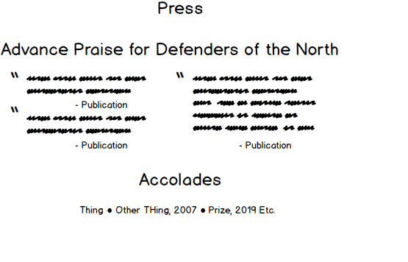

After some consultation and discussion, we decided to replace the News page with an Events page for [reasons]. We also decided on some other changes [if we do, put them here].

## Final Wireframe and Homepage View:

[screenshot of homepage goes here]

Development and Features

## Feature 1: [Name of Feature]

[Kevin's Events]

## Feature 2: [Name of Feature]

[Pablo]

## Feature 3: [Name of Feature]

[Cathal]

## Feature 4: [Name of Feature]

[Liz's game]

## Feature 5: Countdown Banner

[Countdown feature]

Teamwork

At the initial stage of development we all worked together to develop a pitch and generate a general design sensibility. As we began to build the pages, we divided up the work based on our priorities and respective experience.

Pablo: As the team member with greatest experience in web development, Pablotook responsibility for ensuring consistency in our shared CSS stylesheet, ui-kit.css (the UI Kit). Pablo also developed the Home page and the Countdown.js script (shared across all main pages) as well as mentoring team members with less experience as they developed their own JavaScript scripts and CSS styles. [If this is inaccurate, Pablo, please correct it.] Pablo also collaborated on the Contact page, developing the styles for the form.

Kevin took responsibility for developing the Events page, and building [features] that did [things with Javascript and JSON]. Kevin also [did things with wireframes and colours] and [developed styles, particularly for [elements]].

Cathaltook responsibility for developing the Previous Work page, creating content and building [features].

Lizdeveloped much of the written content for the Home, Book, and Author pages. Liz also took responsibility for developing the Author and Book pages, as these were relatively straightforward in implementation; collaborated with Pablo on the Contact page; contributed to the development of styles, particularly for the footer element; and built two JavaScript scripts for the Book page: one to play audio and one to generate a simple text-based game with a random number element.

Deployment

We deployed to GitHub pages because we aren't launching a real-world debut author and their novel. Our only server-side requirements were [requirements] and we used [this service] for them. We deployed our website from [name] GitHub branch, and redeployed several times as we improved feature functionality.

Validation

We validated our final code through:

<http://validator.w3.org/>

[validation screenshot goes here]

and:

<http://jigsaw.w3.org/css-validator/>

[validation screenshot goes here]

1. Not a real person.
2. Liz can provide references if required.