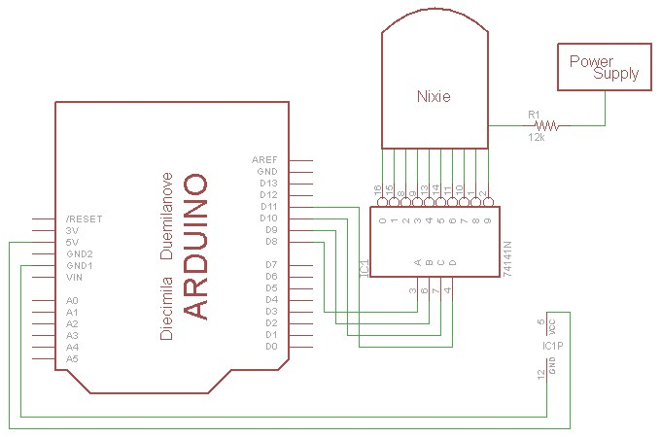

Nixie IN-12

Vingnition = 200v
Vmanitain = 170v
Average Current = 2A

P = 60 mW
R = 15 kOhm

