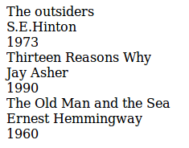
Exercise 1:
title, author, publication_data {
display: block
}

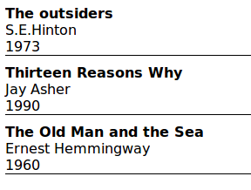
Exercise 2:
book, title, author, publication_data {
display: block;
}

title {
font-weight: bold;
}

book {
border-bottom: solid 1px black;
margin-bottom: 15px;
}

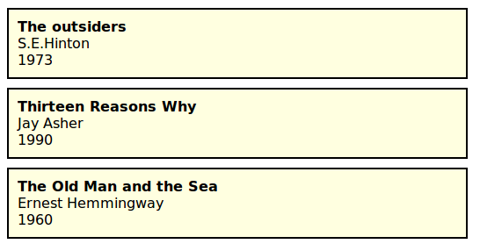
Exercise 3:
book, title, author, publication_data {
display: block;
}

title {
font-weight: bold;
}

book {
margin: 10px;
padding: 10px;
background-color: lightgoldenrodyellow;
border: solid 2px black;
}

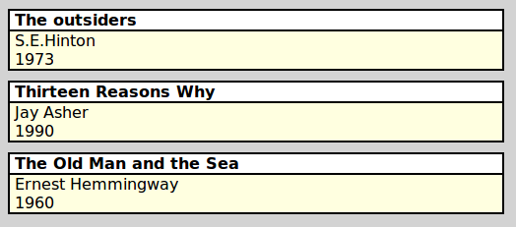

Exercise 4:
book, title, author, publication_data {
display: block;
}

title, author, publication_data {
padding-left: 3px;
}

title {
font-weight: bold;
background-color: white;
border-bottom: solid 2px black;
}

book {
margin: 10px;
background-color: lightgoldenrodyellow;
border: solid 2px black;
}

library {
background-color: lightgray;
}

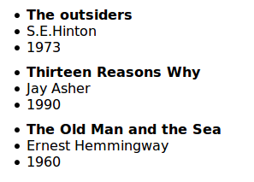
Exercise 5:
book {
display: block;
}

title, author, publication_data {
display: list-item;
list-style-position: inside;
}

title {
font-weight: bold;
}

book {
margin: 15px;
}

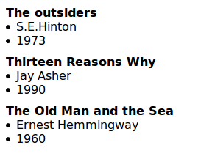
Exercise 6:
book {
display: block;
}

title, author, publication_data {
display: list-item;
list-style-position: inside;
}

title {
font-weight: bold;
list-style-type: none;
}

book {
margin: 15px;
}

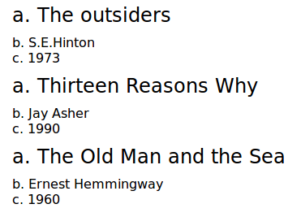
Exercise 7:
book {
display: block;
}

title, author, publication_data {
display: list-item;
list-style-position: inside;
list-style-type: lower-alpha;
}

title {
font-size: 150%;
margin-bottom: 5px;
}

book {
margin: 15px;
}

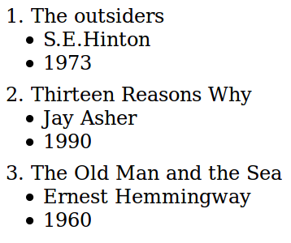
Exercise 8:
book {
display: block;
}

title {
margin-bottom: 5px;
display: inline;
}

author, publication_data {
display: list-item;
list-style-position: inside;
margin-left: 10px;
}

book {
margin: 15px;
}

library {
counter-reset: contador;
}

book:before {
content: counter(contador, decimal) ". ";
counter-increment: contador;
}
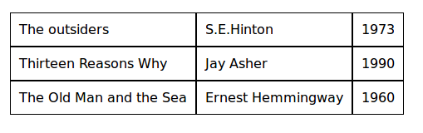
Exercise 9:
book {
display: table-row;
}

title, author, publication_data {
display: table-cell;
padding: 5px;
border: solid 1px black;
}

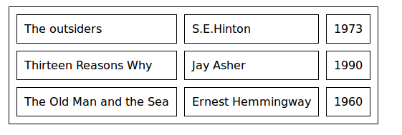
Exercise 10:
library {
border: solid 1px black;
display: table;
border-spacing: 10px;
}

book {
display: table-row;
}

title, author, publication_data {
display: table-cell;
padding: 5px;
border: solid 1px black;
}

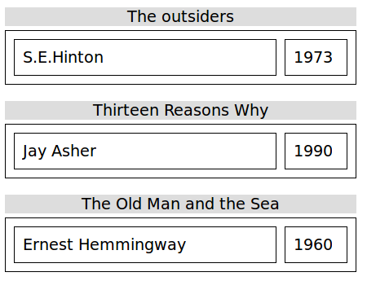
Exercise 11:
book {
display: table;
border-spacing: 10px;
border: solid 1px black;
margin: 20px;
width: 400px;
}

title {
display: table-caption;
background-color: lightgray;
text-align: center;
margin-bottom: 5px;
}

author, publication_data {
display: table-cell;
padding: 5px;
border: solid 1px black;
}

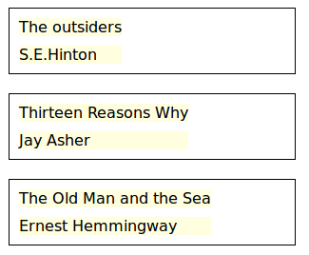
Exercise 12:
book {
display: table;
border: solid 1px black;
border-spacing: 10px;
margin: 20px;
width: 400px;
}

publication_data {
display: none;
}

title, author{
display: table-row;
background-color: lightgoldenrodyellow;
padding: 10px;
}

