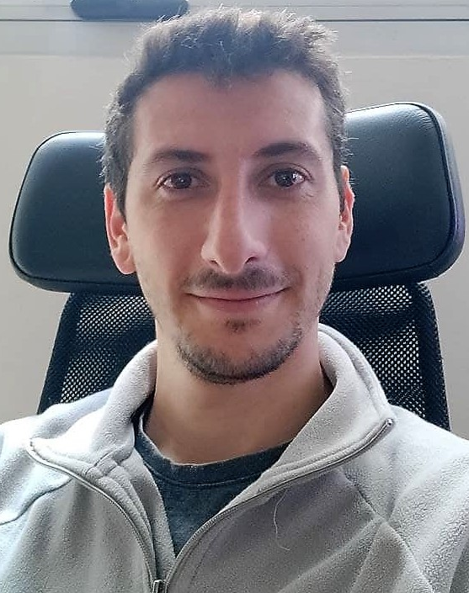
Pablo Uboldi
pabloauboldi@gmail.com
Cel: +52 55 8573 3783
Av. Ejército Nacional 225, Anáhuac I Secc, Miguel Hidalgo, 11320 CDMX

Work Experience
Fluid Mechanics Associate Professor in the National Technology University
March 2018 – Present

As an associate professor in Fluid Mechanics, I oversee the theoretical and practical evaluation activities developed for the students of Aeronautical Engineering at the National Technology University, Haedo.

Responsibilities:
- During the pandemic, I planned, designed and programmed evaluations throughout the global virtual campus. This consisted of the implementation of over 30 evaluations every year for the 35 annual students that would sign up for the course. Evaluations where time-limited and randomized across students with 10 versions of every exercise. Solutions were iterated and obtained in software Wolfram Mathematica
- Before and after the pandemic, I designed the evaluations to be handed out in class as written exercises
- I lead responses in the Q&A section of the virtual campus, answering theoretical and practical questions from students and providing troubleshooting with calculus code

Project Manager in Natural and Exact Sciences Faculty, UBA, Argentina.
March 2014 – August 2021

In the Faculty of Natural and Exact Sciences of the UBA, I was part of the Technical Department, co-leading the electrical maintenance team for small and medium scale projects.

Responsibilities:
- Reception of the electrical project requirement from internal stakeholder
- On-site evaluation of feasibility of the project, measurement, time required and added specifications
- Cost assessment of resources (materials, man hours and/or hiring of an external workforce)
- In case the project required the installation of HVAC units, I also conducted the thermo-mechanical evaluation of the space
- For the largest projects that included the hiring of an external workforce, the confection of pitching documentation was required
- Submission of 3 alternatives cost scenarios was necessary for approval from the Head of the Department
- Purchase of materials
- Coordination of the maintenance team to fulfill the job
- Progress monitoring, corrections and troubleshooting of unforeseen circumstances
- On-time delivery

Also, as part of my own personal interest in technology, I collaborated with the IT Department in software support and troubleshooting of staff’s PCs.
Formula SAE aerodynamics team Co-Director
November 2019 – June 2020

As Co-Director of the formula SAE aerodynamics team of the National Technology University, I was part of the decision-making process regarding the design of the competition car.

Responsibilities:
- Preliminary research on the available race car bibliography and documentation
- Coordination of a team of 10 students to evaluate the characteristics of several aerodynamic profiles and their configurations to be used in the front and rear wing
- Design of prototype front and rear wings in SolidWorks
- Evaluation of time, expertise and cost-efficiency of the implementation of a diffusor

Junior Designer in Vortex Design Solutions S.R.L.
Septiembre de 2013 - enero de 2014

In Vortex I was part of a team of 5 designers that worked directly with the CEO in the development of several projects in SolidWorks.

Responsibilities:
- Design of the KF2200 sport airplane.
- Assembly of documentation for the propulsion system of the SAOCOM satellite.
- Assembly of documentation for the ARSAT 2 satellite

Designer and IT assistant in Lasertech de Liubob Informática, Argentina.
August 2012 - August 2013

In Lasertech I documented projects performed by the company for the client’s safekeeping.

Responsibilities:
- Documentation of network cabling projects in AutoCAD
- IT support of the María Computer System for Customs brokers.
- Virtualization and remote-control software configuration for the company’s clients

Education
National Technology University
Aeronautical and Aerospace Engineer, 2008 – 2021

Philips Argentina Technology Institute
Bilingual electronic and electromechanics technician, 2002 – 2007

Courses
100 Days of Code: The Complete Python Pro Bootcamp in Udemy (2022)
LinkedIn Learning – Engineer Drawings for Manufacturing (2022)
LinkedIn Learning – Introduction to Geometric Dimensioning and Tolerancing (GD&T) (2022)
LinkedIn Learning – SOLIDWORKS: Drawings (2022)
Aeronautical Engine Course (2010)
Systimax Structured Cabling Certification Course (2013)
Cisco Certified Network Associate 1 y 2 (2013)

Languages
Spanish | 
English | 

Skills
AutoCAD
Python – Django – Flask – HTML – CSS/Bootstrap
SolidWorks
Simscale CFD
Matlab/Scilab/Octave
Wolfram Mathematica
Office Suite (Word, Excel, PowerPoint)

