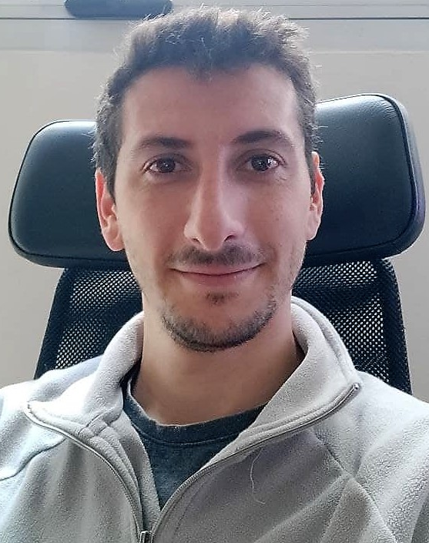
Pablo Uboldi
pabloauboldi@gmail.com
Cel: +52 55 8573 3783
Av. Ejército Nacional 225, Anáhuac I Secc, Miguel Hidalgo, 11320 CDMX

Work Experience
- Freelance Software Engineer
July 2022 – Present

As a freelance software developer I have been involved in various projects, such as:
- Integration of social and cryptocurrency profiles for analysis
- Development of a Discord Bot to collect user data
- Web UX development for impact measurement in digital marketing campaigns, for a startup
- Development of a Python script for solving Taylor-Maccoll equations for supersonic flow around a cone. For university use.

- Fluid Mechanics Associate Professor in the National Technology University
March 2018 – Present

As an associate professor in Fluid Mechanics, I oversee the theoretical and practical evaluation activities developed for the students of Aeronautical Engineering at the National Technology University, Haedo.

- Project Manager in Natural and Exact Sciences Faculty, UBA, Argentina.
March 2014 – August 2021

In the Faculty of Natural and Exact Sciences of the UBA, I was part of the Technical Department, co-leading the electrical maintenance team for small and medium scale projects.

Also, as part of my own personal interest in technology, I collaborated with the IT Department in software support and troubleshooting of staff’s PCs.

- Formula SAE aerodynamics team Co-Director
November 2019 – June 2020

As Co-Director of the formula SAE aerodynamics team of the National Technology University, I was part of the decision-making process regarding the design of the competition car.

- Junior Designer in Vortex Design Solutions S.R.L.
Septiembre de 2013 - enero de 2014

In Vortex I was part of a team of 5 designers that worked directly with the CEO in the development of several projects in SolidWorks.

- Designer and IT assistant in Lasertech de Liubob Informática, Argentina.
August 2012 - August 2013

In Lasertech I documented projects performed by the company for the client’s safekeeping.

Education
- National Technology University
Aeronautical and Aerospace Engineer, 2008 – 2021

- Philips Argentina Technology Institute
Bilingual electronic and electromechanics technician, 2002 – 2007

Courses
100 Days of Code: The Complete Python Pro Bootcamp in Udemy (2022)
LinkedIn Learning – Engineer Drawings for Manufacturing (2022)
LinkedIn Learning – Introduction to Geometric Dimensioning and Tolerancing (GD&T) (2022)
LinkedIn Learning – SOLIDWORKS: Drawings (2022)
Aeronautical Engine Course (2010)
Systimax Structured Cabling Certification Course (2013)
Cisco Certified Network Associate 1 y 2 (2013)

Languages
Spanish | 
English | 

Skills
AutoCAD
Python – Django – Flask – HTML – CSS/Bootstrap
SolidWorks
Simscale CFD
Matlab/Scilab/Octave
Wolfram Mathematica
Office Suite (Word, Excel, PowerPoint)

