Profile Strategy Guide
This guide will help you define a solid profile strategy in Adobe Experience Platform. It was written using the “Swim Journey” use case.

Steps
- Identify the Concepts that define the project
- Namespaces. Create and list of all identifiers needed and their purpose
- Identity Graph List all identities, and define what makes a profile unique.
- Merge policy. Define how the data is put together.

Project Concepts
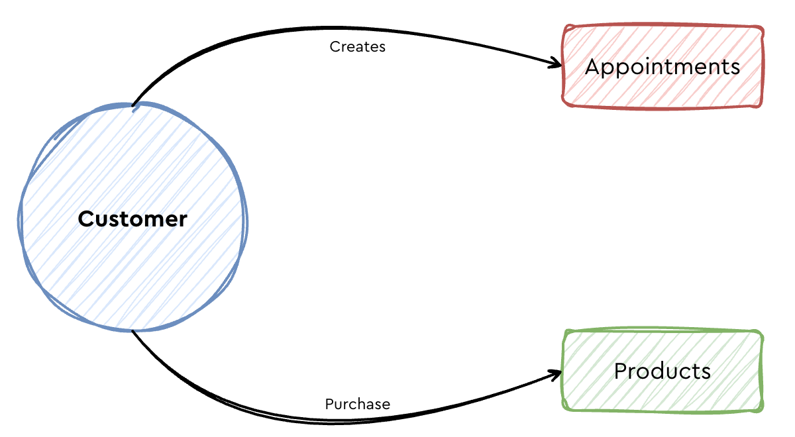

Concept | Description | Identify by
Customer | Customer object, holds the data properties that defines what this customer is. | Swimmer ID generated by the system and the email address as it’s the unique identifier to login in the app or website.
Products | Customer purchase Products on the website, app, or in the physical store. | Product unique identifier. Generated by the online commerce system.
Appointments | A customer books appointments and these appointments have an specific date time. | Appointment ID generated by the booking system.

Namespaces – Project Identifiers
This step defines what namespaces are needed and what type they have.
Identifier | Identity Type | Namespace Type | Namespace | Description
Swimmer ID | Cross-Device ID | Custom | Swimmer_ID | Unique customer identifier generated by the swim system.
Hashed Email | Email | Standard | Email_LC_SHA256 | Hashed lowercase version of the email and hashed using the algorithm SHA256.
Appointment ID | Cross-Device ID | Custom | Appointment_ID | Appointment unique identifier, generated by the booking system.
Product ID | Non-people identifier | Custom | Product_ID | Product unique identifier. Generated by the point of sales commerce system.

Identity Graph
Set how all concepts or objects are linked together and what makes them unique. In this step, the namespaces and priorities are put together.
Priority | Namespace | Identity Type | Unique per Graph
1 | Swimmer ID | Cross-Device ID | Yes
2 | Hashed Email | Email | Yes
3 | Appointment ID | Cross-Device ID | No
4 | Product ID | Non-people identifier | No

Merge Policy
How all datasets and data is linked together.

