**PROBLEM SET 1A**

**Name: Sandeep Pabolu**

**Id: 16230088**

1. Describe your knowledge about knowledge graph?

Ans. Knowledge graph is about collecting information regarding objects in the real worlds. For example, consider a person let it be some famous person, now if one sits of getting information regarding this famous person then this task can be simplifieed by using the knowledge graph. This was basically stared by google where it tried to understand the word and its relationship with other objects in the real world.

For example, when user searches for a content in the web then it relates that word with the web and with help of the knowledge graph it can simply link the related stuff which might be useful and time saving. Furthermore, suppose we type “UMKC” then the searches also notify with the related stuff that the other users have searched for.

This is basically a large set of database interlinked over a vast range of objects. Authoritative sites, such as [Wikipedia](https://www.wikipedia.org/), [CIA World Factbook](https://www.cia.gov/library/publications/the-world-factbook/) and [Freebase](https://www.freebase.com/) are all sources used by Google to [gather data](http://www.civi.com/marketingresearch/data_extraction.html) about people, events, animals, events, history and other topics which together set up as a data base. The main theme of knowledge graph by google is to organize the world’s information and to make it universally accessible and useful.

With the knowledge graph, users can get information about people, facts and places that are interconnected in one way or the other.

1. Why do we want to build such a knowledge graph?

Ans. - To increase the effectiveness in the search of the user.

* Time saving by showing the related searches to quickly land in the correct site.
* Optimizing the control as we normally do.
* Using the schema markups whenever possible
* Encouraging the customer reviews and testimonials
* Accuracy for the “how to” questions increases.
* Sequential instructional guides in the searches
* Increasing the click through ratios

1. What steps are required? Show your own workflow for this task?

Ans. The main steps for the formation of a knowledge graph are

* Identifying the nodes in the given question. These are basically the names, entities, places or events and so on.
* Then the edges. Basically, these are the relationships between the above nodes.

1. What are the challenges?

Ans. The main challenges are:

* The difficulty in identifying the nodes in the given text.
* Differentiating the nodes from their attributes.
* Identifying the relation or the edges.

1. Draw a knowledge graph for the given data?

Ans.

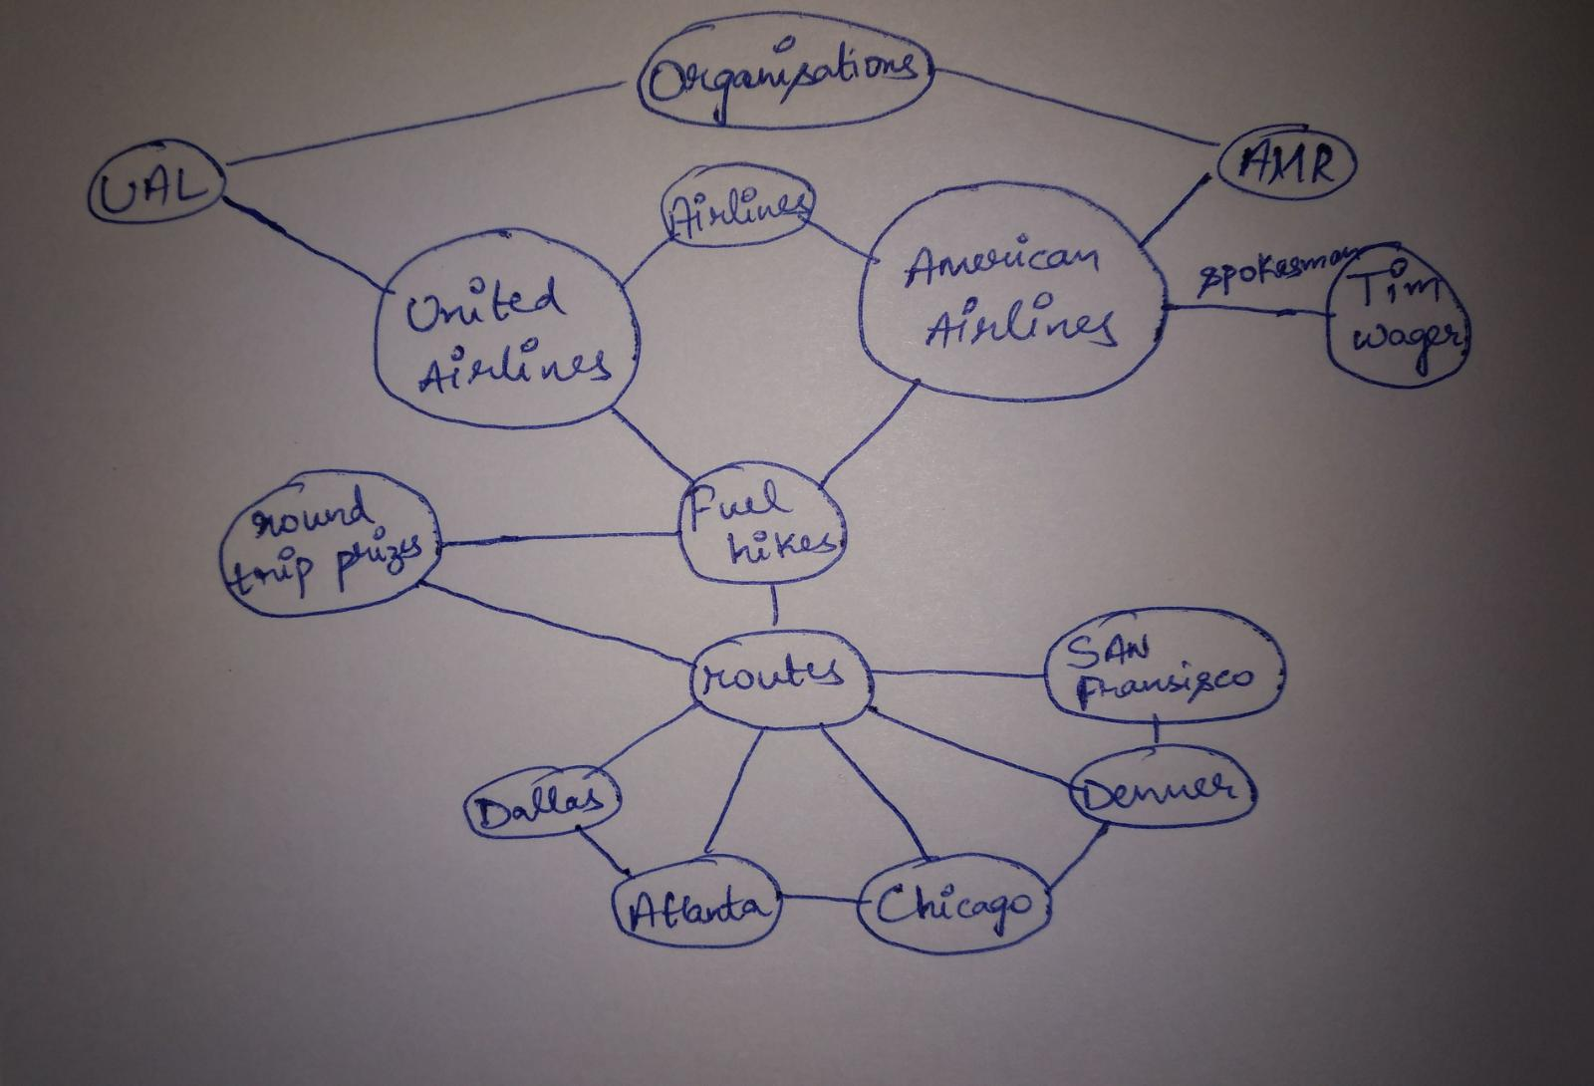

Reference:

1. <http://neilpatel.com/blog/the-beginners-guide-to-the-googles-knowledge-graph/>