**ITEM 5: PERFORMANCE REPORT**

Table of contents

1. INTRODUCTION 3

2. TESTS RAN IN MACHINE 1 3

3. TESTS RAN IN MACHINE 2 12

4. TESTS RAN IN MACHINE 3 15

5. TESTS RAN IN MACHINE 4 20

6. TESTS RAN IN MACHINE 5 25

7.TESTING THE MAXIMUM PERFORMANCE OF THE SYSTEM 27

**DELIVERABLE 11 ITEM 5: PERFORMANCE REPORT**

# 1. INTRODUCTION

The aim of this report is to show the information related to our project performance attained through the performance tests that our group has carried out. Tests have been run in five different computers, the features of each machine will be detailed when showing their corresponding tests. We will use the test that stresses the most our system in order to determine the maximum workload our system can take

# 2. TESTS RAN IN MACHINE 1

This computer has the following features:

Processor: Intel(R) Core(TM) i7-7700HQ CPU @2.80GHz 2.81GHz

RAM memory: 12GB

Hard Disk: 765GB HDD

Wireless adapter: Intel (R) Dual Band Wireless-AC 7260.

Test1: List and search repair shops

With 60 users and 100 loops:

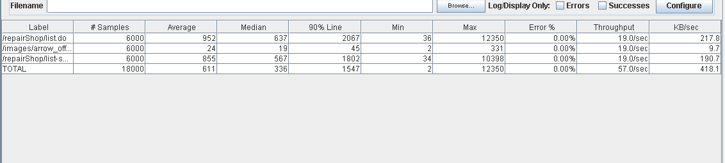

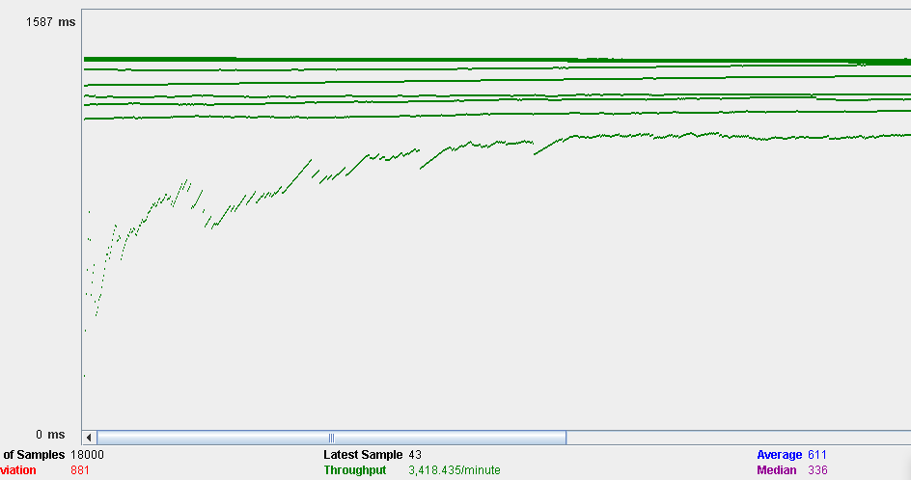

Test 2: Create repair shops

With 60 users and 100 loops:

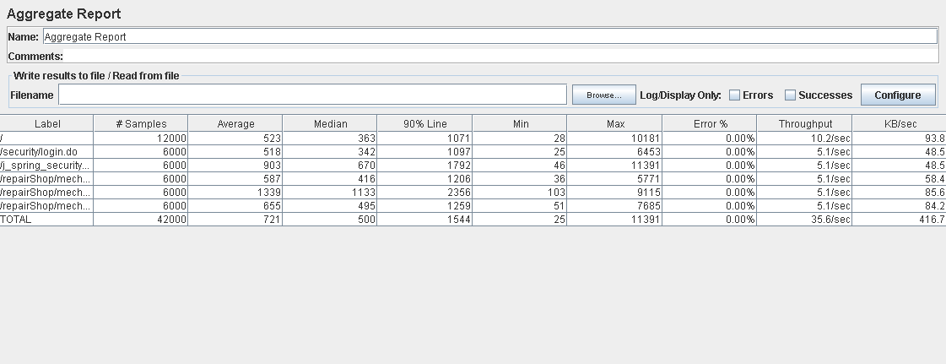

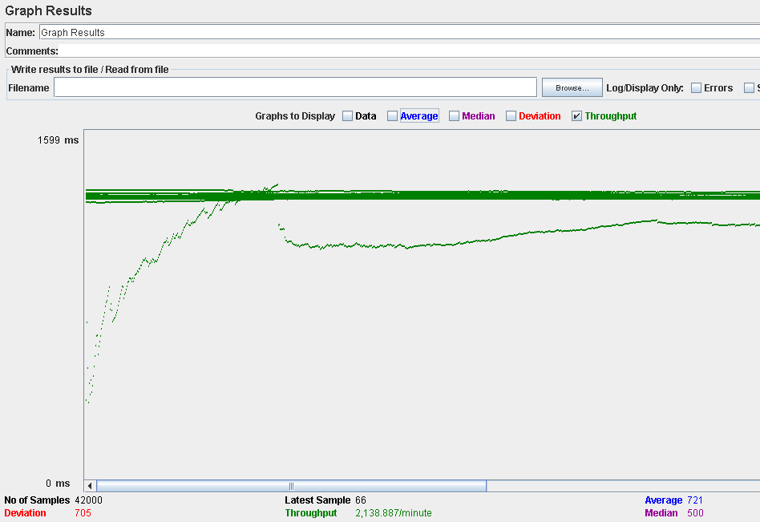

Test 3: A mechanic lists the reservations made to his repair shops.

With 60 users and 100 loops:

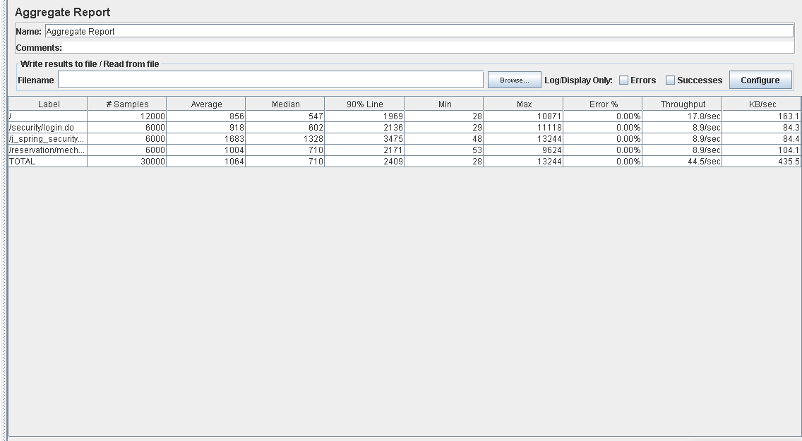

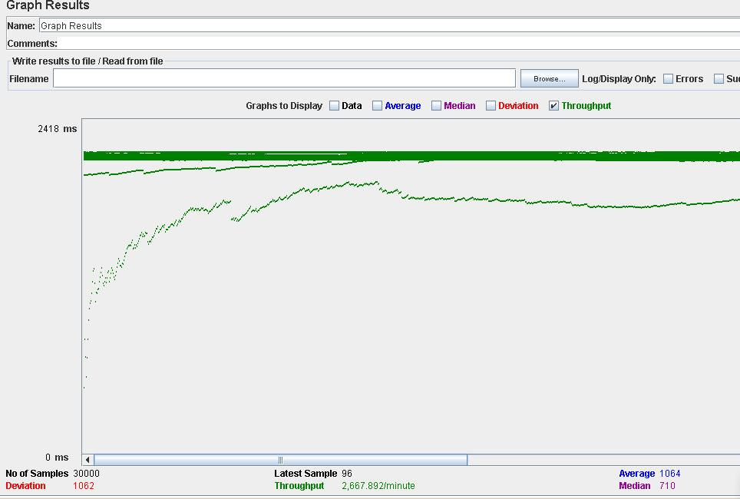

Test 4: Register as a mechanic

With 60 users and 100 loops:

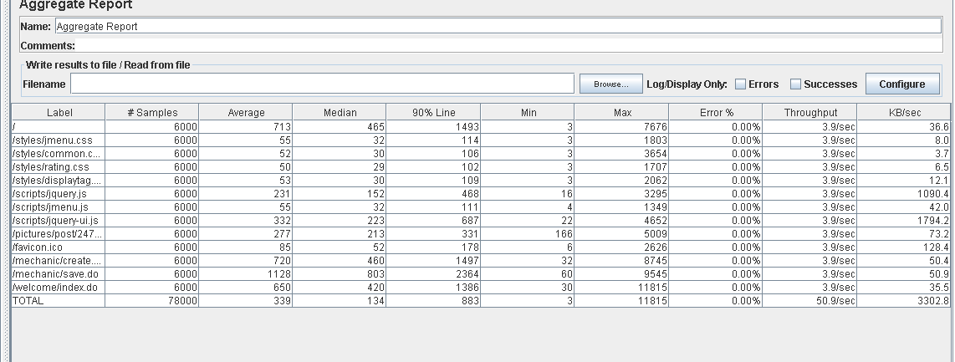

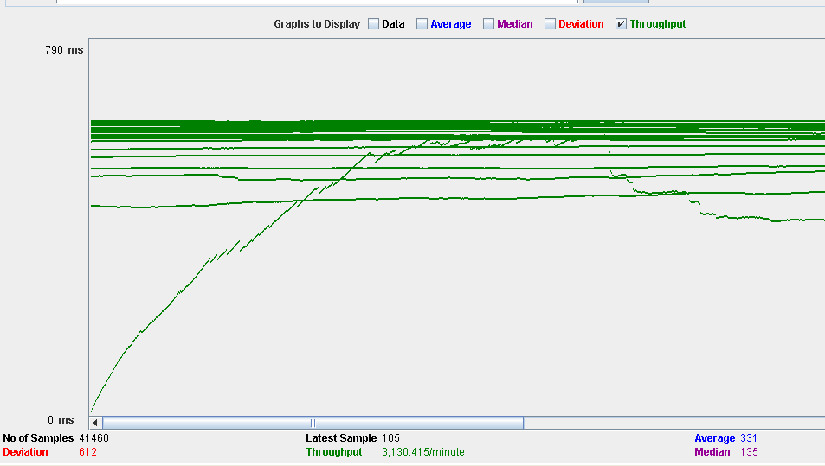

Test 5: Create a service

With 60 users and 100 loops:

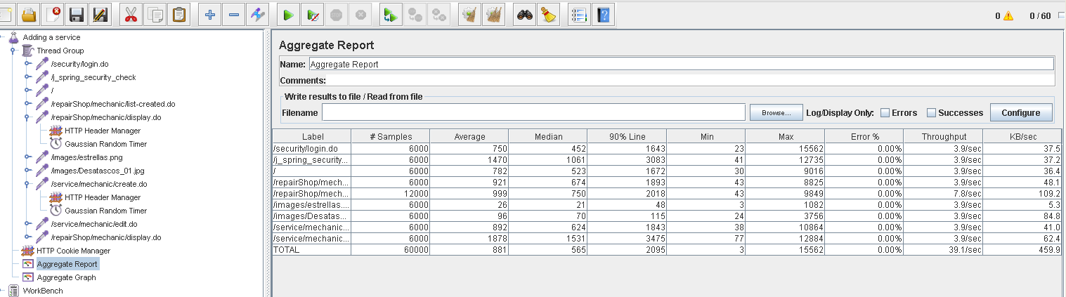

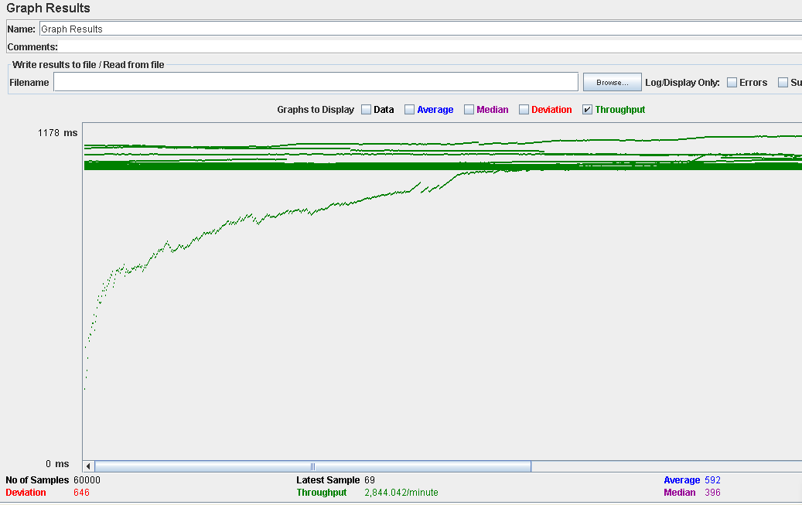

Test 6: Reserve a service

With 60 users and 100 loops:

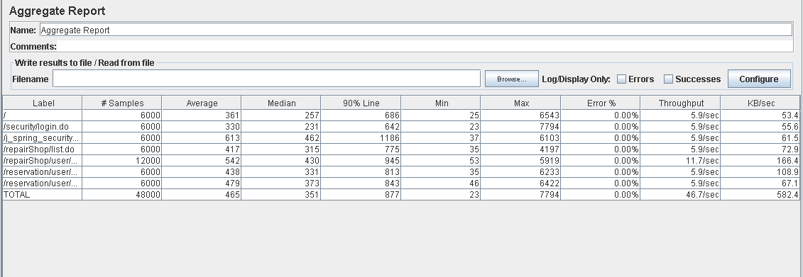

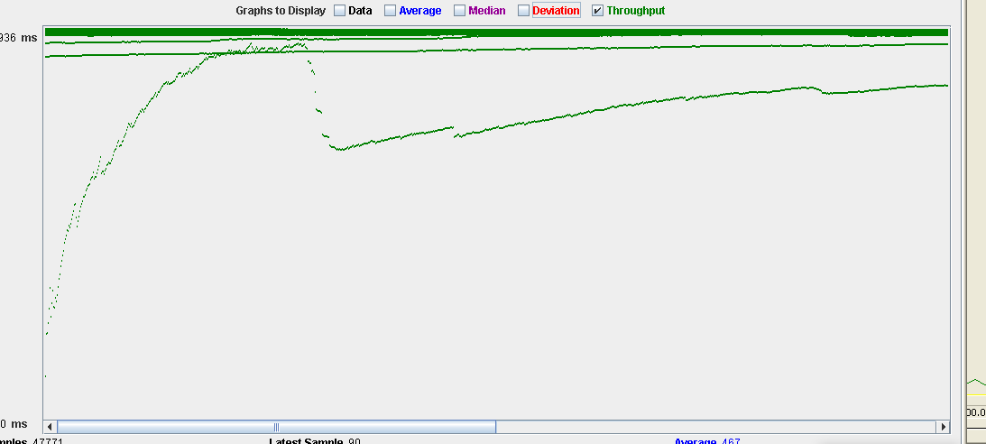

Test 7: Cancel a reservation

With 60 users and 100 loops:

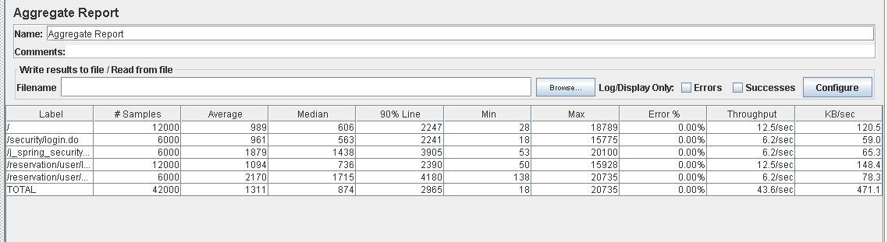

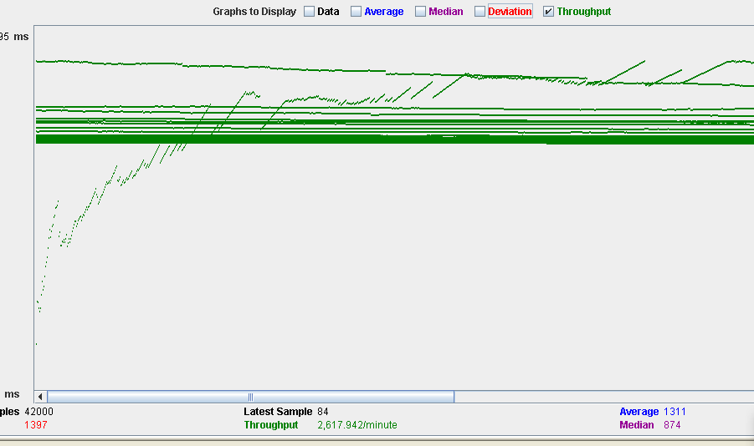

Because this test already stresses our system a bit, we will repeat this test with 100 concurrent users:

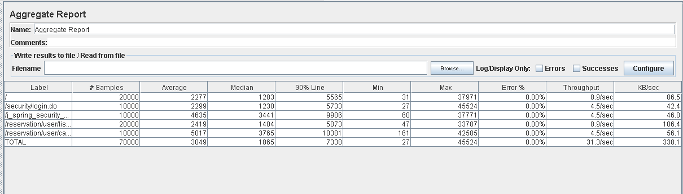

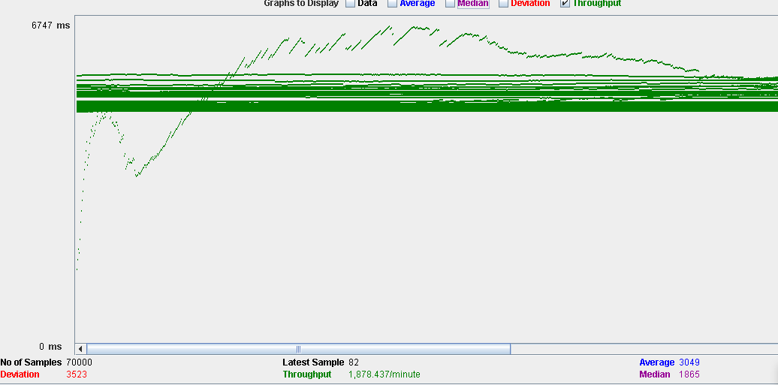

There are actions in this test that already take 10 seconds. We can come to the conclusion that our system can’t take 100 users doing the same thing at once. However, for the sake of determining what puts our system under the biggest stress, we will run other tests with 100 concurrent users when considered necessary.

Test 8: Delete a repair shop as an administrator:

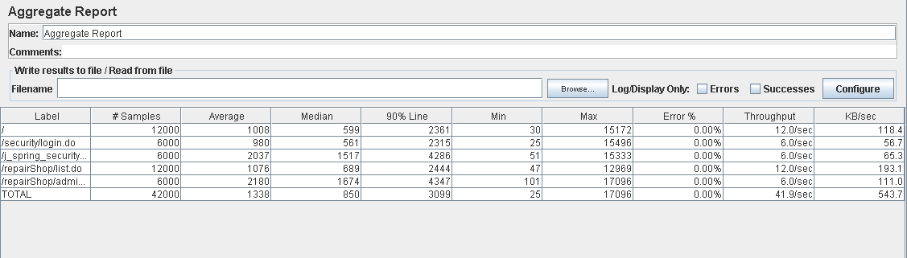

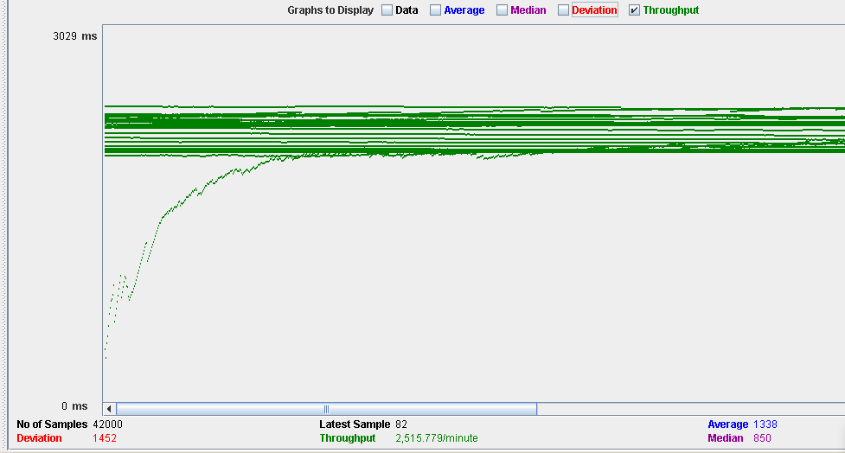

This test could be repeated with 100 concurrent users, but because it is something only an administrator can do, this use case will not have a huge impact in the performance of our system. The same logic applies to any use case that involves being an administrator.

Test 9: Creating a car

With 60 users and 100 loops:

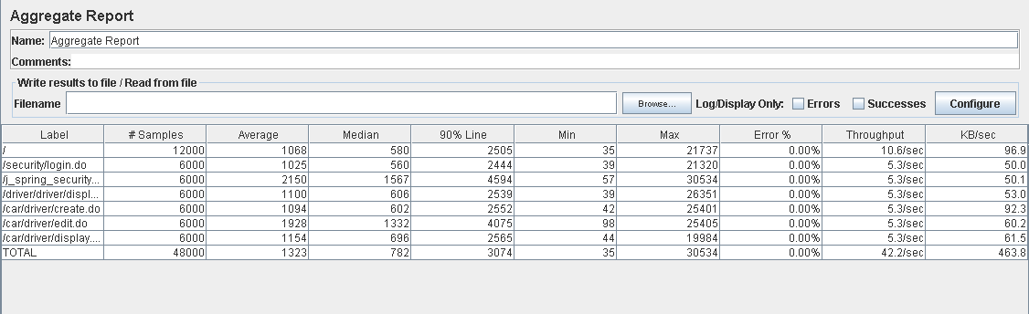

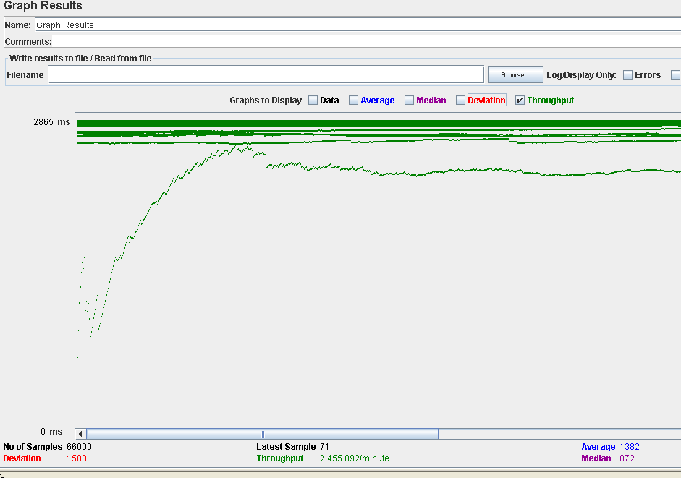

With 100 users and 100 loops:

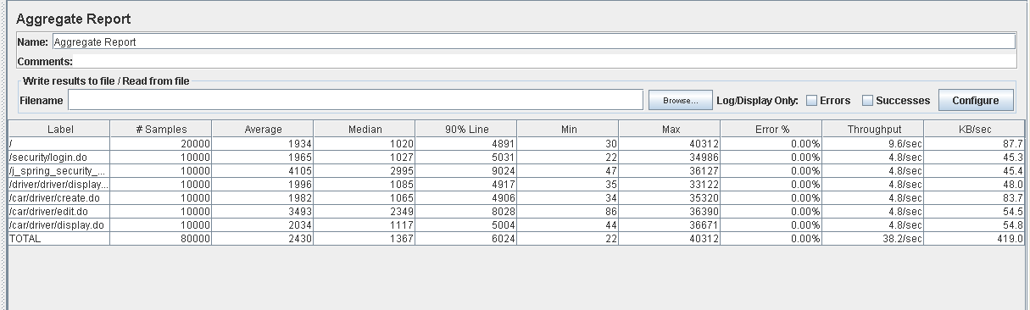

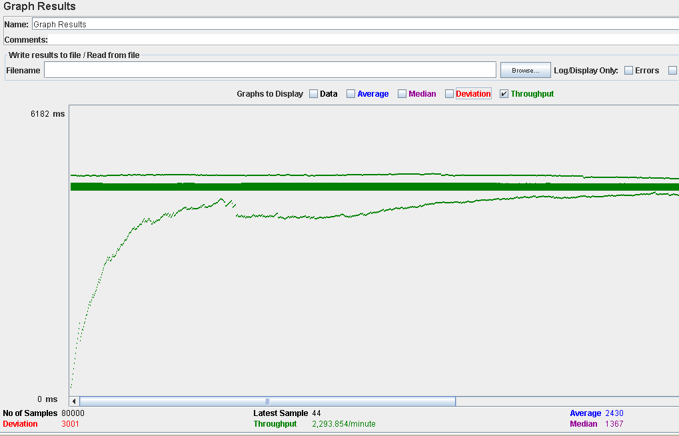

# 3. TESTS RAN IN MACHINE 2

This computer has the following features:

Processor: Intel(R)Core(TM) i5-7200U 2.5GHz with Turbo Boost up to 3.1GHz

RAM memory: 8GB DDR4

Hard Disk: 1000 GB HDD

Wireless adapter: Intel(R) Dual Band Wireless-AC 3168.

Test 10: Managing spamwords

With 80 users and 100 loops

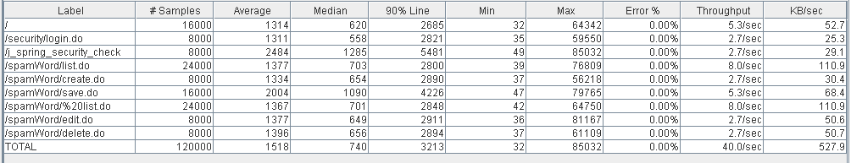

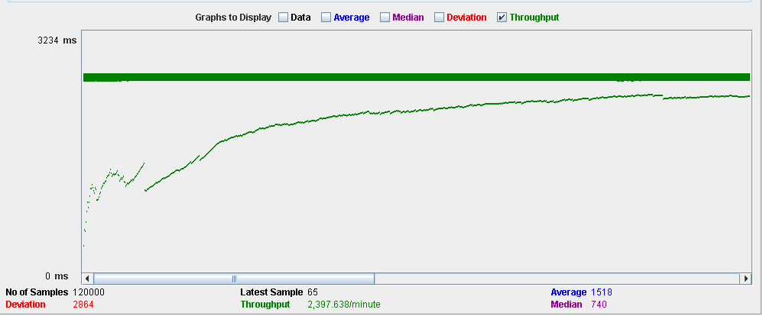

Test 11: Managing IdNumberPatterns

With 80 users and 100 loops:

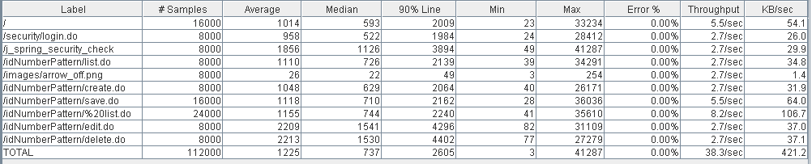

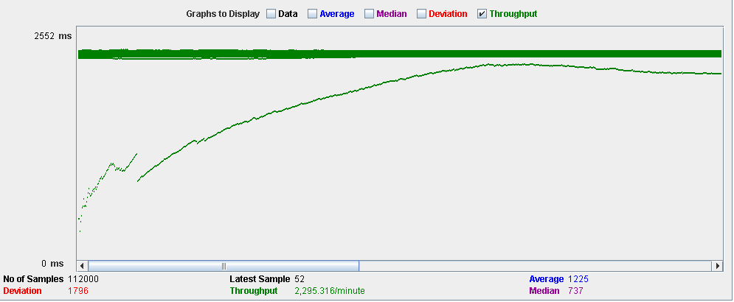

Test 12: Managing requests as a user.

With 50 users and 100 loops.

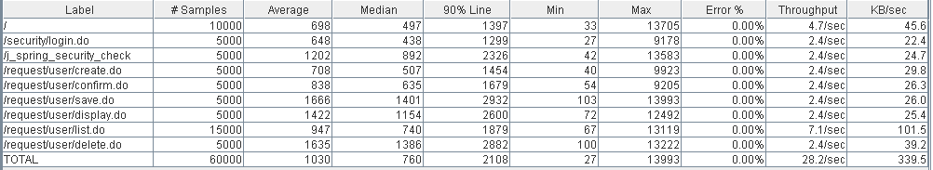

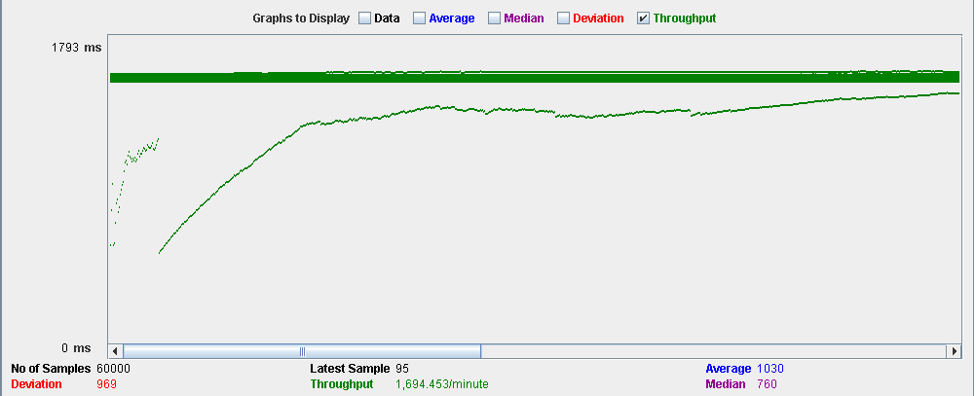

Test 13: Accepting requests

With 50 users and 100 loops:

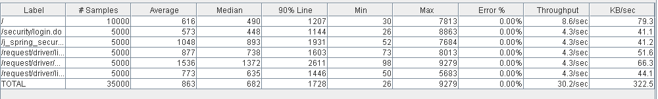

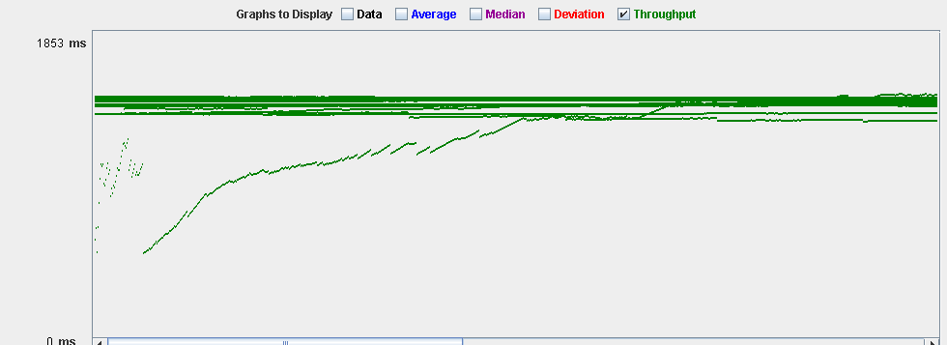

Test 14: Reporting a user

With 70 users and 100 loops

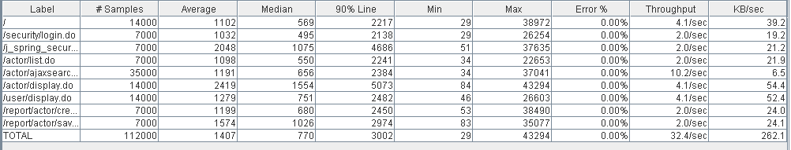

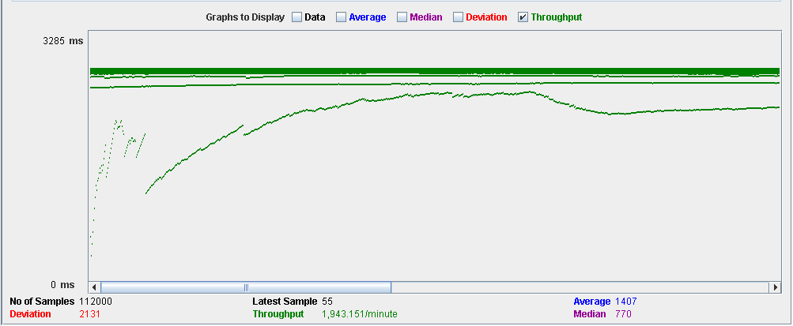

Test 15: Blocking and unblocking a user

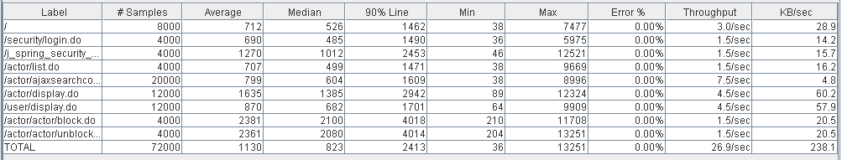

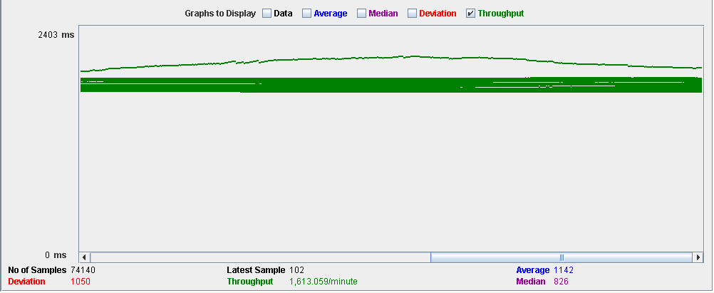

# 4. TESTS RAN IN MACHINE 3

This computer has the following features:

Processor: Intel Core i5-7300HQ (2,5 GHz-3,5 GHz, 6 MB cache, 4 cores)

RAM memory: SDRAM 8 GB DDR4-2400 (1 x 8 GB)

Hard Disk: SATA 1 TB 7200 rpm

Wireless adapter: Intel(R) Dual Band Wireless-AC 7265

Test 16: Edit configurations.

With 30 users and 100 loops

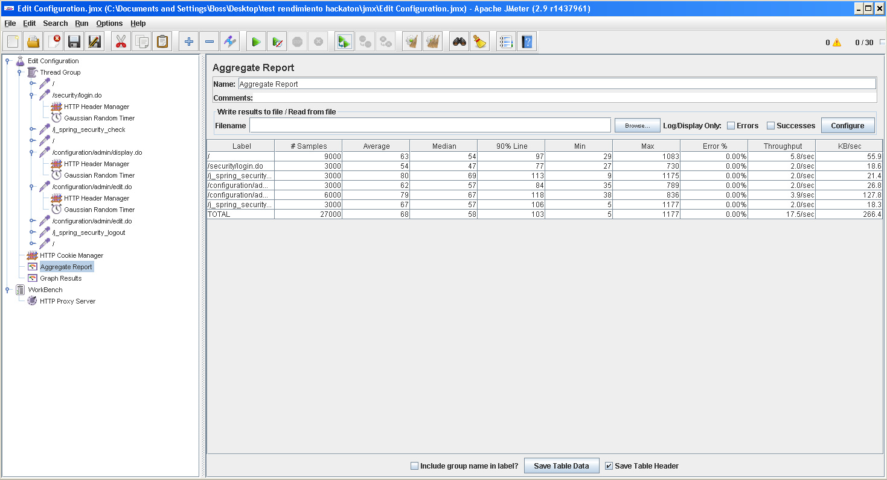

Test 17: Create comment.

With 30 users and 100 loops:

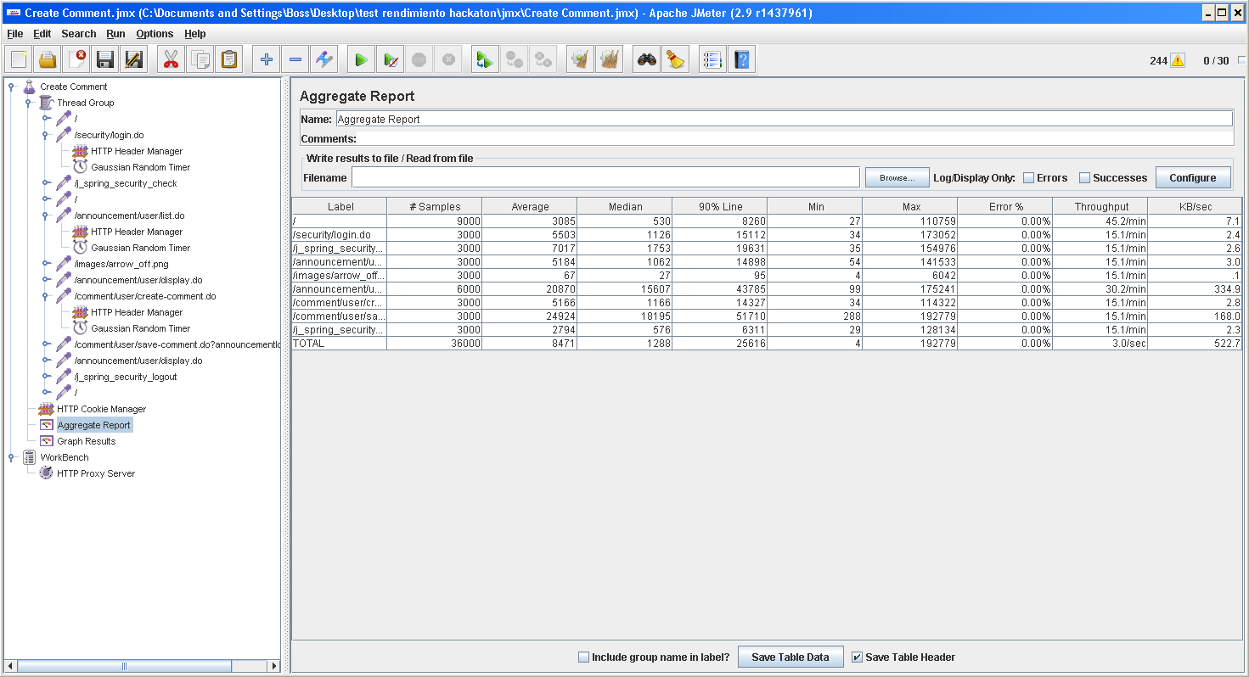

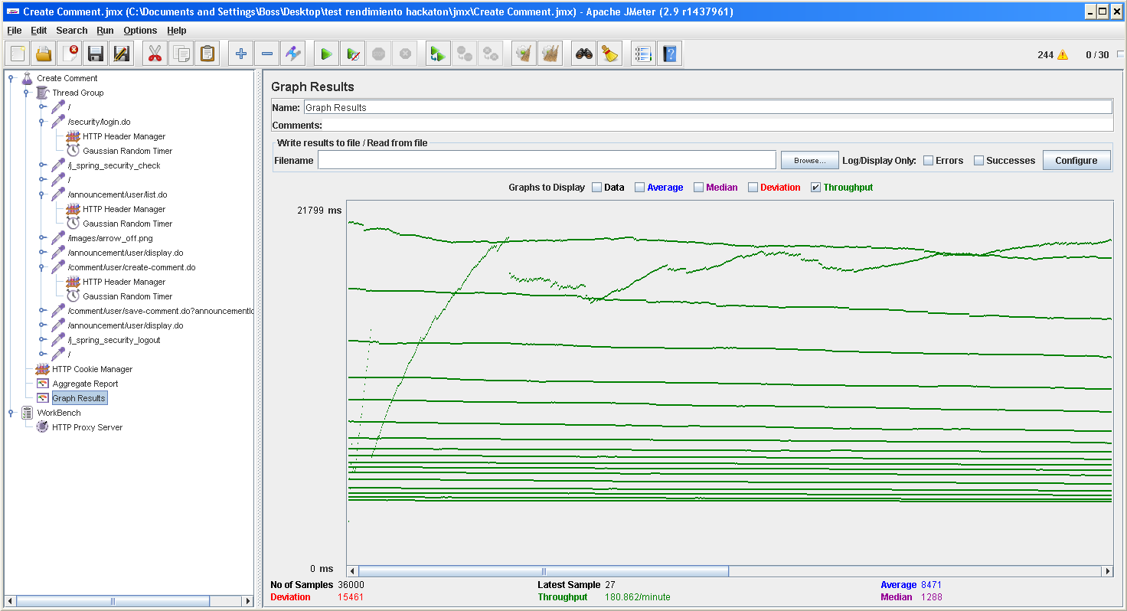

This use case is a big problem for the system performance. For some reason, even with only 30 users the time it takes to create a comment is way too much.

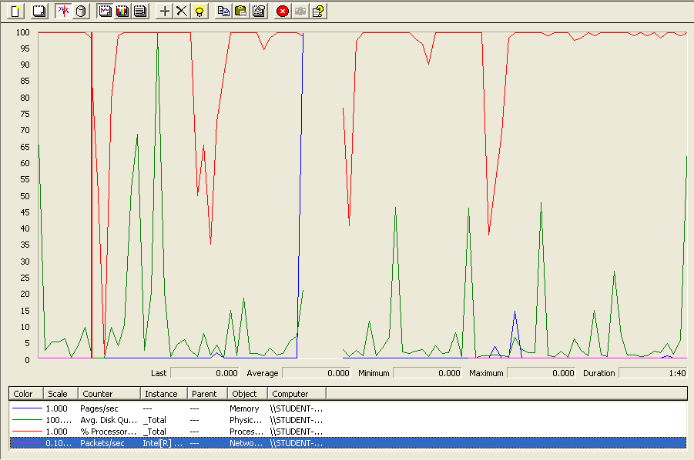

The processor is the bottleneck in this case. Because this is the only case wich such noticeable performance issues, we will carry on the tests without taking this into account.

Test 18: Delete comment

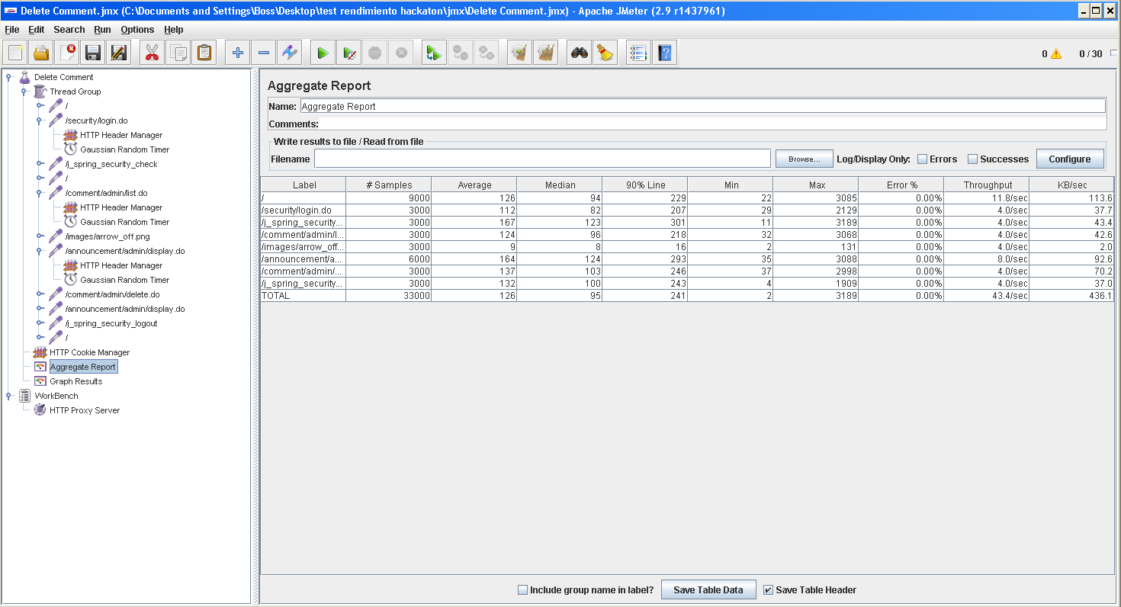

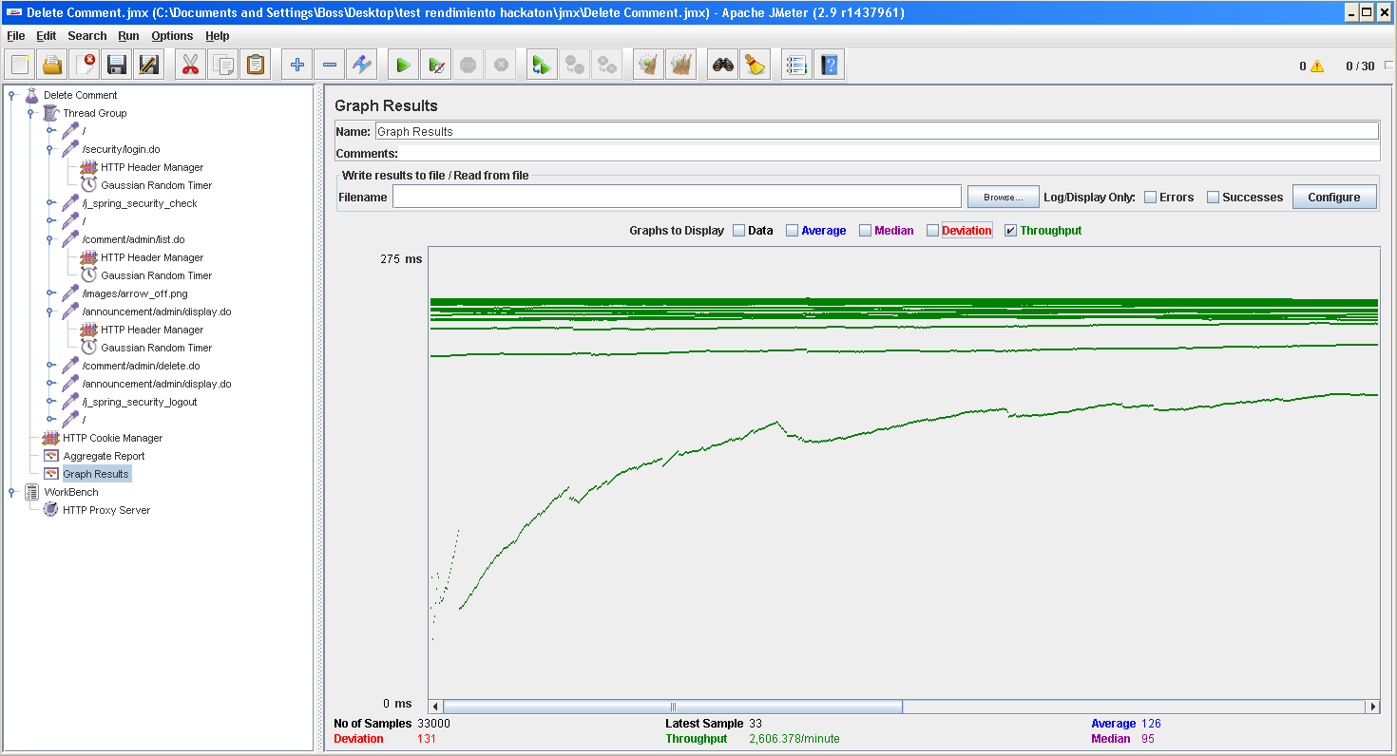

Test 19: Create user

With 30 users and 100 loops:

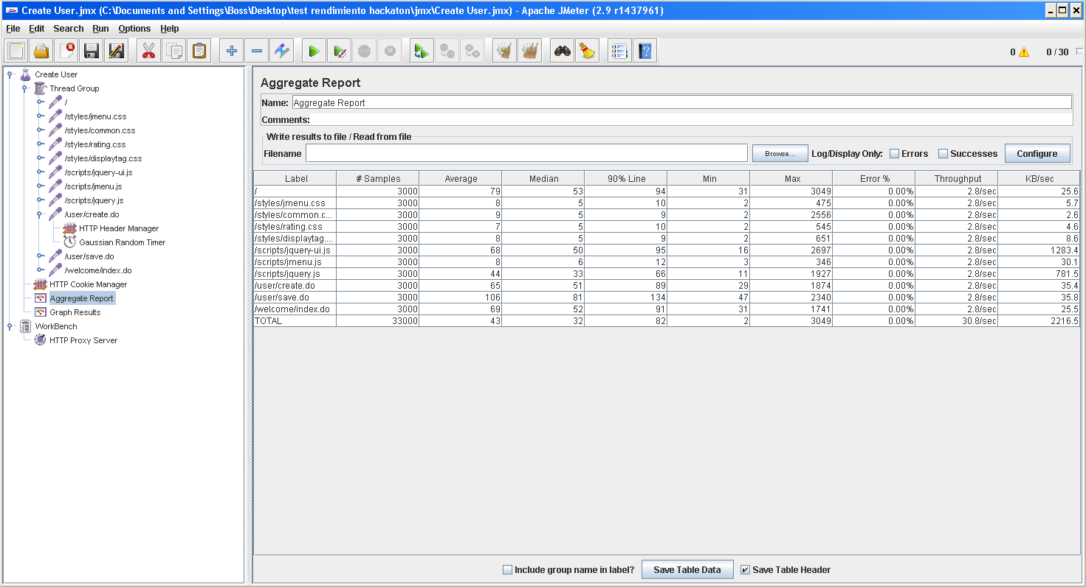

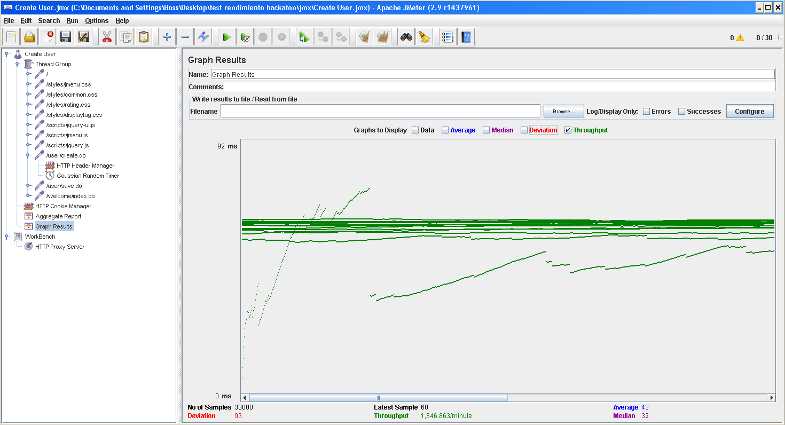

Test 20: Edit user

With 30 users and 100 loops:

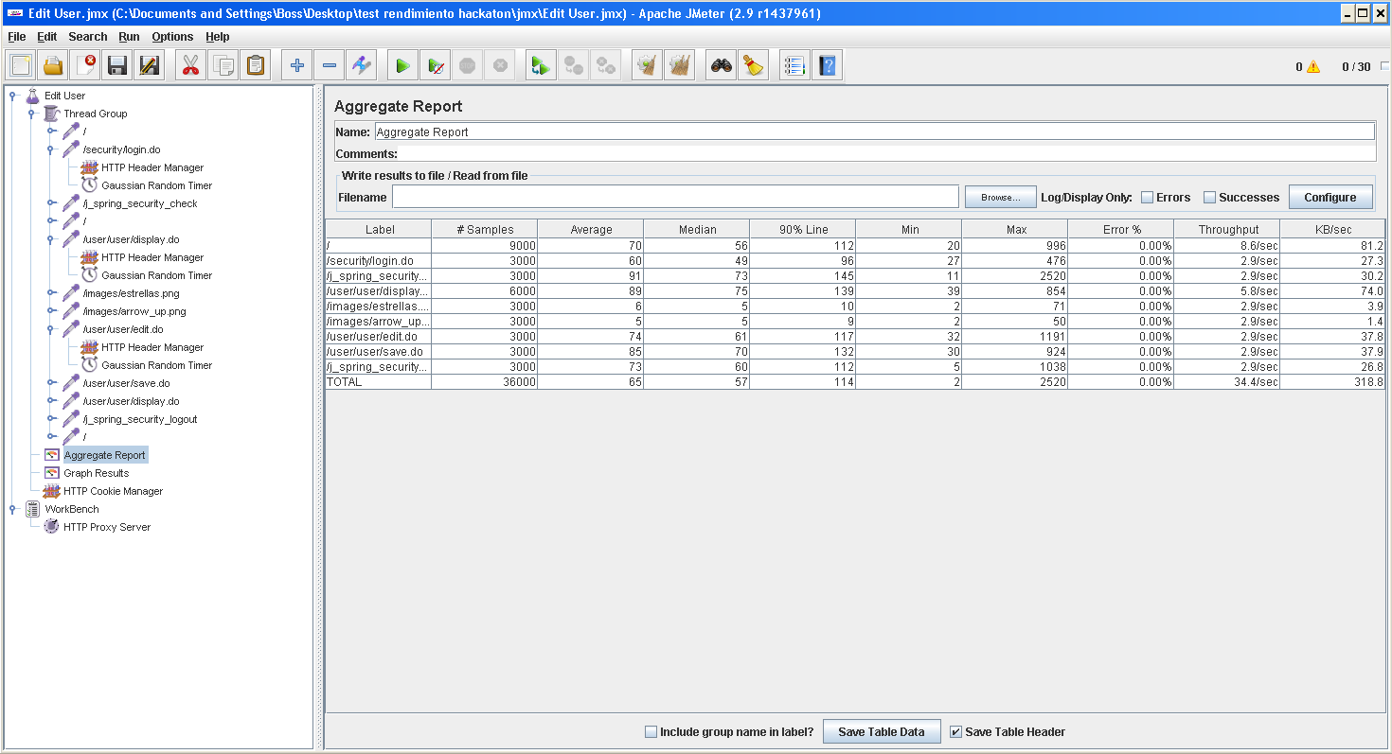

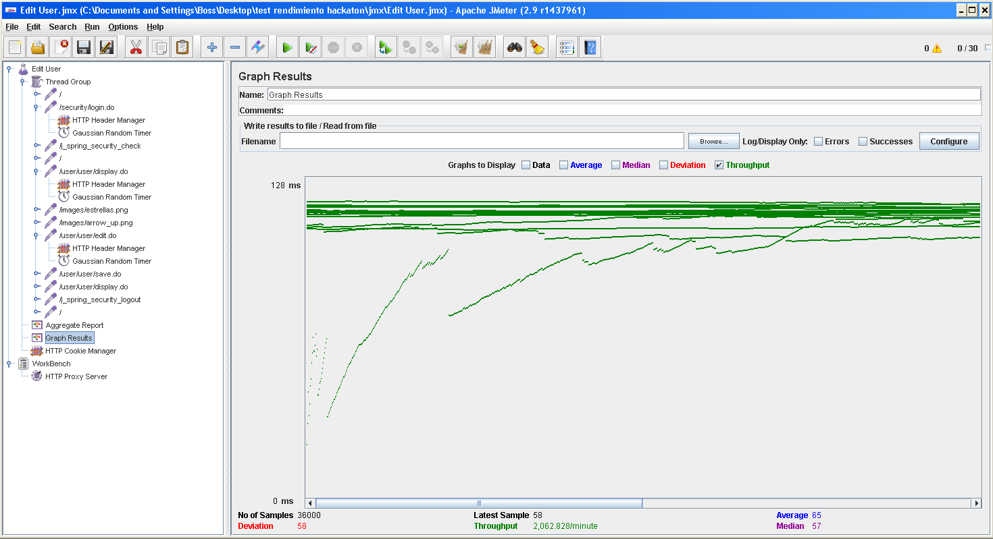

# 5. TESTS RAN IN MACHINE 4

This computer has the following features:

Processor: Intel Core i7-6500U (2-core,2.50-3.10 GHz, 4MB cache)

RAM memory: 8GB DDR3.

Hard Disk: 1000 GB HDD.

Wireless adapter: Qualcomm Atheros QCA61x4A Wireless Network Adapter.

Test 21: Edit a sponsor’s profile

With 60 users and 100 loops:

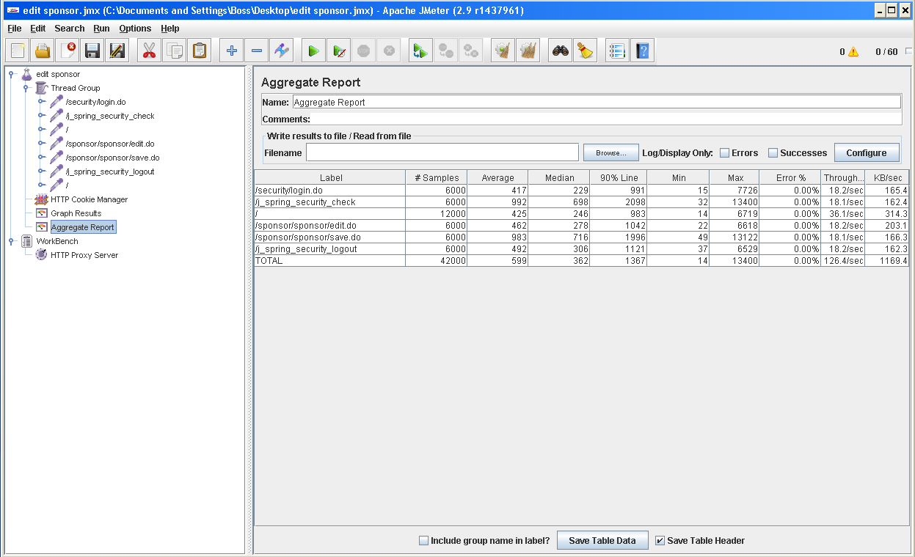

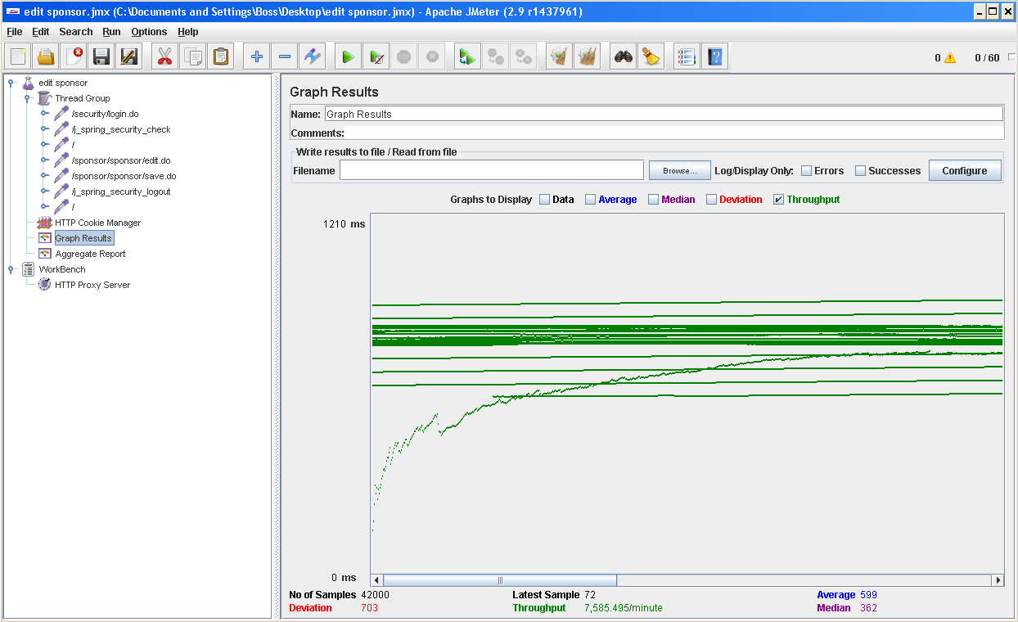

Test 22: Create a sponsorship

With 60 users and 100 loops:

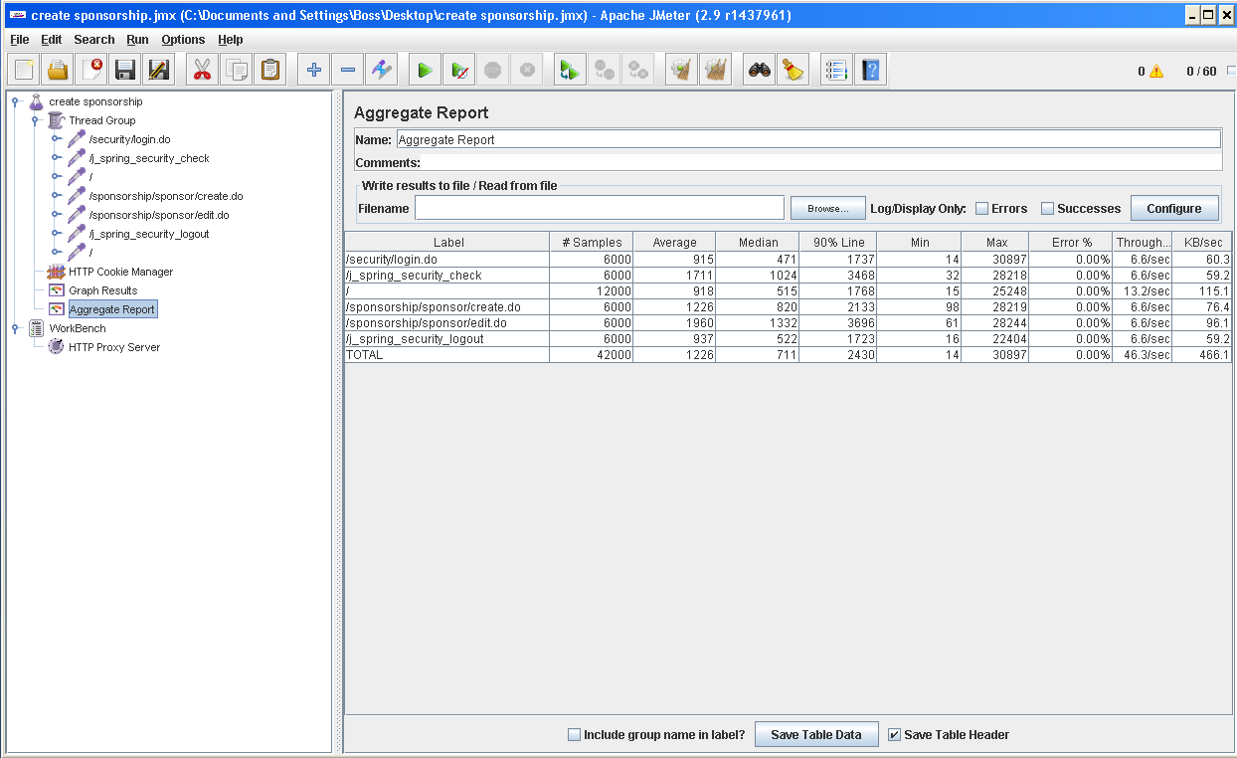

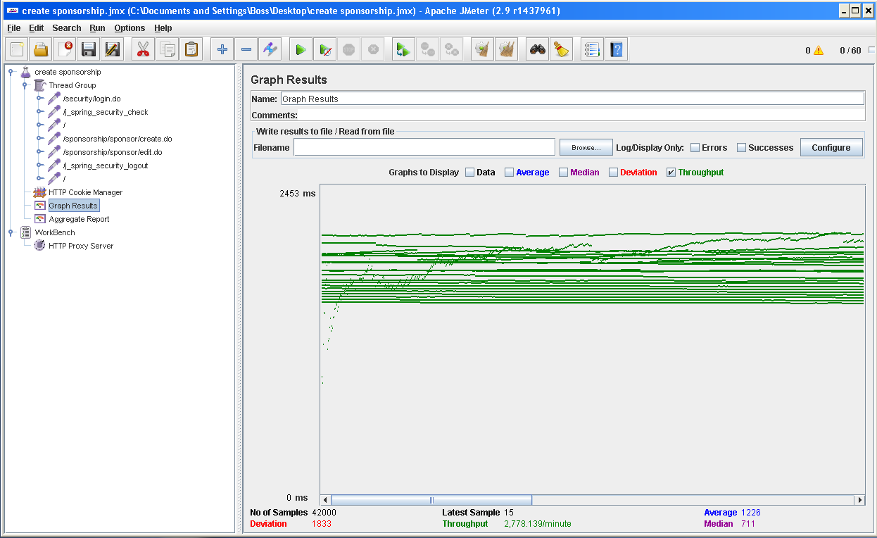

With 100 users and 100 loops.

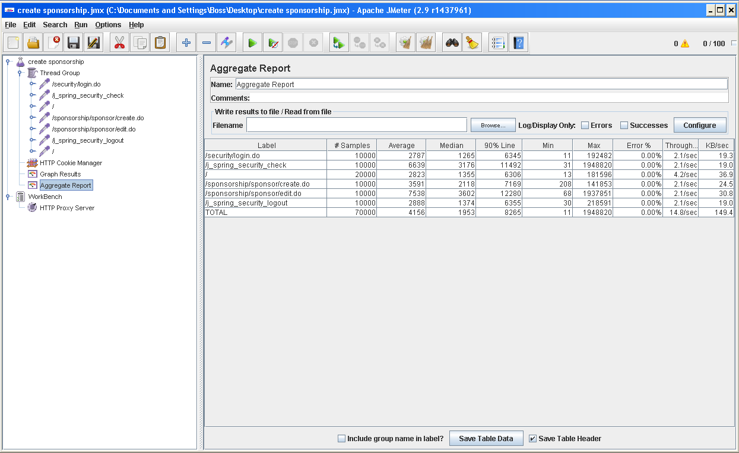

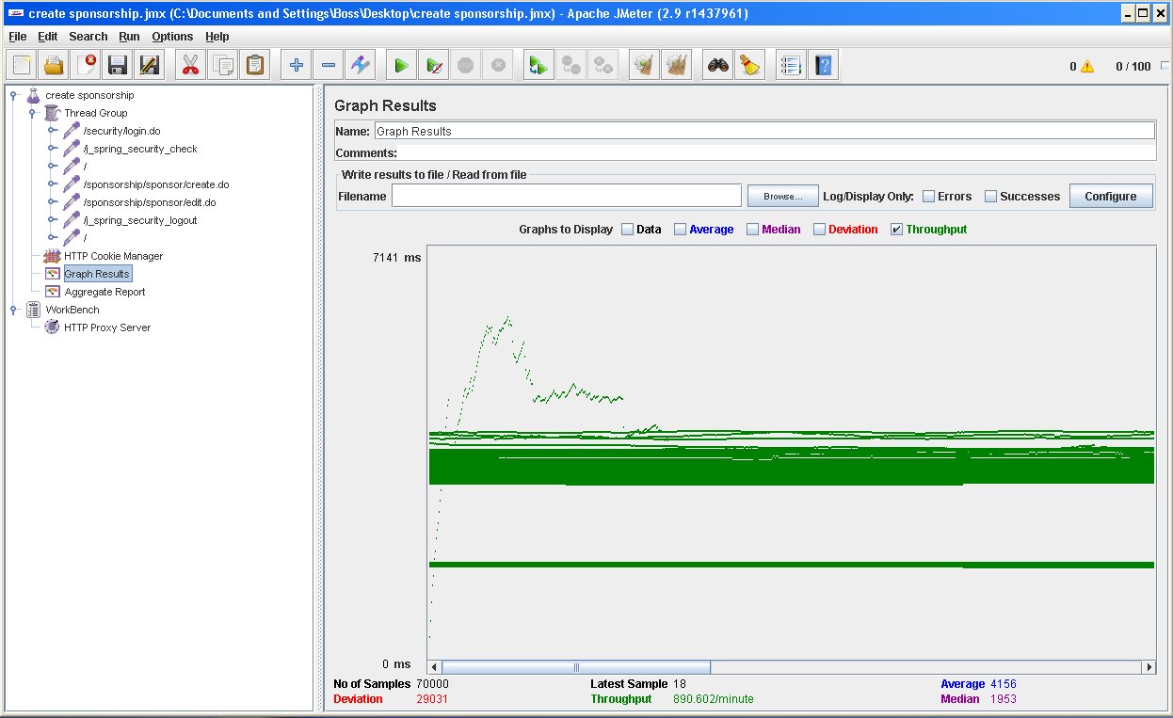

Test 23: Delete a sponsorship

With 60 users and 100 loops:

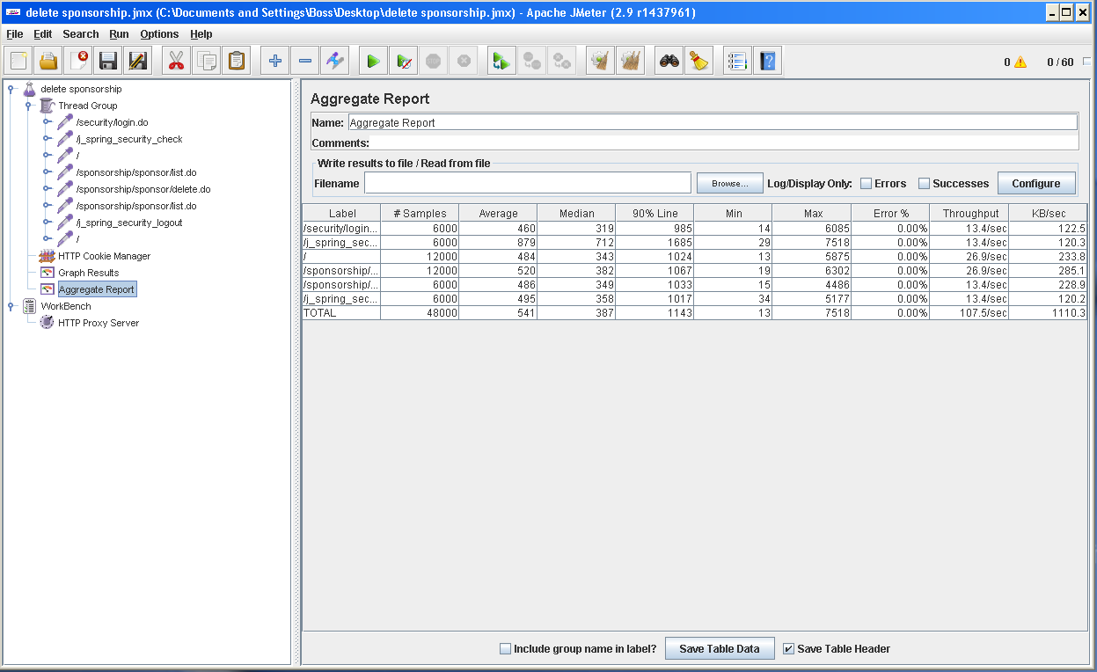

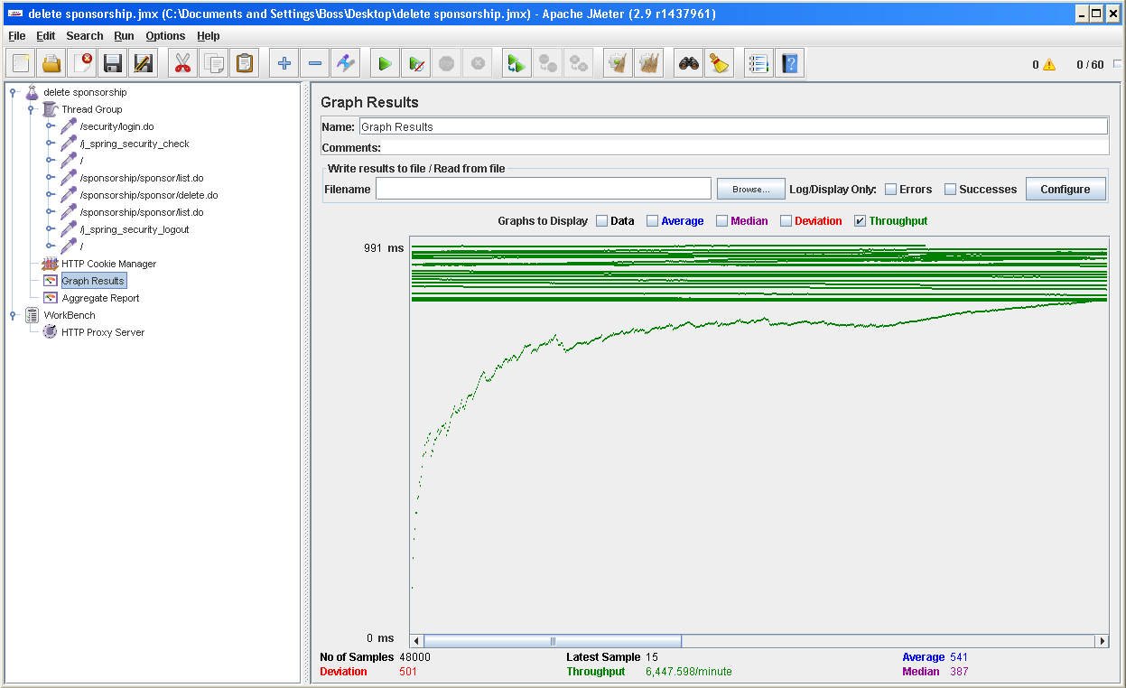

Test 24: Cancel a sponsorship

With 60 users and 100 loops:

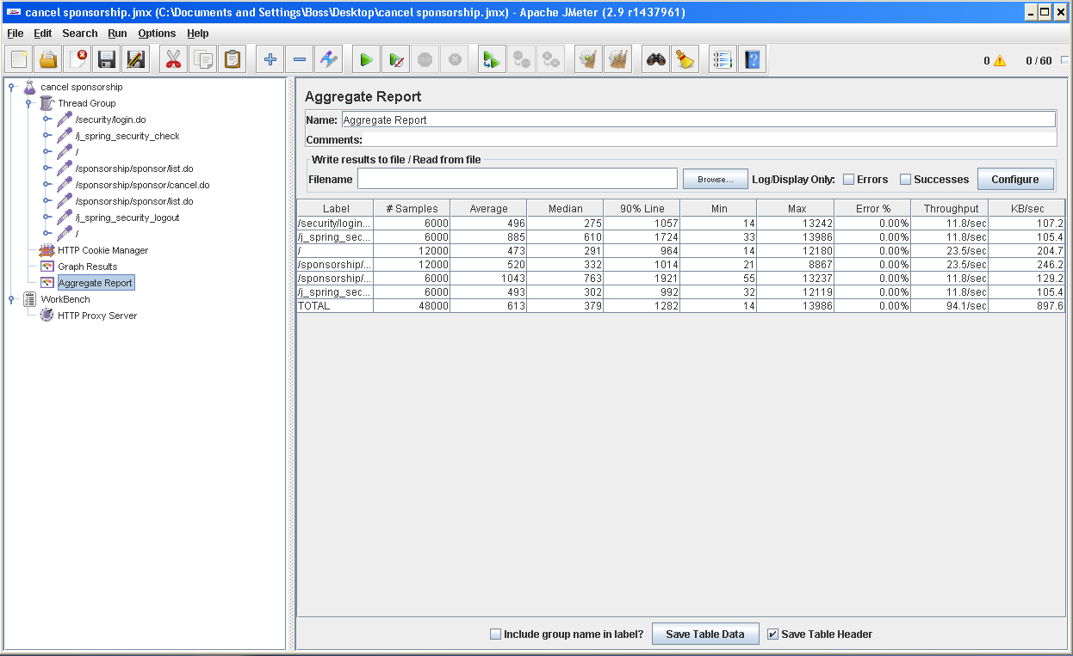

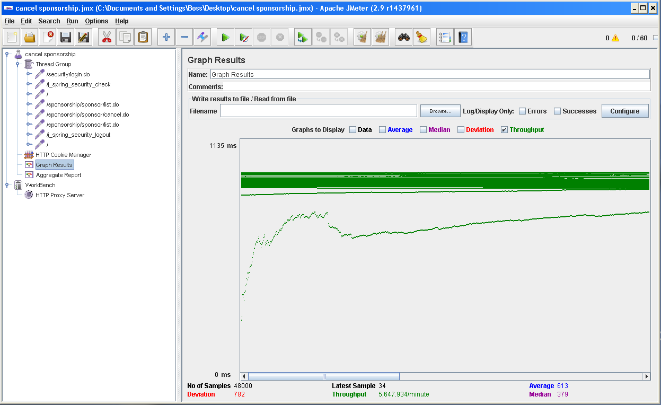

Test 25: List sponsorships that have not been accepted

With 60 users and 100 loops:

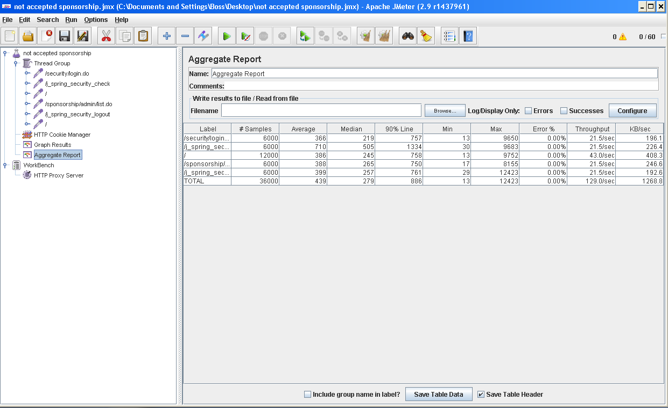

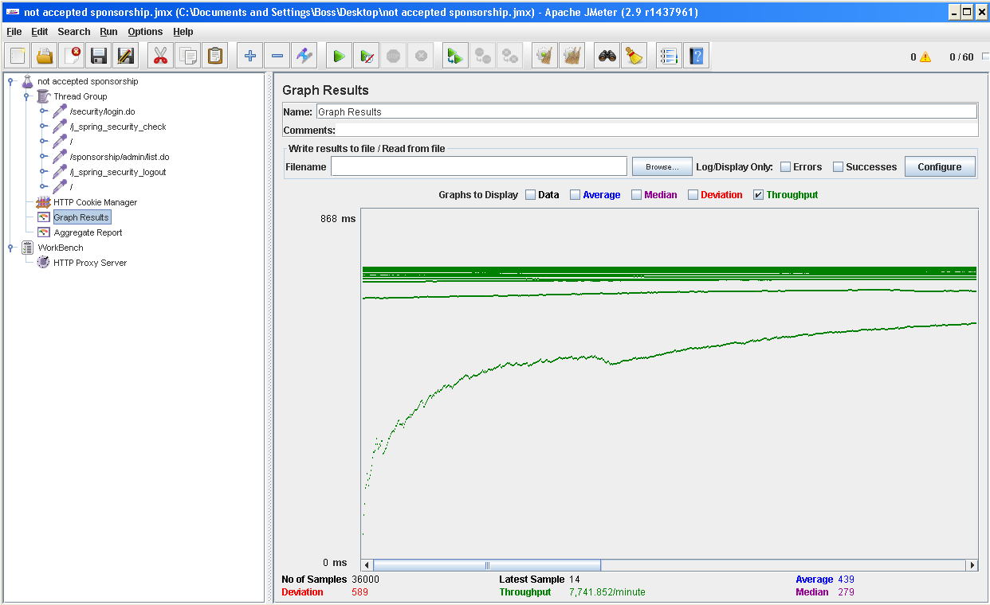

Test 26: Edit a driver’s profile

With 60 users and 100 loops:

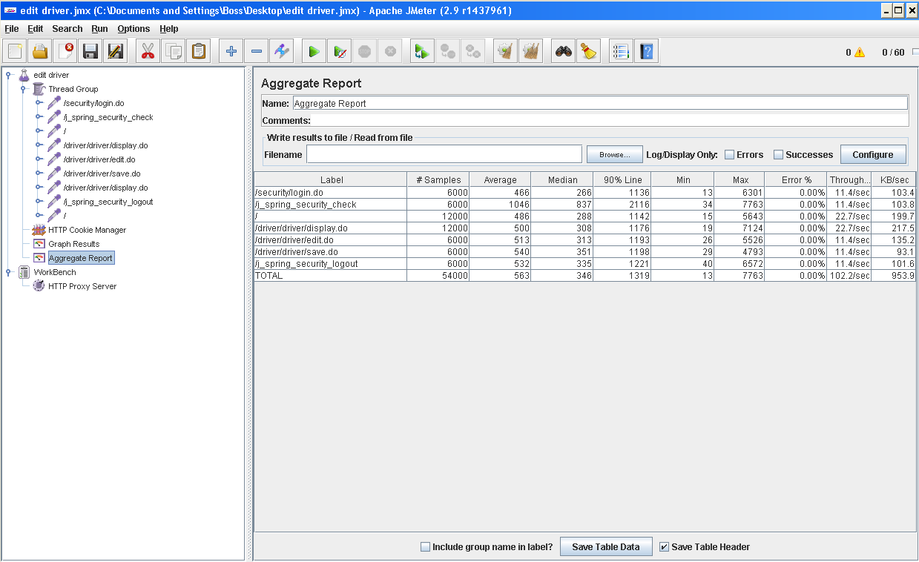

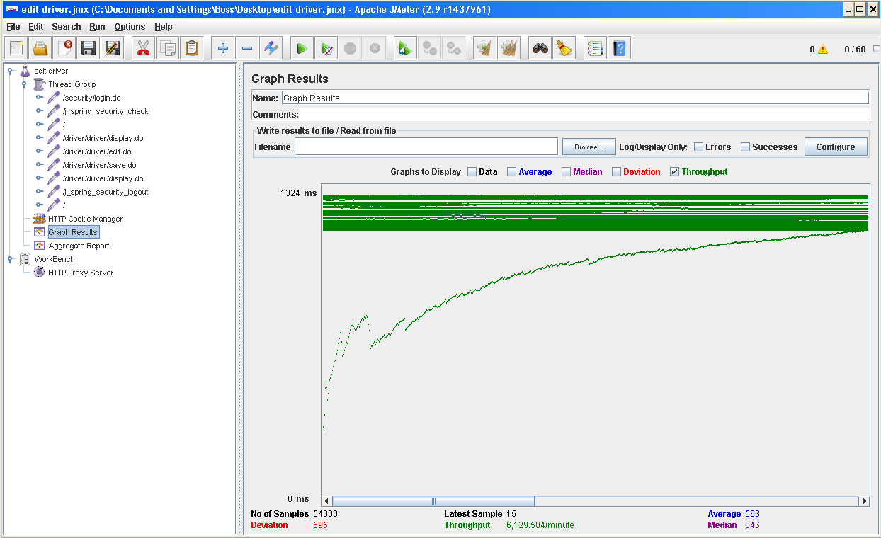

Test 27: Access to the system’s reviews

With 60 users and 100 loops:

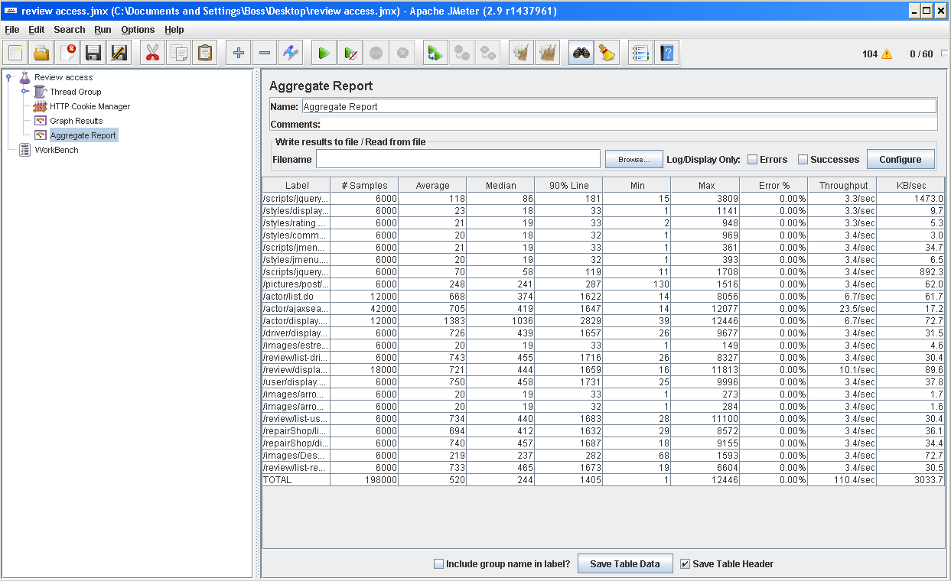

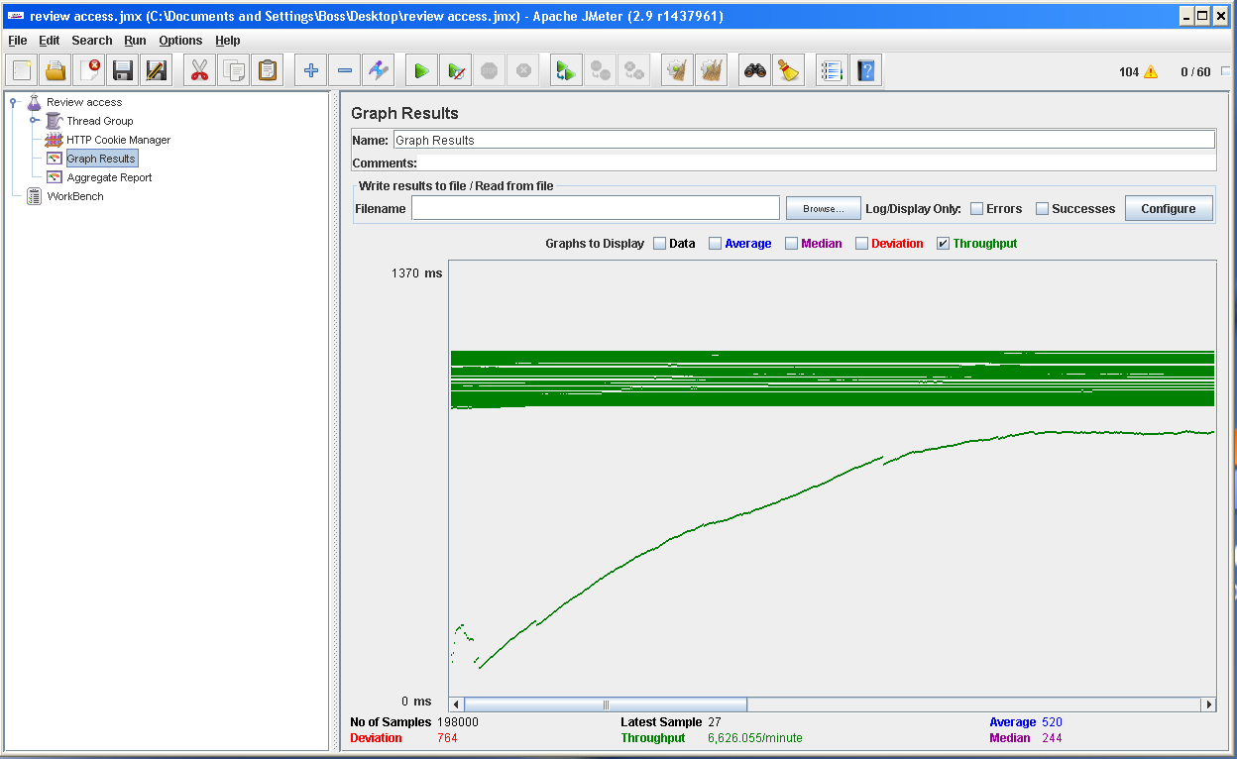

Test 28: Access to the reviews written by a user

With 60 users and 100 loops:

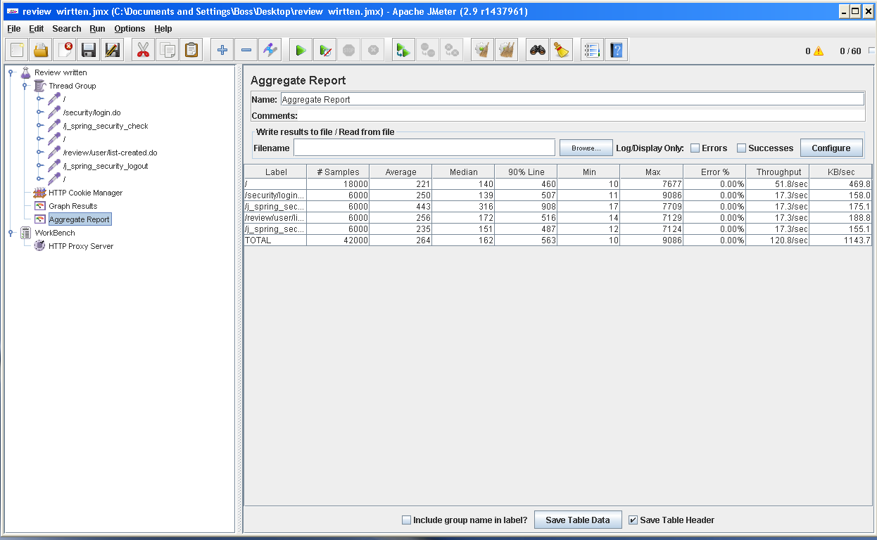

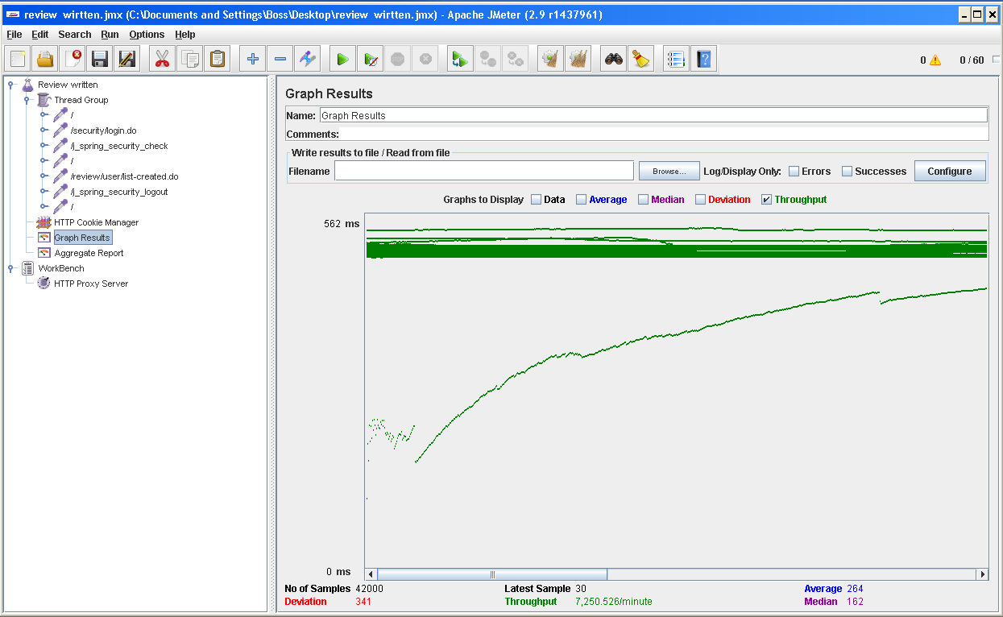

Test 29: List suspicious reviews.

With 60 users and 100 loops:

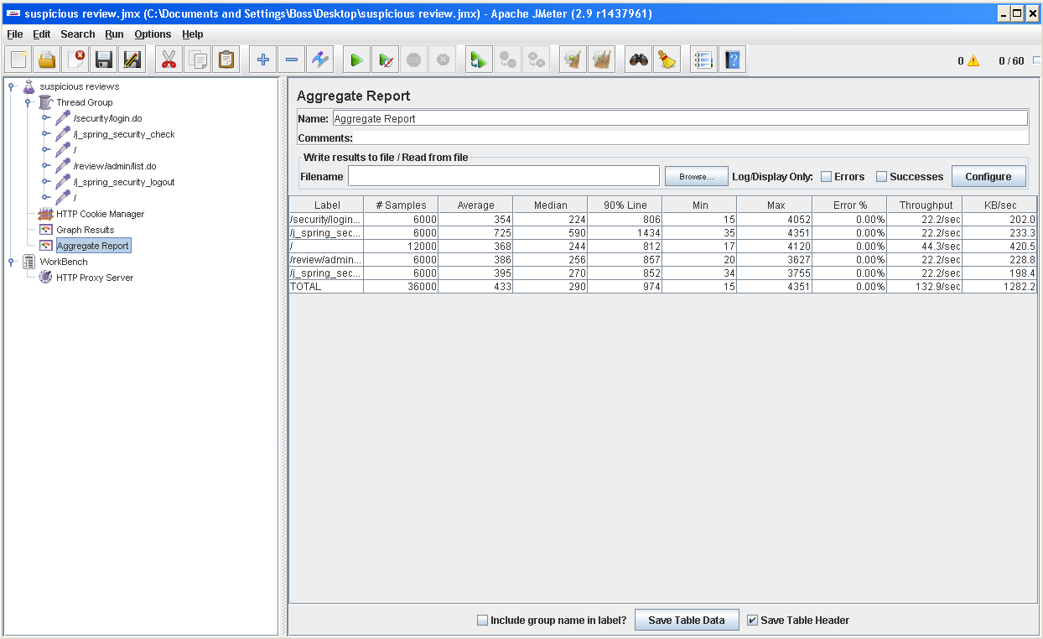

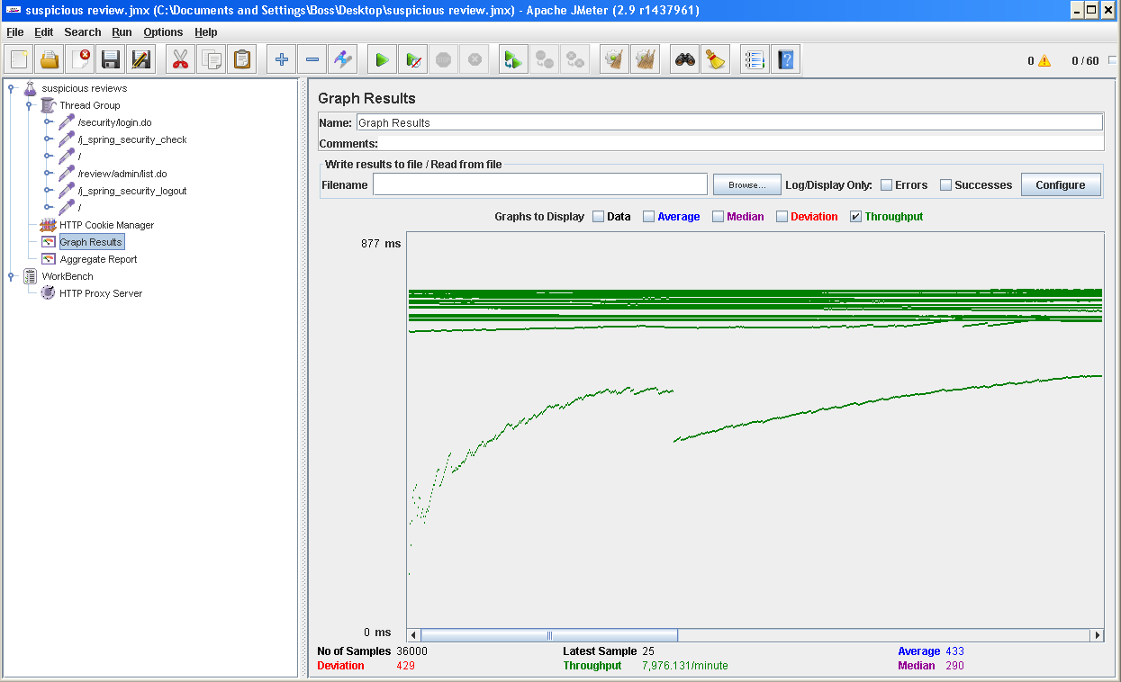

Test 30: List reviews related to a user:

With 60 users and 100 loops:

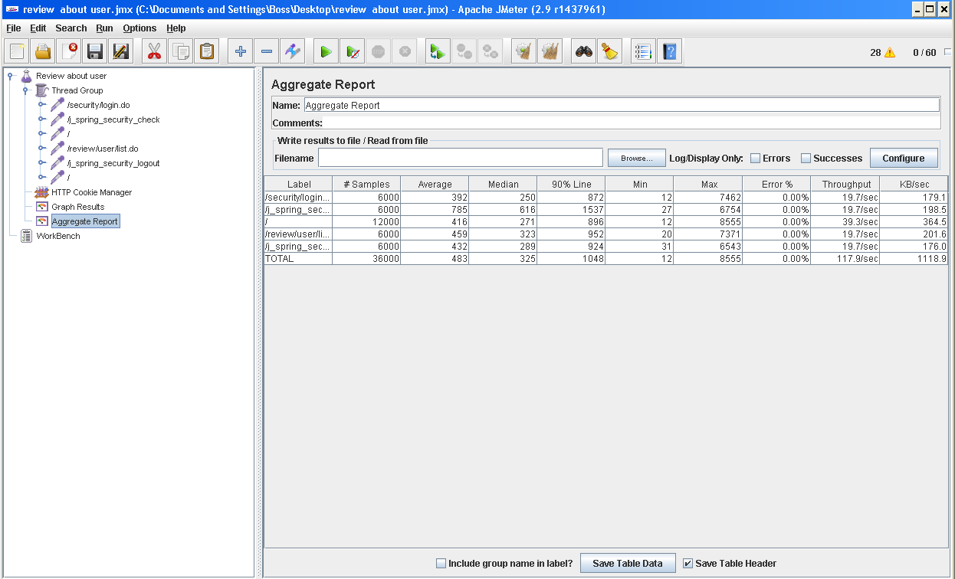

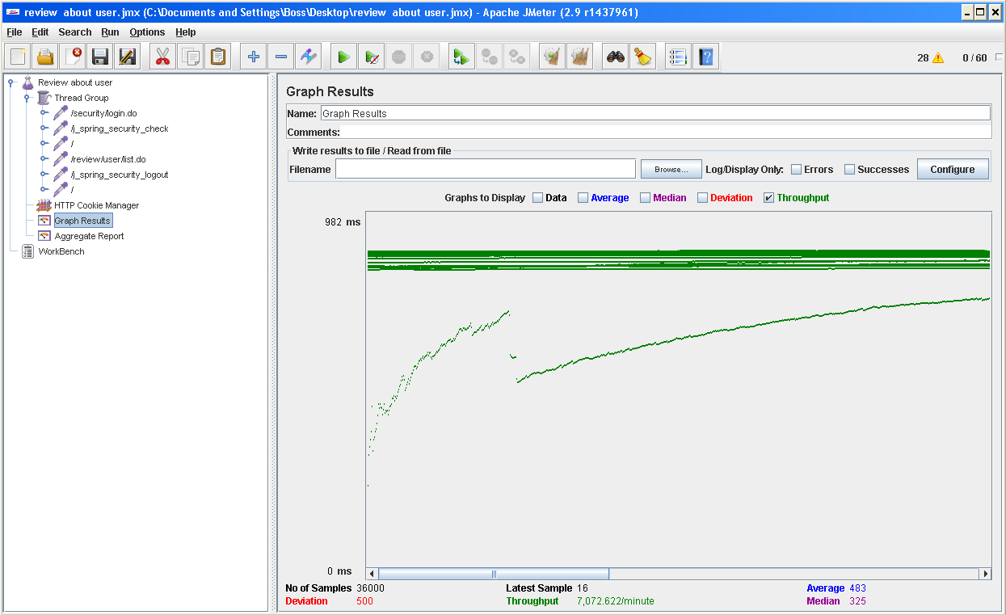

Test 31: List reviews related to a driver:

With 60 users and 100 loops:

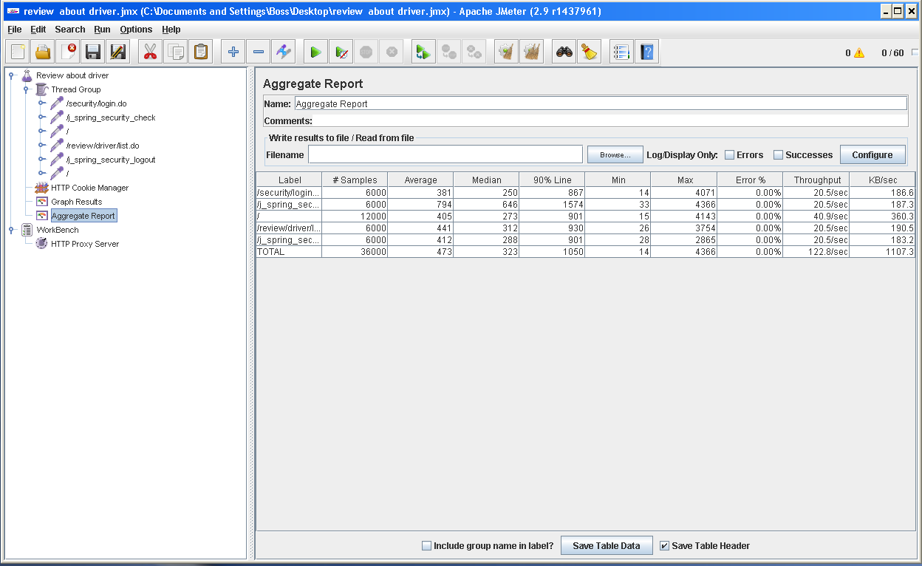

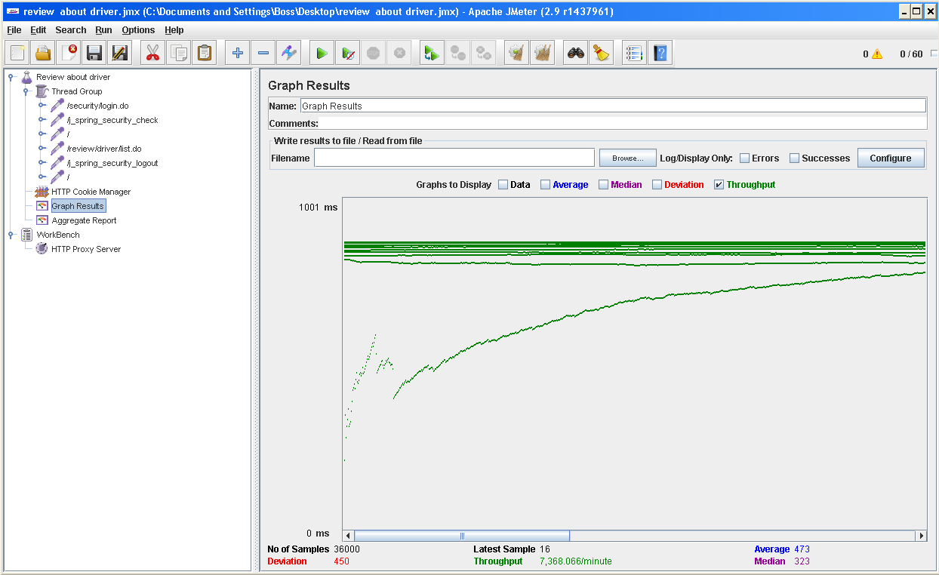

Test 32: List reviews related to a repair shop

With 60 users and 100 loops:

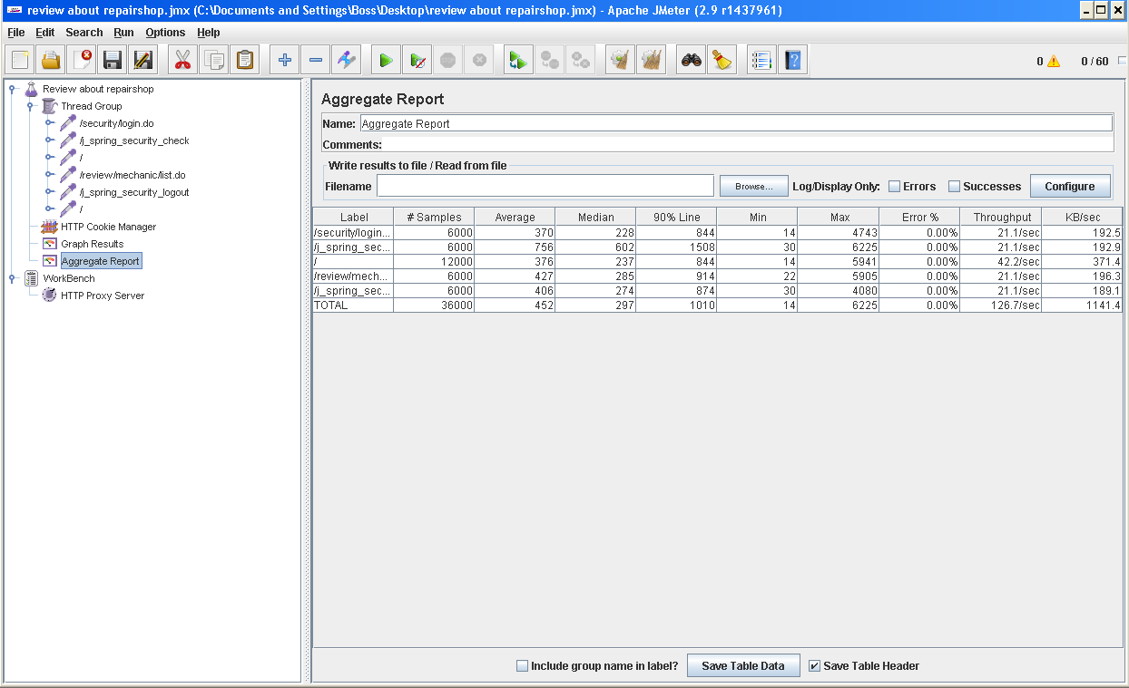

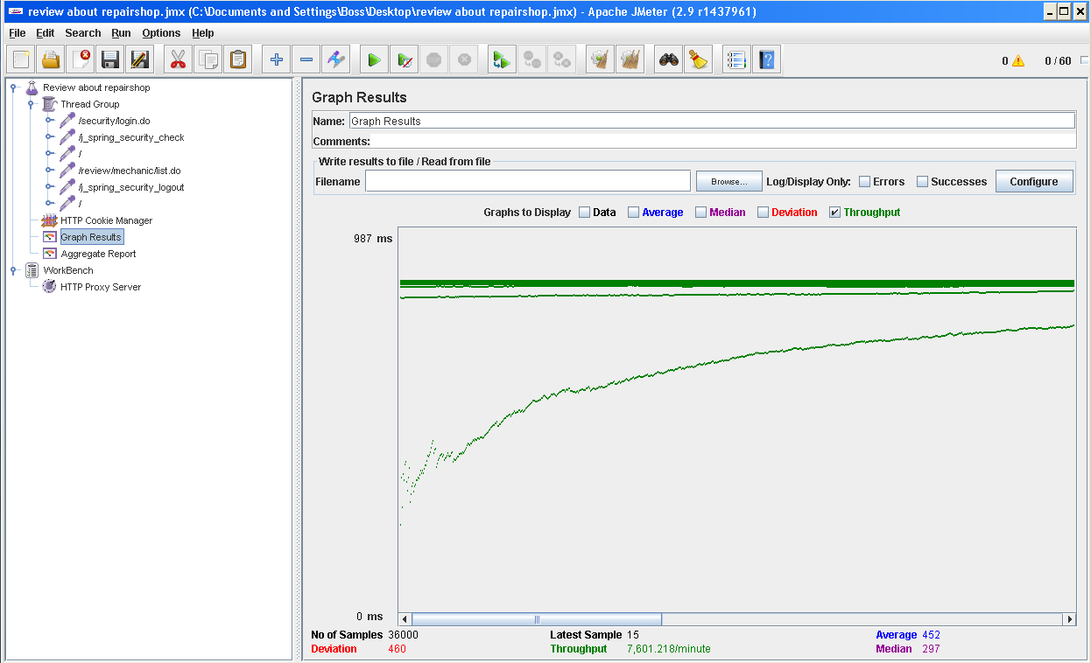

Test 33: Write a review:

With 60 users and 100 loops:

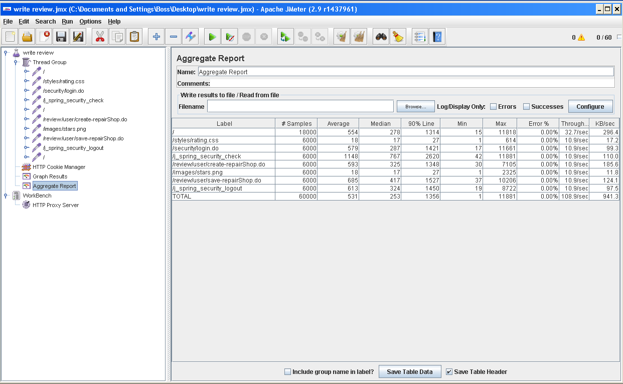

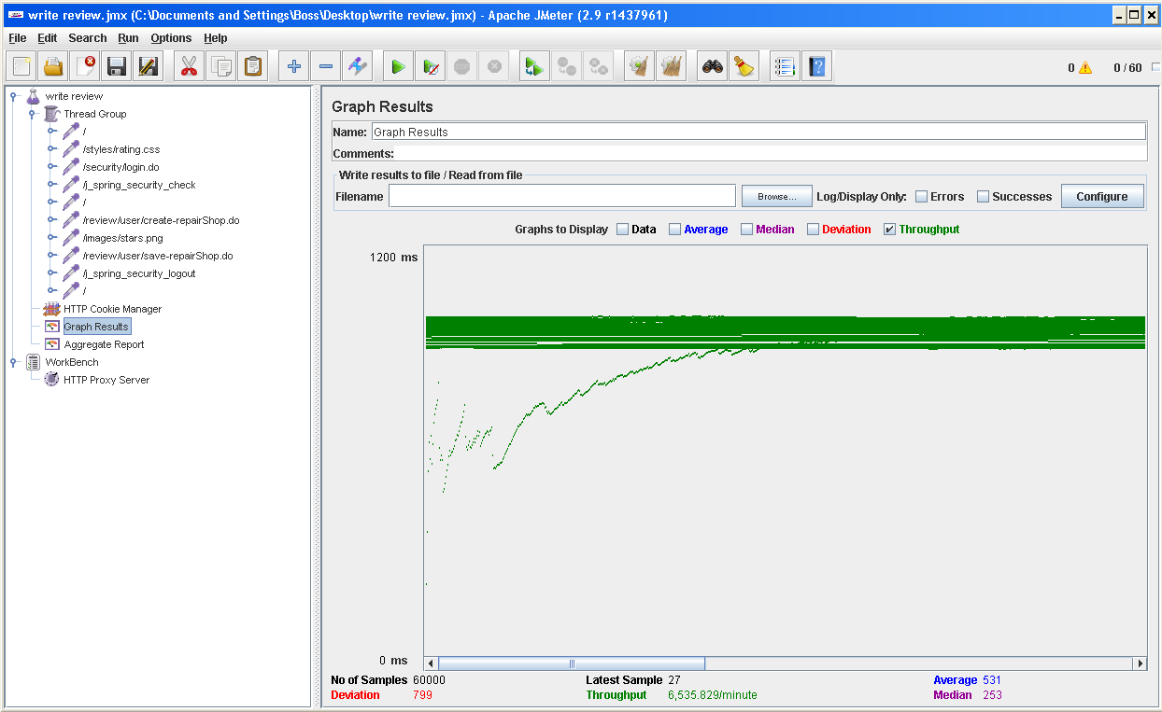

# 6. TESTS RAN IN MACHINE 5

This computer has the following features:

Processor: Intel(R) Core(TM) i7-7700HQ (2.8 GHz, Turbo Boost up to 3.8 GHz, 6 MB cache, 4 cores)

RAM: SDRAM 8 GB DDR4-2400 (2x4 GB)

HDD: 1 TB SATA 7200 rpm

Network Adapter: Intel(R) Dual Band Wireless-AC 7265

Test 34: Displaying the admin dashboard.

With 60 users and 100 loops:

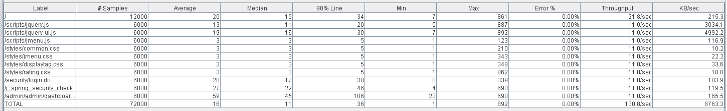

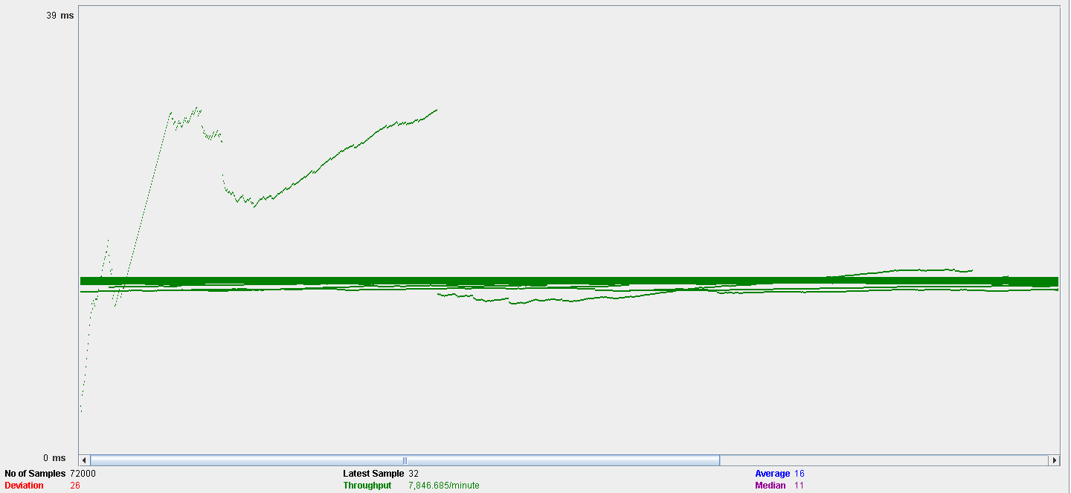

Test 35: Announcement finder.

With 60 users and 100 loops:

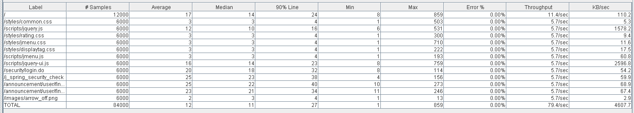

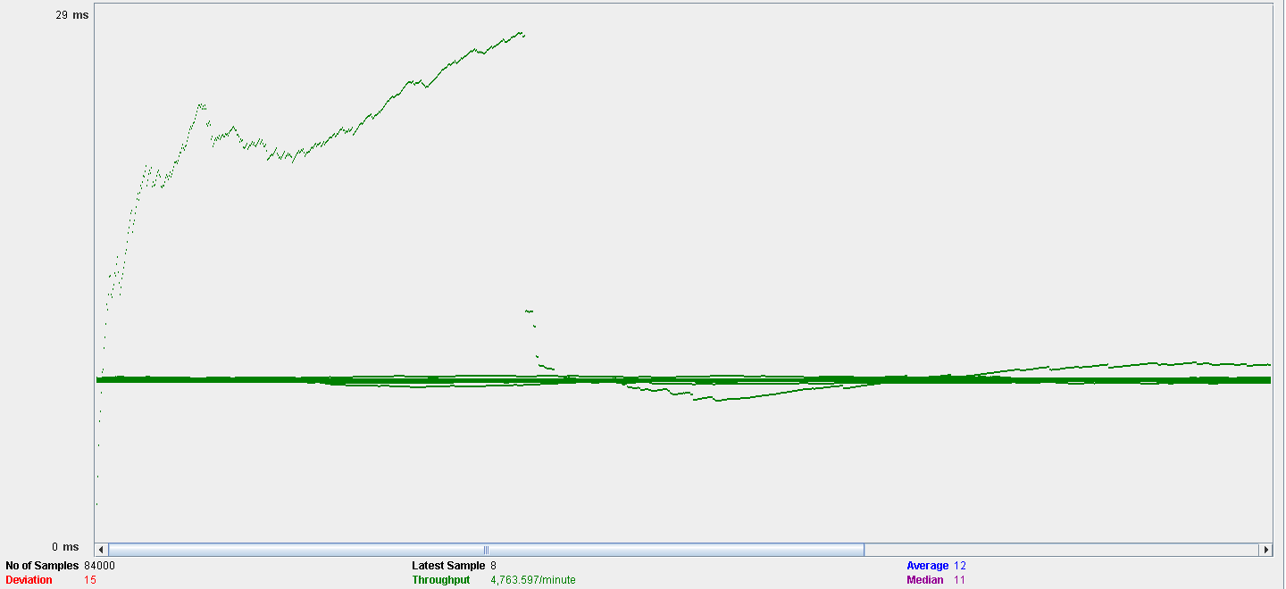

Test 36: Search announcement.

With 60 users and 100 loops:

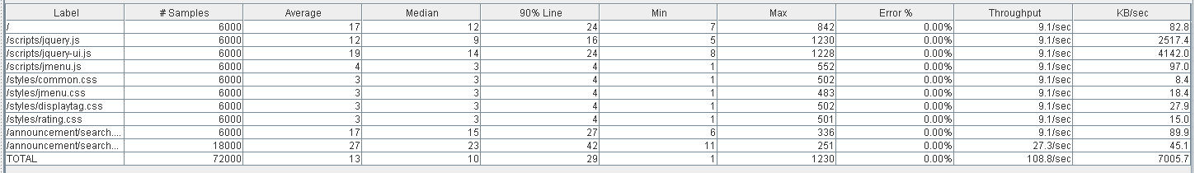

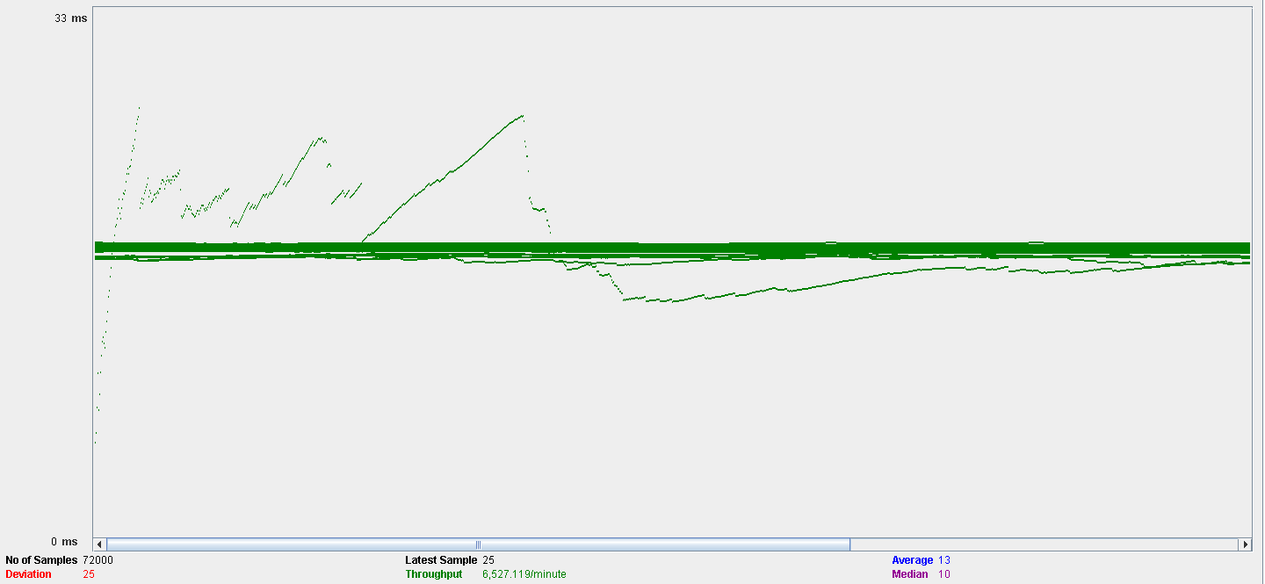

Test 37: Create announcement.

With 60 users and 100 loops:

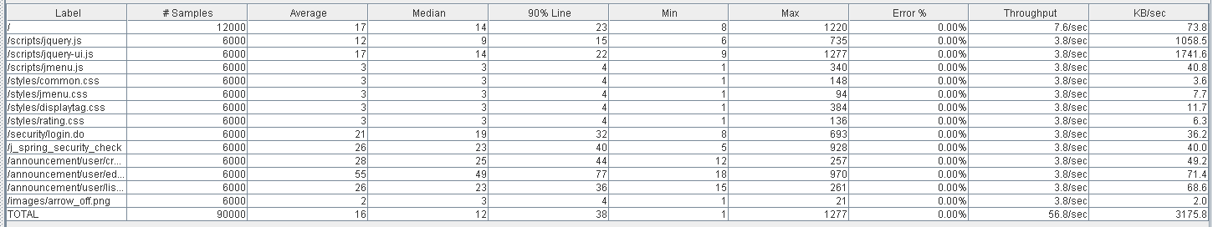

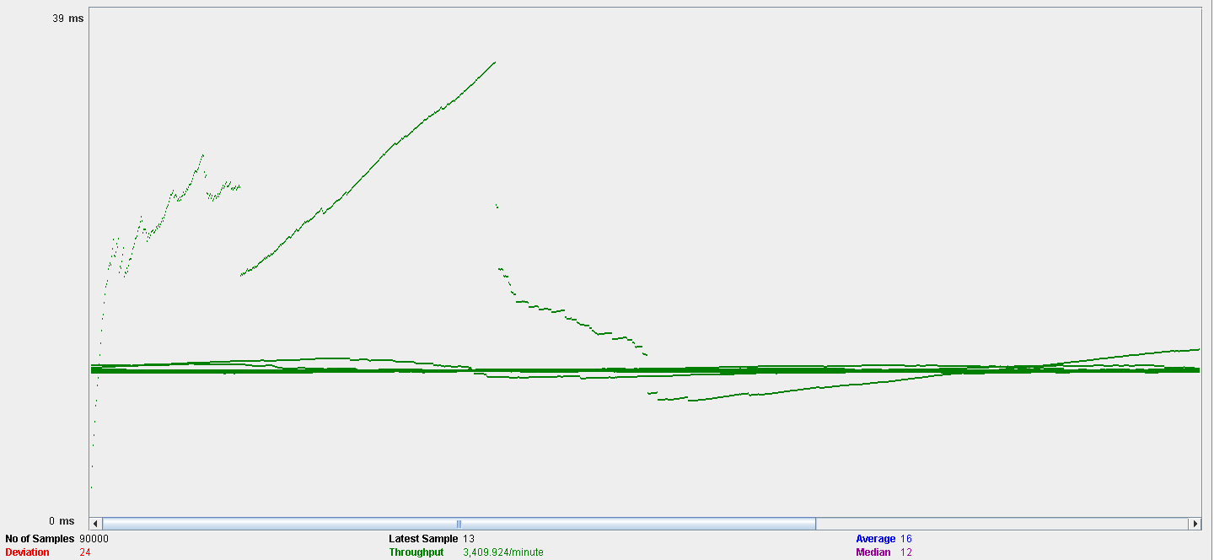

Test 38: Edit announcement.

With 60 users and 100 loops:

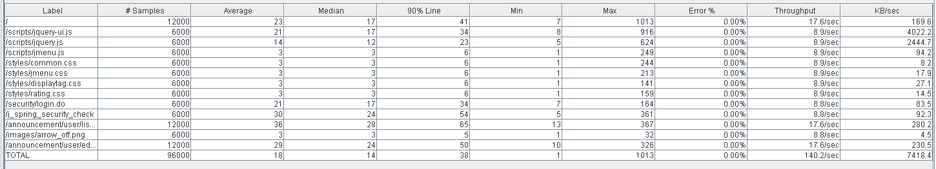

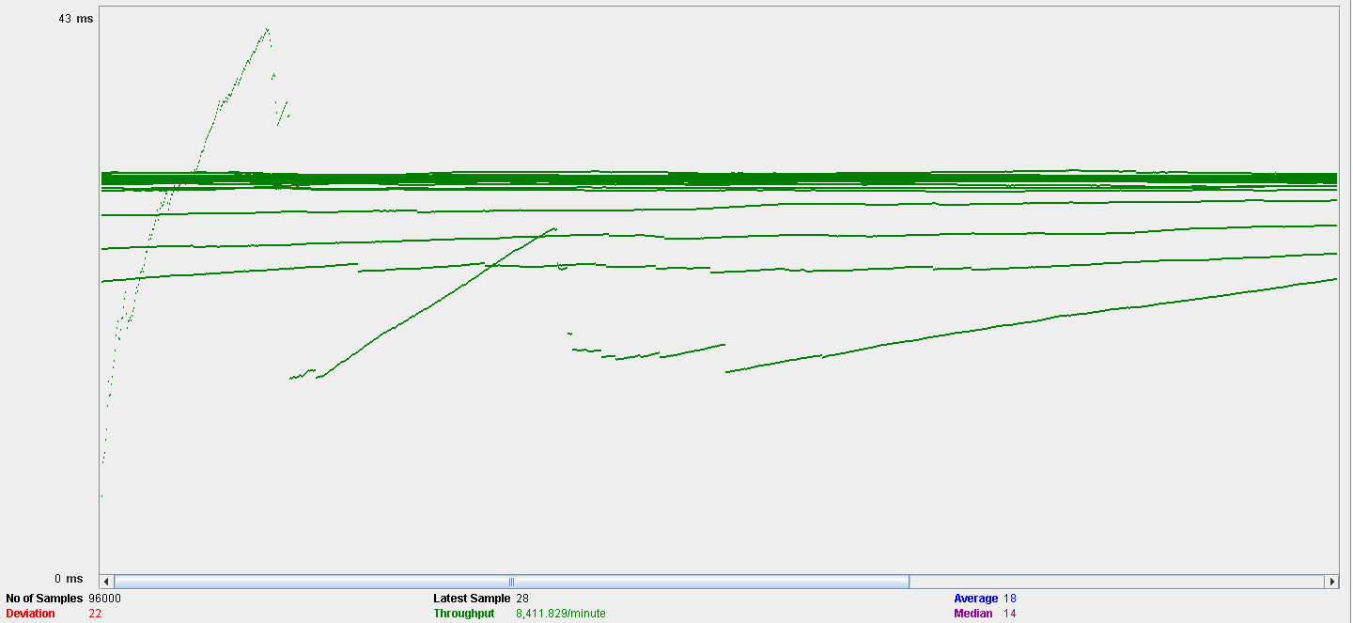

Test 39: Cancel announcement.

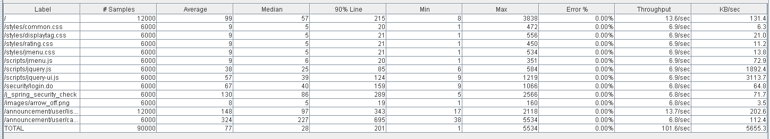

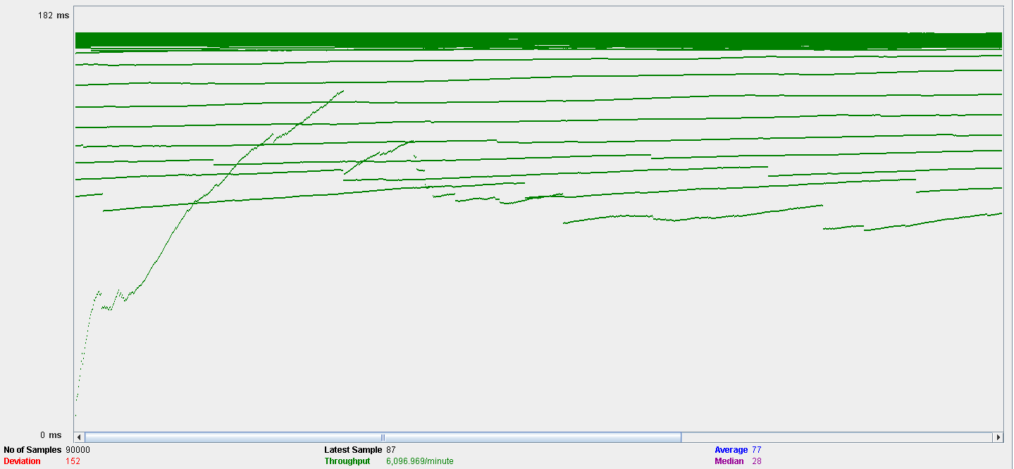

Test 40: Join announcement

With 60 users and 100 loops:

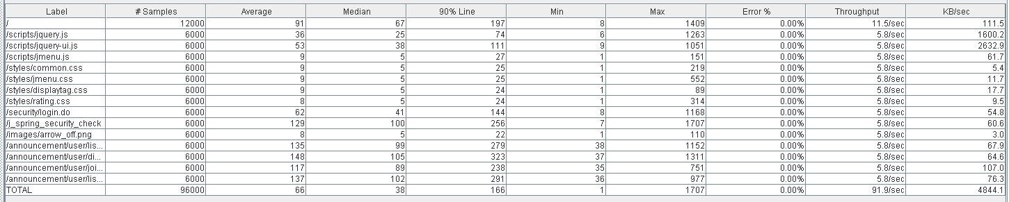

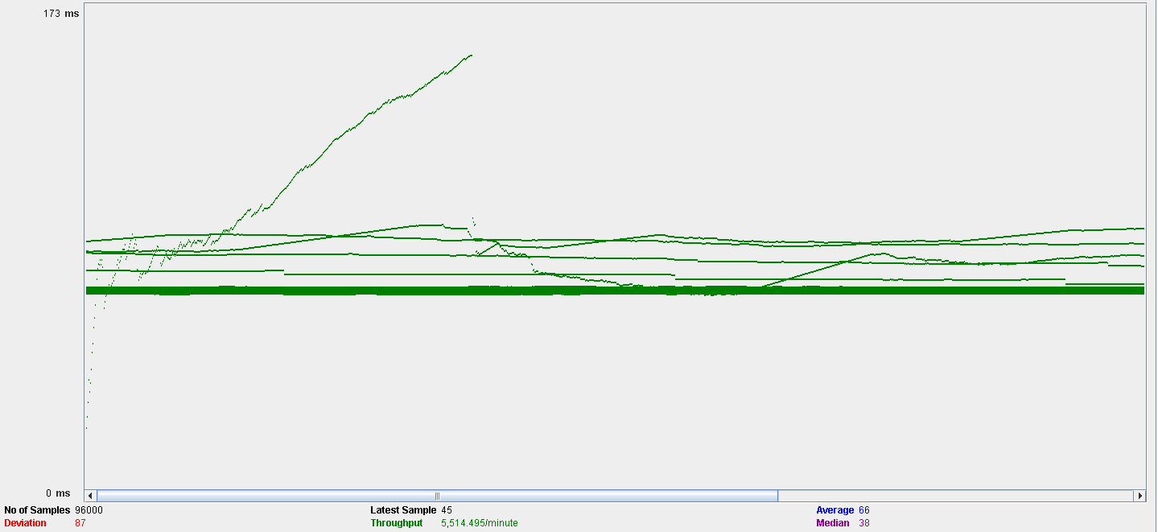

Test 41: Drop out from an announcement

With 60 users and 100 loops:

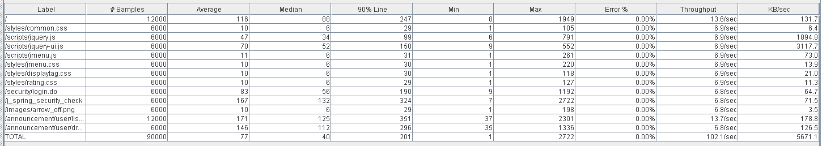

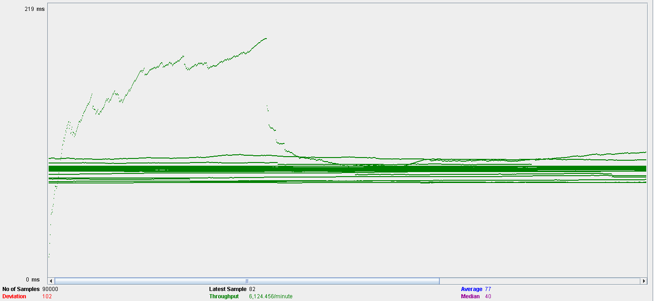

Test 42: Sending a message:

With 60 users and 100 loops:

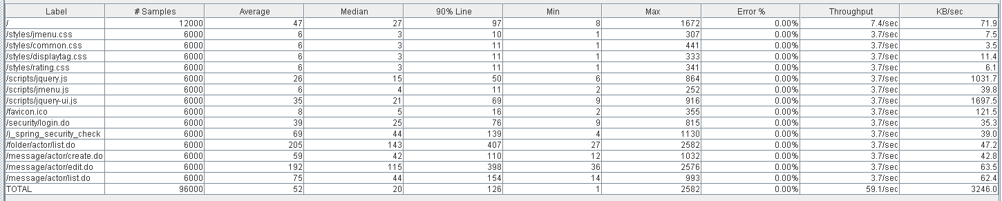

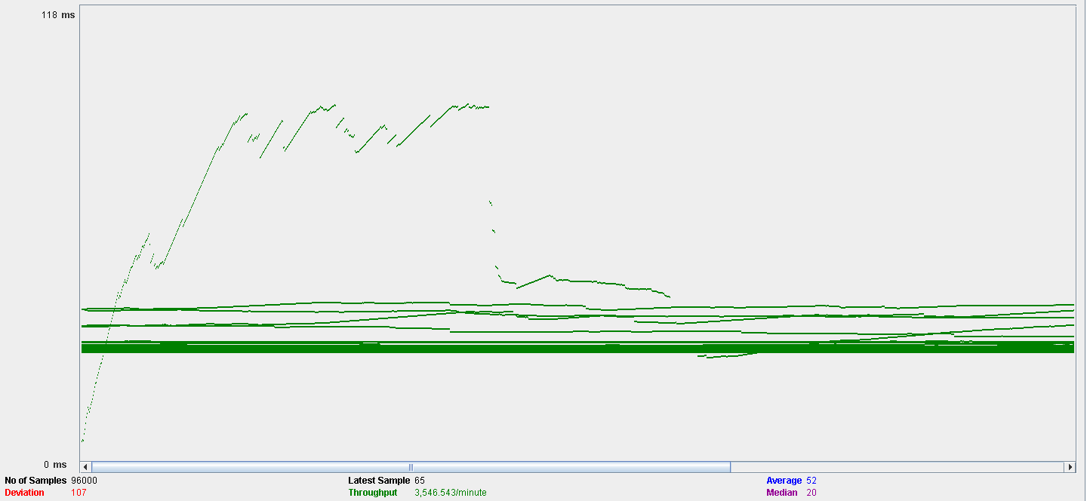

Test 43: Broadcasting a message:

With 60 users and 100 loops:

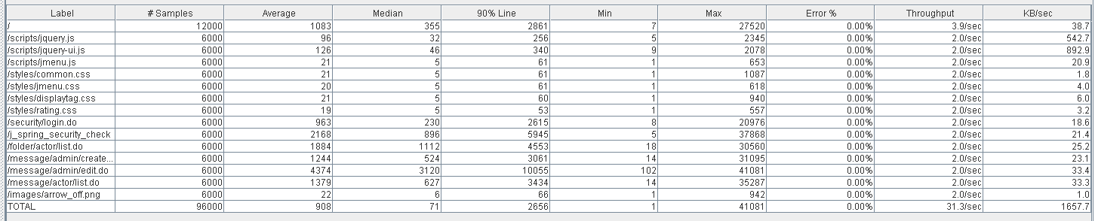

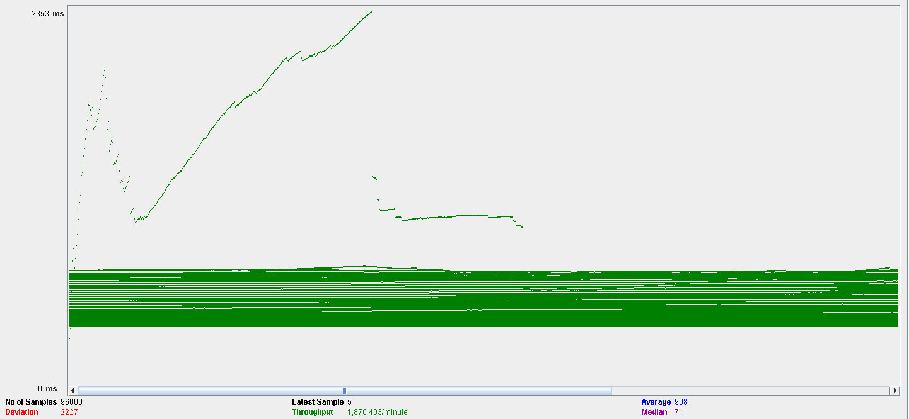

With 100 users and 100 loops:

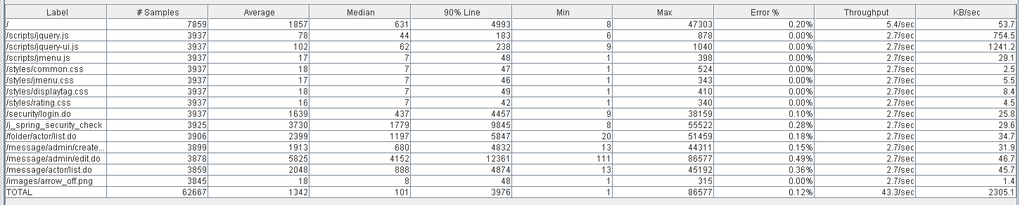

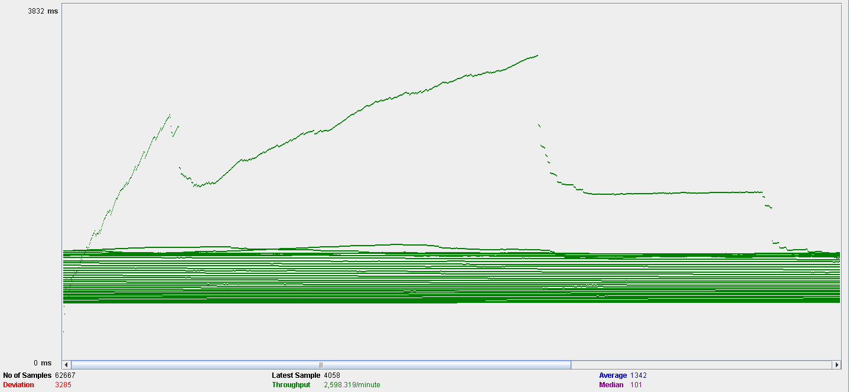

Test 44: Create a folder.

With 60 users and 100 loops:

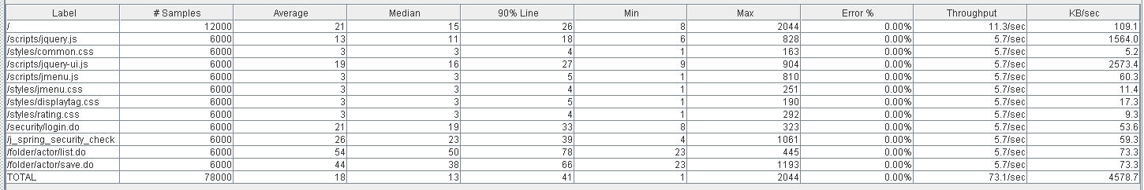

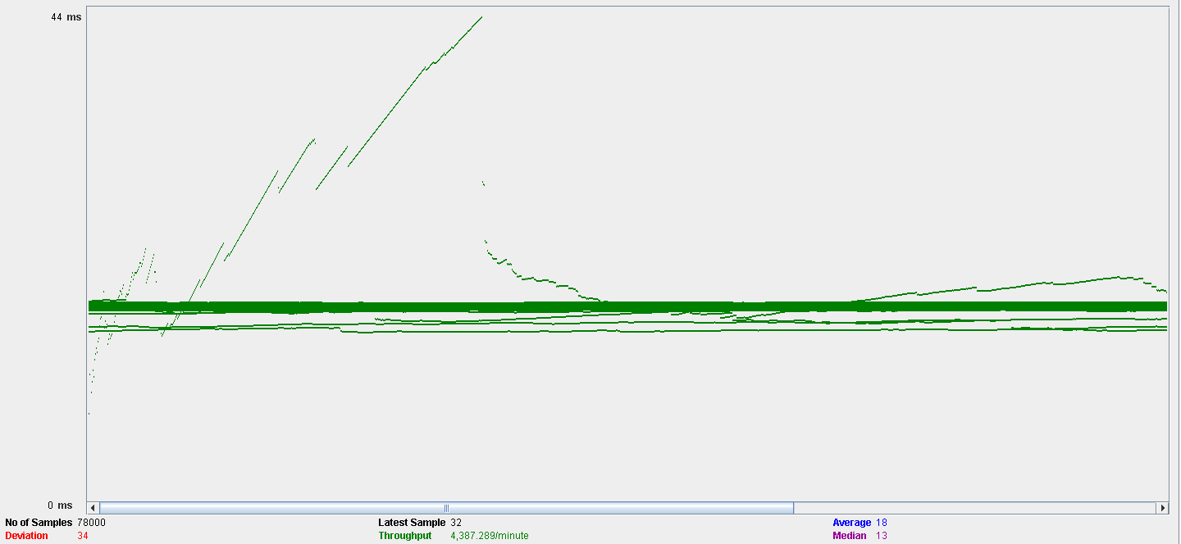

Test 45: Delete folder

With 60 users and 100 loops:





Test 46: Delete message

With 60 users and 100 loops.

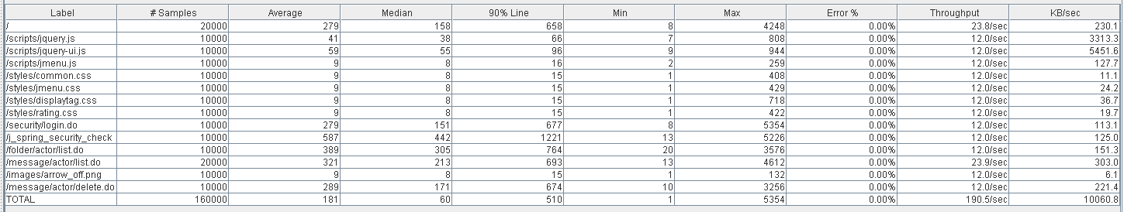

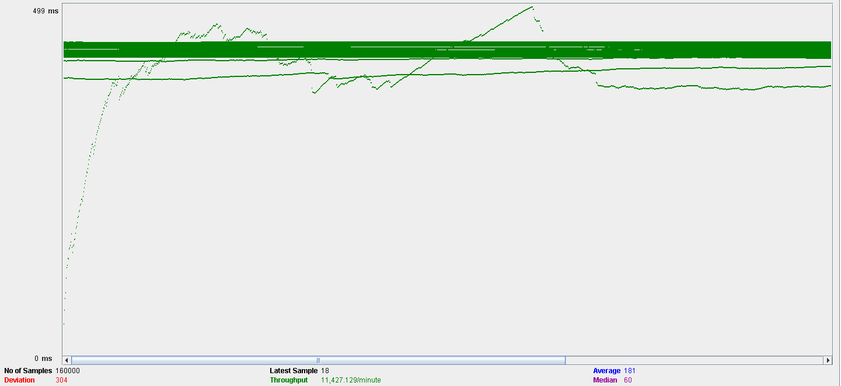

Test 47: Move folder

With 60 users and 100 loops:

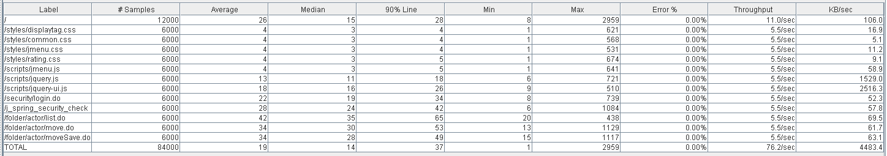

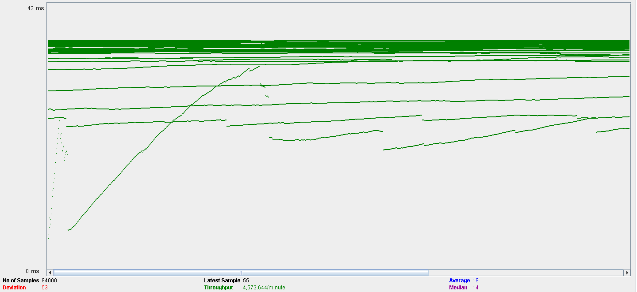

Test 48: Move message

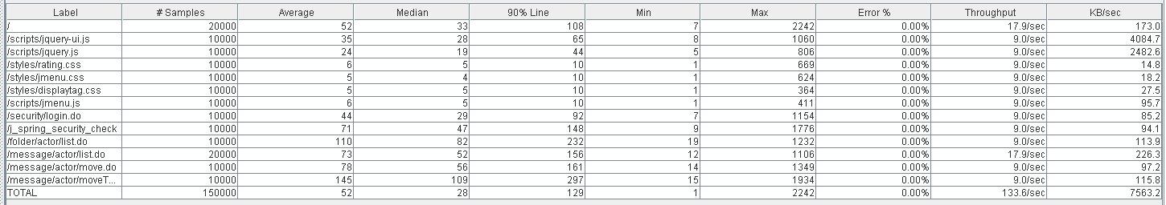

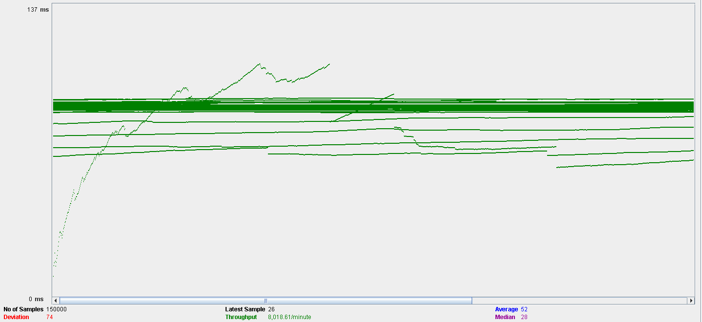

# 7.TESTING THE MAXIMUM PERFORMANCE OF THE SYSTEM

Putting aside the fact that there is a big problem with the performance of the system when it comes to creating comments, out of the tests that have been ran with 100 concurrent users because they put the system in a stress situation, creating a sponsorship is the one that seems to stress the system the most:





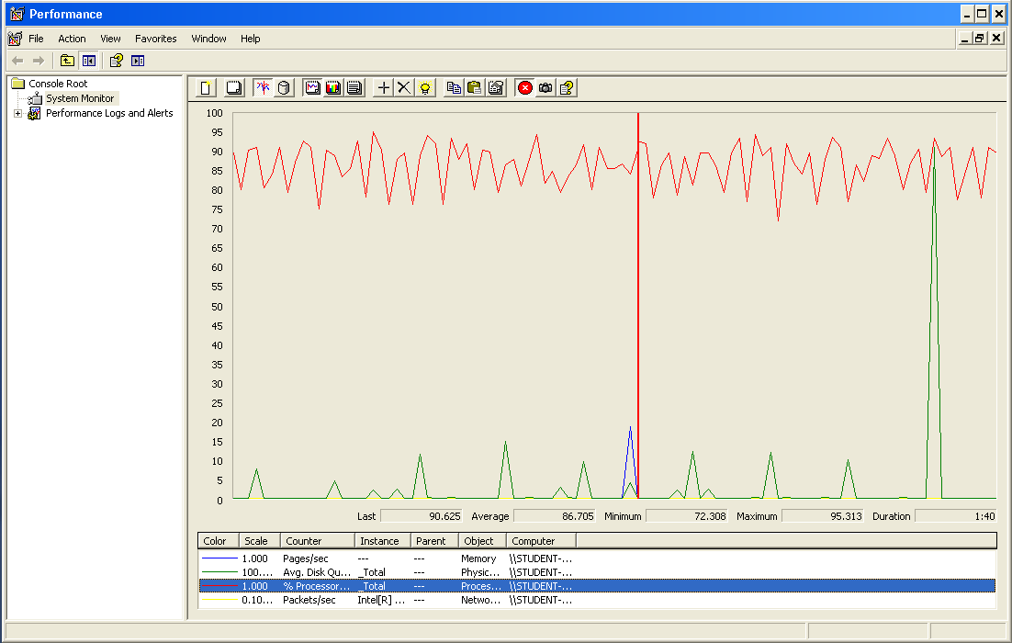

In this case, the processor will be the system’s bottleneck. Because with 100 users the time it takes to create a sponsor is already too long, we can consider that our system can handle less than 100 concurrent users. With 60 users it already takes near 4 seconds, which is still acceptable but noticeable. Our estimation is that the maximum workload our system can handle is around 70 concurrent users