ANDROID DEVELOPMENT ASSIGNMENT

Student: Verónica López

Evaluation criteria

- Delivered on time?

Yes, no problem at all. Thanks for the effort.

- Does the application do the job?

At first glance, the minimum-requirements task works according to what was expected. Follows a snapshot which confirms the above. The application looks very professional and its usage is very intuitive for the user.
When clicking on an item of the ListView object, a coloured dialogue is prompted over, showing extra information about the selection. The dialogue design looks smooth and sophisticated. A collection of buttons is shown allowing the user to control the song track reproductions. When the “play” button or the “next song” button is tapped, the corresponding track is played and a notification message is prompted on the status bar (being cancelable, well done!).
However, there is a main error which relates to the fact that the player does not stop/puase when another song is about to start (after tapping on “next/previous song”). After playing a bit with the application, an odd mixture of songs is sent out through the speakers, leading to a frustrating user experience.
It is remarkable the use of the Google Map API to place a Marker object on the location which was indicated in the question sheet.

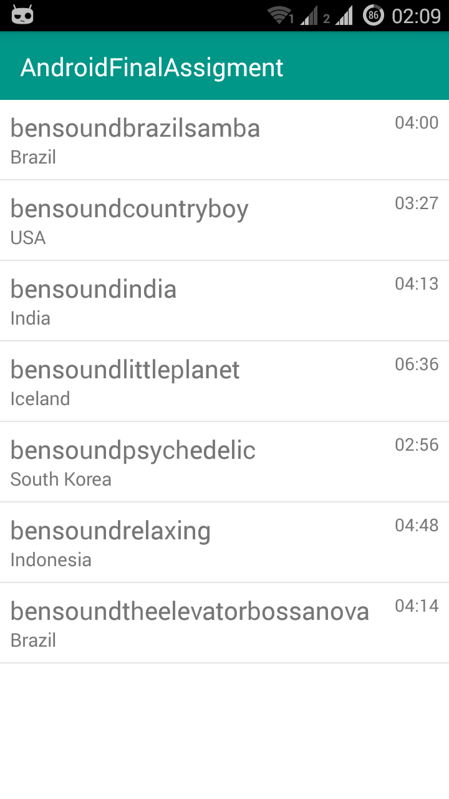
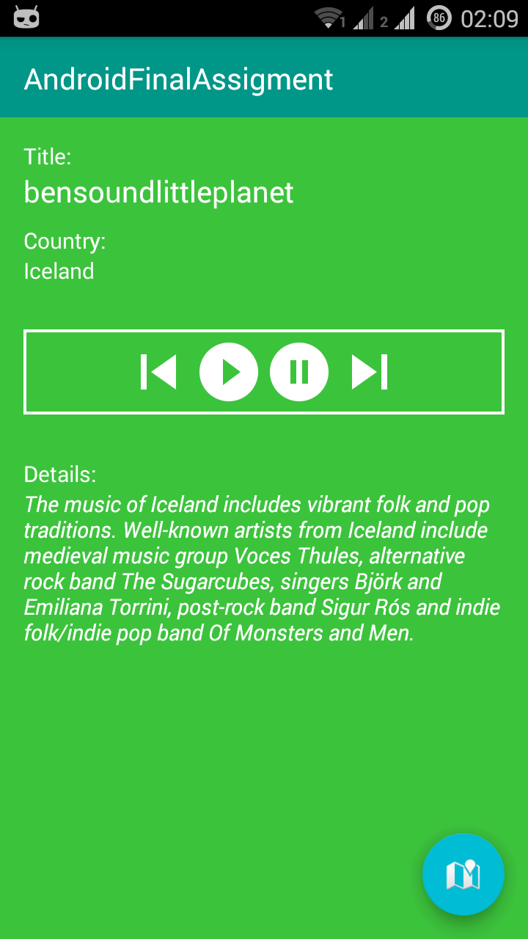


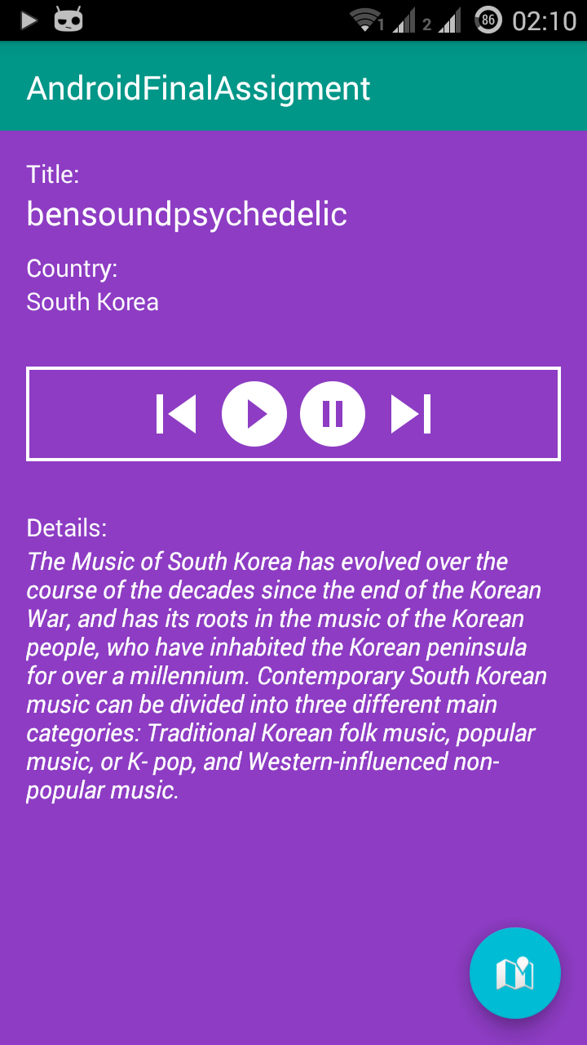
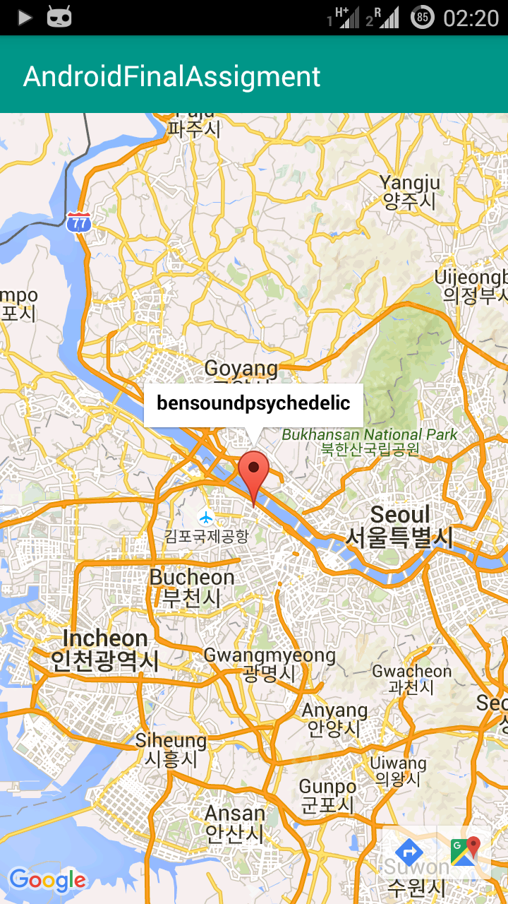

- Has the student made use of Best practices?

The code looks very organised and neat. Unfortunately, not many comments have been included in order to ease code understanding. At least, all String values have been incorporated to the strings.xml file.

- Has the student added any extra feature or undertaken any additional task?

Yes. Extra task 1 (ListView), 2 (ActionBar), and 5 (Google Map) have been successfully implemented, which lead to a better graphical design and an improved user experience. Furthermore, Fragments are wisely employed, making the application follow a sensible structure.

Final comments and grading

It is clear that the application is well intended. The code is well written and easy to follow. The tasks have been properly accomplished and some extra features have been successfully incorporated to the application. As mentioned, the user experience decreases due to the misbehaviour of the application when moving to the next song.

For all the above, this work is graded 9/10. Congratulations and thank you.

