ANDROID DEVELOPMENT RESITTING ASSIGNMENT

Exercise proposal

Create an Android application which comprises 2 Activity objects and allow them to proper communicate with each other. The idea is to reproduce the screenshots below and fulfill the requirements established for each component.
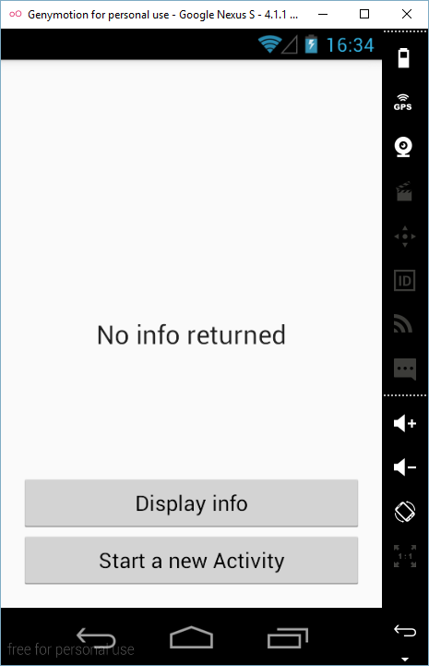
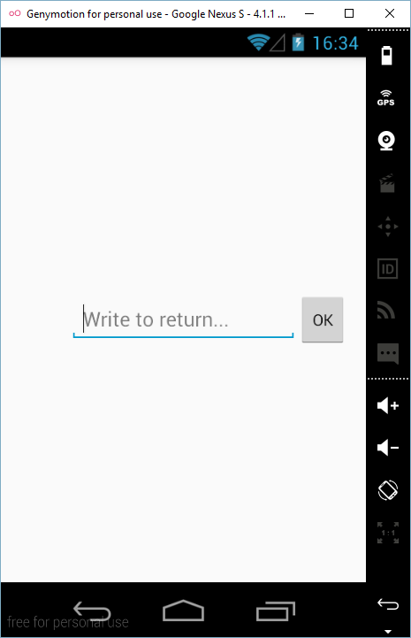
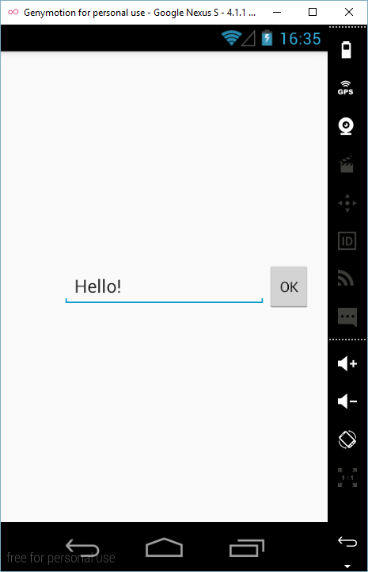
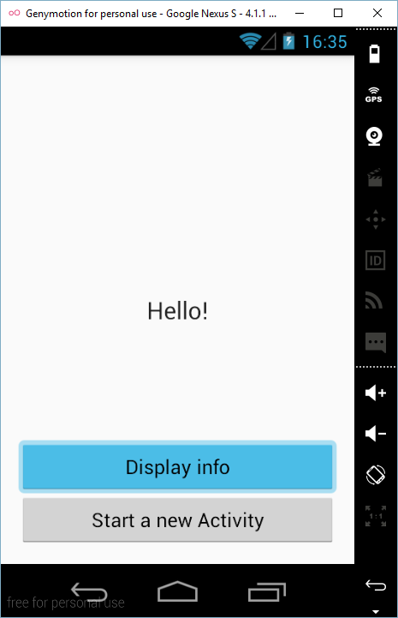

The first Activity will include a TextView and two Button objects. The lower Button instance will start another Activity which will comprise an EditText object and a Button object. The main functionality will consist in:
  - The user starts the app, showing the first Activity.
  - Nothing happens if the upper Button object is pressed, whereas another Activity starts when the bottom Button instance is tapped.
  - The user writes a text on the EditText.
  - When the Button on the second Activity is tapped, it finishes. Then, the first Activity must be brought to the foreground with apparently no change.
  - However, if the first Button object is now pressed, the text previously inserted is displayed on the TextView.
  - For a better user experience, the developer should take care of the configuration changes which may happen during the app execution. In other words, if the device is rotated and the landscape mode is activated by the system, the TextView should still show the information provided by the user.

Note: the student can refer to the official documentation, Lesson 4, for further information about Activity objects and communication strategies.

Program performance

In order to properly assess the performance of the app, it will be required to fulfil all the statements aforementioned.

The student is encouraged to show his design skills proposing some modifications to the app layout (background color, location of design items, etc.) which make it more appealing for potential users.

The submission date has been set up for:

10/07/2016

