GUI DESIGN ASSIGNMENT

Student: Verónica López

Evaluation criteria

- Delivered on time?

Yes, no problem at all. Thanks for the effort.

- Does the application do the job?

This application clearly exceeds the minimum-requirements defined for this project. The main goal was to show design skills in order to copy a proposed template. Although the exercise presented is rather dissimilar, it provides an elegant and smart solution to address the question raised. The design is also consistent in both modes (portrait and landscape).

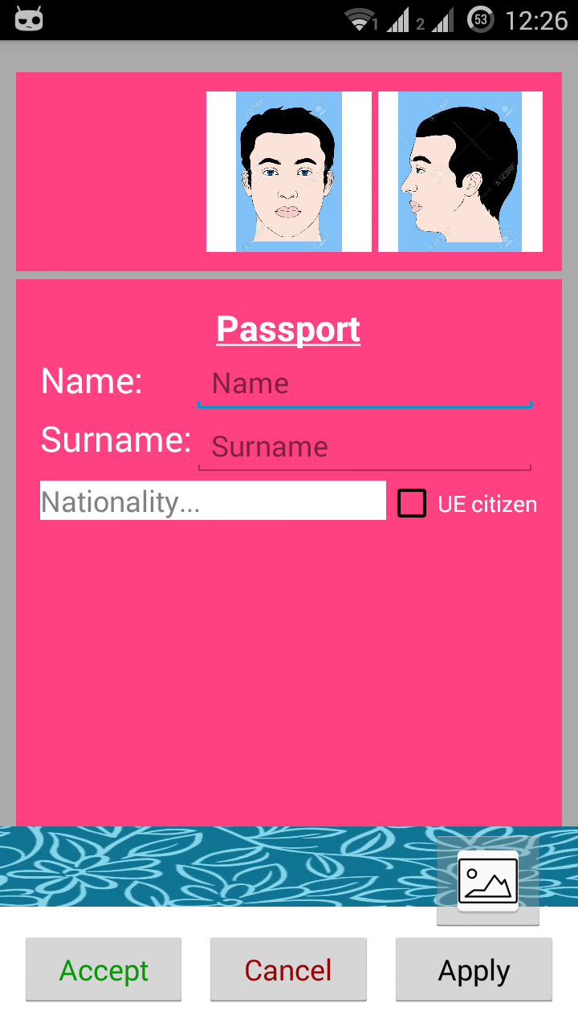
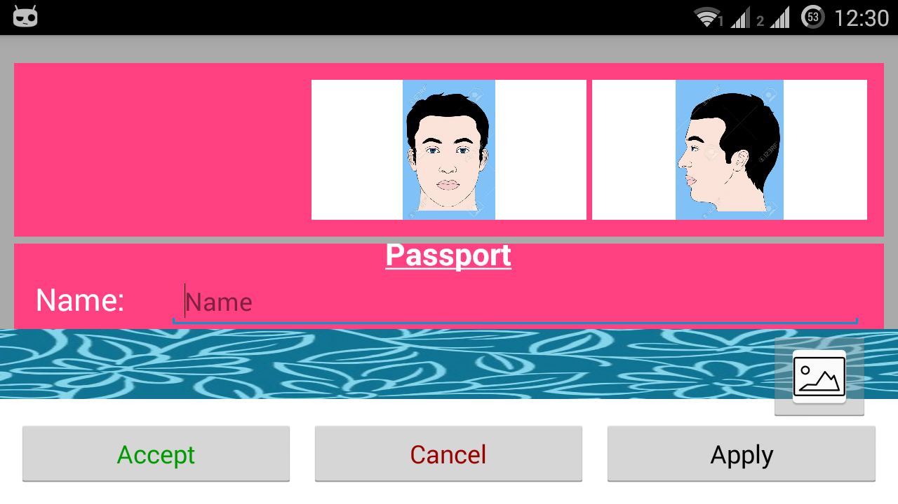
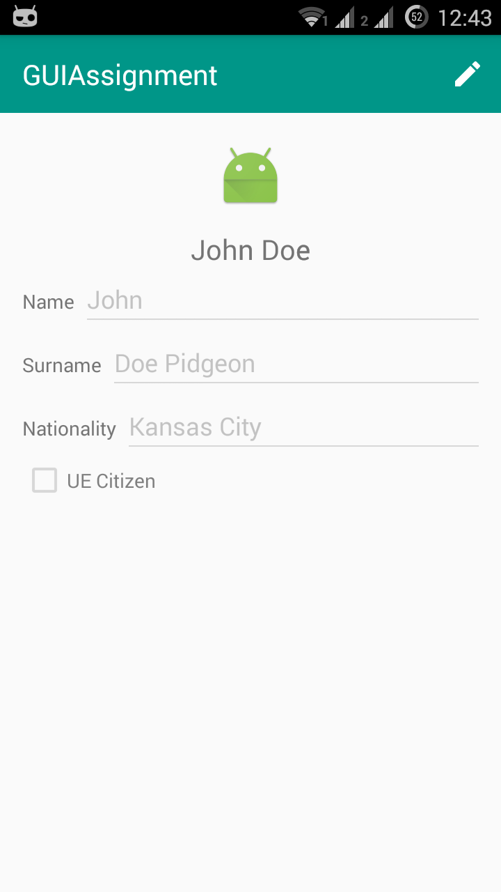

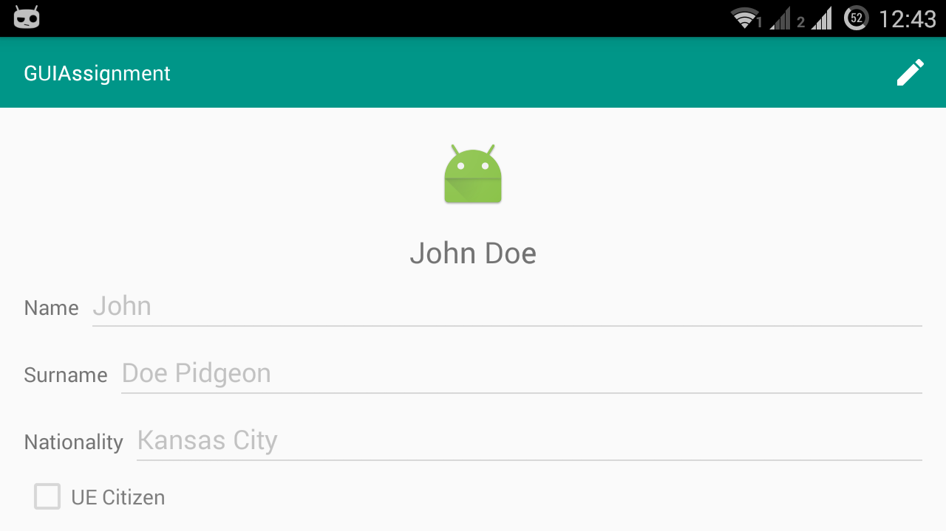

- Has the student made use of Best practices?

The corresponding XML layout file looks rather organised and neat. Furthermore, string values have been defined in the strings.xml file.

- Has the student added any extra feature or undertaken any additional task?

Yes. The student has made use of the Material Design principles, such as colour hierarchy and use of the Toolbar. A Fragment object is also implemented, making the solution flexible to both configurations. The inclusion of an “Edit mode” and the feature which allows the user to select an image from the Android Gallery are both brilliantly achieved.

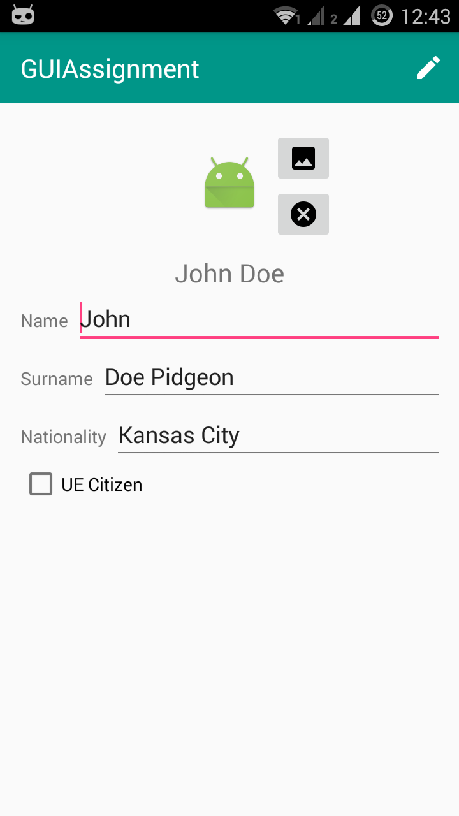
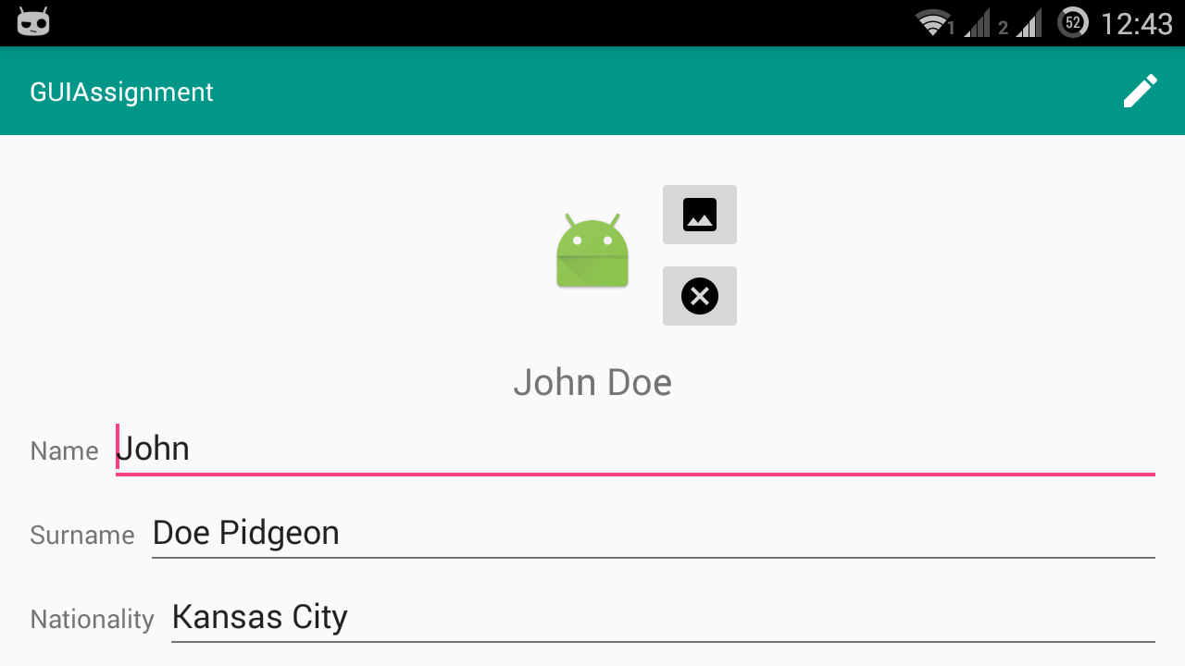

Final comments and grading

It is clear that the application is well intended. The design is well presented and consistent with the corresponding XML code. The task has been properly accomplished and largely improved.

For all the above, this work is graded 10/10. Congratulations and thank you.

