

MBARARA UNIVERSITY OF SCIENCE AND TECHNOLOGY
FACULTY OF COMPUTING AND INFORMATICS
COURSE: BACHELOR OF SCIENCE COMPUTER SCIENCE
COURSE UNIT: INTEGRAL CALCULUS
YEAR: ONE SEMESTER TWO
GROUP NAME: GROUP 7
ASSIGNMENT: ULTRASOUND IMAGE PROCESSING
NAME | REGNO. | STUDENT NUMBER
KYEGOMBE JUMAH  SSEMULI JOSEPH  MULUNGI PRECIOUS PABIRE  AINEMBABAZI DAPHINE  WASSWA EMMANUEL  TUSHABE EDWIG  TUKAHIRWA CLINTON  AYEBARE KEVIN  AKANDWANAHO ONESMAS | 2024/BCS/093/PS  2024/BCS/152/PS  2024/BCS/199/PS  2024/BCS/178/PS  2024/BCS/225/PS  2024/BCS/165/PS  2024/BCS/159/PS  2024/BCS/055/PS  2024/BCS/028/PS | 2400603181  2400603461  2400606638  2400609929  2400602433  2400603311  2400603330  2400603481  2400603339
-

Ultrasound Image Enhancement Using Fourier Transform

Project focuses on improving the quality of ultrasound images by applying Fourier Transform techniques. Using frequency-domain filtering, speckle noise is reduced and important structures are enhanced. Both low-pass and high-pass filters are used to demonstrate noise suppression and edge enhancement respectively. Results show clear improvements in the processed images compared to the original noisy versions.

Introduction
Ultrasound imaging is widely used in medical diagnostics due to its non-invasive and real-time capabilities. However, ultrasound images often suffer from speckle noise, which degrades image quality and complicates accurate diagnosis. Improving the clarity of these images is crucial for better clinical interpretation. This project explores the use of Fourier Transform-based methods to enhance ultrasound images by reducing noise and emphasizing important features.

Background

The Fourier Transform breaks an image into frequency components, allowing targeted noise reduction or edge enhancement.
Speckle noise, common in ultrasound images, reduces clarity and makes diagnosis difficult.
By using low-pass and high-pass filters in the frequency domain, important structures can be enhanced while minimizing noise.

Fourier Transform
The Fourier Transform is a mathematical technique that decomposes an image into its frequency components. In the frequency domain:
Low frequencies represent smooth areas of an image.
High frequencies represent edges, noise, and fine details.
Filtering these frequency components allows targeted manipulation of the image characteristics.

Speckle Noise in Ultrasound
Speckle noise is a form of granular noise that appears in coherent imaging systems such as ultrasound. It results from the constructive and destructive interference of backscattered wavelets and significantly reduces image quality.

Frequency Domain Filtering
Low-pass filter: Allows low frequencies to pass through while suppressing high frequencies, effectively smoothing the image and reducing noise.
High-pass filter: Allows high frequencies to pass, enhancing edges and fine details while removing low-frequency background information.

Methodology

Tools Used
Python programming language
Libraries: numpy, scipy, matplotlib, scikit-image

Processing Steps
Image Loading: Read ultrasound image and convert it to grayscale if necessary.
Fourier Transform: Apply 2D Fourier Transform to convert the image to the frequency domain.
Filter Creation: Create circular masks for low-pass and high-pass filtering.
Filtering: Apply the selected filter to the transformed image.
Inverse Fourier Transform: Convert the filtered image back to the spatial domain.
Visualization: Plot and compare the original and enhanced images.

Experiments

Low-pass Filtering (Noise Reduction)
A low-pass filter with a radius of 50 pixels was applied to the frequency domain. This effectively suppressed the high-frequency components associated with noise while preserving the general structure of the image.

Result

The noise in the image was visibly reduced.
Some fine edges were slightly blurred as a trade-off.

High-pass Filtering (Edge Enhancement)
A high-pass filter with a radius of 50 pixels was applied to enhance the high-frequency components, thus emphasizing the edges.

Result
Fine structures and edges became more pronounced.
Background smooth areas became darker and less dominant.

Results and Discussion
Filter Type | Outcome
Low-pass | Reduced speckle noise, slightly blurred edges
High-pass | Sharper edges, improved structural clarity
Both filtering techniques proved effective for their respective goals. However, applying only a low-pass filter may not be sufficient for diagnostic images that require high detail; thus, a combination of techniques could be explored for better results.
Sample results (screenshots):
Original Image:
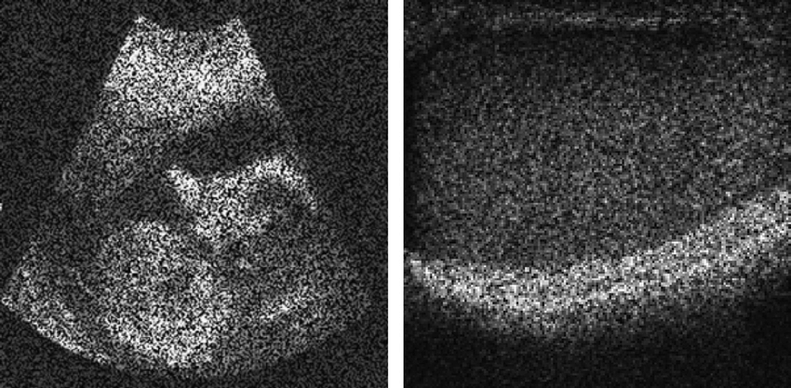

Low-pass Filtered Image:

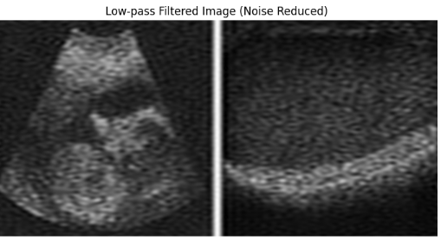

High-pass Filtered Image:
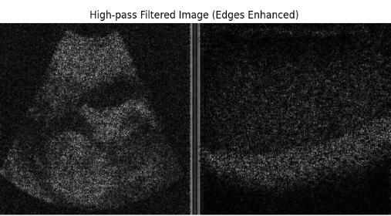

Challenges and Solutions for the Project

Proper Noise Reduction Without Losing Important Detail
When using low-pass filters to remove noise, there’s a risk of also blurring important parts of the image like fine tissue structures or edges which are critical for diagnosis.
To avoid losing important details, we carefully selected the cutoff radius for the low-pass filter. We also used adaptive filters (like Wiener filters) that adjust based on the local characteristics of the image.

Selecting the Right Filter Parameter
Choosing the wrong filter radius can either erase important features or leave too much noise behind, making the image less useful.

To solve this, we experimented with different filter sizes and visually inspected the results.

Avoiding Artifacts After Filtering
Sometimes, after applying Fourier-based filtering, unwanted "ringing" artifacts (known as the Gibbs phenomenon) appeared, especially around sharp edges.
To reduce this, we applied windowing techniques like Hamming or Gaussian windows before the Fourier Transform to smooth transitions. Using smooth masks instead of abrupt cutoffs in the frequency domain also helped in minimizing artifacts.

Dealing with Subjectivity in Image Quality
Image enhancement can be very subjective that is what looks better visually may not necessarily be better for medical diagnosis.
Along with visual inspection, we relied on quantitative evaluation metrics like Structural Similarity Index (SSIM) and Mean Squared Error (MSE)to objectively measure improvement.

Conclusion

Fourier domain filtering offers a powerful approach for ultrasound image enhancement. By selectively attenuating or boosting certain frequency components, it is possible to reduce noise or highlight important anatomical structures. Future work could involve adaptive filters, machine learning methods, or hybrid techniques to further improve the quality of medical images.

References
- Gonzalez, R. C., & Woods, R. E. (2018). Digital Image Processing (4th ed.).
- Wikipedia contributors. "Fourier transforms." Wikipedia, The Free Encyclopedia.
- Open-source libraries: scikit-image, scipy, matplotlib

