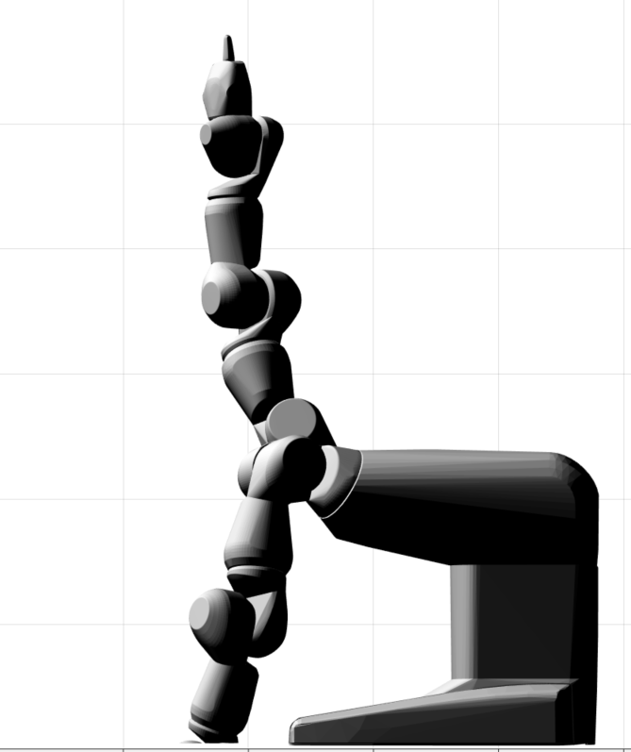

Each square is .2 meters