Cinema homework

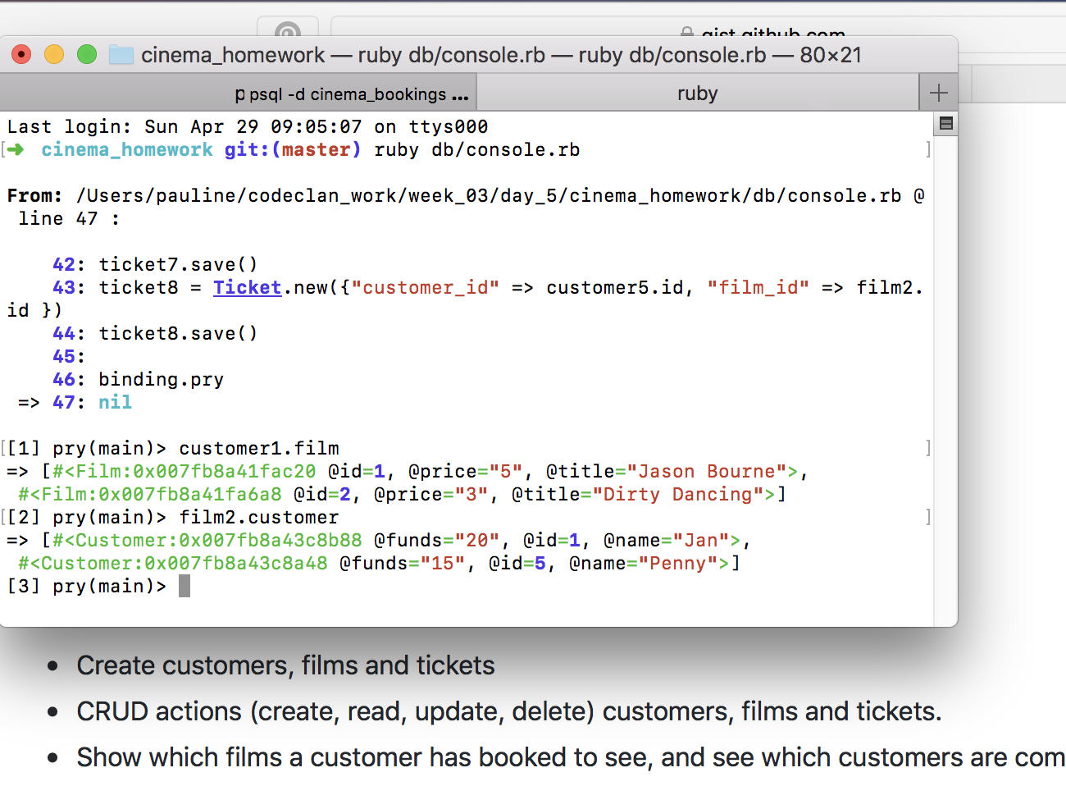Point 3

Check in pry

How many people watching one film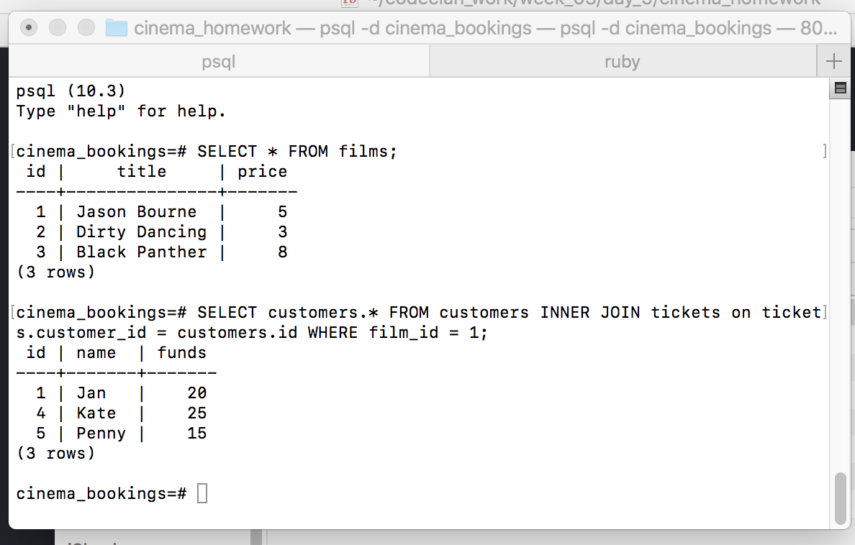

How many films one person watching

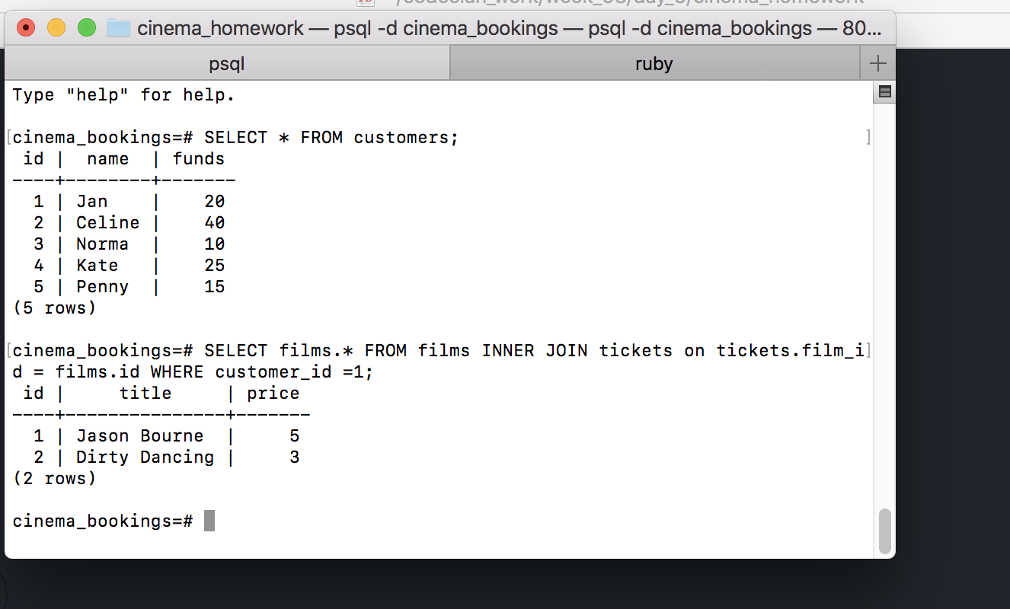

Following gave title and name table – but not correct as Jan sees more than just Jason Bourne

SELECT customers.name, films.title FROM tickets

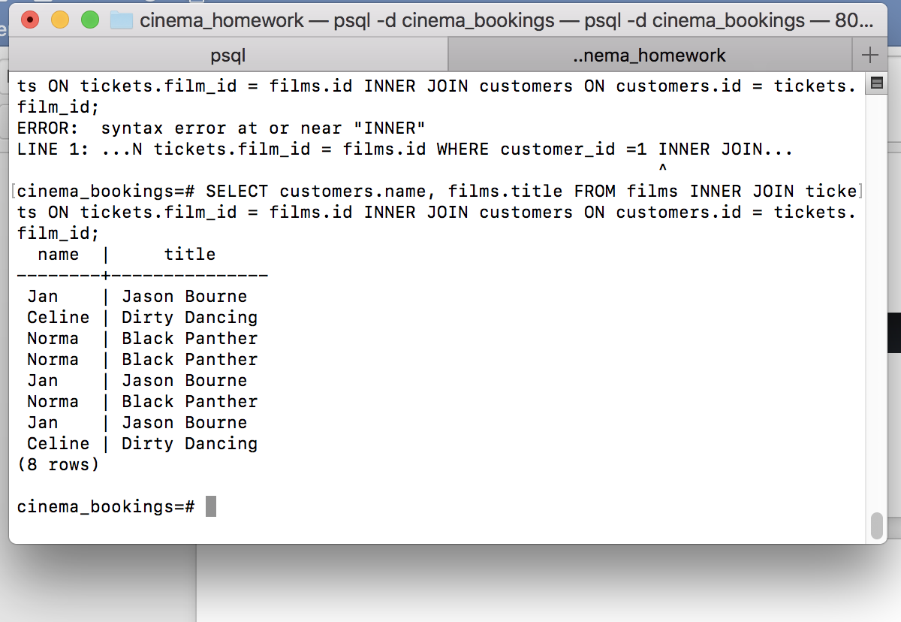

WHERE customer_i