Title: How to Know When You're Actually Due for a Trim
Author: Yuna Seo
Date: 2026-09-11
Section: Trends
Category: Cut & style
Excerpt: Your hair does not care what the calendar says. Here are the signs your ends are actually asking for a haircut.
Slug: trim
Tag: Trim
Read Time: 6
Meta Title: How to Know When You're Actually Due for a Trim | HairProVoices
Meta Description: Your hair does not care what the calendar says. Here are the signs your ends are actually asking for a haircut.
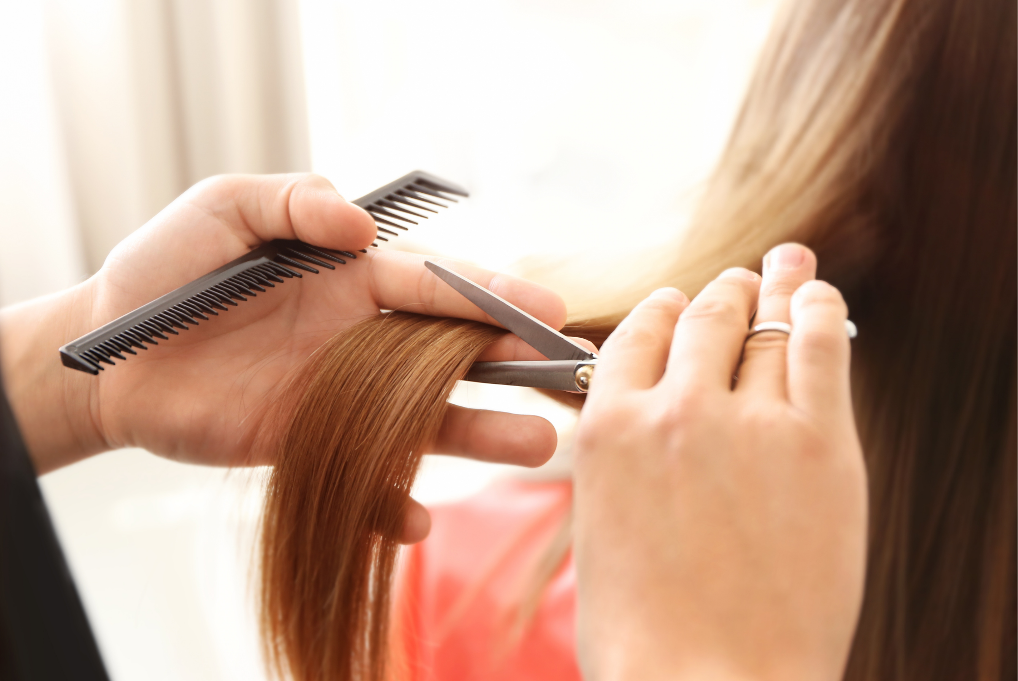
There is a question I hear constantly in the salon: “Do you think I can wait another month?”
Usually, the client is asking because she wants to keep her length. Sometimes she has a wedding coming up. Sometimes she is growing out a haircut. And sometimes she simply does not want to sit in my chair and hear the words, “We need to take more off than you thought.”
I understand it.
But here is the thing: your hair gives you warning signs before it really needs a haircut. If you know what to look for, you do not have to rely on an arbitrary six-week appointment schedule or wait until your ends are visibly falling apart.
Your hair will tell you when it is time. You just have to know how to read it.

Your Ends Start Looking See-Through
This is one of the easiest signs to miss.
Look at your hair from behind, especially if it is long. Does the bottom look noticeably thinner than the rest? Do your ends appear wispy or almost transparent compared with the middle of your hair?
That is often a sign that you are dealing with accumulated breakage and split ends.
The ends are the oldest part of your hair. They have been through every wash, brush, ponytail, heat styling session, color appointment, pillowcase, and winter coat your hair has experienced. Eventually, that history starts to show.
“When the ends lose density, clients often think they just need a better conditioner. Sometimes they need less product and a pair of scissors.”
— Delaney Cross, Stylist & Salon Owner
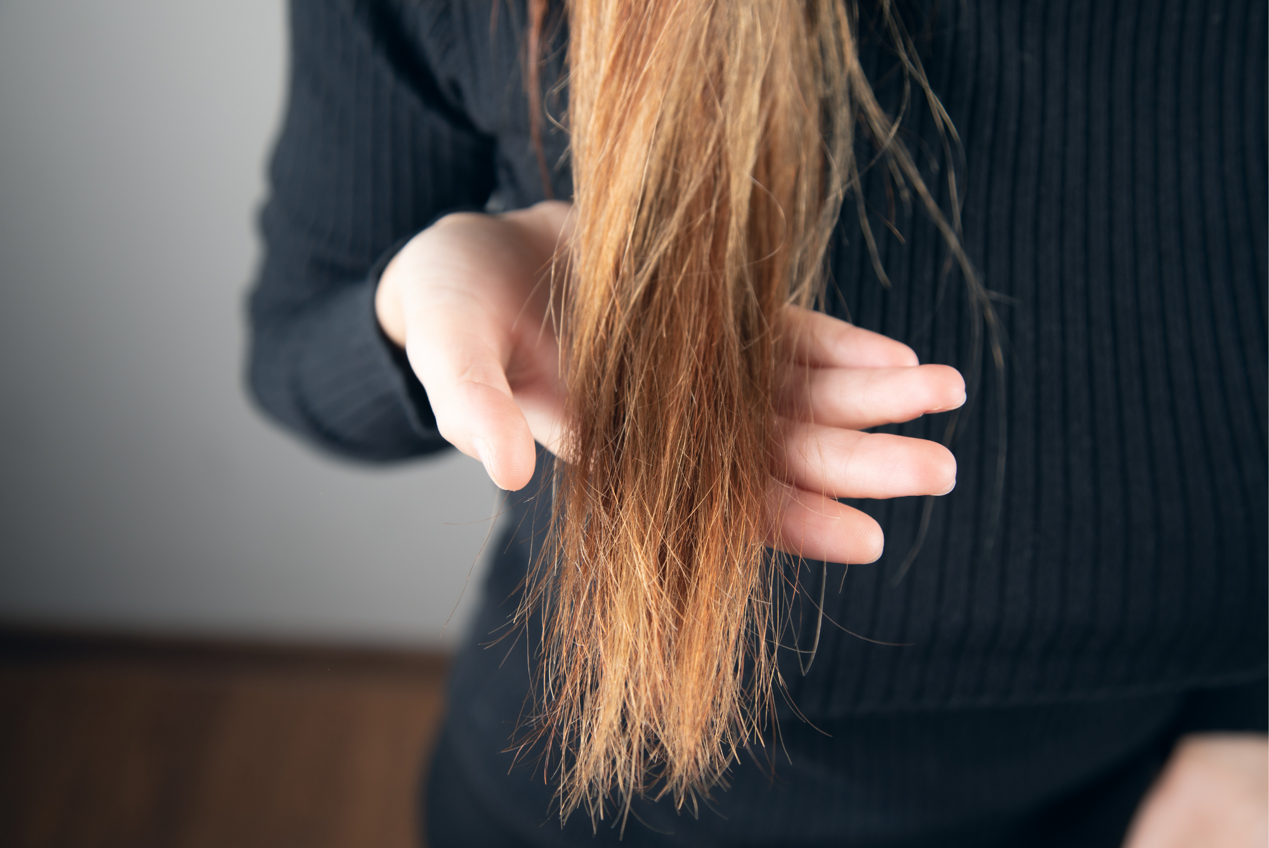

Your Hair Keeps Tangling in the Same Place
A little tangling is normal. Constantly fighting the same knot at the bottom of your hair is different.
Damaged ends have rougher, more irregular surfaces than healthy-looking hair. Those rough edges can catch against neighboring strands, creating tangles that seem to come back no matter how much conditioner you use.
If you brush your hair and keep finding yourself stopping at the last few inches because they will not cooperate, pay attention.
That does not necessarily mean you need a major haircut. But it is worth having a stylist look at the ends.

Your Hair Looks Good Until You Get to the Last Few Inches
This is the classic “my hair looks healthy… except for this part” situation.
Your roots look shiny. Your mid-lengths look smooth. Then you reach the ends and suddenly the texture changes.
They may look fuzzy, dry, uneven, or frayed. They may refuse to hold a style. They may stick out in different directions even after you have carefully blow-dried the rest of your hair.
This is usually where people reach for another mask, oil, serum, or leave-in treatment.
Those products can absolutely improve how damaged hair feels and looks temporarily. They can smooth the cuticle and reduce friction. What they cannot do is turn a physically split strand back into an intact strand.
Once the end is damaged, cutting is the only permanent way to remove that damage.

Your Haircut Has Lost Its Shape
Not every trim is about split ends.
Sometimes you are simply due for maintenance.
Layers that once framed your face beautifully can start falling flat. A bob can lose its clean line. Face-framing pieces can grow into an awkward middle length. Bangs can stop behaving. A shag or wolf cut can lose the intentional imbalance that made it work in the first place.
This is why “How often should I trim my hair?” does not have one universal answer.
A person with a precise bob may need regular appointments simply to maintain the shape. Someone growing long, relatively healthy hair may be able to wait considerably longer.
The question is not only, “How long has it been?”
It is, “Does my haircut still look like the haircut I wanted?”

Your Ends Feel Rough No Matter What You Do
There is a difference between naturally textured hair and ends that have become compromised.
If your hair is curly, wavy, coarse, or naturally dry, some texture at the ends is completely normal. But if the ends suddenly feel significantly rougher than the rest of your hair, especially after you have changed nothing about your routine, that is worth noticing.
Run your fingers down a strand.
Does it feel relatively smooth until you reach the bottom, then suddenly become rough or uneven?
That is your oldest hair showing its age.
Heat, bleach, chemical processing, friction, sun exposure, and mechanical stress can all contribute to wear over time. A trim removes the most compromised portion before the problem continues traveling upward.

Your Hair Stops Holding a Style
This one surprises people.
You use the same curling iron. The same products. The same technique. But your curls fall out faster than they used to.
Or perhaps your ends used to flip under beautifully and now they stick out. Your blowout does not have the same movement. Your hair looks heavier and flatter despite using the same routine.
Sometimes the problem is not the styling product.
It is the shape.
Hair that has grown significantly past its original layers or accumulated uneven breakage can behave differently because the weight distribution has changed.
A small trim can sometimes make a bigger difference to styling than adding another product to your routine.

But How Often Should You Actually Trim?
This is where I wish there were a simple answer.
Six to eight weeks is often repeated as though it is a rule. It is not.
A person with a short, structured haircut may need frequent trims because the entire point of the cut is maintaining a specific shape. Someone growing long hair who rarely colors or heat styles may comfortably go much longer.
Hair that is bleached, chemically processed, frequently heat styled, or prone to splitting may need more regular attention.
And if you are trying to grow your hair, there is an important distinction between growth and length retention.
Your hair grows from the scalp. Cutting the ends does not make your follicles produce hair faster.
But keeping severely damaged ends can lead to more breakage, which means you may grow hair at the root while failing to retain that length at the bottom.
That is why someone can feel as though their hair “stopped growing” when the real problem is that the ends keep breaking.

If You Are Growing Your Hair, You Do Not Always Need a Big Cut
This is where communication with your stylist matters.
If your goal is length, say that before the scissors come out.
You can ask whether you need an actual haircut or simply a small trim or “dusting” to remove damaged tips. Dusting is not appropriate for every situation, particularly when there is significant damage or the shape itself needs correcting, but it can be a useful option for someone whose primary goal is preserving length.
The worst thing you can do is sit silently because you are afraid your stylist will take too much off.
Tell them.
“I want to keep as much length as possible, but I also want the ends to look healthy.”
That gives your stylist something much more useful to work with than, “Just do whatever you think.”

The Bottom Line
You do not need to book a haircut simply because eight weeks have passed.
Look at your ends instead.
If your hair still has a strong shape, the ends feel relatively healthy, you are not dealing with excessive splitting or tangling, and you are happy with how it styles, you may not need a trim yet.
But if the ends are becoming thin, rough, tangled, frayed, or visibly damaged, your hair is probably giving you a much clearer answer than the calendar ever could.
And if you are growing your hair, remember this: the goal is not to avoid scissors forever.
The goal is to use them strategically enough that you can actually keep the length you grow.

