Title: Why Your Hair Changes in Humidity
Author: Delaney Cross
Date: 2026-09-16
Section: Trends
Category: Texture
Excerpt: Humidity can make your hair frizzy, puffy, wavy, or harder to style because hair absorbs moisture from the air. This effect can be more noticeable on damaged or porous hair, but adjusting your routine and working with your natural texture can help your hair stay more manageable in humid weather.
Slug: Humidity
Tag: Humidity
Read Time: 5
Meta Title: Why Your Hair Changes in Humidity| HairProVoices
Meta Description: Humidity can make your hair frizzy, puffy, wavy, or harder to style because hair absorbs moisture from the air. This effect can be more noticeable on damaged or porous hair, but adjusting your routine and working with your natural texture can help your hair stay more manageable in humid weather.
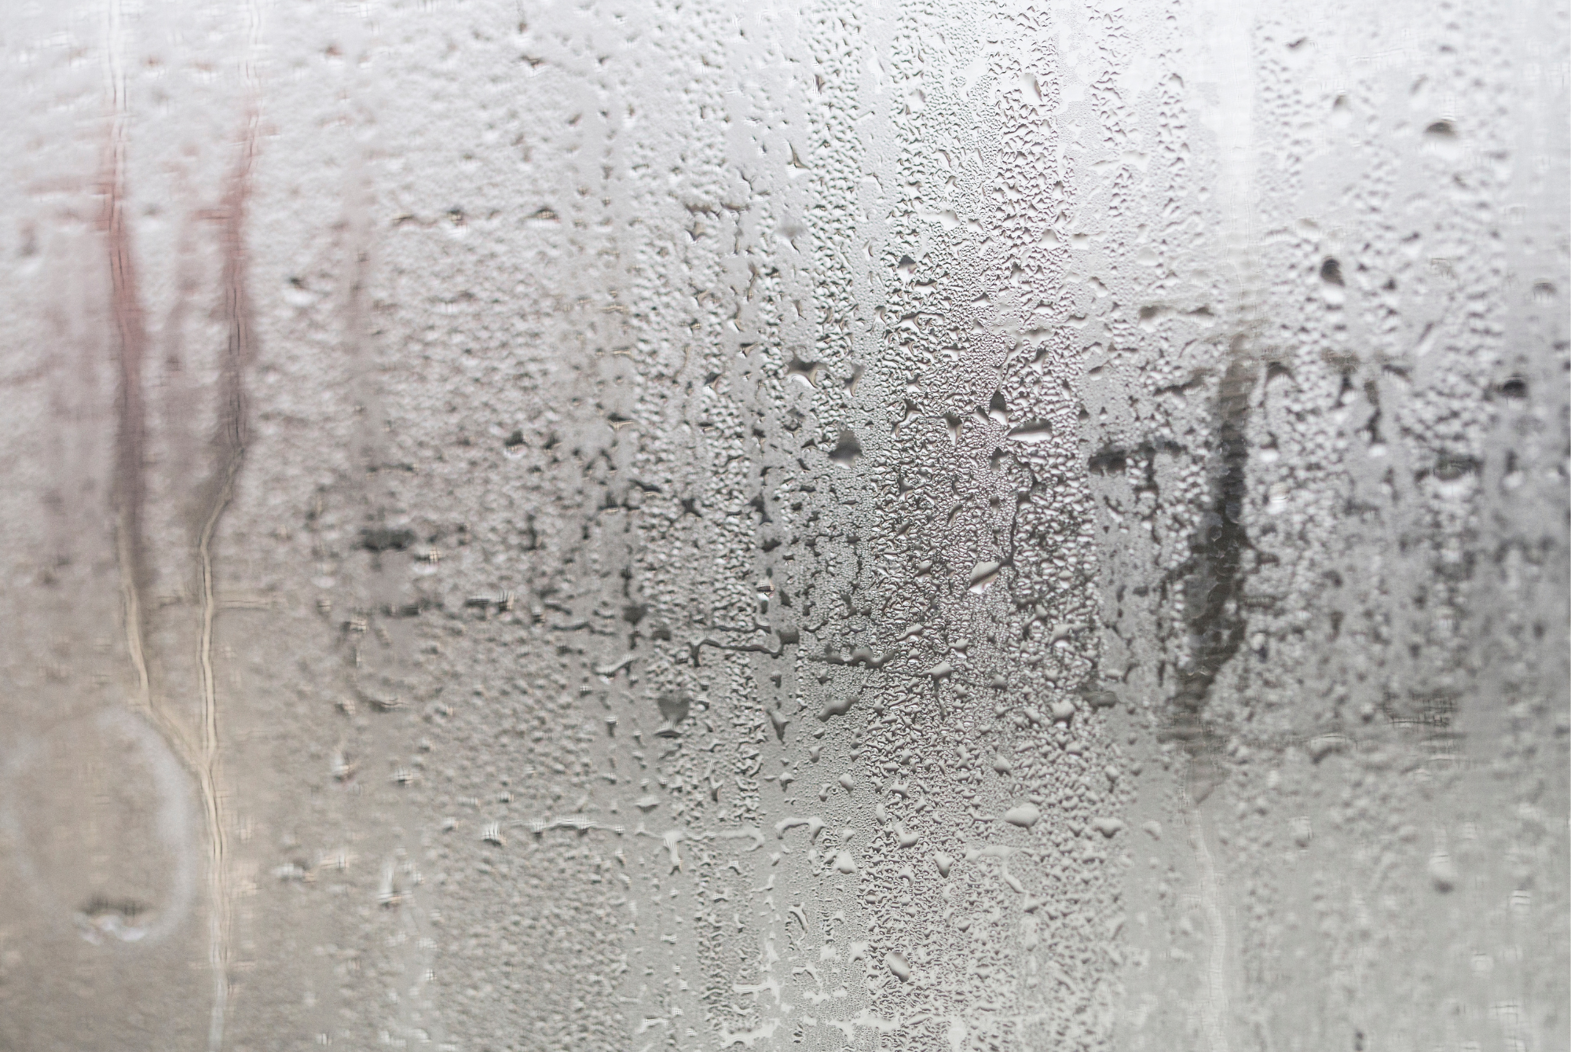
If your hair looks completely different the second you step outside on a humid day, you're not imagining it.
The smooth blowout you spent 45 minutes creating can turn puffy. Curls can become bigger and less defined. Straight hair can suddenly develop waves or frizz that weren't there five minutes ago.
As a stylist, I see this all the time.
And while humidity can feel like your hair's worst enemy, there is an actual reason your hair reacts to it. Your hair is interacting with the moisture in the air.

Your Hair Can Absorb Moisture From the Air
Hair is not completely waterproof. The outer layer of the hair strand, called the cuticle, interacts with water in its environment.
On a humid day, there is simply more water vapor in the air. Hair can take on some of that moisture, which changes the way the individual strands behave.
This is especially noticeable if your hair is porous or damaged. When the cuticle is less smooth and uniform, moisture can move in and out of the hair more easily.
That is one reason damaged or chemically treated hair can seem particularly unpredictable in humid weather.

So Why Does Hair Get Frizzy?
This is where things get interesting.
Your hair's shape is partly controlled by temporary bonds within the hair fiber. Water can disrupt some of these bonds, which is why your hair can change shape when it gets wet.
Humidity does not literally "create" frizz. It can encourage your hair to move away from the shape you created when you styled it.
You blow-dry your hair straight. The humidity adds moisture. Your hair starts responding to that moisture. Suddenly, the smooth shape you created is fighting against the environment.
And if your natural hair pattern is wavy or curly, that reaction can become even more obvious.

This Is Why Curly Hair Can Get Bigger
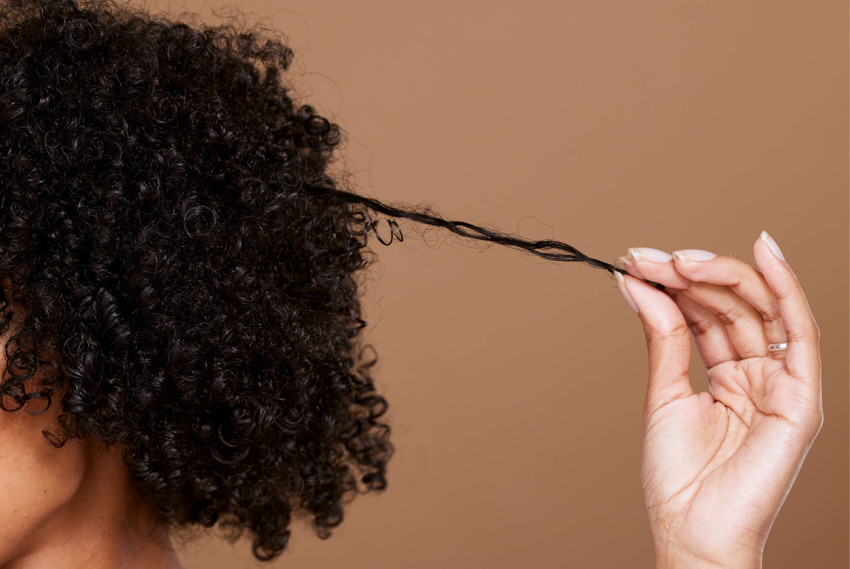
Curly and wavy hair often reacts dramatically to humidity because the strand is already shaped into bends and curves.
Add moisture, and those strands can swell and change their shape.
For some people, that means curls become bigger and softer. For others, it means their definition disappears and individual hairs start separating from the curl pattern.
That is also why someone with naturally wavy hair might notice that their hair suddenly looks much more textured on a humid day.
The humidity isn't necessarily changing your hair type.
It may simply be revealing more of the texture that was already there.

Damaged Hair Can Be Even More Sensitive
If your hair has been bleached, colored, heat styled frequently, or chemically treated, you may notice that humidity affects it more than it used to.
The reason is the condition of the hair fiber.
Healthy hair has a relatively intact cuticle that helps regulate how moisture interacts with the strand. Damage can make that outer layer less uniform.
So when someone tells me, "My hair used to behave perfectly, but now it gets frizzy every time it rains," I don't immediately blame the weather.
I also look at the condition of the hair.
Has it been lightened recently? Are you using hot tools every day? Are the ends becoming rough? Are you brushing aggressively?
Sometimes humidity is simply exposing a problem that was already there.

Should You Stop Fighting Your Hair?
Not necessarily.
But you may need to change your strategy depending on the weather.
If you are trying to maintain a smooth blowout in high humidity, focus on reducing friction and keeping the hair's surface as smooth as possible.
That can mean:
- Using conditioner consistently
- Applying a lightweight leave-in product
- Using a heat protectant before blow-drying
- Making sure your hair is completely dry before going outside
- Avoiding excessive brushing once your hair is styled
- Using a humidity-resistant finishing product when appropriate
- Limiting unnecessary heat touch-ups throughout the day
The goal isn't to completely seal your hair off from the atmosphere. That's not realistic.
The goal is to make your hair less vulnerable to dramatic changes.

Your Hair May Need a Different Routine in Summer
One of the biggest mistakes I see is using exactly the same routine year-round.
Your hair doesn't experience the same environment year-round.
In winter, indoor heating and cold, dry air can leave hair feeling dry. In summer, heat, sweat, humidity, swimming, and more time outdoors can create a completely different set of problems.
That doesn't mean you need an entirely new shelf of products every season.
It means your routine may need small adjustments.
You might need lighter products when your hair feels weighed down in humid weather. Or you may need more conditioning if your hair is becoming rough from frequent swimming and sun exposure.
Pay attention to how your hair behaves instead of following a routine simply because it worked six months ago.

And Sometimes, Your Hair Is Just Going to Be Hair
There is one thing I always tell clients who are frustrated by humidity:
You cannot completely control the weather.
If you have naturally curly hair, it may expand. If you have fine wavy hair, it may lose its smoothness. If you have a blowout, it may not look exactly the same after walking through a humid afternoon.
That doesn't mean your hair is unhealthy.
It means hair responds to its environment.
The better approach is to understand why it happens, keep the hair in good condition, and choose styling techniques that work with your texture rather than constantly fighting it.
Because sometimes the best hair routine isn't the one that makes your hair behave perfectly.
It's the one that helps you understand what your hair is trying to do in the first place.

