Title: Y2K Hair Is Back: 5 Throwback Trends Making a Comeback
Author: Yuna Seo
Date: 2026-08-17
Section: Trends
Category: Cut & Style
Excerpt: From chunky highlights to crimped waves, butterfly clips, and bold animal-print color, Y2K hair trends are making a major comeback. Here are five nostalgic hairstyles and color trends getting a modern update—and how to know which throwback look is right for you.
Slug: Y2K-Hair-Is-Back
Tag: Cut & Style
Read Time: 6
Meta Title: Y2K Hair Is Back: 5 Throwback Trends Making a Comeback | HairProVoices
Meta Description: From chunky highlights to crimped waves, butterfly clips, and bold animal-print color, Y2K hair trends are making a major comeback. Here are five nostalgic hairstyles and color trends getting a modern update—and how to know which throwback look is right for you.
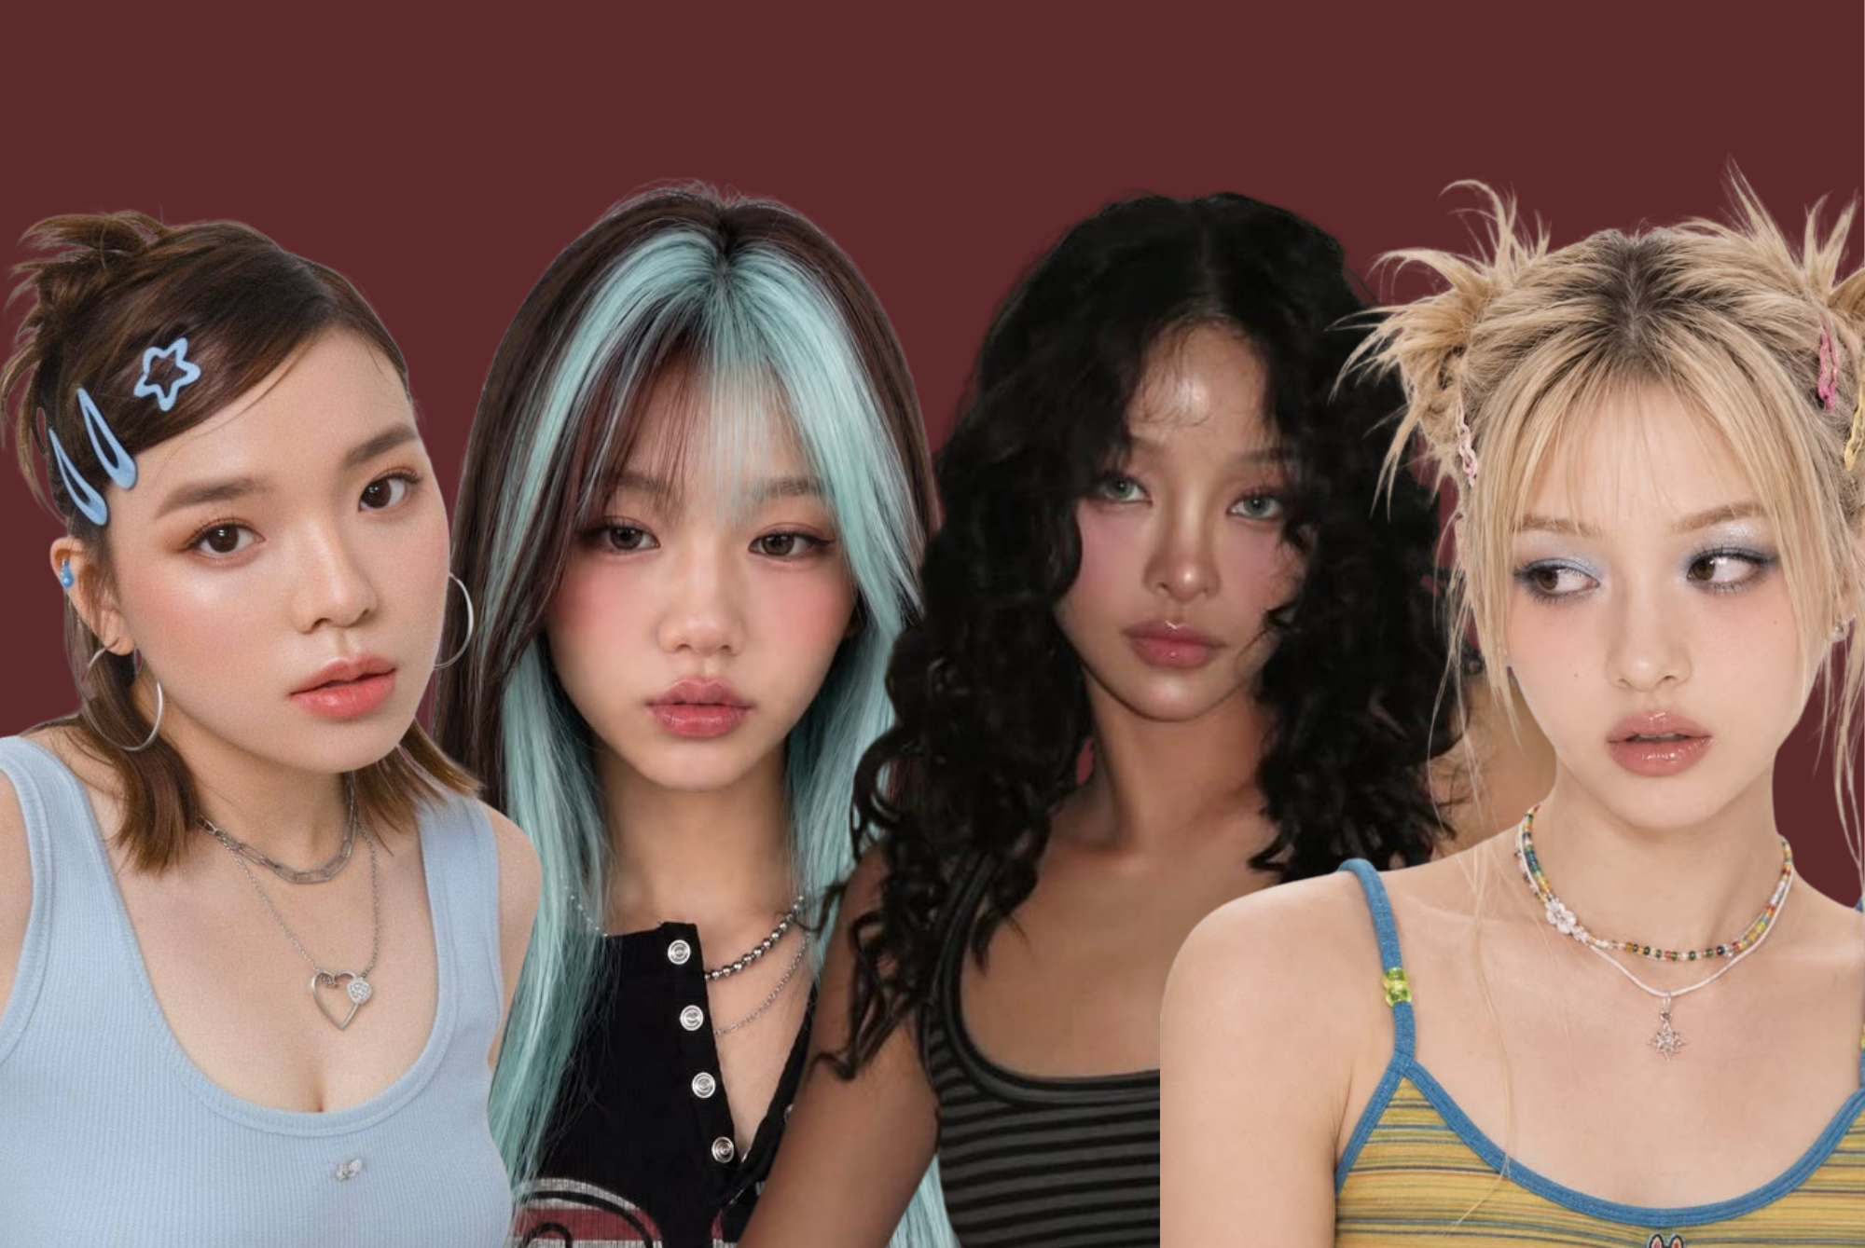

Y2K Hair Is Back: 5 Throwback Trends Making a Comeback
There was a time when hair was not supposed to look effortless. The bigger the highlights, the sleeker the ponytail, and the more butterfly clips you could fit into one hairstyle, the better.
Now, those unmistakably early-2000s looks are making their way back into the spotlight. From chunky highlights to crimped texture, Y2K hair has been showing up across social media, runways, and celebrity looks—with a few modern updates.
The difference this time? We are not necessarily recreating the exact hair we wore in 2002. Instead, stylists and clients are taking the most recognizable Y2K elements and making them softer, shinier, and easier to wear today.
Here are five Y2K hair trends that are officially having another moment.

1. Chunky Highlights Are Getting Bold Again
Remember when highlights were anything but subtle? Chunky blonde streaks were one of the defining color trends of the early 2000s, often creating a dramatic contrast against brunette or black hair.
Now they are back—but you do not have to go full 2003.
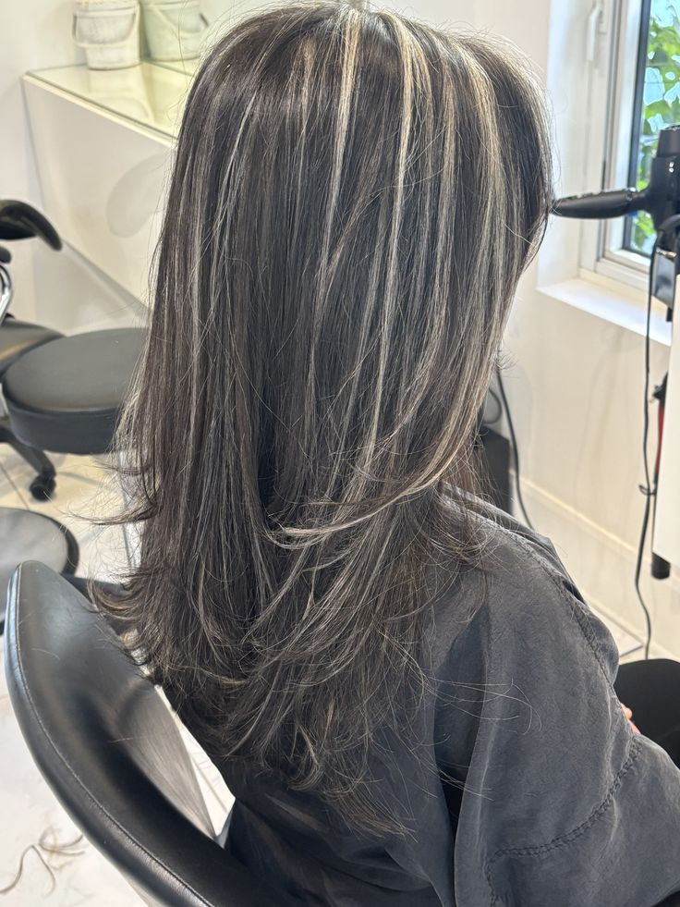
Softer blonde highlights that still pop.
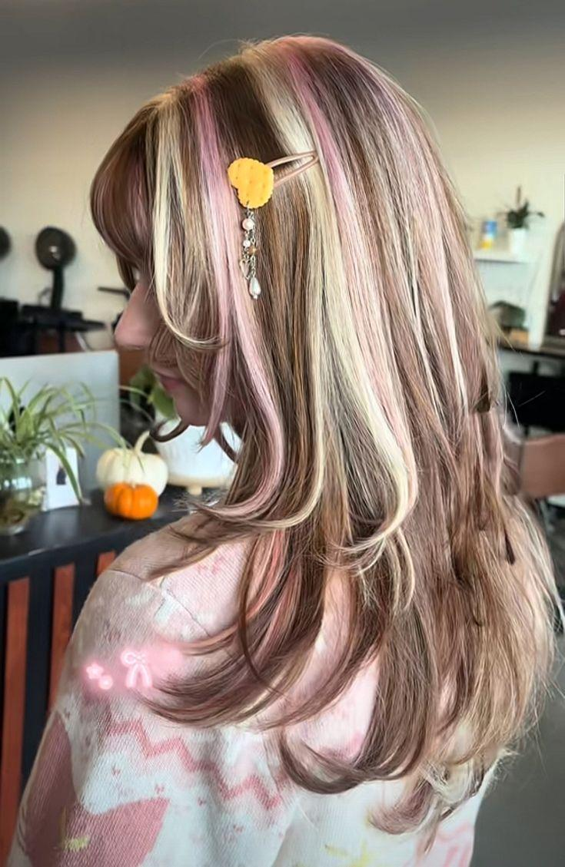
“Neapolitan hair” with pink, blonde and brown. Multiple colors for highlights add even more.
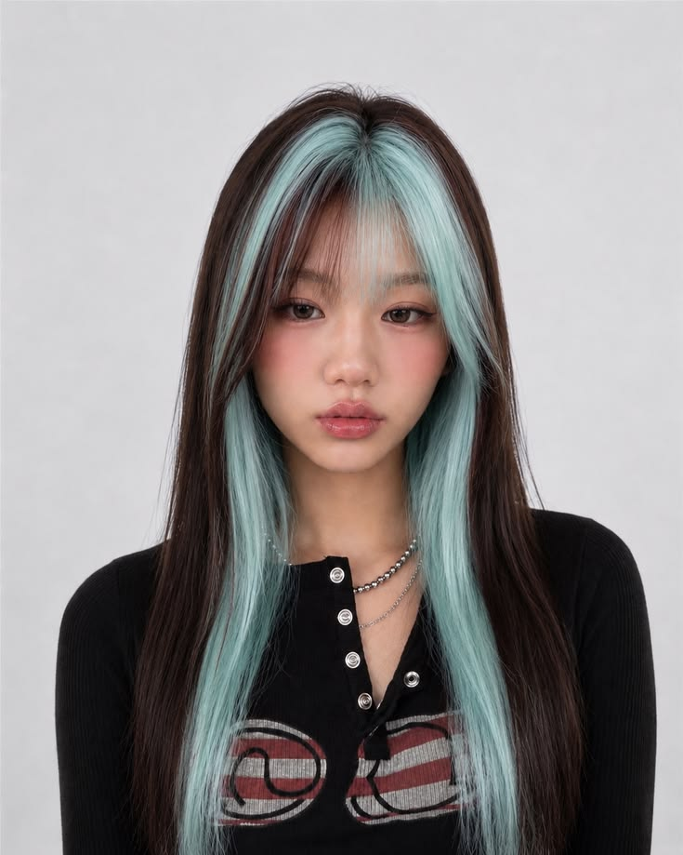
Face framing pieces create a peekaboo effect.
The modern version is all about strategic placement. A stylist might concentrate brighter pieces around the face, creating a high-contrast money-piece effect, while keeping the rest of the hair slightly more blended. Blonde and platinum are the obvious choices, but caramel, copper, pink, and even icy pastel streaks can give the look a more playful update.
This is for the people who want their color to be noticeable. It works especially well for people who like a little edge but are not ready to commit to an all-over fantasy color.
Ask your stylist for: Chunky, high-contrast face-framing highlights rather than traditional fine highlights. If you want the full Y2K effect, ask about adding a few thicker pieces throughout the rest of your hair.

2. Crimped Hair Is Coming Back
Crimped hair has officially escaped the early-2000s photo album.
The tiny zigzag texture that once required a dedicated crimping iron is showing up again, although today's version is often softer and less uniform. Some people are crimping their entire head for maximum texture, while others are using it on select sections to create volume or a more undone finish. Crimped texture is also being reimagined as "mermaid waves," giving the style a less rigid look.
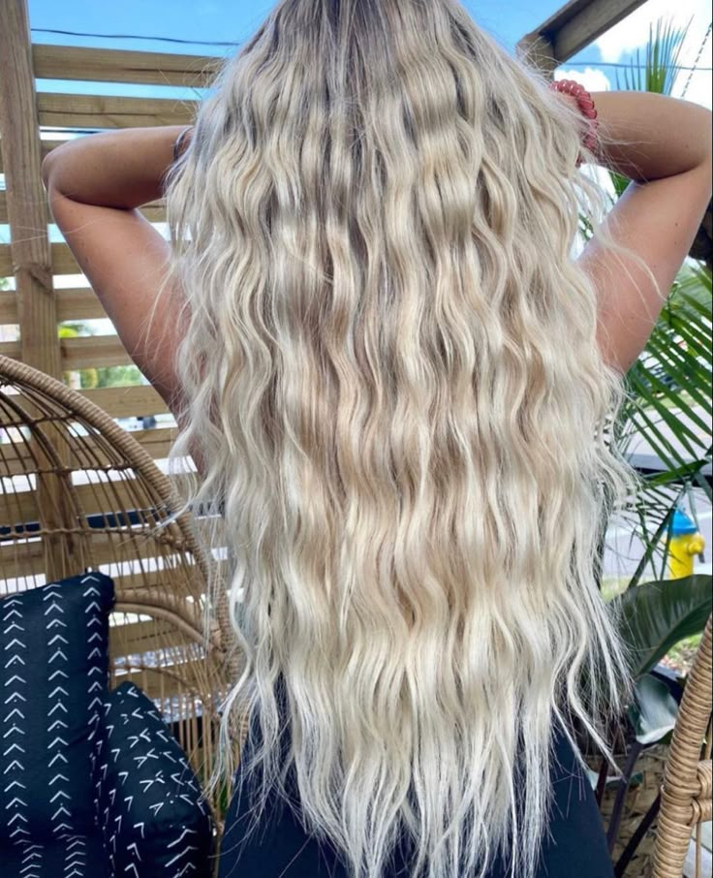
Toussled mermaid waves, perfect for a beach day.
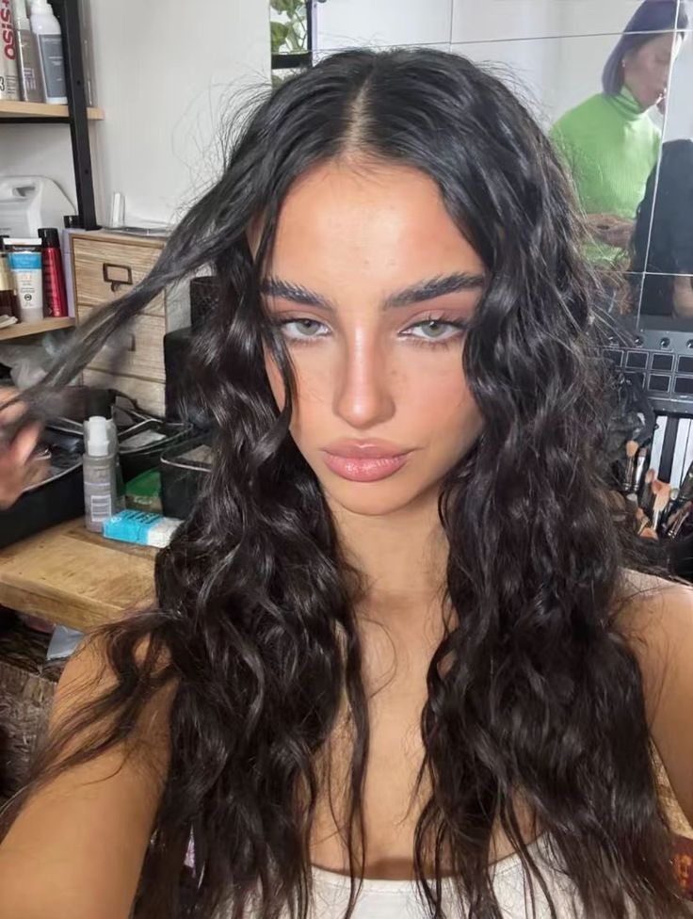
The waves curl around the face to frame it.
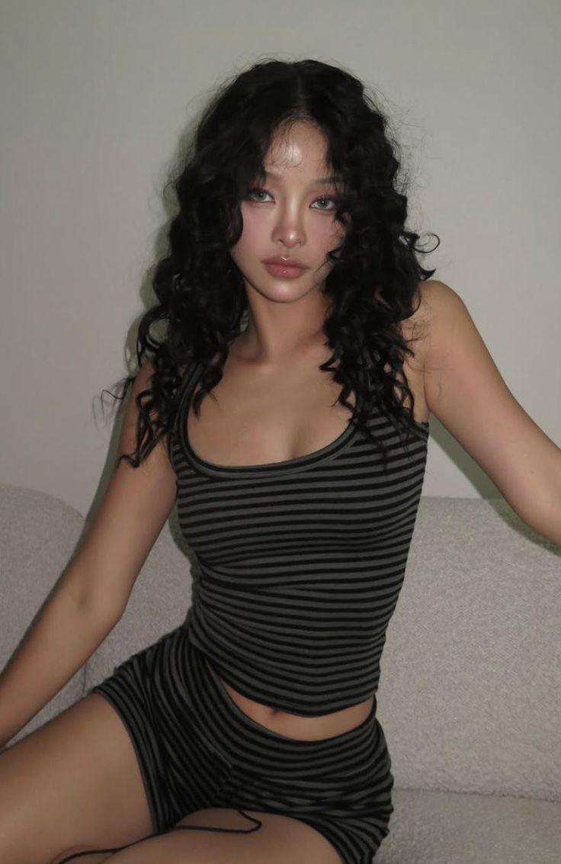
Crimped hair creates more volume.
For a true Y2K moment, pair crimped hair with a deep side part, tiny sunglasses, or a few colorful clips. For something more wearable, crimp only the underneath layers or a few pieces around the face.
This is perfect for anyone with straight or wavy hair who wants to experiment with texture without committing to a permanent change. It is also an easy option for someone who wants their hair to look fuller.
Ask your stylist for: A soft crimped texture rather than tight, uniform zigzags. The goal is movement—not looking like you stepped out of a 2004 school picture.

3. Hair Clips Are Here and Abundant
If there is one accessory that immediately says Y2K, it is hair clips.
Hair clips in fun and different shapes, colors, textures; this trend brings out the maximalism of Y2K. The colorful plastic clips that once appeared in nearly every middle-school bathroom are back, but they are getting a more grown-up treatment. Instead of covering an entire hairstyle in bright accessories, today's versions can be used as small accents in half-up styles, around the face, or scattered through loose hair.
Pastel, iridescent, metallic, and rhinestone versions can make the trend feel more current, while classic colorful butterflies are perfect for anyone who wants to lean fully into nostalgia.
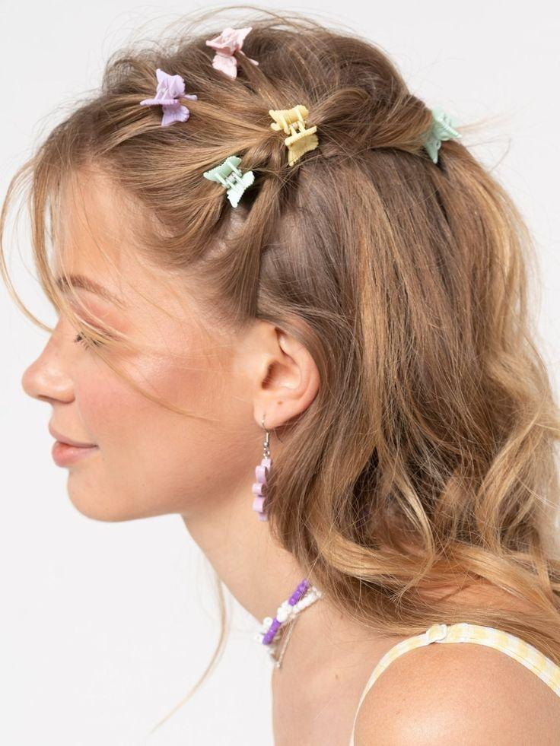
Butterfly clips to add a pop of color in your hair.
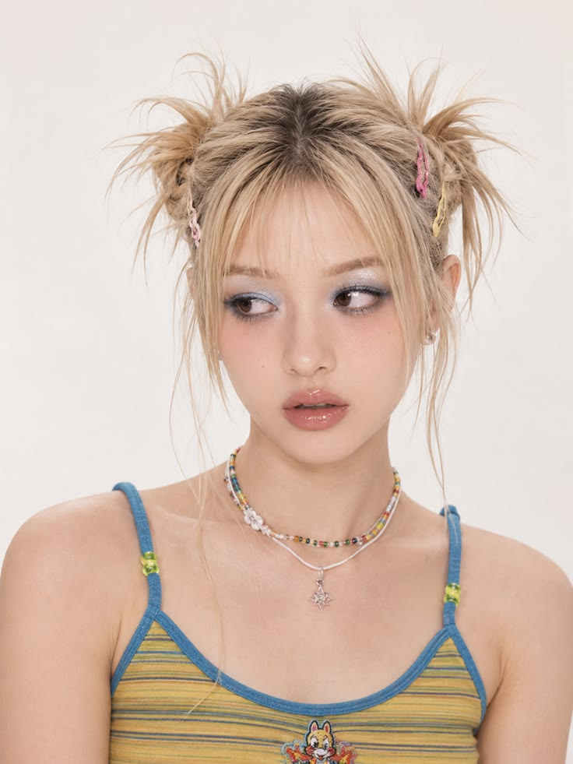
Hair clips to add details to spikey space buns.
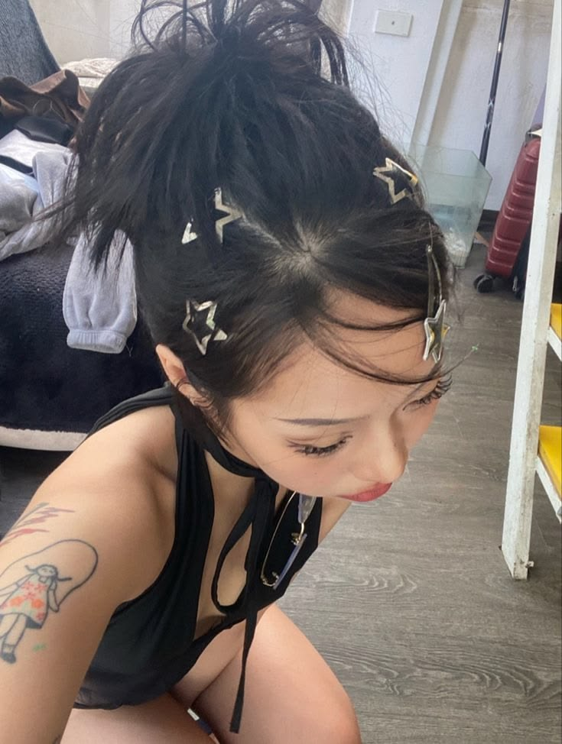
Silver star clips for a sleek look.
This one is for the accessory lovers. It is also the easiest Y2K trend to try because you do not need to change your cut or color.
Try it with: A sleek half-up hairstyle, face-framing tendrils, or two small sections pulled back at the temples. For a more dramatic look, add several clips throughout loose waves.

4. The Sleek High Updo Is Having Another Moment
The Y2K high updo was not casual. It was snatched, shiny, and usually straightened within an inch of its life.
That silhouette is returning, but modern styling is making it much softer. Instead of relying on layers of stiff gel and hairspray, stylists are creating a smooth, glossy finish with flexible styling products and shine-enhancing products. Wrapping a section of hair around the elastic also gives the updo a polished finish.
The height is important. A updo sitting high at the crown gives the look that unmistakable early-2000s energy, especially when paired with straight lengths or flipped ends.
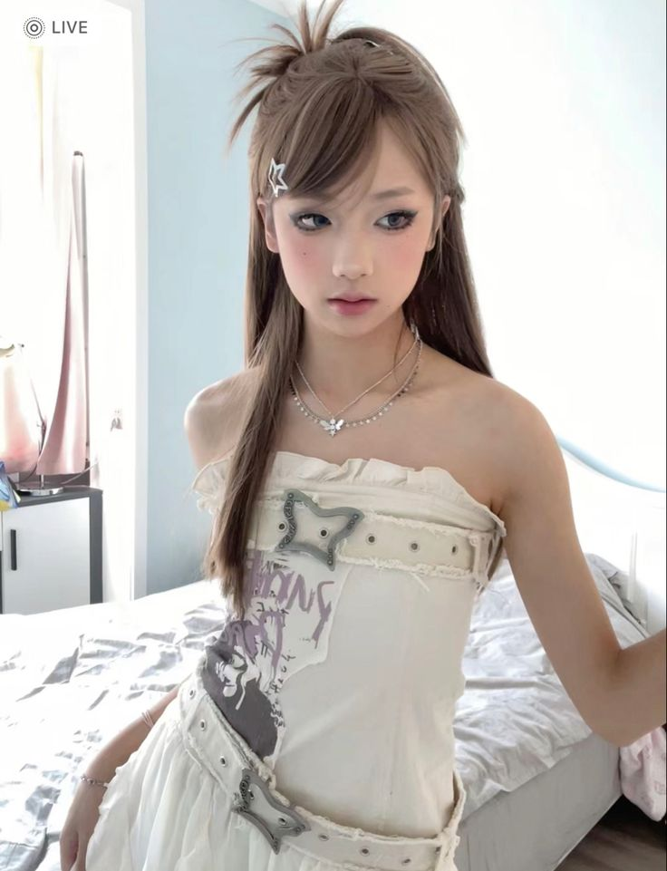
A side bangs with a half up, half down gives volume and is still soft.
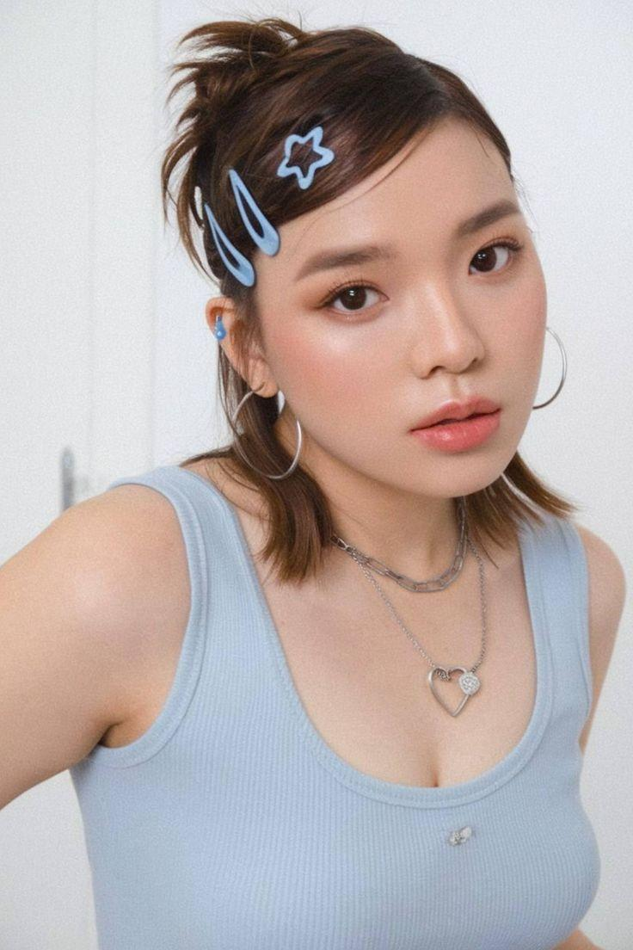
Adding hair clips on your side bangs can help a pop of color.
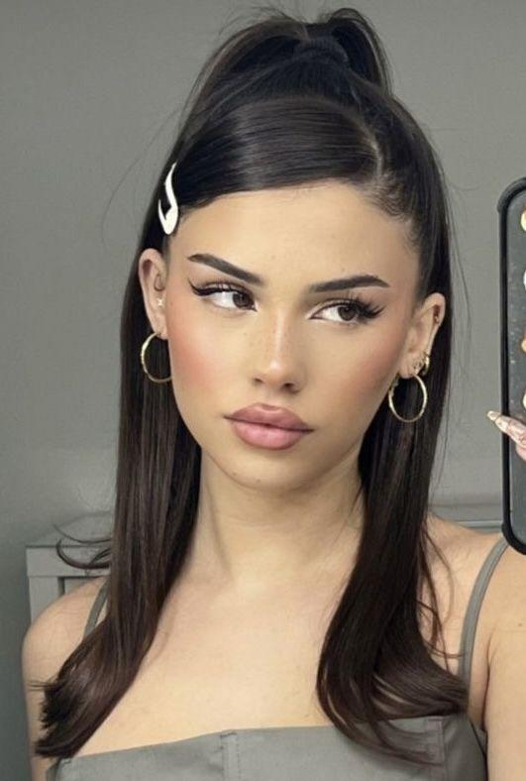
A sleek side bang adds dimension to a polished hairstyle.
Anyone who loves a clean, polished hairstyle would adore this. It is especially flattering for people with medium-to-long hair who want their features to take center stage.
Try it with: A deep side part and long side-swept pieces for a more dramatic Y2K look, or keep the part centered and the finish ultra-glossy for a modern version.

5. Raccoon Tails and Leopard Print Are Taking Hair Color to the Wild Side
Y2K hair was never afraid of a little chaos—and animal-print hair might be the ultimate example.
Raccoon-tail hair, which uses alternating bands of contrasting color through sections of the hair, is getting a modern revival. The original look often featured black-and-blonde stripes, but today's versions can be much more colorful. Think platinum and black, pink and purple, blue and black, or even neon shades for someone who wants to make the look impossible to miss.
Leopard-print hair takes the idea even further. Instead of simply adding streaks of color, stylists can create spotted patterns throughout sections of bleached hair. The print can be concentrated on the ends, hidden underneath the top layer, or placed around the face for a peekaboo effect.

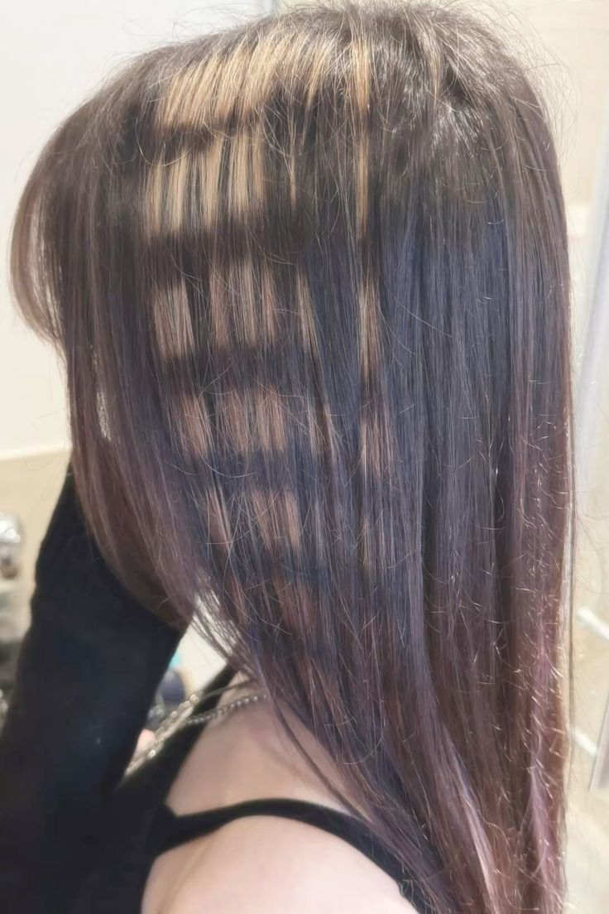
An alternating between blonde and brown hair creates a raccoon tail pattern.
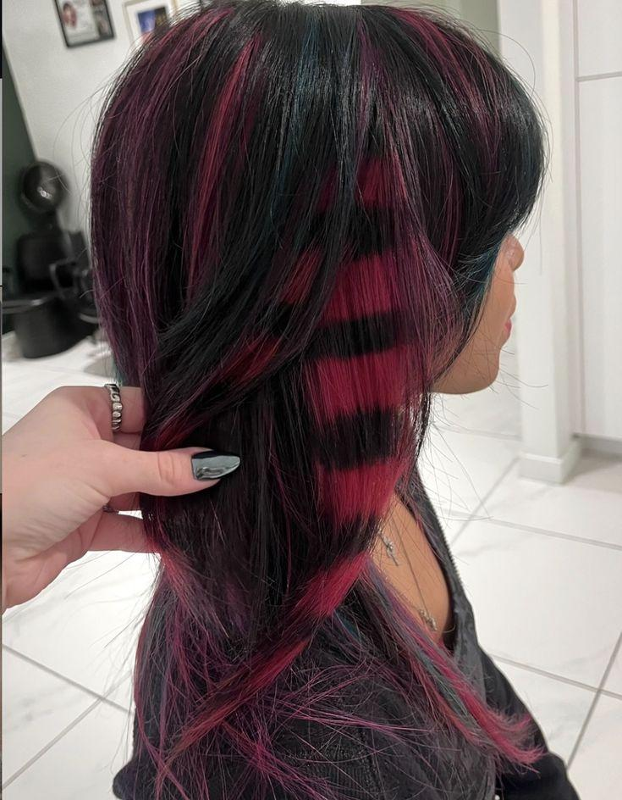
Using a different color for the raccoon tail helps it pop.
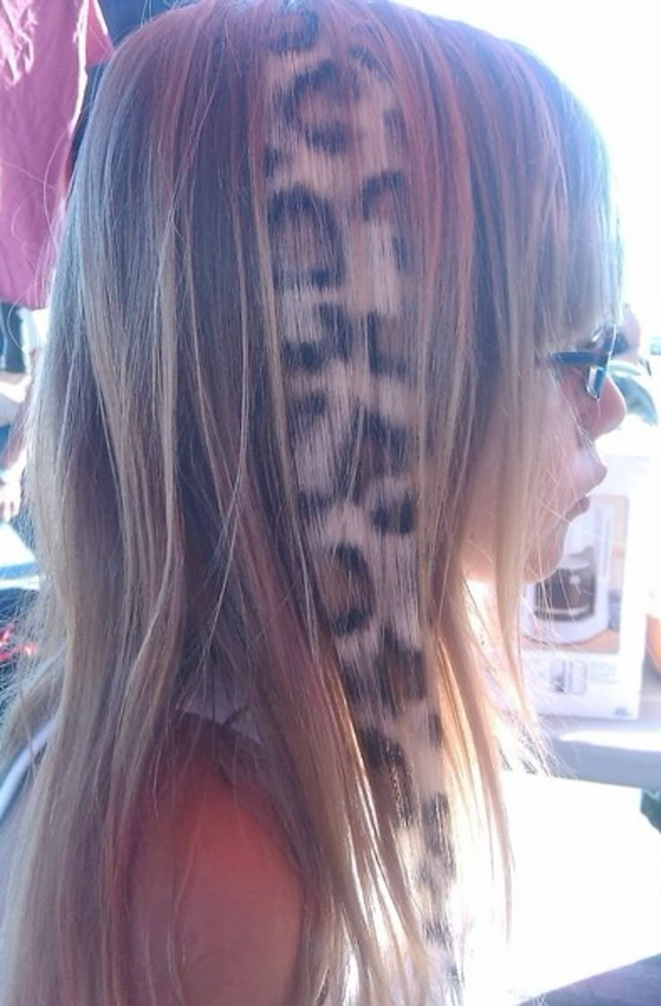
A leopard print detail on your hair can help you incorporate animal patterns into your daily wear.
This is for the person who sees their hair as an accessory rather than something that needs to blend in. It is especially suited to people who love alternative fashion, colorful makeup, or experimenting with statement-making looks.
Ask your stylist for: Raccoon-tail sections in contrasting shades if you want something graphic but relatively simple. If you are ready to go all in, ask about a leopard-print pattern using two or three colors. Keeping the print to a few sections rather than your entire head can make the trend feel more wearable.

The Y2K Hair Revival Is About Having Fun Again
The return of Y2K hair does not mean every trend needs to be recreated exactly as it was 20 years ago. The best versions borrow one or two recognizable elements—chunky color, crimped texture, playful accessories, exaggerated ponytails, or bold patterns—and combine them with today's softer finishes.
And that might be the biggest reason these looks are coming back. After years of understated, "effortless" hair, Y2K is giving us permission to make our hair a little more obvious.
So whether you are ready for platinum streaks, leopard-print pieces, or would rather start with one tiny butterfly clip, there is a way to bring the 2000s back without looking like you are stuck in them.

