**FAQs and Recipes For Top Selling Products**

**Sablefish (Black Cod) Recipes**

* ***Miso Glazed Alaska Sablefish with Sesame Ginger Cucumber Salad***

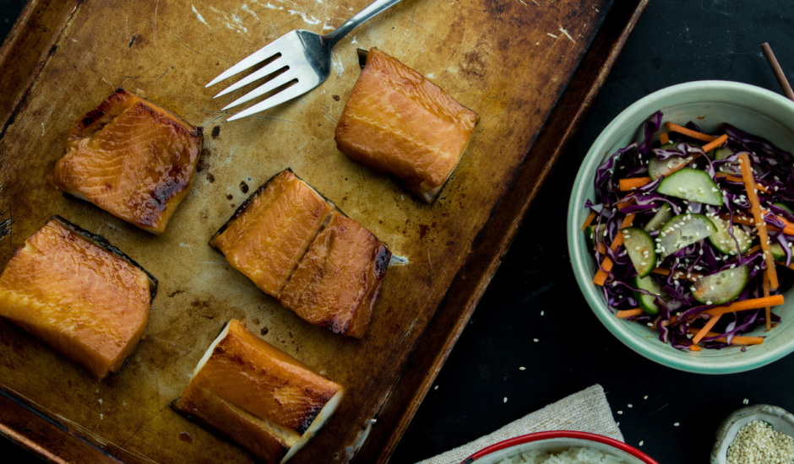

An umami-rich marinade infuses buttery sablefish before it’s broiled to perfection and served with a gingery cucumber salad.

*Prep Time: 12 hours (marinade)*

*Cook Time: 5 minutes*

*Servings: 4*

**Ingredients:**

Alaska Sablefish and Marinade

1/3 cup dry sake

1/3 cup mirin

1/3 cup red miso

3 tablespoons packed brown sugar

2 tablespoons soy sauce

1 teaspoon grated fresh ginger

4 Alaska sablefish fillets (6 ounces each)

2 tablespoons chopped scallions

Sesame Ginger Cucumber Salad

1 pound cucumbers, halved lengthwise and thinly sliced

2 carrots, peeled and cut matchstick-sized (about 6 ounces)

2/3 cup shredded red cabbage

1/2 teaspoon grated fresh ginger

2 tablespoons sesame oil

2 tablespoons rice vinegar

2 teaspoons sugar

1 tablespoon soy sauce

1 teaspoon Sriracha sauce

2 teaspoons toasted sesame seeds

**Instructions:**

***Step 1***

Marinate the fish

In a medium bowl, mix together the sake, mirin, miso, brown sugar, soy sauce and ginger until smooth and blended. Place Alaska sablefish fillets and marinade in a large zip-top bag; squeeze out air and seal. Place the bag in a shallow bowl or baking dish. Refrigerate at least 12 hours or up to 72 hours, turning the bag over occasionally to coat all sides. Remove fish from marinade; drain thoroughly.

***Step 2***

Make the cucumber salad

In a bowl, combine cucumbers, carrots, and cabbage. In a smaller bowl, whisk together the ginger, sesame oil, rice vinegar, sugar, soy sauce and sriracha until the sugar is dissolved. Pour dressing over vegetables; sprinkle with sesame seeds and toss to combine. Cover and refrigerate until serving, up to 8 hours.

***Step 3***

Broil fish and serve

Turn oven on to broil setting. Place fish in an oven-proof pan. Arrange oven rack so that top of fish is 4-5 inches from broiler heat element. Broil 4-5 minutes, or until top of fish is caramelized and dark brown; remove and allow fish to rest 2-3 minutes. To serve, portion about 2 cups cucumber salad on each plate. Top sablefish with 1/2 tablespoon scallions.

* ***Broiled Alaska Sablefish with Fish Sauce and Black Garlic Glaze***

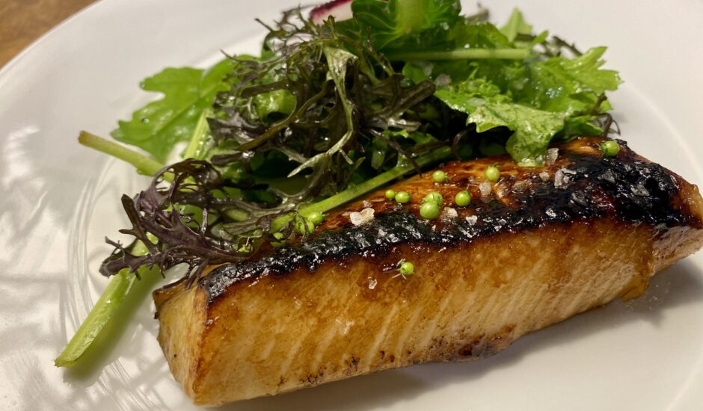

Black garlic, brown sugar and broiling make this sweet and savory Alaska sablefish recipe from chef and entrepreneur Melissa King an easy and decadent entree for weeknights or special occasions

Prep Time: 10 minutes

Cook Time: 35 minutes

Total Time: 45 minutes

Servings: 4

Yield: 4 (6 oz) servings

**Ingredients:**

4 (6 ounce) Alaska sablefish (black cod) filet portions

Freshly ground black pepper

Kosher sea salt

For the Fish Sauce Black Garlic Glaze

1/4 cup light brown sugar

1/3 cup fish sauce

1/3 cup water

2 tablespoons soy sauce

5 cloves black garlic, roughly chopped or mashed

2 gloves garlic, grated

2 teaspoons ginger, peeled, grated

1/2 teaspoon ground white pepper

1/4 teaspoon ground coriander

A few cilantro stems

**Preparation:**

***Step 1***

Make the sauce

Place the brown sugar, fish sauce, water, black garlic, garlic, ginger, white pepper, coriander, and cilantro stems into a small saucepot and bring to a boil on high heat, whisking to distribute ingredients evenly.

Once it’s boiling, immediately reduce to medium-low heat.

Simmer for 15 to 20 minutes and reduce until thickened, with the glaze lightly coating a spoon.

Strain through a fine mesh strainer, pressing on the pulp to squeeze out as much flavor as possible. Allow to cool completely. At this point, the glaze can be stored in an airtight container in the refrigerator for up to one week.

***Step 2***

Prep, Glaze and Broil

Preheat the oven broiler to about 475˚F. Pat the fish dry really well and lightly season with sea salt and black pepper.

Lightly oil a baking tray and place the sablefish portions on it with the side that had the skin facing down.

Brush the glaze generously onto the fish and place under the broiler.

Repeat with more glaze every 2 to 3 minutes, returning to the broiler each time, about 3 times. The top should start to caramelize and slightly char on the edges. Broiler intensity can vary; if the fish gets too charred at any time, move to a lower rack or adjust broiler temperature. Continue brushing on the glaze and broiling until internal temperature reaches 145˚F.

***Step 3***

Serving Suggestions

Top fish with thinly sliced scallions or delicate greens tossed with a light dressing.

Coconut scented rice is also a favorite.

* ***Braised Alaska Sablefish with Ginger & Scallion***

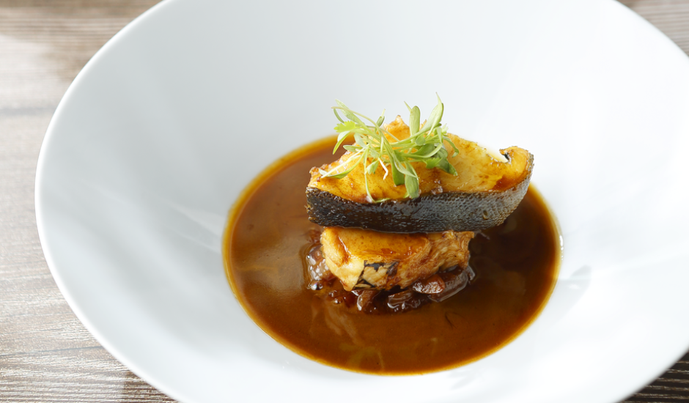

Buttery Alaska sablefish is made even more decadent with the addition of a savory sauce in this simple, yet unusual, recipe.

Prep Time: 5 minutes

Cook Time: 20 minutes

Total Time: 25 minutes

Servings: 2-4

Yield: 4 - 3 oz. servings

**Ingredients:**

12 ounces Alaska sablefish

4 teaspoons olive oil

½ cup shredded scallions

¼ cup cream

Sauce

½ cup sunflower oil

4 teaspoons garlic, minced

4 teaspoons ginger, grated

1 cup chicken stock

4 teaspoons soy sauce

2 teaspoons mirin

Freshly ground pepper, to taste

**Preparation**

**Step 1**

Prepare the sauce

Sprinkle sablefish with salt and set aside while you prepare the sauce. Heat sunflower oil in a small saucepan over medium. Sauté garlic until fragrant, about 30 seconds. Add remaining sauce ingredients, turn heat to high and bring to a boil. Reduce to low heat and simmer for 5 minutes.

**Step 2**

Cook the sablefish

In a straight-sided sauté pan, heat the olive oil over medium-high. Add the sablefish and pan fry until both sides are golden. Add sauce and simmer for 5 minutes on low heat.

**Step 3**

Cook the scallions

In a small saucepan, pour in cream and heat until just below a simmer. Add the scallions and cook until softened, about 3 minutes.

**Step 4**

Plate and serve

Ladle the sauce into two shallow bowls. Cut sablefish into three, 4-ounce portions and place one piece in each bowl. Top with scallions and serve immediately.

* ***Broiled Alaska Sablefish with Fish Sauce and Black Garlic Glaze***

[***https://www.alaskaseafood.org/recipe/broiled-alaska-sablefish-with-fish-sauce-and-black-garlic-glaze/***](https://www.alaskaseafood.org/recipe/broiled-alaska-sablefish-with-fish-sauce-and-black-garlic-glaze/)

* ***Braised Alaska Sablefish with Ginger & Scallion***

[***https://www.alaskaseafood.org/recipe/braised-alaska-sablefish-with-ginger-scallion/***](https://www.alaskaseafood.org/recipe/braised-alaska-sablefish-with-ginger-scallion/)

* ***Miso Glazed Alaska Sablefish with Sesame Ginger Cucumber Salad***

[***https://www.alaskaseafood.org/recipe/miso-glazed-alaska-sablefish-with-sesame-ginger-cucumber-salad/***](https://www.alaskaseafood.org/recipe/miso-glazed-alaska-sablefish-with-sesame-ginger-cucumber-salad/)

* ***Gochujang-Marinated Alaska Sablefish With Shiitakes***

[***https://www.alaskaseafood.org/recipe/gochujang-marinated-alaska-sablefish-with-shiitakes/***](https://www.alaskaseafood.org/recipe/gochujang-marinated-alaska-sablefish-with-shiitakes/)

* ***Spicy Alaska Sablefish in Lettuce Cups***

[***https://www.alaskaseafood.org/recipe/spicy-alaska-black-cod-in-lettuce-cups/***](https://www.alaskaseafood.org/recipe/spicy-alaska-black-cod-in-lettuce-cups/)

***Salmon Recipes***

***King Salmon Recipes***

* ***Slow Roasted Alaska King Salmon with Mexican Street Corn Salad***

[***https://www.alaskaseafood.org/recipe/alaska-slow-roasted-king-salmon-with-mexican-street-corn-salad/***](https://www.alaskaseafood.org/recipe/alaska-slow-roasted-king-salmon-with-mexican-street-corn-salad/)

* ***Alaska King Salmon Fillet “Oscar” by Chef Keoni Chang***

[***https://www.alaskaseafood.org/recipe/alaska-king-salmon-fillet-oscar-by-chef-keoni-chang/***](https://www.alaskaseafood.org/recipe/alaska-king-salmon-fillet-oscar-by-chef-keoni-chang/)

***Coho Salmon Recipes***

* ***Alaska Coho Salmon En Escabeche with Toasted Baguette and Fava Bean Puree***

[***https://www.alaskaseafood.org/recipe/alaska-coho-salmon-en-escabeche-with-toasted-baguette-and-fava-bean-puree/***](https://www.alaskaseafood.org/recipe/alaska-coho-salmon-en-escabeche-with-toasted-baguette-and-fava-bean-puree/)

***Salmon Burger Recipes***

* ***Thai Style Alaska Salmon Burger***

[***https://www.alaskaseafood.org/recipe/thai-style-salmon-burger/***](https://www.alaskaseafood.org/recipe/thai-style-salmon-burger/)

* ***Alaska Salmon Burgers with Rhubarb Chutney***

[***https://www.alaskaseafood.org/recipe/alaska-salmon-burgers-with-rhubarb-chutney/***](https://www.alaskaseafood.org/recipe/alaska-salmon-burgers-with-rhubarb-chutney/)

***Scallops Recipes***

* ***Bacon Wrapped Alaska Scallop Sliders***

[***https://www.alaskaseafood.org/recipe/bacon-wrapped-alaska-scallop-sliders/***](https://www.alaskaseafood.org/recipe/bacon-wrapped-alaska-scallop-sliders/)

* ***Indian Spiced Alaska Weathervane Scallops with Blackberry Agave Sauce***

[***https://www.alaskaseafood.org/recipe/indian-spiced-alaska-weathervane-scallops-with-blackberry-agave-sauce-by-chef-michael-j-watz/***](https://www.alaskaseafood.org/recipe/indian-spiced-alaska-weathervane-scallops-with-blackberry-agave-sauce-by-chef-michael-j-watz/)

* ***Grilled Alaska Scallops Wrapped in Prosciutto***

[***https://www.alaskaseafood.org/recipe/grilled-alaska-scallops-wrapped-in-prosciutto/***](https://www.alaskaseafood.org/recipe/grilled-alaska-scallops-wrapped-in-prosciutto/)

**Object of this Document:**

The purpose of this document is to aggregate all frequently asked questions and recipes for our top selling products. This sheet should be used for new or current employees who are selling products to the public so they can better assist the customers.

**Salmon FAQ’s**

* What is the difference between the types of Salmon?

At PCS we carry multiple types of salmon (King, Coho, Sockeye and Keta) . The best way to answer this question is to gesture to our poster from Alaska Seafood Marketing. Titled “Alaska Salmon Species” and walk the customer through the differences posted make sure to read aloud and ask the customer what they would like from the salmon.

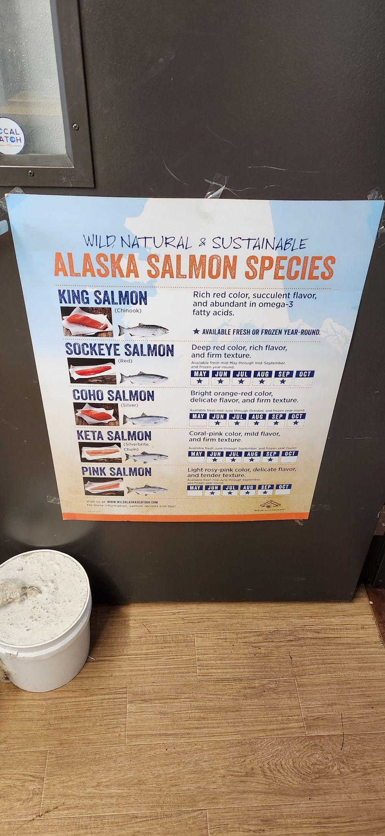

* Why is the King Salmon priced above the other salmon?

Less than 1% of all salmon harvested are king salmon. King salmon is abundant in Omega-3 fatty acids. Strong succulent flavor.

**Crab**

**Scallops**

**Chowder and Burgers**

**Company**