

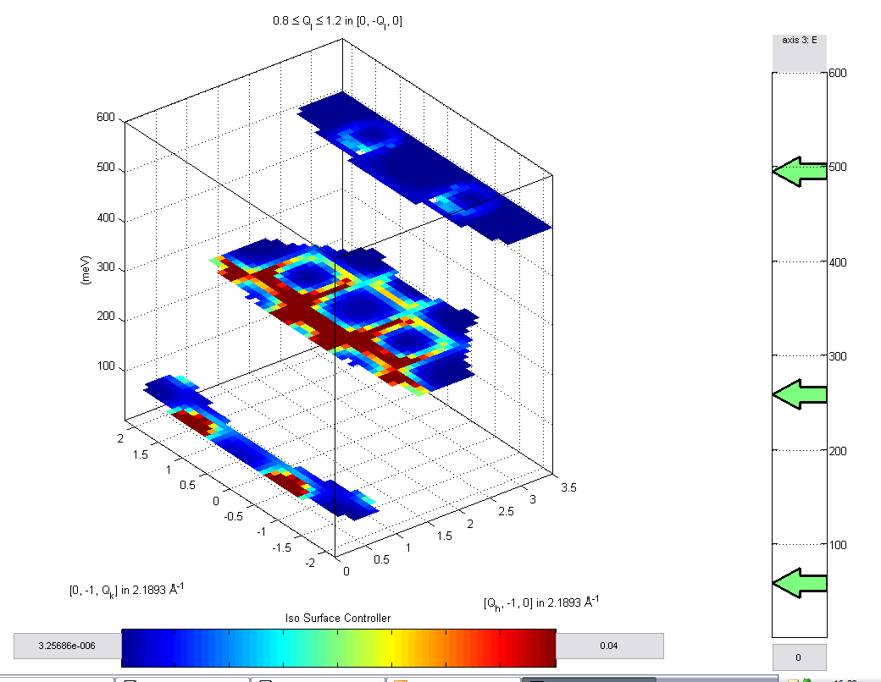

Tehcnical Guide

Dean Whittaker

Following modifications by Dean Whittaker between Feb 2007 and Sept 2007, the following documentation has been produced.

Contents

1 Summary of Changes 3
1.1 Global Changes 3
1.1.1 Removal of the “n” field in datasets 3
1.1.2 Moving operations to libisis 3
1.1.3 Moving plots to Libisis 4
1.1.4 Data input to Horace 5
2 Details of Operation 5
2.1.1 General Methods for dealing with datasets 5
2.1.2 Binary Operations 5
2.1.3 Data Operations 6
2.1.4 Writing data to file 6
2.1.5 Reading in data 6
2.1.6 The way the data is stored in Matlab 7
2.1.7 The way the data is stored in files 7
2.1.8 Arrangement of files 7
2.1.9 Useful functions to know about when creating new functions 7

Summary of Changes

The following is a brief summary of the changes which have been made to Horace

Global Changes

Removal of the “n” field in datasets

- Signal and Error are normalised when read in by slice and cut routines. n is accumulated as before, at the end of the function the data is normalised:
  - slice_3d
  - slice_4d
  - cut_sqe
- Signal of NaN means no contributing pixels / bins
- Data cut from datasets or dataset-written file is normalised by number of contributing bins
  - cut_data_arrays
  - slice_3d
- If there are no contributing pixels to a bin, then that bin does not contribute to larger bins when a dataset is cut – implemented in
  - cut_data_arrays
  - slice_3d
- Data read and written to file from datasets no longer includes n
  - write_grid
  - read_grid
- No normalisation is done in any other routines
- removed dnd_normalise_sigerr
- When the option of returning all data is selected, NaNs in the dataset are replaced with 0, (previously – n’s were replaced with 1’s)
  - fit – method of all datasets
  - fit_sqw – method of all datasets
  - sqw – method of d0d
- Binary operators for d3d and d4d changed so that a NaN in signal with any number is still NaN, a NaN in signal with a number in another signal is the other signal, 2 NaNs in 2 signals is NaN
  - single_plus
  - single_minus
  - single_times
  - single_divide
  - single_power

Moving operations to libisis

- New functions added to facilitate moving to Libisis
  - d0d/convert_to_libisis – converts d0d to IXTdatum
  - d1d/convert_to_libisis – converts d1d to IXTdataset_1d
  - d2d/convert_to_libisis– converts d2d to IXTdataset_2d
  - d3d/convert_to_libisis– converts d3d to IXTdataset_3d
  - convert_to_libisis – returns input (used so that conversions on numbers can be done without interference with operations)
  - d0d/combine_libisis- combines a d0d and IXTdatum into a d0d
  - d1d/combine_libisis- combines a d1d and IXTdataset_1d into a d1d
  - d2d/combine_libisis- combines a d2d and IXTdataset_2d into a d2d
  - d3d/combine_libisis- combines a d3d and IXTdataset_3d into a d3d
  - combine_libisis- returns input (used so that conversions on numbers can be done without interference with operations)
  - dnd_data_op – performs most libisis data operations on Horace datasets through converting and re-combining.
  - dnd_binary_op – performs libisis binary operations on Horace datasets through converting and re-combining.
  - many methods on d1d, d2d, d0d which exist in Libisis
- All methods go through either dnd_data_op or dnd_binary op to operate on data

Moving plots to Libisis

- Mirrors of many Libisis plot operations are made in methods of Horace
  - d1d operations:
    - dh
    - dl
    - dm
    - de
    - ph
    - pl
    - pe
    - pm
    - mp
  - d2d operations:
    - ds
    - da
    - mp
  - d3d operations:
    - sliceomatic (or simply “plot”)
- Titles and labels cut using dnd_cut_titles
- Datasets converted to Libisis datasets, titles and labels are written to the dataset
- Plots made using libisis
- Some manipulations are done:
- Aspect ratio in d3d/plot is set by the function itself (and not libisis)
- Aspect ratio in d2d/da and d2d/ds is set if both x and y are Q axes, but this is done through Libisis
- Sliders are set on da plots
- Horace has it’s own names and a tag
- Horace name and tags stored in IXG_ST_HORACE in ixf_default_properties function. Set when Horace starts.
- No extra information is stored with plots at the current time. However, it should be for future use.

Data input to Horace

- Data input changed so that e_i can also be set in the control file and read in by
  - gen_sqe
  - gen_hkle
- Incident energy field is set in mslice when calculating and writing data for each spe file.
- All read files take into account different energy bins
  - slice_3d
  - cut_sqe
  - slice_4d

Details of Operation

Following is an attempt to describe why and how Horace works.

General Methods for dealing with datasets

- Horace stores 5 different types of datasets outlined above.
- Many operations have counterparts for each dataset type
- These often perform similar tasks
- Therefore a method will usually call a generic “dnd_operation” stored in the Horace directory with arguments that identify the object passed.
- If operation requires change of behaviour, this generic operation is altered
- This gives greater flexibility, more simplicity and allows easy future extension

Binary Operations

- All binary operations are passed to dnd_binary_op
- IXTdataset_2d and IXTdataset_1d binary operations are in FORTRAN and optimised.
- Therefore, binary operations on d1d and d2d use this. It’s also a step towards using Libisis to provide the “grunt work”.
- D1d and d2d are converted to Libisis, operation performed and back again.
- D3d and d4d have their operations contained as methods in their class folders. So dnd_binary op will call these.
- See dnd_binary op for the syntaxes and detailed explanation.

Data Operations

- All operations on IXTdataset_1d and IXTdataset_2d were bought in for d1d and d2d.
- Methods in the class folders call generic dnd_data_op in Horace directory
- Converted to Libisis counterparts and operated on, then converted back again.
- Structure allows for easy future development, easy behaviour change and quick application development.
- Libisis is also good at “grunt work”
- Not all operations are appropriate for libisis. These contain the operations in the methods in the class folders.

Writing data to file

- Gen_hkle and gen_sqe work in a similar way to put data into file. Also, datasets can be written to file from Horace.
- Gen_hkle and gen_sqe take spe files and combine them into a single binary file
- The binary file can be one of 3 types – object, sqe, hkle
- Type is stored in the header information under “grid”
- Hkle writes each spe file underneath the last. It also writes a header at the top which stores information about the data contained underneath. See code for details of contents of header (write_header function).
- Sqe sorts the data by different fields and writes each spe file 4 times (once ordered by each axis) Then writes them underneath each other.
- See the code for different grid types
- If data is being written from SPE files, mslice is used to calculate projections of the data and energy bins for each spe file.
- Header data is comprehensive for future use.
- Write_header, gen_sqe, dnd_writegrid, gen_hkle are all involved in writing data

Reading in data

- Header is read first, method is decided by the grid type
- Other information in header can be used to determine how the operation will work
- SPE files are read in one by one
- Data is accumulated into bins defined by user.
- Number of contributing points to any bin is kept track of (called n in the code)
- At end of accumulation, any signal corresponding to n = 0 bins are turned into nan, all other signal is normalised by number of contributing pixels.
- Then dataset is created from a structure which has been accumulated in the main function.
- If the grid type is an object, then data is accumulated from that. Any signal where all contribution is NaN remains NaN, otherwise NaN is treated as 0.
- Read_sqe, slice_3d, slice_4d, cut_data_arrays, get_header, readgrid, rlu_to_ustep_matrix are all involved

The way the data is stored in Matlab

- Stored in datasets d1d, d2d, d3d, d4d – only difference being the number of plot axes, dimensions of signal and error data.
- Header information stores things like titles and stuff shared between all the datasets
- Used to identify which dataset is being used, or (more precisely) what type of data is being passed (i.e. how many plot axes)
- See dnd_checkfields for list of the stored information
- NaN means nothing contributed to that signal, 0 means there was data but signal was 0.

The way the data is stored in files

- Data from spe files stores each individual pixel.
- Data from object stores the fields of the object as they come
- Files have a header at the top, which stores information about how the data below will be presented.
- Binary files are always used.
- Everything is stored as standard matlab double float or string.

Arrangement of files

- Wherever possible methods are in class directories
- Generic methods are in Horace main directory
- All lower level functions are in private directory

Useful functions to know about when creating new functions

- Rlu_to_ustep_matrix – helps to sort out vectors to transform the data
- Dnd_cut_data_arrays – used for data manipulation
- Dnd_cut_titles – get all the titling information in the correct formats
- Dnd_checkfields – check that you have a valid dataset
- Dnd_data_op – if it’s in libisis, use dnd_data_op to put it into Horace
- Convert_to_libisis
- Combine_libisis
- Data_limits

