

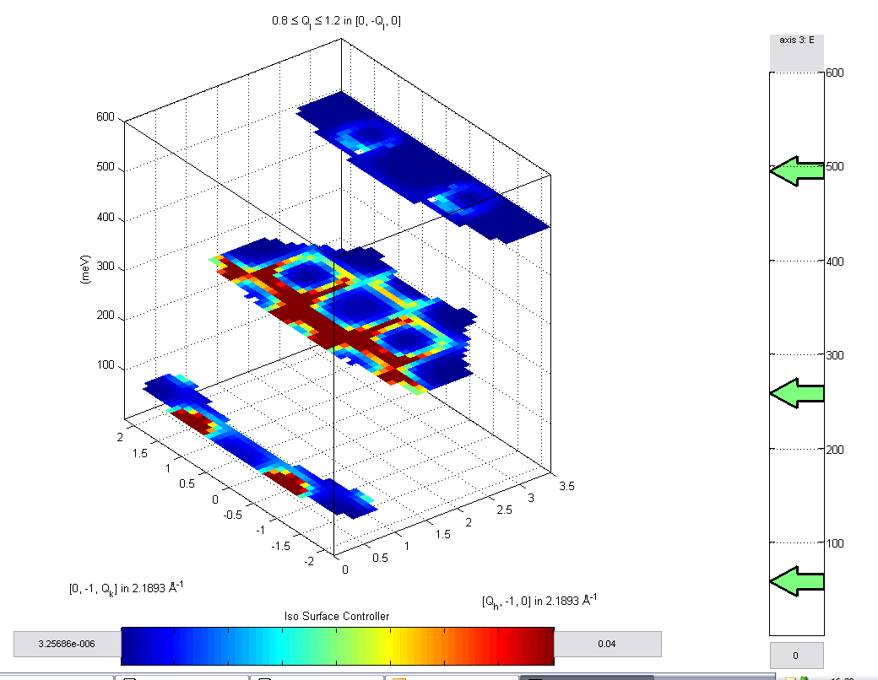

User Guide

Dean Whittaker

Contents

1 Introduction and Installation 3
1.1 Introduction 3
1.2 Installation 3
1.3 Datasets 4
1.4 Getting Help in Matlab 4
2 Reading in data 5
2.1 Generating hkle and sqe binary files 5
2.1.1 The input text file 6
2.1.2 Mslice parameter file 6
2.1.3 Generating the files 6
2.2 Cutting Data and reading into objects. 7
3 Mirrored Functions with Libisis 8
4 Data Manipulation 10
4.1 Binary Operations 10
4.1.1 Dataset and dataset 10
4.1.2 Dataset and number 11
4.1.3 Dataset and array 11
4.2 Compact 11
4.3 Convert to libisis 11
4.4 Cos, cosh, sin, sinh, tan, tanh 12
4.5 Cut 12
4.6 D1d, d2d, d3d, d4d 12
4.7 Fit 13
4.8 Fit_sqw 13
4.9 func_eval 13
4.10 Permute 14
4.11 Section 14
4.12 Smooth 14
4.13 Sqw 15
4.14 user_func 15
4.15 Dispersion 15
4.16 Replicate 15
5 Plotting 16

Introduction and Installation

Introduction

This documentation introduces Horace, a flexible and powerful program for analysing single crystal diffraction data. Horace allows the user to view (Q,w) space in full, take slices and cuts from data and manipulate data in an intuitive but powerful way. It uses the power of Libisis for many of it’s operations.

Bold to indicate an array
ww or d2d to indicate a d2d object
w or d1d to indicate a d1d object

This documentation should be used in conjunction with the Libisis and Libisis Graphics documentation.

Installation

Before using Horace, you must have libisis installed. See the libisis manual for more information. To install Horace, follow the steps below:

- Copy all files and folders to a directory of your choice.
- Start matlab
- Type:

>> edit startup.m

- Add the following lines to the mfile:

addpath(‘pathname’)
horace

- If libisis is currently installed, one can remove the lines

libisis_init

- Save startup.m and restart matlab.
- Horace is now active, you should see:

-----------------------------------
Horace started successfuly
-----------------------------------
for help and support contact:
T.G.Perring@rl.ac.uk
-----------------------------------
for libisis support go to :
www.libisis.org
-----------------------------------

If you do not see this, then contact support.

Datasets

Horace uses 4 main dataset objects, these correspond to the number of dimensions which are stored for the plot axes. These objects are named d1d, d2d, d3d and d4d where the number indicates the dimensionality of the dataset.

A d4d will hold all the information about the (Q,w) space that is available from the spe files which have been combined. However, this will normally contain too much information, and can not be plotted. Therefore, the dimensionality is reduced so that the data can be more tangibly handled. One or more dimensions (the 3 components of Q or the energy axis) is integrated over a range to give a lower dimension dataset.

To see fields contained within the datasets type

>> help dnd_checkfields

Getting Help in Matlab

Online help for most user functions is available by typing:

>> help function

Where function is the name of the function that help is required for.

Many functions are shared between datasets, but a slightly different version of the function is used for each dataset. At the end of the help, there will be hyperlinks to these various versions contained in folders named after the dataset (d1d, d2d, d3d or d4d). For instance typing help smooth will give the following help:

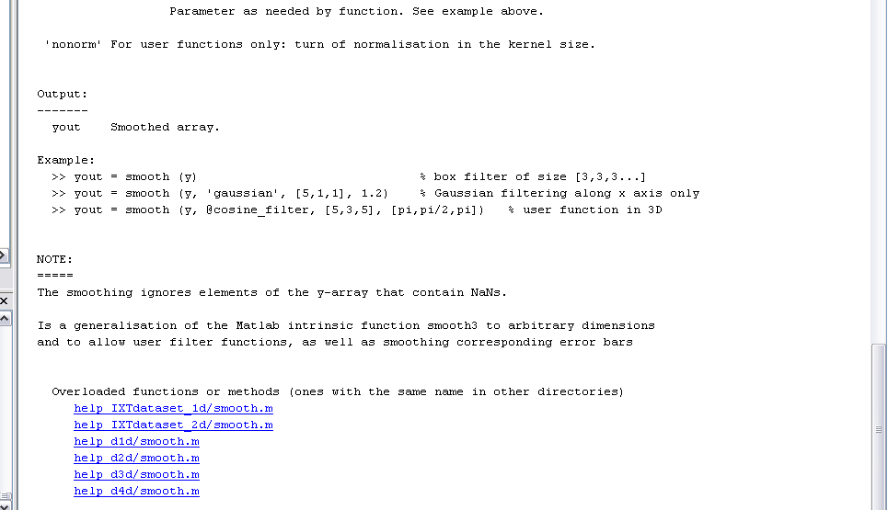

The hyperlinks will lead to the help for the specific dataset functions “smooth”. Sometimes these specific functions may have slightly different function calls or formats. Therefore, they may be worth looking at.

Reading in data

Data must be read into Horace in 2 steps

- Generate a hkle or sqe binary file
- Cut data and read into an object

Generating hkle and sqe binary files

Horace takes data from .spe files and combines them. These files should be taken from runs with differing angles and incident energies but the same sample on the same instrument. This allows Horace to build a detailed picture of (Q,w) space.

The data will be read in, set against an orthonormal set of projection axes. This can be any orthonormal set, however once chosen the data can only be viewed in planes made by these axes.

Before Horace can read the data, the following files and procedures are needed:

- An input text file (see below)
- A folder containing all the .spe files
- An orthonormal set of projection axes (as in mslice)
- An mslice parameter file
- An output file name

The input text file

This is a standard text file with tab delimited column information about the way in which the data in the .spe files is connected. It may contain 2 or 3 columns of data. No header information should be given. The two required columns are:

Ψ Filenames

Filenames gives the file names of the .spe files to be combined while ψ gives the ψ angle of the sample in those runs. A third column can be added which gives the incident energy of the run. If this is omitted, then incident energy is assumed to be contained in the mslice parameter file and be the same for all .spe files.

The text file should look like:

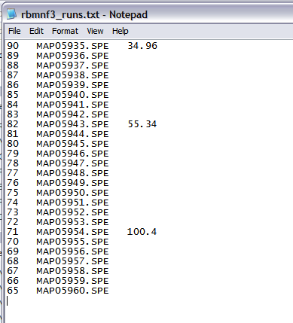

Horace assumes that when a value of incident energy is given, the same value corresponds to the spe files named below, until another value of incident energy is given. For instance, here it will be assumed that files MAP05935.spe to MAP05942 will have incident energy of 34.96 and MAP05943 to MAP05953 will have incident energy of 55.34 etc.

Mslice parameter file

You can save parameter files from the mslice window. These files describe the crystal structure, lattice constants and other information. This file is used by Horace for all the data which does not change between .spe files.

Generating the files

There are two functions which generate the required hkle or sqe binary files.

Gen_hkle

>> gen_hkle (msp, data_in_dir, fin, fout, u1, u2, u3)

Where msp is the mslice parameter file, data_in_dir is the folder containing the .spe files, fin is the input text file, fout is the output file name and u1, u2, u3 are vectors describing the orthonormal projection axes.

A hkle files takes up less space (typically 10GB) but will take longer to read in for step 2 of the reading in process (step 2 will typically be done several times while this stage will usually only be performed once or twice).

Gen_sqe

Uses the same syntax as gen_hkle except an sqe binary file is produced. This is faster to read in for step 2 but takes up 4 times as much space. It is usually recommended that sqe files be created.

WARNING: If the output file already exists, Horace assumes that you want to append it rather than overwrite it. This is a useful feature if more data becomes available in which you wish to incorporate. However, it also means that if you wish to overwrite a file, then you must first delete the original copy.

Cutting Data and reading into objects.

The data is typically too large to be handled all at once., which is why the intermediate binary files are used and why data must be “cut” and reduced.

The binary file will contain all information from the experiment. Now it must be cut down from 4 dimensions to a reduced set of data in 4 dimensions, or lower dimensionality.

Once data has been read into one of the dataset objects, it can be further reduced and manipulated. For instance a d3d object can be cut into a d2d object rather than cutting straight from the raw data. This is a lot faster, but data is not as accurate. Conversely, data from d2d objects can be combined into a d3d object.

The routines for reading in data from the binary files are:

- Slice_3d
- Slice_4d
- Cut_sqe

Routines for reducing dimensionality of current objects:

- Cut

See the individual help on these routines for assistance.

Mirrored Functions with Libisis

Many functions from Libisis are directly mirrored in Horace. Within Horace, d1d is internally converted to IXTdataset_1d, and d2d to IXTdataset_2d so that relevant functions can be performed. The datasets are then converted back to their Horace counterparts and returned. See the libisis documentation for more information on these functions.

The following functions are directly mirrored:

Horace Function | Libisis Function | Purpose
cos | cos | Take the cos of the signal data on the plot axes
cosh | cosh | Take the cosh of the signal data on the plot axes
dd | dd | Plot signal data using plot axes
de | de | Plot signal data using plot axes
dh | dh | Plot signal data using plot axes
dl | dl | Plot signal data using plot axes
dm | dm | Plot signal data using plot axes
dp | dp | Plot signal data using plot axes
pd | pd | Plot signal data using plot axes
pp | pp | Plot signal data using plot axes
pe | pe | Plot signal data using plot axes
pm | pm | Plot signal data using plot axes
pl | pl | Plot signal data using plot axes
ph | ph | Plot signal data using plot axes
ds | ds | Plot signal data using plot axes
da | da | Plot signal data using plot axes
tan | tan | Take the tan of the signal data on the plot axes
tanh | tanh | Take the tanh of the signal data on the plot axes
sin | sin | Take the sin of the signal data on the plot axes
sinh | sinh | Take the sinh of the signal data on the plot axes
exp | exp | Take the exp of the signal data on the plot axes
log | log | Take the log of the signal data on the plot axes
plus | plus | Binary operations on datasets
minus | minus | Binary operations on datasets
mtimes | mtimes | Binary operations on datasets
mrdivide | mrdivide | Binary operations on datasets
mpower | mpower | Binary operations on datasets
plus_p1 | plus_x | Binary operations on datasets
plus_p2 | plus_y | Binary operations on datasets
minus_p1 | minus_x | Binary operations on datasets
minus_p2 | minus_y | Binary operations on datasets
times_p1 | times_x | Binary operations on datasets
times_p2 | times_y | Binary operations on datasets
divide_p1 | divide_x | Binary operations on datasets
divide_p2 | divide_y | Binary operations on datasets
rebin | rebin, rebin_xy | rebin plot axes data
rebin_p1 | rebin_x | rebin plot axes data
rebin_p2 | rebin_y | rebin plot axes data
rebunch | rebunch, rebunch_xy | rebin plot axes data
rebunch_p1 | rebunch_x | rebin plot axes data
rebunch_p2 | rebunch_y | rebin plot axes data
regroup | regroup, regroup_xy | rebin plot axes data
regroup_p1 | regroup_x | rebin plot axes data
regroup_p2 | regroup_y | rebin plot axes data
scale | scale | Scale plot axes data
scale_p1 | scale_x | Scale plot axes data
scale_p2 | scale_y | Scale plot axes data
interp | interp | Interpolate a dataset signal data
interp_p1 | interp_x | Interpolate a dataset signal data
interp_p2 | interp_y | Interpolate a dataset signal data
shift | shift, shiftxy | Shift plot axes data
shift_p1 | shiftx | Shift plot axes data
shift_p2 | shifty | Shift plot axes data
smooth | smooth | Smooth plot axes data
flip | flip | Flip plot axes data
flip_p1 | flip_x | Flip plot axes data
flip_p2 | flip_y | Flip plot axes data
deriv | deriv1 | Numerical derivative of signal data
deriv1 | deriv1 | Numerical derivative of signal data
deriv2 | deriv2 | Numerical second derivative of signal data
deriv1p1 | deriv1x | Numerical derivative of signal data
deriv1p2 | deriv1y | Numerical derivative of signal data
deriv2p1 | deriv2x | Numerical second derivative of signal data
deriv2p2 | deriv2y | Numerical second derivative of signal data
integrate | integrate | Integrate a d1d
unspike | unspike | Unspike signal data

Data Manipulation

Binary Operations

Binary operations (+, -, /, *) can be performed on all datasets. However, d1d and d2d use Libisis and therefore have a wider range of input options. See libisis for details of additional input options, here only options which are available for all datasets are described. The following cases can be operated on:

Dataset and dataset

If two datasets are operated on then the result will be a dataset of the same dimensionality. All header information and plot axes data will come from the left hand dataset (the first dataset), while the signal will be operated on with the right hand dataset. Errors are added using error addition methods. For example

Wout = w1 + w2

Means that

Wout.s(i) = w1.s(i) + w2.s(i)

Wout.e(i) = w1.e(i) + w2.e(i)

Dataset and number

If a single number is operated on with a dataset, that number will be added to each signal value in the dataset such that

Wout.s(i) = w1.s(i) + number

Dataset and array

If an array of numbers is added to a dataset then the numbers will be added to the corresponding element in the signal data. For instance,

Wout.s(i) = w1.s(i) + array(i)

Compact

>> w2 = compact(w1)

Available for dataset types:
d1d
d2d
d3d
d4d

compacts a dataset by eliminating empty bins.

Convert to libisis

>> w2 = convert_to_libisis(w1)

Available for dataset types:
- d1d
- d2d
- d3d

Converts datasets to their Libisis counterparts. There is a loss of information about crystal parameters and integration axes, use of this function should be limited.

Cos, cosh, sin, sinh, tan, tanh

>> w2 = cos(w1)
>> w2 = cosh(w1)
>> w2 = sin(w1)
>> w2 = sinh(w1)
>> w2 = tan(w1)
>> w2 = tanh(w1)

Available for dataset types:
- d1d
- d2d

each signal value will be the cos, cosh, sin, sinh, tan or tanh of the input signal value. Errors remain unchanged.

Cut

>> cut(w1, i_ax1, range, i_ax2, range, ….)

Available for dataset types:
- d1d
- d2d
- d3d
- d4d

Averages the signal over an interval in one or more axes to reduce the dimensionality of a dataset.

D1d, d2d, d3d, d4d

>> w2 = d1d(w1)
>> w2 = d2d(w1)
>> w2 = d3d(w1)
>> w2 = d4d(w1)

Available for dataset types:
- d1d
- d2d
- d3d
- d4d

Constructors for datasets. Input can be either a structure with the correct fields (see dnd_checkfields) or individual fields entered in a specific order given in the online help.

Fit

>> [w2, fitdata] = fit(w1, func, pin, …)

Available for dataset types:
- d1d
- d2d
- d3d
- d4d

fits datasets to a particular function given by function handle as func, the output dataset w2 will contain the fitted signal values. Fitdata contains statistics about the fit. See the online help for more details

Fit_sqw

>> [w2, fitdata] = fit_sqw(w1, func, pin, …)

Available for dataset types:
- d1d
- d2d
- d3d
- d4d

fits datasets to a particular function given by function handle as func, the output dataset w2 will contain the fitted signal values. Fitdata contains statistics about the fit. See the online help for more details… I can honestly say I have no idea if this is any different to your standard fit

func_eval

>> w2 = func_eval(w1, func, pin)

Available for dataset types:
- d1d
- d2d
- d3d
- d4d

evaluates a function at the plot axes data points. The output dataset signal will be the function evaluated at the input plot axes data points. Pin are any parameters required by the function.

Permute

>> w2 = permute(w1)
>> w2 = permute(w1, order)

Available for dataset types:
- d1d
- d2d
- d3d
- d4d

permutes the order of the plot axes in a dataset.

Section

>> w2 = section(w1, [p1lo, p1hi], [p2lo, p2hi], ….)
>> w2 = permute(w1, order)

Available for dataset types:
- d1d
- d2d
- d3d
- d4d

Takes a section of a dataset within the given limits

Smooth

>> w2 = smooth(w1) uses default values
>> w2 = smooth(w1, width, shape)

Available for dataset types:
- d1d
- d2d
- d3d
- d4d

Smooths a dataset, where width defines a range to smooth over and shape defines the weight to give the smooth range. By default these are 3 and ‘hat’ respectively. Width can be a vector defining the width along each dimension being smoothed. 0 means no smoothing.

Sqw

>> w2 = sqw(w1, func, p, …)

Available for dataset types:
- d1d
- d2d
- d3d
- d4d

similar to func_eval except specifically for functions which calculate S(q,w)

user_func

>> w2 = sqw(w1, func, p, …)

Available for dataset types:
- d1d
- d2d
- d3d
- d4d

Allows a user defined function to create a dataset with signal, error and title information (not just signal information as in func_eval)

Dispersion

>> w2 = dispersion(w1, dispreln, p)

Available for datasets types:
d2d

calculates the dispersion relation along the momentum axis of a d2d object. Dispreln and p define the function and parameters, w2 will be a 1d dataset containing the dispersion relation. One axis in w1 must be energy.

Replicate

>> w2 = replicate(w1, wref)

Available for datasets types:
d1d
d2d
d3d

makes a higher dimensional dataset from a lower dimensional one by replicating the data along the extra dimensions. Wref is a reference dataset which contains appropriate annotations.

Plotting

Plot(dataset) will give the most relevant plot to whichever dataset is given as input. For d1d this will be a line plot, for d2d this will be an area plot and for d3d a sliceomatic plot.

D1d and d2d carry other plot options. These are listed below

Plot Type | D1d type? | D2d type?
Dl – lineplot | Yes | yes
Dm – marker plot | Yes | yes
Dh – histogram plot | Yes | yes
De – errorbar plot | Yes | yes
Mp – multiplot | Yes | Yes
Da – area plot | No | Yes
Ds – surface plot | No | Yes

See the online documentation or libisis graphics documentation for more information on these plot types. Note that p1 corresponds to x, p2 to y and p3 to z from the documentation.

