# Excitations Data Analysis Training Course – Solutions 1

## MSlice GUI

MSlice is a program within Mantid for viewing powder inelastic neutron scattering data from time-of-flight (ToF) spectrometers. It can read nxs and nxspe files created by the reduction scripts used at ToF neutron sources.

### Starting MSlice

You need to install [Mantid](https://www.mantidproject.org/) in order to use MSlice. This is already installed in the [IDAaaS](https://isis.analysis.stfc.ac.uk/) analysis cluster. Go to “Applications” (bottom left) → Software → Mantid Workbench. Once Mantid starts, go to the “Interfaces” menu → Direct → MSlice to start MSlice. You should see a window with your home folder in the centre panel. Change to the folder: /home/dl11170/edatc/data by either typing this in the address bar or navigating there.

Load all the files in this folder by pressing Ctrl+A and then pressing Enter. (You can also double click individual files or use Shift+Click to select a range of files, or Ctrl+Click to select individual files.

Once the files are loaded the GUI switches immediately to the workspaces view.

### Phonons

Select the aluminium_Ei60 workspace and click “Display” (bottom right hand side of GUI).

What are the spots of color at E=0?

Hint: You can overplot Bragg peaks for common sample can materials from the “Information” menu

Answer: Aluminium Bragg peaks

Adjust the color scale by either double clicking the colorbar and setting new limits or putting values in the “Intensity From [ ] to [ ]” boxes in the main GUI and clicking “Display” again. Adjust the maximum intensity color scale until you can see inelastic scattering. Also try the zoom tools or click on the x/y-axes to adjust their ranges.

Why does the excitation seem to make a “V” shape?

Where is the base of the “V”? (What point does this correspond to?)

Hint: What is the approximate dispersion of an acoustic phonon mode?

Answer: The phonon dispersion near the Bragg peak is linear (slope is the speed of sound), and the base of the V is a structural Bragg peak (the phonon frequency is proportional to **q**=**Q**-**G**). The shape is not strictly a symmetric V, but is asymmetric because we’re plotting |Q| - and a given Δ***Q*** yields a smaller Δ|Q| on the lower |Q| side than on the higher |Q| side.

Make a cut along Q integrating over the **inelastic** intensity (do not include the elastic line). Then change to the “MD Histo” tab, select your cut, and click “Save to Workbench” (bottom right button).

In the workbench GUI, select the workspace, right click on it and click “Plot” → “Spectrum” (or “Spectrum with Errors”). Then in the plot window, click “Fit”. Right click on the plot and click “Add Other Function” and type (or navigate to) “UserFunction” and click OK. On the left hand side, click the arrow to the right of “f0-UserFunction” and in the field “Formula” (or “For…”) type “A*x*x+B”. Click “Fit” → “Fit” on the top of the Fit panel.

Is the Q2 intensity approximation for phonons valid?

Where is the largest deviations and why do you think this is?

Hint: Consider the kinematic restrictions and detector coverage.

Answer: Looks pretty good (integrating between 10 and 40meV).

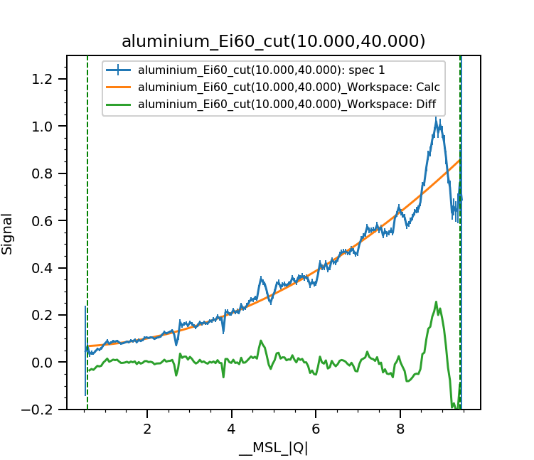

Deviation at high Q is due to kinematic reasons – the maximum energy transfer at |Q|=9Å-1 is around 20meV, but this corresponds to a peak in the Aluminium DOS – the DOS dips again above 20meV before rising around 35meV – but this is missing from the data and would have lowered the integrated intensity if we could have measured it.

Often powder INS is used to obtain the *neutron-weighted* density of states *Z*neut(E):

https://latex.codecogs.com/png.latex?%5Clarge%20%5Csum_d%20%5Cfrac%7B%5Csigma_d%7D%7Bm_d%7D%20Z_d%28E%29

which is the sum of the partial DOS *Zd*(E) for each atom *d* weighted by its neutron cross-section and mass.

This can be computed in the *incoherent approximation* in Mantid (not yet in the MSlice GUI) using the script /home/dl11170/edatc/scripts/mslice_dos.py – open this in the main Mantid Workbench script window, edit the parameters at the start and hit Ctrl+Enter or click the green arrow on the top right corner to run it.

Once this script is run, a new workspace with “_DOS” appended will be created in the “MD Histo” tab. You can then select this and click Plot to view the calculated neutron-weighted DOS. In future this calculation will be included in the MSlice GUI.

Now do the same DOS plot for the other phonon datasets, silicon_Ei80_300K, zinc_Ei50_300K and zinc_Ei50_100K. Plot the DOS of the Aluminium and Silicon together. Note that neither datasets have been normalised to a vanadium standard so the overall intensities should not be compared (they are due to different mass of sample and different flux from different *Ei* and are not physically significant).

What are the major differences in the DOS of Si and Al?

What does this tell you about the inter-atomic forces in Si and Al?

Hint: Consider a ball-and-spring oscillator. What quantities affects the natural frequency of the oscillations? Consider where Si and Al are in the periodic table.

Answer: The frequencies of the optic modes in Si are much higher than in Al. Si and Al are next to each in the periodic table and so have similar mass. In a harmonic oscillator, the natural frequency is proportional to the (square-root) force constant and inverse proportional to the mass. So we can infer than the bonding in Si is stronger than in Al.

Now overplot the 300K Zinc data.

How is this different to the Al DOS?

Where do you think the difference comes from?

Hint: Consider a ball-and-spring oscillator. What quantities affects the natural frequency of the oscillations? Consider where **Zn** and Al are in the periodic table

Answer:

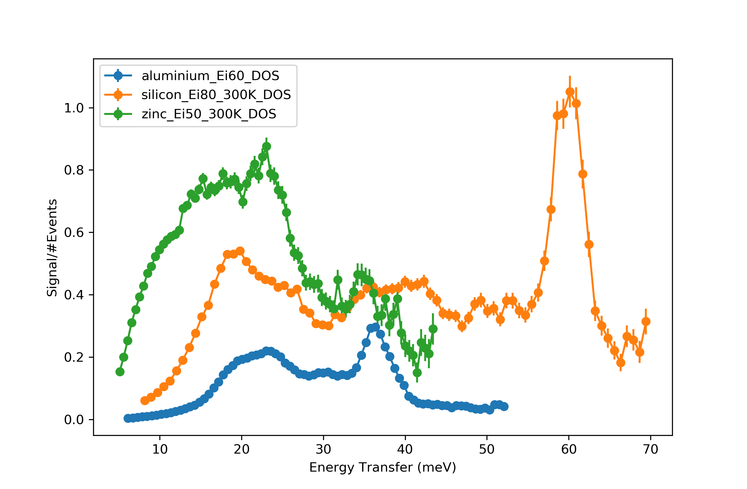

The Zn DOS is much lower than either Al or Si. Zn is in the period below Al and Si so it is much heavier (about twice as heavy). Since the frequencies are inversely proportional to the mass, heavier elements have lower phonon frequencies.

Finally, plot the 100K and 300K Zinc data together.

What differences do you see?

What is the reason for this?

Answer:

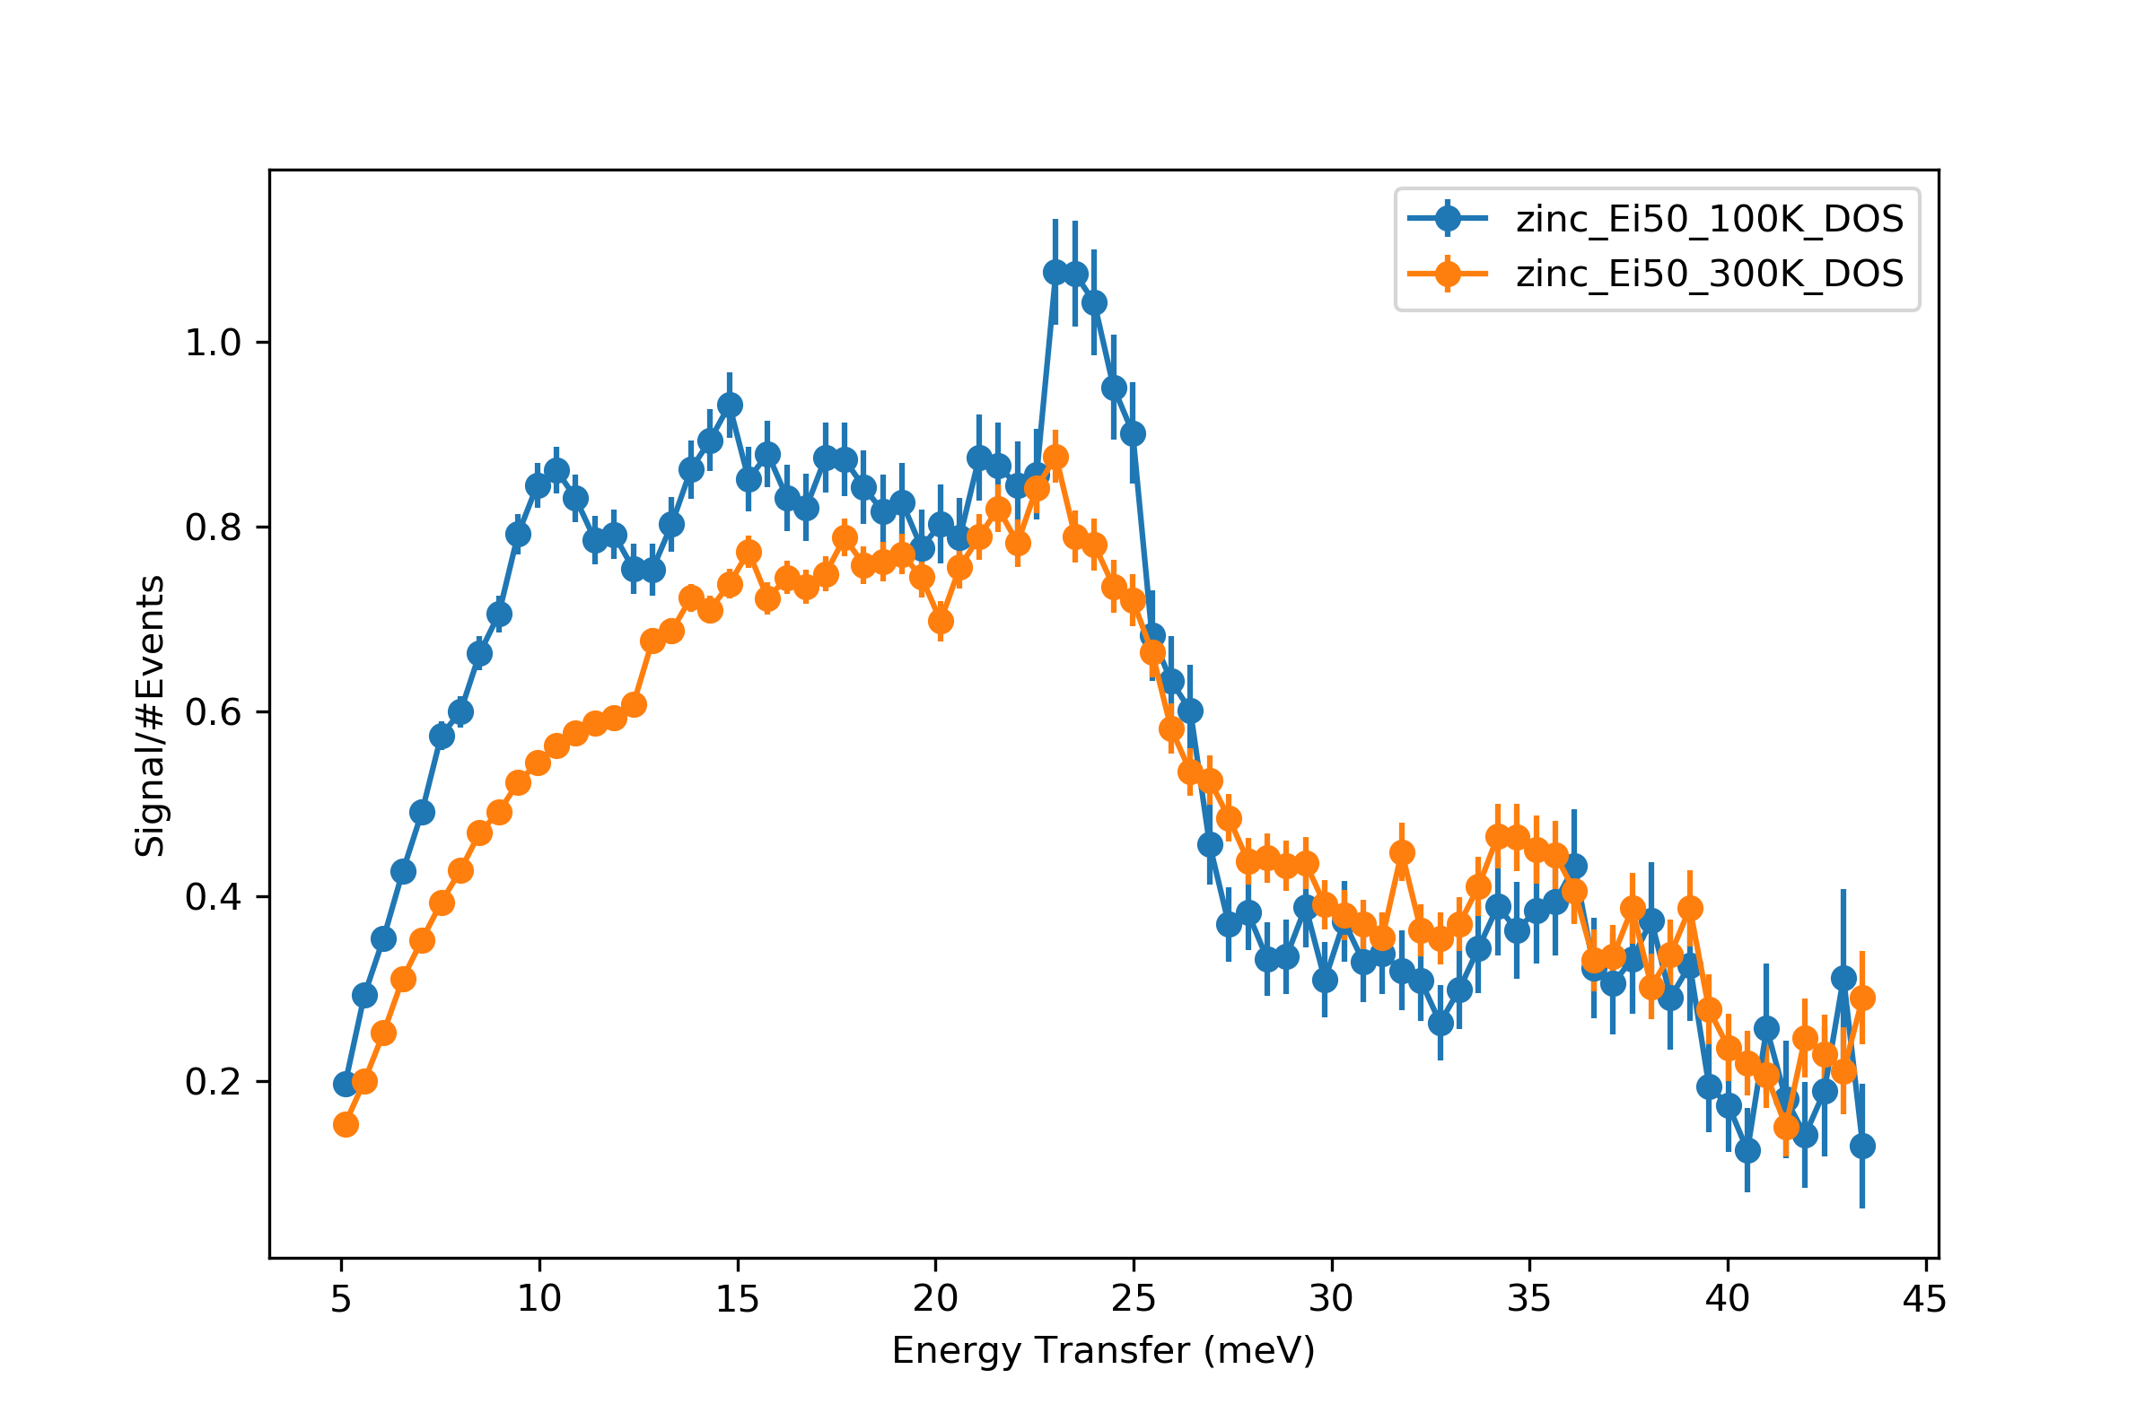

The DOS at 300K is much broader and more featureless than that at 100K. This is because at higher temperatures there is more phonon-phonon scattering so the lifetime of the phonon excitation (inversely proportional to excitation peak width) decreases – so the peak widths increase and the excitations look broader.

For this session, we’ve only looked qualitatively at the phonon data. For quantitative data analysis, often a DFT phonon calculation is needed, which is beyond the scope of this course. On Day 9, however, is a session on Euphonic, a program which, given the force constants calculated from DFT, can be used to calculate the INS spectrum to compare to experiments.

### Magnons

We now turn to look at dispersive spin excitations. Load the bi2fe4o9* datasets (there are 4, at 5K, 100K, 200K, and 300K). Plot the 2D powder spectrum of the 5K data (using the “Display” button in the “Slice” tab).

What features of the spectrum relates to the magnetic excitations, and what to the lattice dynamics?

Hint: Remember the |Q|-dependences of phonon and magnetic neutron scattering intensities.

Answer: Low |Q| is magnetic; high |Q| is phonon. You should see a nice spin wave coming out of a magnetic Bragg peak at 1.2Å-1.

Now we’re going to make a cut of the data; with the 5K Bi2Fe4O9 workspace still selected, click on the “Cut” tab and select a cut **Along** “DeltaE” **from** -20 **to** 30 **step** 0, and **over** “|Q|” **from** 1 **to** 1.5. Then click “Plot”. Now shift-select all the other Bi2Fe4O9 datasets and click “Plot” to overplot all of them on a single graph. (You can also select individual workspaces and click “Plot over”). Set the y-axis limits to between 0 and 1000.

What happens to the excitations as the temperature increases?

Why do you think this occurs?

Hint: Magnons are the collective deviations from an ordered magnetic state.

Hint: Bi2Fe4O9 is a layered system where the inter-layer exchange interaction is much weaker than the intra-layer exchange interactions. The Neel temperature TN=265K.

Answer: You should see a peak around 20meV which slowly decreases in energy until it suddenly becomes quasi-elastic above TN (although still with significant inelastic weight). In principle magnons cannot exist outside the ordered magnetic state. In layered materials with weak inter-layer interactions, however, you can have short ranged order within single planes so that some magnon modes can still propagate within the planes even when long range magnetic order is lost.

The neutron-magnetic cross-section scales with the magnetic moment *gS*(*S*+1), and for the Fe3+ ion in Bi2Fe4O9, S=5/2 is large, so the magnetic scattering intensity is larger than the phonon scattering intensity. In many cases, however, the magnetic scattering intensity can be much weaker, for example for S=1/2 systems such as Cu2+ containing compounds. In these cases, some estimate of the phonon needs to be subtracted to get a clearer picture of the magnetic signal.

This can be done using several methods:

1. By measuring a compound with the same structure and elements but with the magnetic ion replaced by a non-magnetic ion. This is called a *phonon blank*. For Bi2Fe4O9 this would be Bi2Al4O9, where Fe3+ is replaced by Al3+. The magnetic signal is obtained by subtracting the spectrum of the phonon blank from that of the desired sample, after normalising for sample size, mass and scattering lengths. (We will not show such a subtraction in this practical.)
2. By using higher temperature data above the magnetic transition on the same sample, and applying a correction for the thermal population (“bose”) factor. (Demonstrated below)
3. By using high |Q| data at the same temperature on the same sample and correcting for the polarisation (“Q2”) factor. (Demonstrated below, best for 1D energy cuts).

We’re now going to apply method 2.

Load the PdCrO2 datasets (one at 5K and one at 180K). Plot them.

What do you notice about the low angle scattering in the 180K dataset compared to the 5K?

Consider how this will affect the subtraction.

Hint: Like Bi2Fe4O9, PdCrO2 is also a layered system with weak inter-layer interaction. The Neel temperature is much lower though at TN=37K.

Answer: Like for Bi2Fe4O9 there is residual QENS even well above TN (in PdCrO2 we’re much further above TN than for Bi2Fe4O9 but there is still short ranged order) – this will mean the background will be overestimate and be over-subtracted.

Now select the 180K dataset and click “Compose” then “Bose”. Enter “180” for the current temperature and “5” for the target temperature. This should generate a workspace with the “_bosed” suffix which is the 180K dataset rescaled to look as if it was at 5K.

Now select the 5K dataset and click “Subtract”. Select the “_bosed” workspace from the list and click OK. This should create a “_subtracted” workspace. Plot this, setting the color scale maximum to be quite low.

How good is the subtraction?

What features can you still see at high |Q|?

Hint: Think about what else is in the beam beside the sample.

Answer: The subtraction is ok, but there are still features which look like Al phonons (see previous section) because the CCR and sample can is made from Al.

Further quantitative analysis of magnon spectra requires modelling, which will be covered in the SpinW sessions next week.

### Crystal Field transitions

Crystal field (or crystalline electric field) levels are low energy electronic states which can be excited by neutrons. They appear as flat bands (dispersionless) in the spectra.

Load the Er2Ir2O7 datasets (three files, all measured at 5K, with Ei=10, 30 and 180meV), and plot them.

At what energies do you see the crystal field levels?

Answer: Around 5.5, 9.0, 20 and 67meV.

We’re now going to check that the magnetic excitations follow the form factor for Er3+. Make a cut along |Q| of the 30meV dataset integrating from 3 to 7meV. Then open the script /home/dl11170/edatc/scripts/mslice_formfactor.py in the script editor window of the main Mantid Workbench. Edit the parameters at the start and run it – it should create a workspace in the “MD Histo” tab with a suffix “_F2” – this is the calculated form factor. Plot it together with your Q-cut and see if it fits.

Finally, we will now use method (3) above for subtracting an estimate of the phonons from a magnetic signal. We will make two cuts along energy (“DeltaE”) – one at low |Q| and one at high |Q|. The high |Q| cut will be scaled to match the low Q and subtracted off to get an estimate of the magnetic signal. Unfortunately this needs to be done in a script.

We will use the “script generator” to help construct this script. First, using the 180meV Er2Ir2O7 dataset make a cut along **|Q|** integrating over intermediate energies (e.g. 20 to 55 meV – make sure you avoid the elastic line). Click on the “File” menu option and select “Generate Script to Clipboard”. Then open a new script in the main Mantid Workbench and copy the clipboard contents. This script should reproduce the plot you just opened. Most commands are to do with the plot itself; at the moment we’re only interested in the “Load” and “Cut” command lines.

Look at the syntax of the Cut command – can you figure out how to make the low and high Q **energy** (“DeltaE”) cuts?

Answer: Change the IntegrationAxis parameter.

lo_q_cut = mc.Cut(ws_er2ir2o7_Ei180_5K, \

IntegrationAxis="|Q|,2.0,5.0,0.0", \

CutAxis="DeltaE,-20,100,1", NormToOne=False)

hi_q_cut = mc.Cut(ws_er2ir2o7_Ei180_5K, \

IntegrationAxis="|Q|,13.0,16.0,0.0", \

CutAxis="DeltaE,-20,100,1", NormToOne=False)

We also need to determine the scaling factor. We’ll use the first |Q| for this, using the numpy interp function. For this we need to extract the x and y values of the cut as numpy arrays and then pass them to interp:

xx = cut_ws_0.get_coordinates()

xx = xx[list(xx.keys())[0]]

yy = cut_ws_0.get_signal()

factor = np.interp(low_q, xx, yy) / np.interp(high_q, xx, yy)

where low_q and high_q and the average (mid-point) |Q| values of the integration range of the energy cuts you made above. You can then multiply the high Q cut by this factor and plot it against the low Q cut to see if it makes sense. Then you can subtract it to obtain the magnetic signal.

Hint: An example script is in /home/dl11170/edatc/scripts/mslice_1d_phonon_correction.py but see if you can write it yourself.