# Excitations Data Analysis Training Course – Worksheet 7

## Contents

1. Ba3NbFe3Si2O14 – A chiral triangular lattice system and polarised inelastic neutron scattering
2. Sr3NiIrO6 – Magnetic form factors in a compound with two different magnetic ions

## SpinW II – Excercise 1: Ba3NbFe3Si2O14

In this exercise, we’ll look at Be3NbFe3Si2O14 langasite which has a non-centrosymmetric chiral crystal structrure which then leads to a chiral magnetic structure and thence to chiral excitations [ Loire et al., PRL **106** 207201 (2011)].

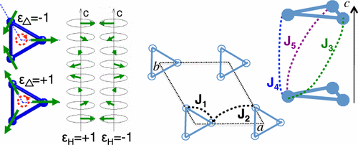

1. To get you started quickly, use the following template and fill in which bond correspond to which exchange Jn according to the graphic above (replace the “???” and uncomment the addcoupling lines)

banb = spinw;

banb.genlattice('lat_const',[8.539 8.539 5.2414], ...

'angled',[90 90 120],'sym','P 3 2 1');

banb.addatom('label','MFe3','r',[0.24964 0 1/2],'S',5/2,'color','gray');

banb.gencoupling;

% Values from PRL 106 207201

J1 = 0.85;

J2 = 0.24;

J3 = 0.053;

J4 = 0.017;

J5 = 0.24;

banb.addmatrix('value',J1,'label','J1','color','red')

banb.addmatrix('value',J2,'label','J2','color','lightgray')

banb.addmatrix('value',J3,'label','J3','color','orange')

banb.addmatrix('value',J4,'label','J4','color','b')

banb.addmatrix('value',J5,'label','J5','color','purple')

%banb.addcoupling('mat', 'J1', 'bond', ???)

%banb.addcoupling('mat', 'J2', 'bond', ???)

%banb.addcoupling('mat', 'J3', 'bond', ???)

%banb.addcoupling('mat', 'J4', 'bond', ???)

%banb.addcoupling('mat', 'J5', 'bond', ???)

plot(banb,'range',[-0.5 1.5;-0.5 1.5;0 1.5])

1. Once you have the exchange use the following code which uses the optmagstr and gm_planar functions to try to find the optimum magnetic structure. Do you understand how the code works? (If not ask a demonstrator) – what do the parameters x0 to gm_planar mean? Why have xmin and xmax been set that what they’ve been set?

% Use optmagstr with the planar magnetic structure (moments in a-b plane)

% Parameters for gm_planar are:

% phi_1, phi_2, ..., k_x, k_y, k_z, n_theta, n_phi

% phi_1, etc are the rotation angles of each spin in the plane

% k_x, k_y, k_z define the propagation vector

% n_theta and n_phi determine the rotation plane

% We just want to vary phi_*, and k_z

n_spin = numel(banb.matom.S);

x0 = [[0 2 4]*pi/3 0 0 1/7 0 0];

xmin = [zeros(1, n_spin) 0 0 0 0 0];

xmax = [ones(1, n_spin)*2*pi 0 0 1 0 0];

banb.genmagstr('mode', 'func', 'func', @gm_planar, 'x0', x0)

optres = banb.optmagstr('func', @gm_planar, ...

'xmin', xmin, 'xmax', xmax, 'tolfun', 1e-9)

% Rotates the spin so the first spin is along the a-axis

xfit = optres.x;

xfit(1:3) = xfit(1:3) - xfit(1)

banb.genmagstr('mode', 'func', 'func', @gm_planar, 'x0', xfit)

plot(banb,'range',[-0.5 1.5;-0.5 1.5;0 2.5])

1. Run the above code several times and look at the plot of the optimised structure – each time when the code results in a non-zero propagation vector, what is the chirality of the triangles εΔ? (compare to the picture above). What is the chirality of the helix εH? Is there a relation between them? Run the code again until you get εΔ=-1 and εH=1 as in the PRL.
2. Calculate the spin wave dispersion from (01 $\overline{1}$) to (012), but before you plot the dispersion (before running sw_egrid) run sw_neutron with the 'pol', true option and also set 'uv', {[0 1 0], [0 0 1]} to calculate the polarised neutron cross-sections and define the horizontal scattering plane as the (0*kl*) plane. Then run sw_egrid with 'component', 'Sperp' to plot the unpolarised cross-section and then rerun the plot with sw_egrid with 'component', '-Myz+Mzy' to plot the chiral cross-section. Compare your plots with those in the PRL paper below. (The situation with the exchange parameters J1-J5 described by the paper corresponds to a structural chirality εT=-1 - you can get the other case by swapping the values of J3 and J5). Note that we’re using '-Myz+Mzy' as the component instead of 'Myz-Mzy' because it seems that the definition of the xyz coordinate system for the polarised neutron cross-section is opposite in the PRL paper compared to that in SpinW. The <My>, <Mz> components are in principle defined by x||Q, z vertical and y = x × z but it seems that in the paper this is taken as the negative of x × z. (note that in the online version of this [tutorial](https://spinw.org/tutorials/15tutorial), it was chosen to use the negative of Q instead of swapping the polarised components.)

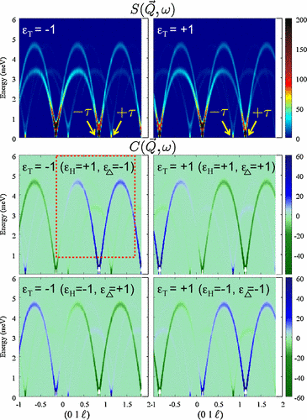

## SpinW II – Exercise 2: Sr3NiIrO6

This spin chain material has both magnetic Ni2+ and Ir4+ ions. The excitations associated with each are well separated in energy so we’re going to use the form factor calculation and substitution to find out which bands belong to which ion. The data and model is taken from [Toth et al., *Phys. Rev. B*, **93** 174422 (2016)](http://dx.doi.org/10.1103/PhysRevB.93.174422).

1. Use the following script to set up a model for Sr3NiIrO6:

sni = spinw();

sni.genlattice('lat_const', [9.61 9.61 11.1658], ...

'angled', [90 90 120], 'spgr', 'R -3 c')

sni.addatom('r', [0 0 0], 'S', 0.5, 'label', 'MIr4');

sni.addatom('r', [0 0 0.25], 'S', 1, 'label', 'MNi2');

sni.gencoupling('maxDistance', 6)

% Values from PRB 93 174422 (2016)

Jxy = 21.6; Jz = 46.6; A = 4.95;

J2b = 0; J3a = -2.83; J3b = -1.37; Jtri = 1.46;

J3c = (Jtri - J3b + 2*J3a*0.5) / (0.5^2);

sni.addmatrix('label','J1','value',diag([Jxy Jxy Jz]),'color','white');

sni.addmatrix('label','J2b','value',J2b,'color','gray');

sni.addmatrix('label','J3a','value',J3a,'color','lightgray');

sni.addmatrix('label','J3b','value',J3b,'color','purple');

sni.addmatrix('label','J3c','value',J3c,'color','red');

sni.addmatrix('label','A','value',diag([0 0 A]));

sni.addcoupling('mat', 'J1', 'bond', 1);

sni.addcoupling('mat', 'J2b', 'bond', 3);

sni.addcoupling('mat', 'J3a', 'bond', 4);

sni.addcoupling('mat', 'J3b', 'bond', 5);

sni.addcoupling('mat', 'J3c', 'bond', 6);

sni.addaniso('A', 'MNi2');

sni.genmagstr('mode', 'direct', ...

'S', [0 0 0 0 0 0 0 0 0 0 0 0;

0 0 0 0 0 0 0 0 0 0 0 0;

-1 -1 1 -1 1 -1 1 1 -1 1 -1 1]);

plot(sni)

1. Plot a spin wave spectrum and verify that there are bands at around 30meV and 90meV as expected from the paper:

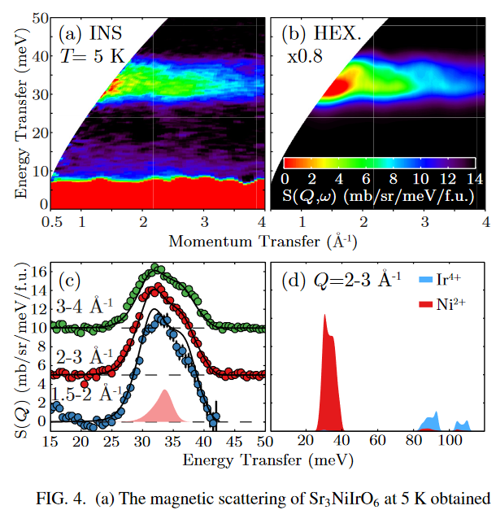

1. Examine the unit_cell field of the spinw object (type: sni.unit_cell) – information on the sub-fields are here: <https://spinw.org/SWproperties/#unit_cell> – make a copy of the form factor field. Then set the form factor coefficients corresponding to Ir4+ to zero (you can run: [~,coeff] = sw_mff('MIr4') to get an idea what the coefficients of the form factor of Ir4+ is.
2. With the Ir4+ form factor set to zero, calculate a powder spectrum with 'formfact', true and check that the main spectral weight is now from the 30meV mode. Integrate your powder spectrum over Q to get a plot similar to the red shaded area in Fig 4d. of the PRB paper (reproduced above).
3. Repeat the calculation with the Ni2+ form factor set to zero and see if you can reproduce Fig 4d. (Use the saved form factor coefficients you made earlier to restore the Ir4+ form factor, or just run the setup script in the blue box above again).