# Excitations Data Analysis Training Course – Worksheet 10

## Fitting the crystal field parameters of Yb2Ti2O7

Yb2Ti2O7 is famous as a “quantum spin ice” material – the “quantum” part comes from the fact that at low temperatures it behaves as an effective S=1/2 system with strong anisotropy which is needed to stabilise a quantum spin liquid. This is because although the magnetic Yb3+ ions actually have a full moment of J=7/2, the crystal field splits this into 4 doublets and the splitting is such that the ground state doublet has a large energy gap to the first excited state. We will be looking at fitting the crystal field parameters of Yb2Ti2O7 in today’s practical.

The data file is available at:

/mnt/ceph/auxiliary/excitations/edatc/powder_data/yb2ti2o7_Ei200_100K.nxspe

1. Load the data using MSlice and make two cuts along energy, the first integrating from Q=0 to Q=5 Å-1 and the second from Q=12 to Q=17 Å-1. Then make another cut along |Q| integrating from 10 to 50 meV in energy. From this last cut determine a scaling factor to scale the high-Q energy cut to low-Q to be used as a background.

Hint: You can either just inspect the scale factor by eye or fit a Q^2 dependence to the Q-cut and evaluate the fitted function at 2.5 Å-1 and 14.5 Å-1 and take the ratio.

1. Export the three cuts to the Mantid Workbench using the “MD Histo” tab. In the workbench script editor, type the following code to make the background subtraction:

cf_cut = mtd[<name_of_lowQ_cut>] - scaling_factor*mtd[<name_of_highQ_cut>]

where <name> is the name of the workspaces you exported (you can drag and drop the workspace name from the Workbench workspaces list to the script window), and scaling_factor is the factor you determined in step 1.

1. Create a resolution model for the measurement with the following code:

from CrystalField import ResolutionModel

from PyChop import PyChop2

mari = PyChop2('MARI', 'S', 600)

mari.setEi(200)

resmod = ResolutionModel(mari.getResolution, xstart=-200, xend=199)

1. Set up a CrystalField model with ion Yb, in 'D3d' symmetry at 100K with the ResolutionModel defined above and random parameters here:

nonzero_parameters = ['B20', 'B40', 'B60', 'B43', 'B63', 'B66']

Blm = {}

for pname in nonzero_parameters:

Blm[pname] = np.random.rand()*2-1

1. Set up a CrystalFieldFit object with the Model specified in step 4 and InputWorkspace as the cf_cut subtracted cut created in step 2. Run the estimate_parameters function of the fit object with EnergySplitting set to 100, and Parameters set to nonzero_parameters. You can also set NSamples to 1000 (or so) and set Seed=int(np.random.rand()*1e5). Select the best sample (using .select_estimated_parameters(1) – note that I was wrong in the lecture, index 1 is the best sample) and then run the fit against the data. Plot the resulting fit vs the data – is it any good? (You’ll probably have to run this step several times to get a good-ish set of initial parameters for the fit).
2. Calculate the susceptibility along the x- and z-direction and compare to this graph:

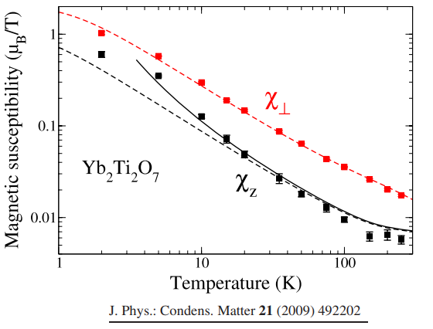

Where the x-direction is the perpendicular direction – does your graph match the data? (Is the x-axis susceptibility higher than the z-axis susceptibility? If not, try step 5 again.

1. Print out the eigenvalues of the Hamiltonian and check the energy from the ground state to the first excited state is large. Print the eigenvectors – what is the ground state wavefunction in terms of the |mJ> states? Do you think the system will have easy-axis or easy-plane anisotropy?

Hint: You can plot the magnetisation to work it out.