???

Introduction

Motivation
Understanding and predicting player behaviour in modern video games is a core objective in their development. Monitoring how players interact with a game allows developers to dynamically adjust the difficulty, mitigate player frustration and ultimately improve player retention[1,2]. Early game design relied largely on the intuition of the designer, developer and small-scale playtesting, while contemporary studios increasingly use the play sessions as a measurable data stream that can be used for deeper insights[3]. This ability to accurately forecast outcomes, such as a player will successfully complete a level or abandon the attempt, therefore it has a direct indication for game design, monetisation, and the overall experience for the player[4].
One particularly attractive application of this prediction capability is the construction of a live Win-Prediction of the player. Estimating and continuously updating during playing, of how likely the current session is about to end in success or failure. Such an estimate is the precondition for any reactive system that wishes to intervene before a player disengages, rather than analysing the disengagement after the fact. Live outcome prediction of this kind is already well established in competitive multiplayer settings like esports analytics systems predicting match winners in real time from game stats, both for professional broadcast and for research purposes[5,6]. Those systems however operate server-side, on data from games with rich multiplayer-state. The present work is motivated by the observation that the live prediction idea has not, to the author’s knowledge, been carried into the architecturally opposite setting: a singleplayer browser platformer in which the prediction must be computed by the game client itself, from behavioural telemetry alone and without any server. Consequently, the main contribution of this work is methodological, rather than merely presenting a prediction model, it examines the pitfalls of data leakage, the implication of row-level analysis compared to session-level analysis, and the architectural limits of client-side inference.

Problem Statement
The central challenge in this thesis is the real-time prediction of level completion (Win-Prediction) in a 2D platformer, adapting within-session outcome prediction paradigms already established in competitive multiplayer settings [5,6]. Traditionally, machine learning models in games rely on vast amounts of historical data processed on dedicated backend servers [3,7]. Server-side inference, however, introduces two undesirable costs. First, every prediction introduces network latency, which is incompatible with the sub-second responsiveness expected of an action-oriented platformer. Second, maintaining an inference backend imposes ongoing infrastructure expense and operational complexity that is disproportionate for a single-level browser game.
The problem therefore demands a predictive model that can assess a live telemetry data stream and execute predictions entirely on the client side(in the browser), without relying on a server backend. This constraint shapes every subsequent design decision. The model must be small enough to ship with the game, fast enough to run alongside rendering and physics and free of demanding runtime dependencies.

Objectives
The thesis aims to develop and evaluate a complete machine learning pipeline from telemetry data collection to in-game integration. Three concrete research questions structure the work:
- Can telemetry-based models predict the outcomes of gameplay sessions more accurately than a naive baseline model, even when evaluated using previously unknown gameplay sessions?
- To what extent do behavioral features contribute to predictive accuracy beyond spatial progress through the level?
- Can a machine learning model capable of making such predictions even be integrated directly into a web-based game client without a server backend?
The success criterion is not merely a high offline accuracy, but a model that simultaneously satisfies the deployment constraints of computational efficiency and zero server dependency and whose reported accuracy only counts if it still holds up when tested on completely new player’s sessions, not just on new moments from sessions it already learned from.

Structure of the Thesis
Chapter 2 provides the theoretical foundation and reviews related work in game analytics, machine learning for game prediction, client-side inference, and the evaluation of models trained on session-structured data.
Chapter 3 details the architecture of the testbed game, JumpOne, and its telemetry system.
Chapter 4 outlines the dataset and the preprocessing pipeline, including the cleaning, labelling, and exploratory distribution analysis.
Chapter 5 covers model development and evaluation under two protocols, a row-level split and a session-level cross-validation, together with an assessment of probability calibration and the interpretation of the final model’s feature importances.
Chapter 6 explains the technical in-game integration via m2cgen, reports the cost of client-side inference, and sets out which design decisions the evaluation of Chapter 5 supports and which it rules out.
Chapter 7 offers a critical discussion of the results and their limitations and concludes with directions for future work.

Foundations and Related Work

Game Analytics and Player Telemetry
Game analytics relies heavily on telemetry data, which provides a quantitative representation of player actions[3]. Telemetry, the automatic, instrumented logging of in-game events, has become standard practice for understanding the player experience, balancing difficulty and prediction churn[1,3]. Rather than asking players to self-report their experience via questionnaires, which suffer from subjective rating biases and memory decay[23], telemetry captures behaviour implicitly as it unfolds, offering an ecologically valid and highly scalable data stream[17].
The literature distinguishes between raw telemetry (low-level events such as position, input, and state) and derived metrics (aggregated quantities such as success rates or average timings) that summarise behaviour over a window of play. While traditional feature engineering compresses telemetry into summary statistics, one line of work avoids this manual step by learning features directly from raw event streams via deep convolutional architectures[10, 11]. The feature engineering performed in this thesis (Chapter 4) follows precisely this pattern, condensing raw records into a small set of behaviourally meaningful predictors.

Machine Learning for Game Prediction
Machine learning is frequently used to classify player behaviour and to predict outcomes such as churn, frustration, playing style, or even personality traits[4, 9, 12, 13]. Churn prediction in particular has produced a substantial body of work: studies on free-to-play and mobile titles routinely frame disengagement as a binary classification problem and compare a range of supervised algorithms[1, 2, 7, 14]. The Win-Prediction problem addressed here is structurally a binary outcome inferred from behavioural features, but differs in its time horizon, since the prediction concerns the immediate session rather than a player’s long-term return.
A second research approach models the player experience directly, predicting perceived difficulty, fun or frustration from level and log data[4, 15, 16]. Of particular relevance is work on player frustration: hesitation, repeated failures, and long pauses have been identified as strong precursors of frustration[4]. This finding creates a strong expectation for the predictive models, though Chapter 5 shows that the corresponding feature measured pause duration rather than hesitation and therefore could not test this expectation.More recent approaches extract features from raw telemetry(spatial coordinates and event frequencies) to enable accurate profiling of player success, sometimes via deep convolutional architecture operating directly on event logs and level data[10, 11]. Comprehensive overviews of this player-modelling landscape are given by Yannakakis and Togelius[17].
The closest methodological relatives of this thesis are the real-time win-prediction systems developed for esports. Hodge et al. trained models that predict the winner of professional Dota 2 matches live, as the match unfolds, and deployed them in broadcast settings[5]; Katona et al. predict imminent player death in the same title from streaming telemetry[6]. These works establish that within-session outcome prediction from behavioural state is feasible and useful. The present thesis differs in three respects: the target is a single-player game, so the predictive signal is individual skill dynamics rather than team state; the deployment target is the game client itself rather than a server- or broadcast-side service; and the platform is the browser, which imposes the strict resource constraints motivated in Section 1.2.

Gradient Boosting and XGBoost
Gradient Boosting is an ensemble learning method that sequentially trains weak learners, typically shallow decision trees, so that each new learner corrects the residual errors of the ensemble built so far. The result is a strong additive model that captures non-linear interactions between features without requiring the explicit feature scaling or distributional assumptions that linear models demand. XGBoost[18] is a widely adopted, regularised and computationally efficient implementation of this idea and it has repeatedly been shown to offer superior sensitivity and predictive performance in behaviour prediction tasks such as player churn, compared with traditional baselines like Logistic Regression[1].
Two properties of tree-based boosting are decisive for this thesis. First, the method is invariant in monotone feature transformation, because trees split on threshold comparison instead of distance or linear coefficients, the strong skew of several behavioural features(discussed in Chapter 4) poses no obstacle. Second, the model’s complexity can be tightly controlled through the number of estimators and the maximum tree depths, which is essential when the model must later be exported into a compact, browser-deployed form(Chapter 6).

Model Export and Client-Side Inference
While neural networks and deep learning models often require heavy computational resources, running models directly on edge devices, such as web browsers, reduces latency and removes server dependency[8]. Real-time classification inside a game engine demands strict computational parsimony, so that the predictive component does not compete for the resources required by rendering and gameplay[12].
This thesis adopts the most parsimonious option available. Rather than shipping a model runtime at all, the trained XGBoost model is transpiled into pure, dependency-free JavaScript using m2cgen[19]. The model becomes ordinary source code, a sequence of conditional expressions, that the browser executes natively. This eliminates both the network round-trip and any third-party inference library, satisfying the client-side constraint set out in Chapter 1.

Evaluating Models on Session-Structured Data
A dataset in which many rows originate from a few sessions is clustered. Rows within a session share a player, a trajectory, and, in this thesis, cumulative features that change only slightly from one sample to the next. Such data with row-level random split is known to produce optimistic estimates, because near duplicates of test rows are present in the training set. Which means the model is rewarded for recognising clusters instead of generalising beyond it. This is a form of data leakage in the sense of Kaufman et al. [20], and its practical impact has been demonstrated in clinical machine learning, where record-wise cross-validation overestimated the accuracy of subject-clustered models by a large margin in comparison to subject-wise cross-validation [22]. The standard remedy to circumvent this problem is grouped evaluation. All rows of a session are assigned to the same fold, as implemented, for example, by scikit-learn’s “GroupKFold” and, in the limit, leave-one-group-out cross-validation.
A second evaluation concern is specific to the intended use of the model’s output. The deliverable of this thesis is a win probability, consumed as a continuous confidence value. Yet accuracy, F1, and AUC-ROC measure only correctness and ranking, not whether a predicted 0.8 empirically corresponds to an 80% success rate. Tree ensembles, like boosted trees, are known to produce systematically distorted probability estimates unless explicitly calibrated [21]. A complete evaluation therefore also relies on calibration diagnostics alongside the threshold and ranking metrics.

The Game: JumpOne

Gameplay and Mechanics
JumpOne is a custom-developed 2D platformer (Jump’n’Run) in which the player must navigate a character through a level using directional inputs and jumps. The core loop of the gameplay is based around jump timing, platform navigation and a fail-and-retry rhythm. The player attempts difficult passages, frequently fails, and tries again. The primary objective for the player is to successfully finish the level, recorded as the “Finish”-state. In case the player is not able to achieve this goal, therefore abandoning the attempt resulting in a recorded “Quit”-state. This binary outcome is the target that the Win-Prediction-Model must learn to anticipate from the behaviour leading up to it.
The fail-and-retry design is significant for the modelling task because it produces a rich behavioural signal even within just a single level, showing a struggling player with many failed jumps, falls, and long pauses, compared to a more skilled player with a more smooth progression. These contrasting behavioral signatures are what the telemetry system is designed to capture.
The level is a single vertical shaft of 20 × 110 tiles at 64 px each, so 1,280 × 7,040 px in total. The character starts at the bottom at “pos_y” = 6612 px and climbs upwards; the goal sits above the top edge at “pos_y” = −70. Smaller values of pos_y therefore mean more progress, and this inverted axis is assumed throughout Chapters 4 and 5. Along the way lie five checkpoints, which are just inform the player of their progress rather then actually be useful, and 24 tiles of ice with reduced friction. The jump is chargeable: holding the space bar builds up jump force, which the telemetry records as the “Charging” state and which makes the timing of a jump, not only its direction, part of the skill the model is meant to read.
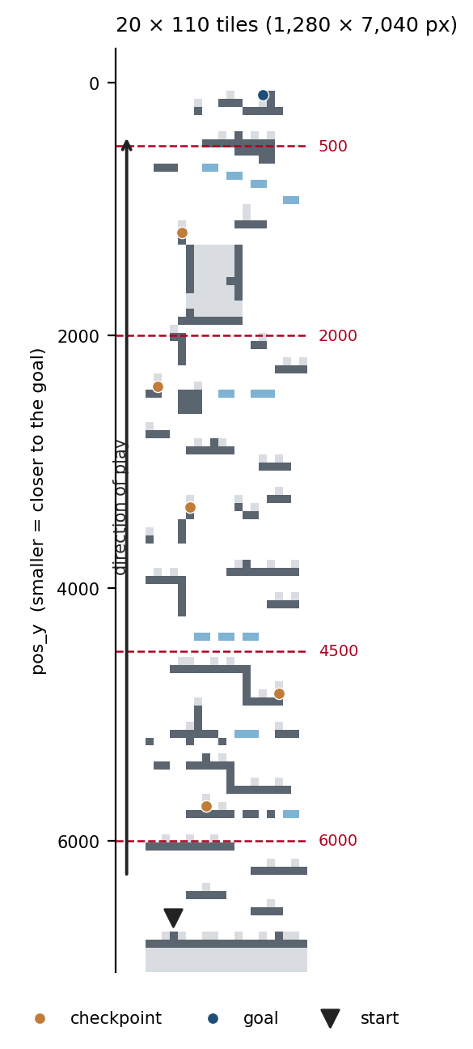
The level with the pos_y axis and the five progress bands used in Section 5.5

Technical Architecture
The frontend is built using TypeScript and the Phaser3-Framework, running directly in the browser. A Supabase (PostgreSQL) backend is purely used for storing the user generated telemetry data. The overall data flow is a closed loop, where the game client streams telemetry to the database during gameplay, the accumulated data then gets exported and used offline to train the model, and the resulting model is then compiled back into the game client as source code. After the model is fully implemented into the games code, and the loop is closed, the Supabase backend is no longer required, because training the model on telemetry being compromised by the users knowledge of their chance of winning is not beneficial.
The separation of concerns keeps the architecture simple. The database is a write-only sink during the data collection and is irrelevant at inference time, which means the deployed game has no runtime dependencies like network stability or server uptime for its prediction feature.

Telemetry System
The game continuously logs the player state every ~100 milliseconds, producing a dense record of each played session. Each record contains 23 database fields. These include spatial data, movement vectors, discrete input flags as well as a set of derived, skill-oriented metrics computed cumulatively over the session. The most relevant are summarised in Table 3.3.1
Telemetry Fields
Feature | Type | Description
pos_x, pos_y | Float | Position of the character
velocity_magnitude | Float | Overall speed
jumpSuccessRate | Float | Proportion of successful jump (0-1)
jumpsFailed | Integer | Number of failed jumps
totalJumpsAttempted | Integer | Total jump attempts
totalFalls | Integer | Total number of falls
avgFallDistance | Float | Average fall height
maxFallDistance | Float | Maximum fall distance
distancePerJump | Float | Distance covered per jump
avgTimeBetweenJumps | Float | Average pause between jumps (ms) (excluded from the model)
sessionDuration_sec | Float | Session duration (s)
session_id | String | Unique identifier per session
state | String | Current game state
The high sampling frequency means that even a short session already contributes hundreds or thousands of rows. As mentioned in Section 2.5, this row volume must not be mistaken for sample size. A session is the unit of independent observations, not the rows themself.

Game States
Telemetry records are categorised into different game states: Running, Jumping, Falling, Charging, Idle, Finished, Quit, AFK, and Paused. These states are fundamental for two reasons. First, Finished and Quit define the session’s outcome, which determines the target label of Will_Finish. Second, the Idle and Pause states define rows that do not represent active gameplay.
Two consequences resulting from these semantics deserve a more precise statement. The Quit state is only generated through one code path, the exit button in the pause overlay, which posts a final Quit row before exiting. Reaching this menu is either reached after pressing ESC, or the gear icon in the top right corner or automatically after ten seconds when the engine does not recognise any user inputs, also resulting in an AFK state. A session that is ended via the closing of the browser tab produces no terminal row which is later labelled as a non-completed session. Both rows either containing Quit or Finished are removed before training, they do not carry no label information and serve as description purpose only.
# ml_pipeline/data_parser.py, preprocess_data()
# 1 if ANY row in the session is 'Finished', 0 otherwise
session_outcomes = df.groupby('session_id')['state'].apply(
lambda x: 1 if (x == 'Finished').any() else 0)
df['Will_Finish'] = df['session_id'].map(session_outcomes)
# Drop rows that are actual outcome states
df = df[~df['state'].isin(['Finished', 'Quit'])]

Dataset and Preprocessing

Raw Data Description
The initial dataset consisted of approximately 165,991 telemetry rows collected across 48 sessions, following that, the data was exported from Supabase as a PostgreSQL file. Because the telemetry gets sent several times per second (every 100ms), the shear volume is large compared to the overall played sessions, and the distribution of number of rows is highly uneven.
All of the data was generated by a group of individual volunteering testers from the author’s personal environment, who each were asked to play the level one to two times until completion or until they chose to stop. Participation was voluntary and unpaid. Participants were informed before playing that the game was developed for this thesis and that their play sessions would serve as its data basis. Consent was obtained orally at the time of participation For the 26 sessions recorded before September 2026 no player identifier existed, so the number of individuals behind them cannot be reconstructed; as an approximation, 18 separate play occasions can be identified from gaps of more than two hours between sessions. The 15 sessions recorded afterwards carry an anonymous, persistent player_id and originate from 13 distinct individuals, two of whom played twice. This asymmetry is carried through to the evaluation as Protocol B′ (Section 5.1).

Exploratory Data Analysis
Exploratory analysis showed that the lengths of each session were extremely different. For example a single abandoned session comprises 42,341 lines, 26% of the entire raw export, and would have dominated training irrespective of its content. The next largest abandoned sessions, including 16,980 and 13,021 rows, are of comparable character. The first of these two is in fact among the most active runs of the all, with roughly 21.8% Jumping and 21.2% Falling rows, reaching “pos_y” 376, which is quite close to the goal. The imbalance in session length is addressed by subsampling each session to at most 500 randomly selected rows, to provide a more equal contribution of each session. Idle accounts for 21.5% of the total training rows and is retained deliberately, since hesitation before a jump is part of the behaviour to be modelled. Sessions with less than 100 rows are excluded because they do not carry relevant information and contain no active play.

Data Cleaning Pipeline
On the basis of this analysis, a custom Python script “session_overview.py” was used to remove sessions in a single step. Sessions with less than 100 rows were discarded, in which the player never left the spawn point, which resulted in no active player behaviour to learn from. The exclusion is applied at load time by every evaluation script, so the exported telemetry remains unmodified; session_overview.py in the repository root was used to identify the affected sessions. Seven sessions meet this criterion. No further session is removed.
Removed | Sessions | Rows | Share of raw export | Reason
Sessions with fewer than 100 rows | 7 | 418 combined | 0.25% | Player never left the spawn
The remaining dataset contains 41 sessions with a total of 165,573 rows, of which, 165,548 remain after the 25 Finished and Quit lines are dropped. Instead of removing additional sessions, the imbalance in session length is balanced by the row limit per session. All reported models were trained with the “–max-rows 500” option, which limits the number of rows sampled to 500 randomly selected ones, so that each session contributes roughly the same amount, resulting in a total of 17,798 training rows.
Regarding “–max-rows 500” it is still important to mention that it is still crucial to distinguish between two distinct structural challenges in the dataset. Session weight imbalance that the clustered nature of the observation. Subsampling each session to a maximum of 500 rows solves only the first challenge. It makes sure that exceptionally long runs do not disproportionately dominate the loss function during model training, so that each session contributes roughly the same amount of valuable data. However, this subsampling does not solve the second problem, the lack of independence between the samples. Even though limited to 500 rows, observations drawn from the same session remain strongly autocorrelated. Therefore, controlling the session weight during training does not eliminate the problem of data leakage. A session-wise cross-validation still remains essential.
One limitation must be acknowledged and should not be overlooked. Because no line gets written when a player simply closes the tab or browser, a session that terminates implicitly is indistinguishable at labeling time from one the player ended deliberately, both are marked as incomplete due to the absence of the Finished state line. Of the 28 non-completed sessions in the cleaned dataset, only 12 carry a Quit line, while 16 end without any completion marker. Such runs are therefore present in the training data and are not excluded from it, but the moment of disengagement itself is not observable, all of these sessions simply stop during a run ending with a Idle state, which are indistinguishable from a pause the player takes before a jump. The model therefore estimates whether a run will end in completion, rather than if a player is disengaging at a given moment.

Label Generation (Will_Finish)
The target variable for the model, Will_Finish, was propagated at the session level rather than the row level. If a row within a session contains the Finished state, the label 1 is assigned to every row of this session, 0 otherwise. The Finished and Quit rows are removed afterwards, so the training operates only on intermediate gameplay states (Idle, Charging, Running, Jumping, Falling, AFK, and Paused). This encodes the task as follows: the model estimates whether this session will end in completion, based on the observed behaviour at an arbitrary moment.
The Finished and Quit rows are removed, because they no longer describe gameplay. A Finished row marks the moment the outcome has already occurred and a Quit state the instant a session got terminated. Both no longer provide behaviour from which completion could be anticipated. After this step the dataset contained 17,798 training rows with a class distribution of 36.5% positive (Will_Finish = 1) and 63.5% negative (Will_Finish = 0).
Completed sessions account for 31.7% of the sessions (13 of 41), but for 29.3% of the rows before subsampling and 36.5% after the 500-row cap. Both row-level figures miss the session-level one, in opposite directions. Before the cap the share is too low because the longest run in the dataset, at 42,341 rows, was abandoned. After the cap it is too high because all 13 completed sessions are long enough to contribute the full 500 rows, while only 16 of the 28 abandoned sessions are, leaving that class at an average of 404 rows.
The row-level balance therefore says nothing reliable about the session-level balance, which is one reason the evaluation in Chapter 5 is carried out at session level.
Two structural characteristics of this labelled dataset are relevant to everything that follows. First, although the classes are moderately balanced at the row level, only 13 of the 41 sessions (31.7%) showed a positive outcome at the macro level; the number of independent observations is therefore 41, not 17,798.
Second, completed runs last longer than abandoned ones, a median of 3.6 against 3.2 minutes. Counters that grow with elapsed time, “totalJumpsAttempted” above all, therefore carry information about the label before any learning takes place. This cannot be seen in the row counts, because the longest single run in the dataset is an abandoned one: it lifts the average for the negative class to 4,178 rows against 3,736 for the positive class.
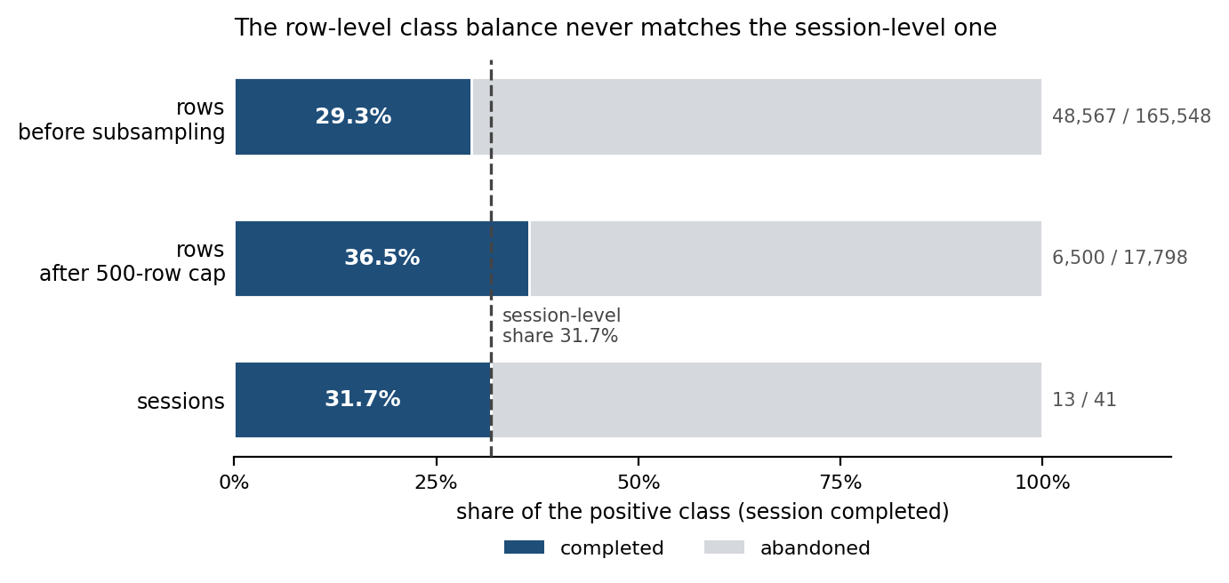
Class distribution of the labelled training data (row level vs. session level)

Feature Selection
Nine Prediction features were selected for the training. Metadata like session_id, timestamp, and the raw state field were deliberately excluded because they carry identifying or outcome information rather than behavioural signals. Two additional columns were excluded for content-related reasons, avgTimeBetweenJumps, whose measured value included the time during which the game was paused(the computational error was for later sessions corrected), and avgFallDistance, which is a redundant value calculated based on totalFallDistance / failedJumps.
The selected features are:
# ml_pipeline/models.py — the single definition of the trained feature set.
FEATURES = [
'jumpSuccessRate', 'jumpsFailed', 'totalFalls', 'maxFallDistance',
'distancePerJump', 'totalJumpsAttempted',
'velocity_magnitude', 'pos_x', 'pos_y'
]
The term skill metric is deliberately avoided for the remaining cumulative measures. As mentioned in Section 4.4, four of these increase monotonically with session duration and therefore strongly correlate with elapsed time. Since completed sessions last longer than abandoned ones, they partially encode the classification by design.
Nevertheless, the feature set is retained in this form, as quantifying its behaviour is part of the research question. It allows the model to access the player’s current position (pos_x, pos_y) as well as the data collected so far during the playthrough. Chapter 5 measures the extent to which the resulting performance is determined more by position and elapsed time than gameplay behaviour.

Distribution Analysis of the Features
To characterize the behavioral metrics and justify the choice of model family, the distribution of each measured variable was examined using D’Agostino’s K² test. The test was applied to the aggregated values of the sessions rather than to individual telemetry lines: With sample sizes at the line level, a normality test yields a negative result even with minor deviations, so aggregating the data to one value per session makes the test meaningful. However with just 41 aggregates per feature, the resulting p-values are more indicative rather than conclusive, and they are reported as a description of the data, not as a hypothesis test. The analysis covers the nine measured behavioral variables and thus also includes “avgFallDistance” and “avgTimeBetweenJumps,” which are described here but are not used for training (Section 4.5), while the positional variables are excluded because they do not describe playing style.
Three variables are compatible with a normal distribution: “maxFallDistance” (skewness +0.10, p = 0.947), “avgFallDistance” (skewness +0.13, p = 0.801) and “velocity_magnitude” (skewness −0.22, p = 0.414). However, the metrics most closely related to gameplay behavior do not. “jumpSuccessRate” (skewness −1.96) and “distancePerJump” (skewness −2.90) are heavily left-skewed, while the cumulative counters “totalFalls” (+3.11), “totalJumpsAttempted” (+2.42), and “jumpsFailed” (+2.31) are heavily right-skewed, all with p < 0.001. The right-skewness of the counters results directly from their construction: they are accumulated over the entire session and therefore inherit the skewness of the session duration distribution described in Section 4.2.
A supplementary principal component analysis of the same aggregates yields a first component that explains 40.3% of the variance. It is tempting to interpret this component as a general measure of general skill, and completed sessions do score higher on it, but this interpretation does not hold up to a close examination of the loadings. All nine variables load positively, and the four largest are the cumulative counters: “totalJumpsAttempted” (+0.49), “jumpsFailed” (+0.48), “totalFalls” (+0.46) and “maxFallDistance” (+0.43). A skill axis would have to separate success from failure, here “jumpSuccessRate” loads only +0.06 and is therefore barely represented at all, while the failure counters dominate. What the component orders is how much happened during a session, which is confirmed by its correlation with session duration (Spearman ρ = +0.85). Recalculating the analysis using exposure-normalized metrics (attempts, failures and falls per minute) eliminates the correlation with duration (ρ = -0.02) but leaves the sign structure unchanged: success and failure continue to load together. The first component is therefore reported as an activity component rather than a measure of skill, and the tendency of completed sessions to score higher scores on it mainly reflects the fact that completed runs take longer (Section 4.4).
The practical implication is more of a motivation than proof. A linear model such as logistic regression implicitly favors input values that are approximately Gaussian-distributed, whereas tree-based models such as XGBoost are invariant to monotone transformations of individual features, since they split based on threshold comparisons rather than on linear combinations of standardized input values. The observed skewness is therefore consistent with the preference for gradient boosting over the linear baseline, but does not in itself explain this preference.
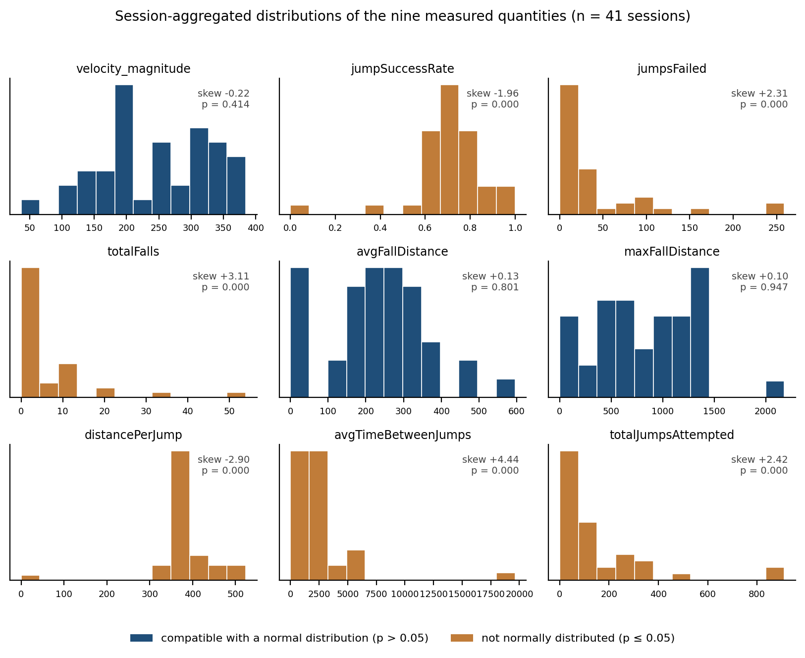
Session-aggregated distributions of the nine measured quantities, with skewness and D’Agostino p-value

ML Model Development and Evaluation

Experimental Setup and Evaluation Protocols
All models were trained on the 17,798 labelled rows of the working dataset described in Section 4, using the nine features of Section 4.5, with scikit-learn 1.8.0 and xgboost 3.2.0. The XGBoost configuration, 30 estimators, maximum depth 3, learning rate 0.1 and a base score fixed at 0.5, was chosen a priori from the deployment constraint of Chapter 6 rather than by search: deeper or more numerous trees enlarge the transpiled JavaScript payload. No hyperparameter search was conducted and no validation split was reserved for one, so all reported figures are those of an untuned model.
Building on the reasoning in Section 2.5, model quality is reported under two protocols with distinct epistemic roles.
Protocol A - row-level hold-out
The rows are partitioned into 80% training and 20% testing using a stratified split with a fixed random state of 42. Since rows from the same session appear on both sides of the split and the cumulative features make consecutive rows within a session nearly identical duplicates, this protocol measures in-distribution row classification. It is retained for comparability with standard practice and as an upper bound and no evidence of generalization.
Protocol B - leave-one-session-out cross-validation (primary evidence)
Forty-one folds; in each fold, every row of one session forms the test dataset and the remaining 40 sessions form the training set. The results are aggregated at the session level, each session receives the mean predicted probability across its rows, and the session-level AUC is computed over the resulting 41 values, with a 95% confidence interval based on 4,000 bootstrap resamples over session. The session, not the row, is the independent unit.
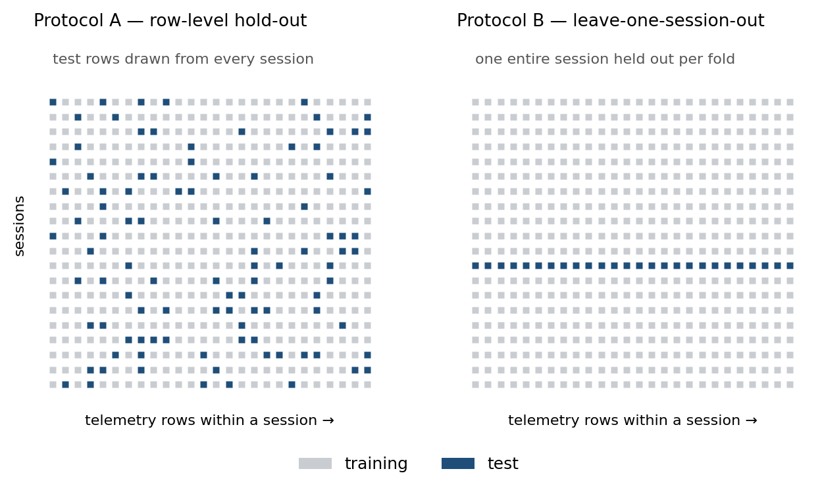
The two protocols. Under Protocol A test rows are drawn from every session; under Protocol B one entire session is held out per fold.
Protocol B’ - leave-one-player-out
Since September 2026 the game client stores an anonymous, persistent “player_id”. 15 of the 41 sessions have a unique identifier covering 13 individuals, two of them who played twice. The 26 earlier were retroactively assigned a single identifier and therefore form one group by necessity, not because they originate from one person. Protocol B’ repeats the cross-validation over these 14 groups and is the most rigorous test available for generalisability to an unseen player.
Reference baseline
All results are contextualised by the majority-class predictor, which always predicts non-completion and is correct in 28 out of 41 sessions (68.3 %). Session counts are tested against this baseline with a one-sided binomial test.
Single-feature reference
Since the label is defined to reach the top of the level and one of the features is the vertical position, a model that is using “pos_y” alone is reported alongside every feature set. It quantifies how much of a measured performance is actually achieved through learning.
Stratified evaluation
To separate outcome “prediction” from outcome “recognition”, Protocol B results are further broken down into five bands of “pos_y”. Within a band, the position is approximately the same, so a feature set containing information beyond the progress must exceed 0.5 there. A second breakdown based on elapsed session time (Section 5.7) addresses the additional question of how early the prediction becomes usable.

Protocol A - Row-level Hold-out
Model comparison under Protocol A (row-level hold-out, 20%, stratified, random_state = 42). In-distribution upper bound.
Model | Accuracy | F1-Score | AUC-ROG
Majority-class baseline | 63.5% | - | 0.500
Logistic Regression | 85.0% | 0.779 | 0.913
Decision Tree (depth = 4) | 87.9% | 0.813 | 0.936
XGBoost (30 trees, depth = 3) | 92.5% | 0.892 | 0.973
An AUC of 0.973 indicates nearly perfect ranking of held-out rows. Per Section 2.5, rows are not independent observations: at any moment the tuple of “totalJumpsAttempted”, “totalFalls”, “jumpSuccessRate” and “pos_y” nearly fingerprints a session. Therefore a model can just reach these figures by recognising which session a row belongs to. Table 5.2.1 is therefore an upper bound, and every claim of this thesis rests on Table 5.3.1.

Protocol B - Leave-One-Session-Out
Model comparison under Protocol B (leave-one-session-out, 41 folds; primary evidence). Session-level AUC with bootstrap 95 % CI; p from a one-sided binomial test of the session count against the majority baseline.
Feature set / model | Session AUC | 95% CI | Sessions correct | p | Brier
Majority-class baseline | 0.500 | - | 28/41 | - | -
pos_y alone (XGBoost) | 0.923 | [0.81, 1.00] | 38/41 | 0.0002 | 0.109
All nine features (Logistic Regression) | 0.876 | [0.70, 1.00] | 37/41 | 0.0010 | 0.107
All nine features (XGBoost) | 0.868 | [0.70, 0.99] | 36/41 | 0.0036 | 0.121
All nine features (Decision Tree) | 0.874 | [0.69, 0.99] | 34/41 | 0.028 | 0.114
Cumulative features without position | 0.838 | [0.66, 0.97] | 33/41 | 0.061 | 0.149
Rolling behavioural features (Section 5.6) | 0.876 | [0.76, 0.97] | 33/41 | 0.061 | 0.137
Four observations follow.
First, the telemetry-based prediction outperforms the majority baseline. Three configurations clear the threshold with room to spare: “pos_y” alone at 38 of 41 sessions (p = 0.0002), Logistic Regression on the nine features at 37 of 41 (p = 0.0010) and XGBoost on the same features at 36 of 41 (p = 0.0036). All three remain significant under a Bonferroni correction for the six comparisons in the table (Section 5.8). This is the first configuration of this pipeline for which the statement can be made at all, because an earlier dataset of 25 sessions produced 19 out of 25 against a baseline of 17 out of 25, which is indistinguishable from pure chance (p = 0.27).
Second, the gap between protocols remains large. XGBoost falls from an AUC of 0.973 on held-out rows to 0.868 on held-out sessions. The difference indicates the extent to which row-level performance was attributable to session detection rather than transferable behaviour.
Third, “pos_y” alone still achieves the highest session-level AUC (0.923) and the most correct sessions (38/41). No learned model on the full feature set improves on a single positional variable at session level.
Fourth, the model ordering of Protocol A does not survive. On rows, XGBoost leads the Decision Tree, which leads Logistic Regression. On sessions the three lie within 0.008 of each other and within each other’s confidence intervals, with the linear model marginally ahead. Protocol A ranks models on their ability to recognise sessions, which is not the ability of interest.

An Instrumentation Artefact: avgTimeBetweenJumps
An earlier configuration of this pipeline, trained on a feature set of 10 features that still contained “avgTimeBetweenJumps”, achieved an accuracy of 95.9% and an AUC of 0.997 under Protocol A, with “avgTimeBetweenJumps” being the strongest predictor at 30.4%. This result was interpreted as confirming the literature on frustration described in Section 2.2: Long pauses before a jump indicate disengagement. The interpretation was incorrect, and the mechanism is instructive.
The feature was calculated on the client as the difference between the landing and the next jump. Phaser’s scene clock is paused while the game is paused, but the global clock is not; therefore, the entire duration of a pause was included in this difference. In one affected session the value jumps from 1,331 ms to 6,286 ms across a pause, and in another from 1,083 ms to 22,992 ms. Every one of the twelve sessions that ever crossed the model’s threshold was abandoned, which is why the rule was learned so decisively. The model therefore learned that “this player has paused” implies the prediction “this player will quit”. The structure is visible in the exported model: 25 of the 30 trees tested avgTimeBetweenJumps at the root, 21 of them at 1940.95 ms and four more at 1908.01 ms, and the alternative branch led to a constant negative leaf, where all further inputs including the position were ignored. When evaluated at the same position shortly before the goal, 1,900 ms yielded a 96.1% probability of winning, while 1,941 ms yielded an 11.8% probability; a single pause or the automatic pause after ten seconds of inactivity (Section 3.4) pinned the displayed probability at approximately 12% for the remainder of the run.
The shape of a single tree in the exported model shows the mechanism directly. input[5] is avgTimeBetweenJumps, input[9] is pos_y:
// src/scenes/WinPredictor.ts, model version of 10 June 2026
if (input[5] < 1940.9534) {
if (input[9] < 5981.333) { ... } // position and further features still consulted
else { ... }
} else {
var0 = -0.19991912; // constant: everything else ignored
}
Once the threshold is crossed, the tree returns a constant negative value. Neither the position in the level nor any behavioural feature is consulted any further.
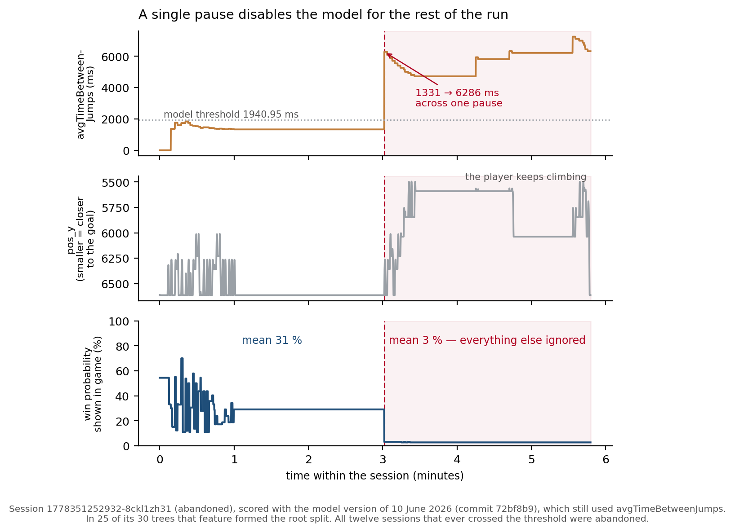
A single pause disables the model for the rest of the run. Session 1778351252932-8ckl1zh31 (abandoned), scored with the model version of 10 June 2026
The instrumentation was corrected in the client in September of 2026, and the correction is verifiable in the telemetry. The fix subtracts the time spent paused between landing and the next jump:
// src/scenes/Level.ts, applyJump()
if (this.landTime > 0) {
// Only time actually spent playing counts as planning time —
// whatever the player paused is subtracted.
const pausedSinceLanding = this.totalPausedTime - this.landPausedTotal;
const planning = (this.jumpStartTime - this.landTime) - pausedSinceLanding;
this.totalPlanningTime += Math.max(0, planning);
this.planningTimeCount++;
}
Across the 26 sessions recorded before it, the per-session maximum of “avgTimeBetweenJumps” has a median of 1,907 ms and reaches 22,992 ms, with six sessions above 5,000 ms. Across the 15 sessions recorded after the fix, the median is 2,233 ms and the maximum 3,621 ms, with no session above 5,000 ms. The extreme values are now gone.
Two conclusions must be distinguished from one another. The measurement was invalid, and results derived from it cannot be interpreted. However, this does not imply that the pause is unrelated to the abandonment: the substantive question was rendered unmeasurable, not answered.

The Dominance of Vertical Progress
XGBoost feature importance, nine-feature model.(Fitted on all 17,798 training rows rather than out-of-fold)
Rank | Feature | Gain | Description
1 | pos_y | 35.2 % | Vertical position, i.e. progress through the level
2 | totalJumpsAttempted | 12.7 % | Cumulative jump attempts
3 | totalFalls | 12.6 % | Cumulative falls
4 | jumpsFailed | 11.6 % | Cumulative failed jumps
5 | jumpSuccessRate | 10.1 % | Proportion of successful jumps
6 | distancePerJump | 7.5 % | Distance covered per jump
7 | maxFallDistance | 7.3 % | Largest fall so far
8 | pos_x | 2.9 % | Horizontal position
9 | velocity_magnitude | 0.0 % | Never used as a split
The largest single contribution comes from the vertical position, and Section 5.3 showed that “pos_y” alone performs better at the session level than the entire dataset. Since the label is defined as having reached the top of the level, the question arises as to whether the model predicts a result or specifies a position. The stratified evaluation provides an answer to this question.
Session-level AUC within bands of vertical progress (out-of-fold predictions, Protocol B; 60-second window for the rolling sets). Smaller “pos_y” means closer to the goal.
Feature set | Start > 6000 | early 4500–6000 | middle 2000–4500 | late 500–2000 | goal ≤ 500
pos_y alone | 0.635 | 0.489 | 0.453 | 0.231 | 0.000
All nine features | 0.687 | 0.701 | 0.718 | 0.641 | 0.692
Cumulative, without position | 0.516 | 0.520 | 0.624 | 0.615 | 0.615
Rolling, behavioural only | 0.802 | 0.819 | 0.803 | 0.538 | 0.346
Rolling, including motion measures | 0.775 | 0.842 | 0.855 | 0.590 | 0.385
Sessions in band | 13 W / 28 L | 13 W / 17 L | 13 W / 9 L | 13 W / 3 L | 13 W / 2 L
The two right-hand bands (late 500-2000 & goal ≤ 500) contain two and three negative sessions and are not interpretable; they are shown for completeness and excluded from the discussion.
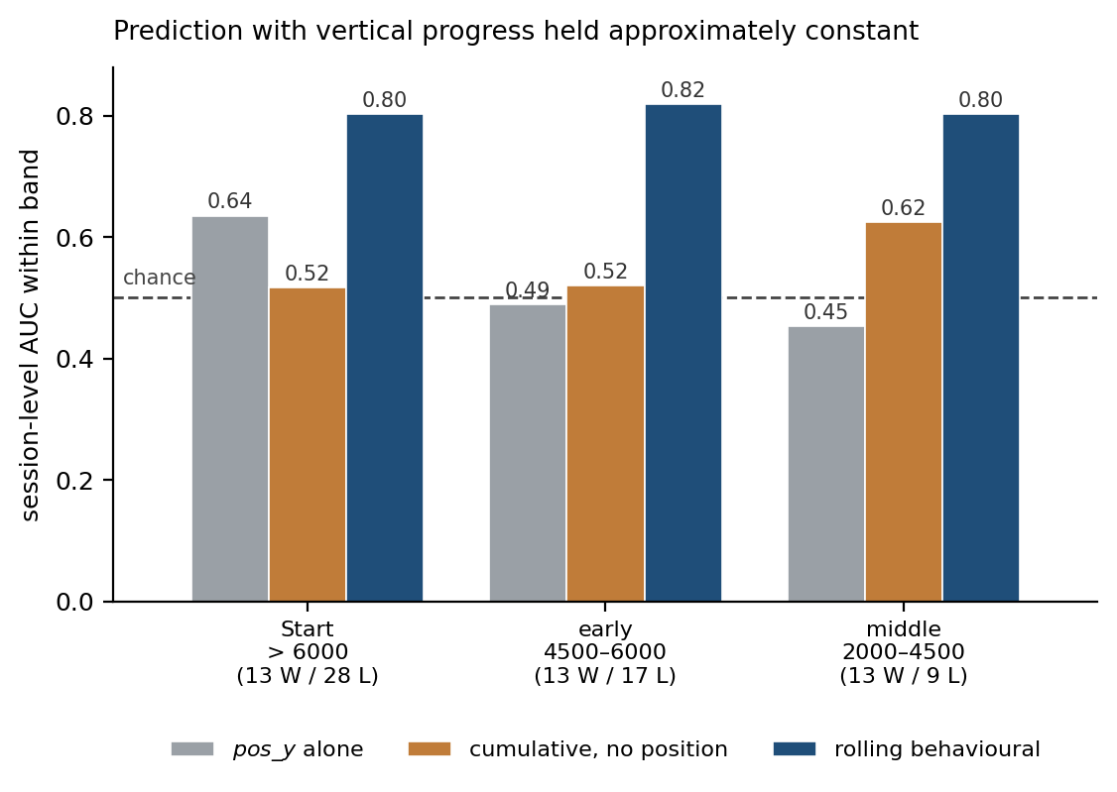
Session-level AUC within the three interpretable progress bands
In the three bands that carry enough sessions, “pos_y” alone performs at chance (0.635 / 0.489 / 0.453), which is the expected result once height is held approximately constant. The strong session-level result of Table 5.3.1 therefore rests almost entirely on one nearly circular fact: a player who is close to the goal usually reaches it. This is not specific to the present system, in the esports win-prediction models that motivate this work, the gold and experience differential plays the role that “pos_y” plays here [5]. Position dominance is a property of live outcome prediction, not a defect of this implementation.
The rows that answer the second research question are the last two. For behavioural features expressed as rates over a moving window(rolling), the model reaches 0.80 to 0.82 within every interpretable band. Clearly above chance, and clearly above both the position-based and the cumulative datasets. Behavioral telemetry thus makes a contribution that goes beyond spatial progress. Whether this is the case depends on how the features are constructed, which is the subject of the next section.

Feature Construction: Cumulative Counters and Rolling Windows
Four of the seven cumulative behavioral measures increase monotonically with session duration and correlate accordingly with elapsed time: totalJumpsAttempted at Spearman ρ = +0.95, jumpsFailed at +0.95, maxFallDistance at +0.81 and totalFalls at +0.77, against +0.05 for distancePerJump and −0.10 for jumpSuccessRate. They are basically clocks. Since completed runs take longer than aborted ones (median 3.6 versus 3.2 minutes), a time-based metric naturally contains information. The clock alone, however, does not account for the result. “totalJumpsAttempted” on its own reaches a session-level AUC of 0.651 and session duration 0.615, against 0.838 for the full cumulative set.
What really limits the cumulative features is not their correlation with time but how they behave once progress is held constant. In the two best-populated bands of Table 5.5.2 they reach only 0.516 and 0.520. Compare two players at the same height: how many attempts each has made since the start says little about which of them will finish.
A second feature set was therefore built. Instead of totals, it records what happened in the last 60 seconds: each counter is compared with its value at the start of the window and divided by the seconds that passed. The construction is a difference against the row at the window boundary:
# ml_pipeline/rolling_features.py — i is the current row, j the first row
# still inside the window, span_s the seconds actually covered by it.
for src, name in [('totalJumpsAttempted', 'jumps'),
('jumpsFailed', 'fails'),
('totalFalls', 'falls')]:
c = g[src].to_numpy(dtype=float)
delta = c[i] - c[j]
out[f'w_{name}'] = delta
out[f'w_{name}_per_s'] = delta / span_s
# No jump inside the window leaves the success rate undefined; 0.5 is the
# neutral value that does not push the model in either direction.
out['w_success'] = np.where(out['w_jumps'] > 0,
(out['w_jumps'] - out['w_fails']) / np.maximum(out['w_jumps'], 1),
0.5)
This gives jump attempts, failed jumps and falls per second, the jump success rate within the window, and the share of the window spent idle, charging a jump, or holding an input. Unlike the cumulative counters, none of these grow with session length. These features must be computed on the complete row stream in chronological order, before terminal states are removed and before subsampling, or otherwise the window has gaps and the rates come out wrong.
The result is the fourth row of Table 5.5.2. A consistent within-band AUC of 0.80 to 0.82, against 0.52 to 0.62 for the cumulative construction on the same raw telemetry. At session level the two sets are close (0.876 against 0.838). Neither contain “pos_y”, yet both carry indirect traces of how far the run got, and at that level those traces dominate both scores. The comparison is therefore blind to the difference between the sets. The difference appears only once progress is taken into account, which is precisely the comparison the second research question asks for.
One caveat on this set is itself a finding. Adding the three motion measures (w_vel_mean, w_vel_std, and w_y_std) raises the session-level AUC from 0.876 to 0.915, but the gain comes largely from “w_y_std”, the spread of vertical position within the window, which correlates with “pos_y” at ρ = −0.81, a positional indicator inside a feature set built to avoid exactly that. The behavioural-only set, which excludes all three motion measures, is therefore the one reported as evidence.

Prediction over Elapsed Time
Section 5.5 asked what the model can do once the position is held constant. For a system intended to intervene while a run is still in progress, a second question matters just as much: how early is the prediction usable at all? Table 5.7.1 answers this by grouping the same out-of-fold predictions by elapsed session time rather than by height. No model is retrained, just the grouping changed.
Session-level AUC by elapsed time within the session (out-of-fold predictions, Protocol B).
Feature set | 0–30 s | 30–60 s | 60–120 s | 120–240 s | > 240 s
pos_y alone | 0.766 | 0.906 | 0.893 | 0.906 | 0.855
All nine features | 0.750 | 0.860 | 0.821 | 0.856 | 0.527
Rolling behavioural features | 0.786 | 0.818 | 0.769 | 0.778 | 0.727
Sessions in window | 13 W / 28 L | 13 W / 22 L | 13 W / 18 L | 12 W / 15 L | 5 W / 11 L
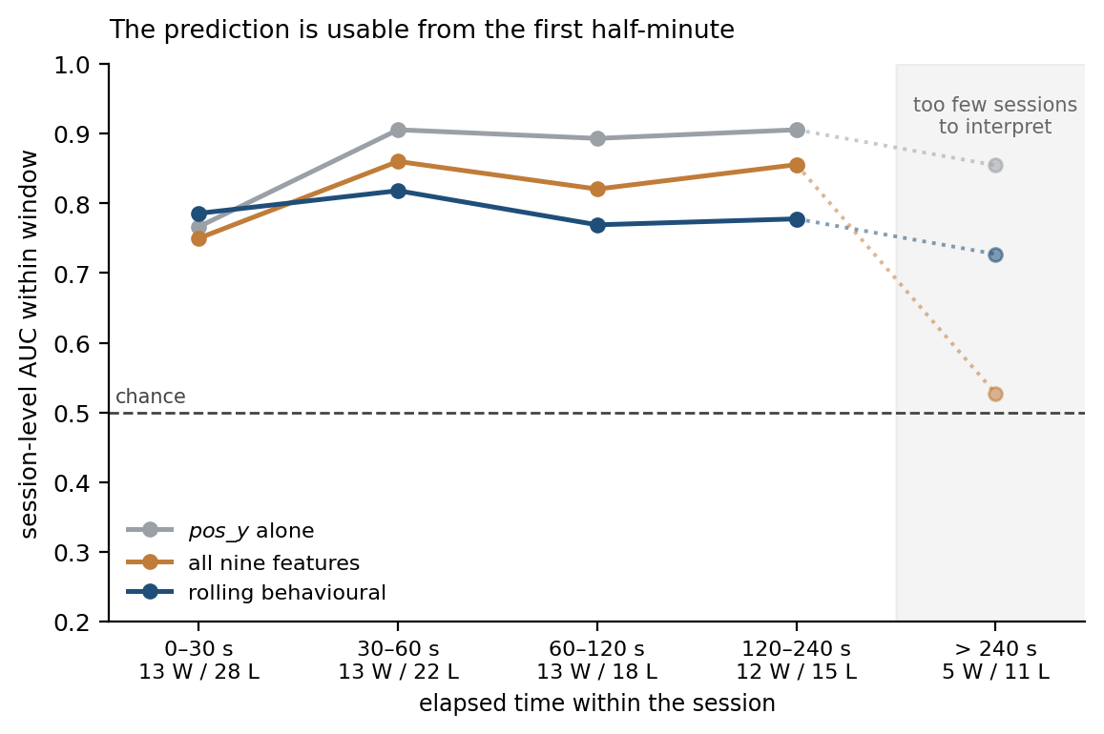
Session-level AUC by elapsed time within the session
The prediction is therefore usable from the first 30 seconds. In this timeframe, all three feature sets range between 0.75 and 0.79, and after one minute the single-feature positional model reaches 0.906. The premise of early prediction outlined in Section 1.1 is thus confirmed. A run can be assessed long before it ends, which is a prerequisite for any reactive system.
The result also qualifies the reading of Section 5.5. Within the first 30 seconds the sessions have already separated: runs that were later completed reach a median “pos_y” of about 5,600 by the end of that window, against roughly 6,360 for runs that were later abandoned, from a common starting point of 6,612. At a fixed point in time, “pos_y” is therefore not just a location but also a rate of progress, and it is informative for that reason. The two breakdowns hold different things constant and therefore give opposite answers about “pos_y”: comparing sessions at the same height removes its prediction value (Table 5.5.2), while comparing them at the same moment preserves it.
In the earliest window the rolling behavioural features are the strongest of the three sets, marginally ahead of the single-feature positional model (0.786 against 0.766). But the margin is too marginal to carry any weight with just 13 completed sessions. The final column rests on 5 completed and 11 abandoned sessions and is not interpreted, the apparent collapse of the 9 feature model is a characteristic of this model and not a finding.

Robustness
Collection waves
The 41 sessions come from two collection waves, 26 before September and 15 after. If the model were telling the waves apart rather than reading behaviour, its scores would order sessions by wave. They do not, the nine-feature model separates old from new at an AUC of 0.513 and the rolling set at 0.497.
Player-level generalisation (Protocol B’)
Grouping by player rather than by session leaves the results intact: pos_y alone 0.931 (37/41), the nine-feature model 0.846 (38/41), the rolling behavioural set 0.904 (34/41). The 15 post-September sessions, from 13 identified individuals, can also be evaluated on their own, where all three sets reach 0.98 to 1.00 with 14 of 15 correct. With five completed sessions that is an indication rather than an estimate, but it is the only measurement in this thesis taken exclusively on identified, independent players.
Further checks
Window lengths from 10 to 300 seconds give session-level AUCs between 0.849 and 0.893 with no identifiable optimum, so the 60-second window is a convention rather than a tuned value. Three different subsampling seeds change the result by less than 0.006.
Multiple comparisons
Table 5.3.1 tests six feature sets against the same baseline on the same 41 sessions, so the chance of at least one false positive at the 0.05 level is roughly 26 %. A Bonferroni correction (0.05 / 6 = 0.0083) leaves the three leading configurations significant and the other three below the threshold. The correction is strict here, since the tests share data and features, but the conclusions of this chapter rest on the configurations that survive it.
Calibration
The Brier scores in Table 5.3.1 favour the simplest models, Logistic Regression at 0.107 and pos_y alone at 0.109, against 0.121 for the nine-feature XGBoost. No reliability diagram is reported: with 13 completed sessions, any binning of the predicted probabilities leaves one or two positive cases per bin, and the resulting curve would show sampling noise. The in-game display of Chapter 6 is therefore a monotone score, not a calibrated probability.

Summary of Findings
- Under a row-level split the model reaches 92.5 % accuracy and an AUC of 0.973. Under leave-one-session-out evaluation it falls to 0.868. The gap is the share of the row-level figure that came from recognising sessions rather than reading behaviour.
- Three configurations beat the majority baseline at p ≤ 0.0036 and survive correction for multiple comparisons. The strongest single predictor is pos_y alone, correct in 38 of 41 sessions.
- Within bands of comparable progress, neither the positional nor the cumulative features exceed chance. The headline figures therefore rest on a nearly circular fact: a player close to the goal usually reaches it. Published live win-prediction models behave the same way.
- Behavioural telemetry does contribute beyond progress, but only as rates over a moving window: 0.80 to 0.82 within every interpretable band, against 0.52 to 0.62 for the same telemetry accumulated over the session. The prediction is usable from the first 30 seconds.
- Four shortcuts were found with the same check: a pause-duration artefact in avgTimeBetweenJumps, session recognition under the row-level split, positional dominance in the feature importances, and a positional proxy (w_y_std) inside the feature set built to avoid it. The results survive player-level grouping and a check on the two collection waves.

In-Game Integration

Model Export with m2cgen
The deployment constraint of Section 1.2 rules out a server, and it also rules out shipping a model runtime with the game. The trained model is therefore transpiled into plain JavaScript with m2cgen [19]. What ships is not a model file but source code: a fixed sequence of comparisons and additions that the browser executes like any other script. There is nothing to load and nothing to install. The cost is the size of that code. Because the ensemble was deliberately kept small, 30 trees of depth 3, chosen for exactly this reason (Section 5.1). The exported model is 23,482 characters.

Integration into the Game Client
The transpiled code sits in “WinPredictor.ts”. During play the game reads nine values from its own state, in a fixed order, and passes them as a plain array. Inference runs about once per second and is suspended outside active play. Inference cost was measured in two environments that share the same JavaScript engine: in the browser over 500,000 consecutive calls, and in Node.js with a nanosecond-resolution timer. The two disagree by a factor of six (0.04 µs against 0.21 µs per call), which is characteristic of just-in-time compilation rather than of a real difference. Either figure is at least four orders of magnitude below the 16.7 ms frame budget at 60 frames per second, and inference runs once per second. The overhead is therefore not measurable in practice.
What the output may claim is a separate question. Section 5.8 established that the model produces a monotone score and not a calibrated probability: a higher value does mean a better chance, but a value of 0.3 does not mean 30% win-chance. The display is therefore an unlabelled bar whose colour moves continuously from red to green, with no printed number and no fixed thresholds.

What the Deployment Supports
A live prediction shows how a run is going while it is still going, which is what makes assistance during a run possible at all. Whether either is a good idea is a separate question.
The question for this chapter is narrower: is the deployed model good enough to act on? Within a band of comparable progress it reaches an AUC of 0.69 to 0.72. That is a real signal, but weaker than the 0.80 to 0.82 of the window-based feature set of Section 5.6 and the window-based set is not the one deployed. Using it would require the game to remember the last sixty seconds of counter values and to differentiate them at each prediction. That is a change to how the client keeps state, not a change to a list of feature names, and it is the most concrete extension this thesis leaves open.

Discussion & Conclusion
draft:
On an earlier dataset of 25 sessions with eight completions, no model beat the majority baseline, and the behavioural features reached only 0.60 to 0.63 within progress bands. A learning curve on that dataset rose steeply through its final point. This suggested that the limit was the amount of data, not the choice of method, and fifteen further sessions were collected. The suggestion held: the within-band figures rose to 0.80 to 0.82, and the session counts became separable from the baseline.
Recomputed on the present 41 sessions, the curve no longer rises. The earlier slope was therefore a property of the smaller sample, not of the problem itself. The conclusion was right, but the evidence for it was weaker than it looked at the time. There is also no reason now to expect large gains from more sessions of the same kind. What limits the result is the width of the confidence intervals, and that is set by the 13 completed sessions.

References
[1] Mustač, K., Bačić, K., Skorin-Kapov, L., & Sužnjević, M. (2022). Predicting player churn of a free-to-play mobile video game using supervised machine learning. Applied Sciences, 12(6), 2795.
[2] Milošević, M., Živić, N., & Andjelković, I. (2017). Early churn prediction with personalized targeting in mobile social games. Expert Systems with Applications, 83, 326–332.
[3] Lee, E., Jang, Y., Yoon, D., Jeon, J., Yang, S. I., Lee, S. K., Kim, D. W., Chen, P. P., Guitart, A., Bertens, P., Periáñez, Á., Hadiji, F., Müller, M., Joo, Y., Lee, J., Hwang, I., & Kim, K. J. (2019). Game data mining competition on churn prediction and survival analysis using commercial game log data. IEEE Transactions on Games, 11(3), 215–226. https://doi.org/10.1109/TG.2018.2888863
[4] Wolterink, M., & Bakkes, S. (2021). Towards explainable prediction of player frustration in video games. In Proceedings of the 16th International Conference on the Foundations of Digital Games (FDG 2021). ACM.
[5] Hodge, V. J., Devlin, S., Sephton, N., Block, F., Cowling, P. I., & Drachen, A. (2021). Win prediction in multiplayer esports: Live professional match prediction. IEEE Transactions on Games, 13(4), 368–379. https://doi.org/10.1109/TG.2019.2948469
[6] Katona, A., Spick, R., Hodge, V. J., Demediuk, S., Block, F., Drachen, A., & Walker, J. A. (2019). Time to die: Death prediction in Dota 2 using deep learning. arXiv Preprint arXiv:1906.03939. https://arxiv.org/abs/1906.03939
[7] David, D., & Zahra, A. (2024). Player churn prediction in free to play game using ensemble learning. Action Research Literate, 8(4), 543–549. https://doi.org/10.46799/arl.v8i4.280
[8] Jia, F., Jiang, S., Cao, T., Cui, W., Xia, T., Cao, X., Li, Y., Wang, Q., Zhang, D., Ren, J., Liu, Y., Qiu, L., & Yang, M. (2024). Empowering in-browser deep learning inference on edge through just-in-time kernel optimization. In Proceedings of the 22nd Annual International Conference on Mobile Systems, Applications and Services (MOBISYS ’24) (pp. 438–450). Association for Computing Machinery. https://doi.org/10.1145/3643832.3661892
[9] Bontchev, B., & Georgieva, O. (2018). Playing style recognition through an adaptive video game. Computers in Human Behavior, 82, 136–147. https://doi.org/10.1016/j.chb.2017.12.040
[10] Liao, N., Guzdial, M., & Riedl, M. (2017). Deep convolutional player modeling on log and level data. In Proceedings of the 12th International Conference on the Foundations of Digital Games (FDG ’17). ACM. https://doi.org/10.1145/3102071.3106346
[11] Bombardieri, N., & Guzdial, M. (2022). Improving deep localized level analysis: How game logs can help. In Experimental AI in Games Workshop (EXAG 2022). arXiv Preprint arXiv:2212.03376. https://arxiv.org/abs/2212.03376
[12] Cowley, B., Charles, D., Black, M., & Hickey, R. (2013). Real-time rule-based classification of player types in computer games. User Modeling and User-Adapted Interaction, 23(5), 489–526. https://doi.org/10.1007/s11257-012-9126-z
[13] Quwaider, M., Alabed, A., & Duwairi, R. (2023). Shooter video games for personality prediction using five factor model traits and machine learning. Simulation Modelling Practice and Theory, 122, 102665.
[14] Emre, İ. E., & Çotul, S. E. (2026). Prediction of player churn in mobile games using classification algorithms. Journal of Data Applications, 4, 20–29. https://doi.org/10.26650/JODA.1742874
[15] Wheat, D., Masek, M., & Hingston, P. (2016). Modeling perceived difficulty in game levels. In Proceedings of the Australasian Computer Science Week Multiconference (ACSW ’16). ACM.
[16] Pedersen, C., Togelius, J., & Yannakakis, G. N. (2009). Modeling player experience in Super Mario Bros. In 2009 IEEE Symposium on Computational Intelligence and Games (CIG 2009) (pp. 132–139). IEEE. https://doi.org/10.1109/CIG.2009.5286482
[17] Yannakakis, G. N., & Togelius, J. (2018). Artificial intelligence and games. Springer.
[18] Chen, T., & Guestrin, C. (2016). XGBoost: A scalable tree boosting system. In Proceedings of the 22nd ACM SIGKDD International Conference on Knowledge Discovery and Data Mining (KDD ’16) (pp. 785–794). ACM. https://doi.org/10.1145/2939672.2939785
[19] BayesWitnesses. (2019). m2cgen (Version 0.10.0) [Computer software]. GitHub. https://github.com/BayesWitnesses/m2cgen
[20] Kaufman, S., Rosset, S., Perlich, C., & Stitelman, O. (2012). Leakage in data mining: Formulation, detection, and avoidance. ACM Transactions on Knowledge Discovery from Data, 6(4), Article 15. https://doi.org/10.1145/2382577.2382579
[21] Niculescu-Mizil, A., & Caruana, R. (2005). Predicting good probabilities with supervised learning. In Proceedings of the 22nd International Conference on Machine Learning (pp. 625–632). Association for Computing Machinery. https://doi.org/10.1145/1102351.1102430
[22] Saeb, S., Lonini, L., Jayaraman, A., Mohr, D. C., & Körding, K. P. (2017). The need to approximate the use-case in clinical machine learning. GigaScience, 6(5), Article gix019. https://doi.org/10.1093/gigascience/gix019
[23] Seif El-Nasr, M., Drachen, A., & Canossa, A. (Eds.). (2013). Game analytics: Maximizing the value of player data. Springer. https://doi.org/10.1007/978-1-4471-4769-5

