Title* (use style : paper title)

Line 1: 1st Given Name Surname
Line 2: dept name of organization (of Affiliation)

This electronic document is a “live” template and already defines the components of your paper [title, text, heads, etc.] in its style sheet [1]. *CRITICAL: Do Not Use Symbols, Special Characters, Footnotes, or Math in Paper Title or Abstract[2]. (Abstract)
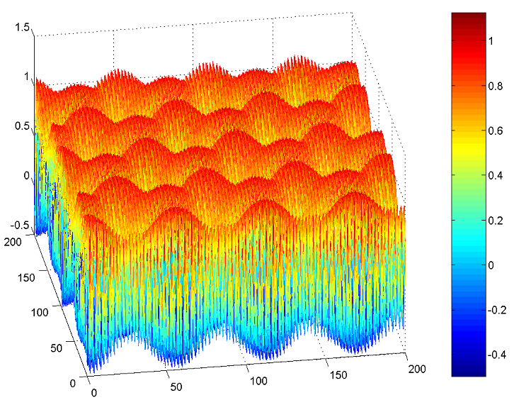
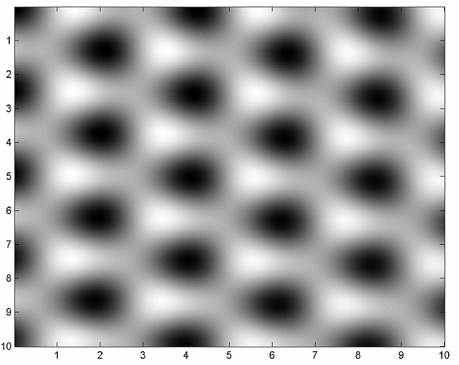
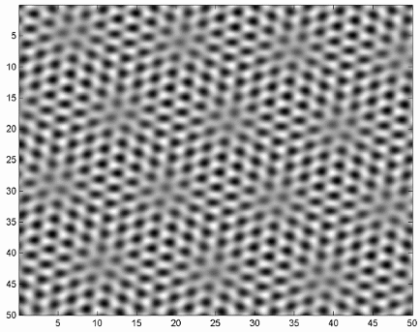

Fig.1 – Figure details
Fig.1 – Figure details

Fig.1 – Figure details

References
[1] C.R. Clemmer, T.P. Beebe Jr., Science 251 (1991) 640
[2] J. Xhie, K. Sattler, M. Ge, N. Venkateswaran, Phys. Rev. B 47 (1993) 15835
[3] R. Hentschke, B. Schurmann, J. Rabe, J. Chem. Phys. 96 (1992) 6213

