**Git Whole Practice Assignment**

Initialize a new repository for the project using Git.

**A:** Use git add command to stage a new file. Use “git commit” command with commit message to commit changes in the git repository. Check the status using “git status” command. Check commit history in Git Repository using git log.

**B:** Create an account in GitHub. Use git pull command to pull changes from GitHub

and git push command to push local changes into GitHub repository.

**C**: Create a feature branch in the git repository using git checkout –b command and modify the file. Commit the changes. Switch to the master branch. Use git diff command to view differences between master branch and feature branch. Use git difftool command to view differences in the p4merge tool.

**D**: Use p4merge tool to resolve the merge conflicts. Create Lightweight and Annotated tags for the commits. Create a branch from the stash using git stash branch command to move the changes to new branch.

**Initialize a new repository for the project using Git.**

* Created **MyFirstGitRepo** project using Git

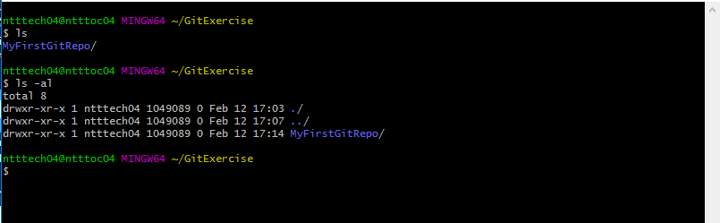

**-** Use **git add** command to stage a new file.

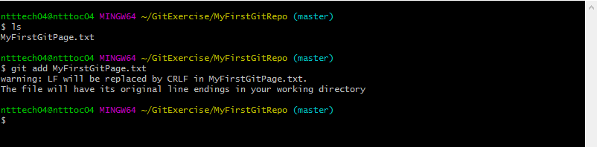

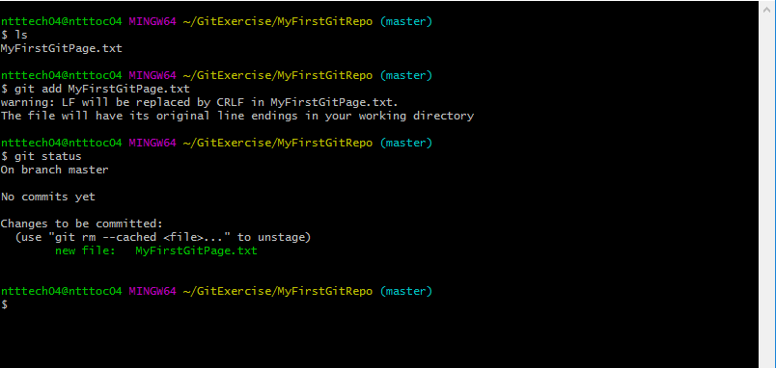

* Use “git commit” command with commit message to commit changes in the git repository.

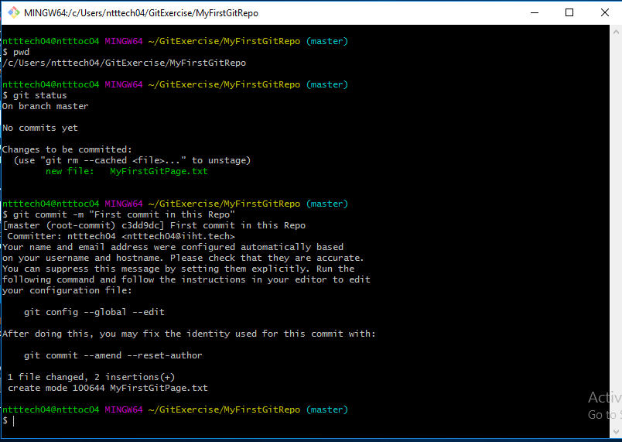

* Check the status using “git status” command.

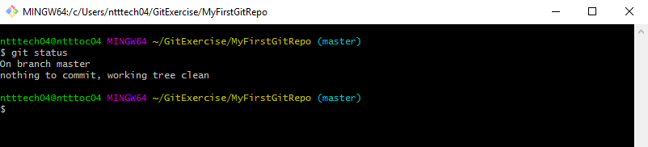

* Check commit history in Git Repository using git log.

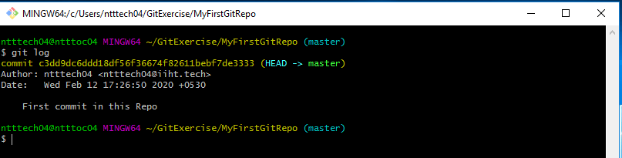

**B. Create an account in GitHub.**

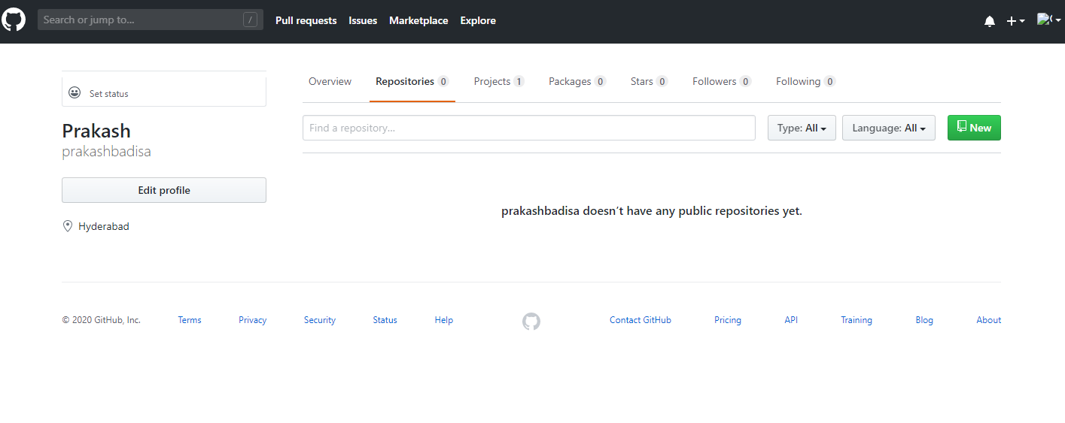

* Use git Push command to push changes to GitHub.

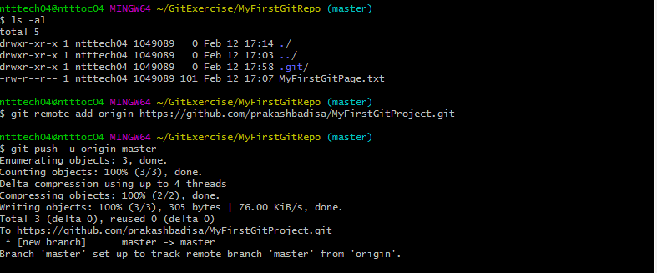

**-** Use git pull command to pull changes from GitHub

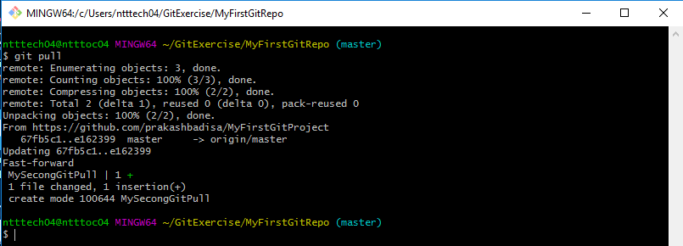

**C.** Create a feature branch in the git repository using git checkout –b command and modify the file.

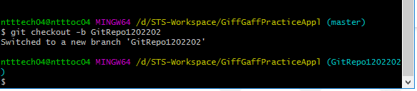

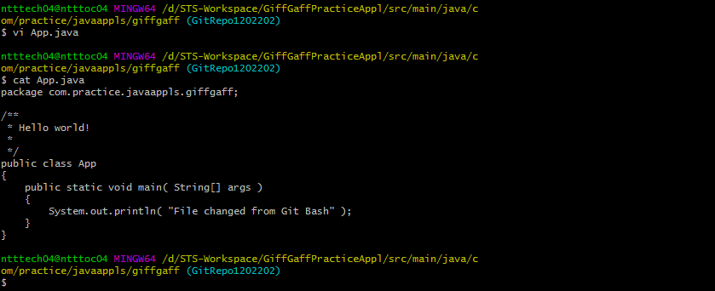

Commit the changes.

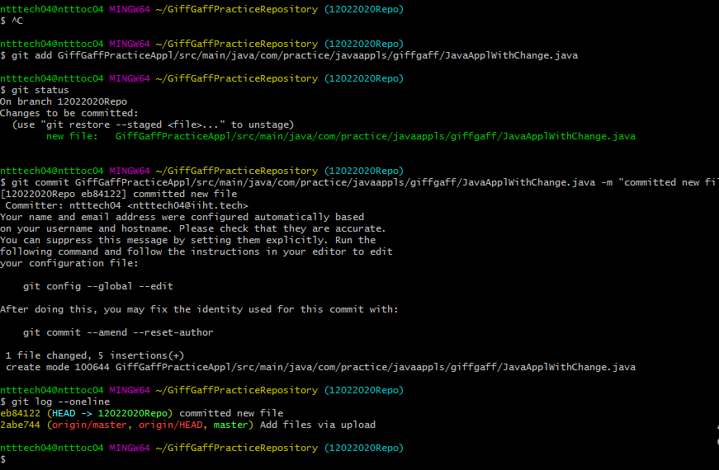

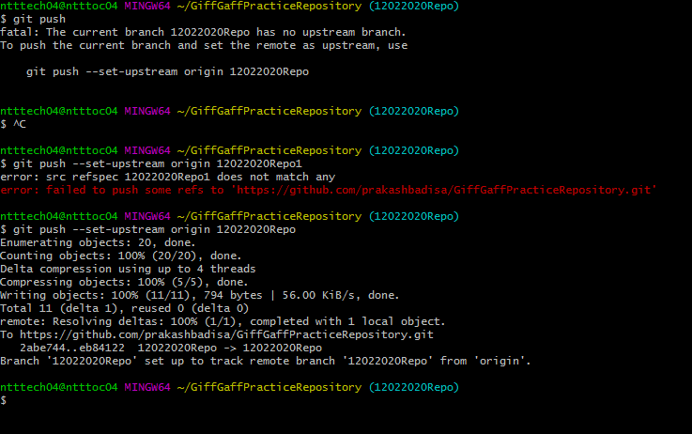

Switch to the master branch.

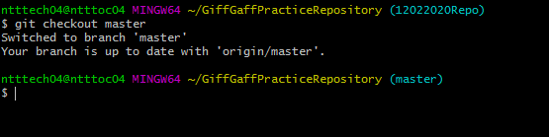

Use git diff command to view differences between master branch and feature branch.

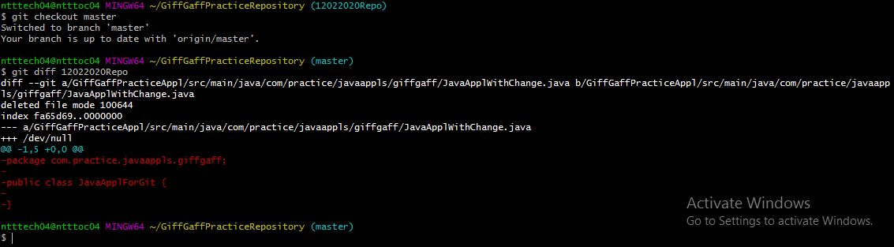

To view differences in the p4merge tool.

