## MOCKITY WITH JUNIT WHOLE PRACTICE DOCUMENT

Create a simple maven project with group id com.in28mins & write a Junit test for the

Truncate A In First 2 Positions method by passing a string & add test case & assertEquals run the test without failure & run successful Junit.

1). Run a test method that includes before, after, before class & after class methods.

2). Write a mocks example ToDo service management system & create a unit test using a stub to implement the ToDo service.

3). Write a test mock list get using BDD in a Given, When & Then style add a delete Todo method in the service interface.

4). Add the ham crest library dependency to porm.xml & use the assert that method & do ham crest matchers test.

1). Create a simple maven project with group id com.in28mins & write a Junit test for the

truncateAInFirst2Positions method by passing a string & add test case &assert Equals run the test without failure & run successful Junit.

Run a test method that includes before, after, before class & after class methods.

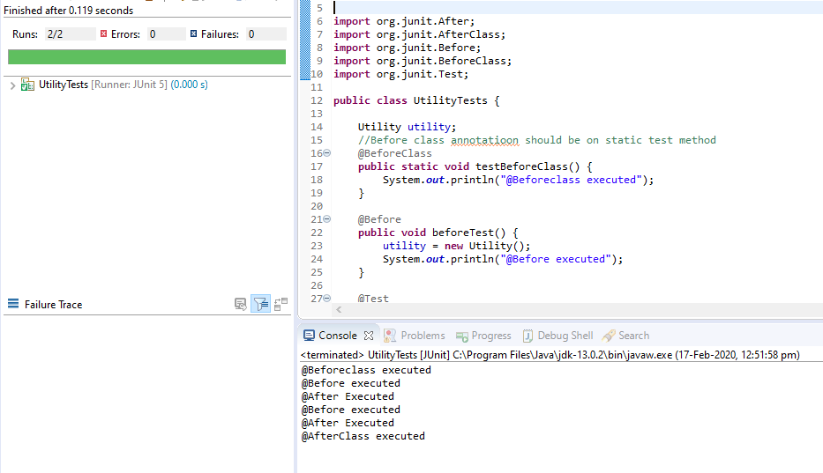

2) Write a mocks example ToDo service management system & create a unit test using a stub to implement the ToDo service.

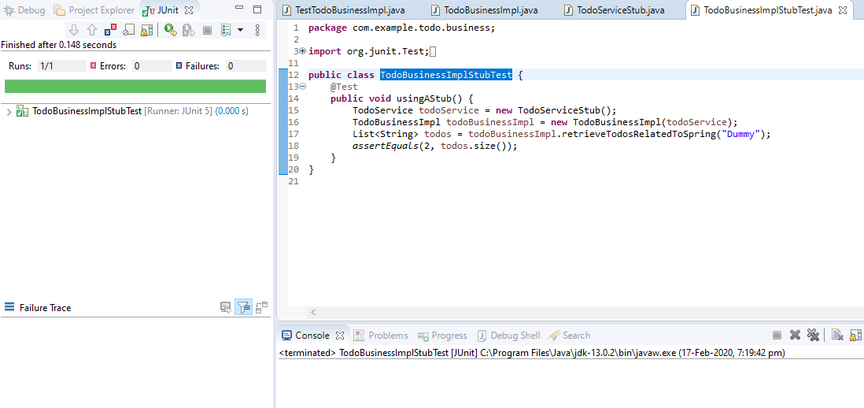

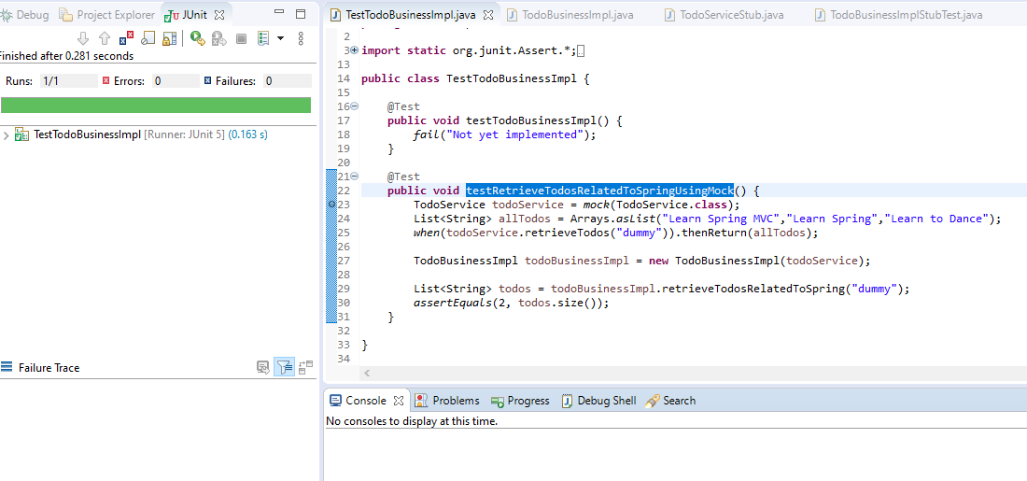

3) Write a test mock list get using BDD in a Given, When & Then style add a delete Todo method in the service interface.

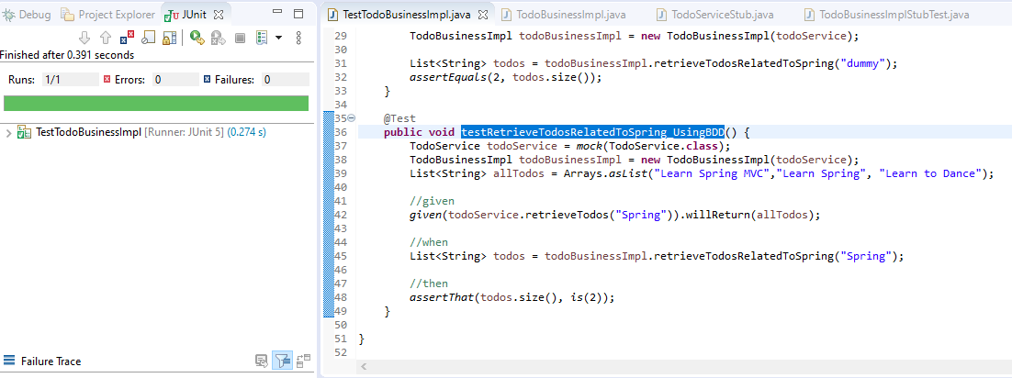

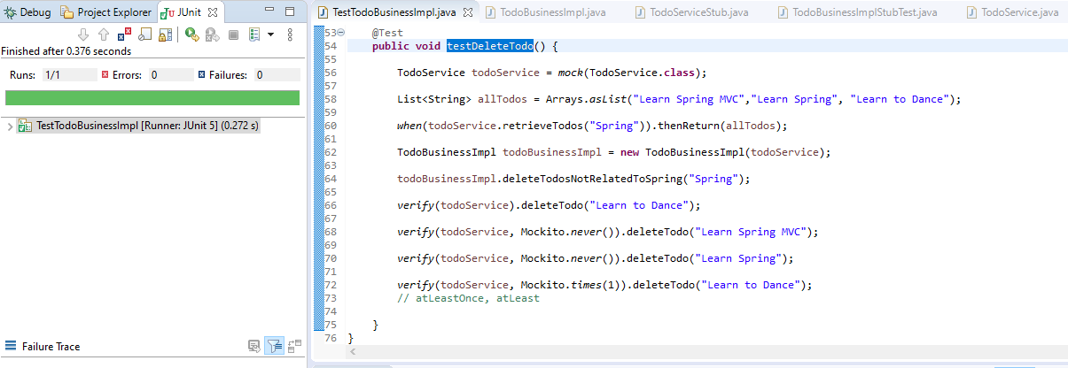

4) Add the ham crest library dependency to porm.xml & use the assert that method & do ham crest matchers test.

