**Java Assignment:**

**Git hub Repository:**

**https://github.com/in28minutes/spring-boot-master-class**

1. **Build a spring application with the implementation of spring JPA repository and display the outputs.**

**2. Develop a simple application for integrating the Rest API and perform the Http CRUD operations through postman.**

**3. Create a simple project with the implementation mockito**

**Solutions:**

1. **Build a spring application with the implementation of spring JPA repository and display the outputs.**

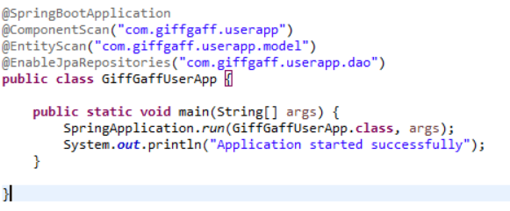

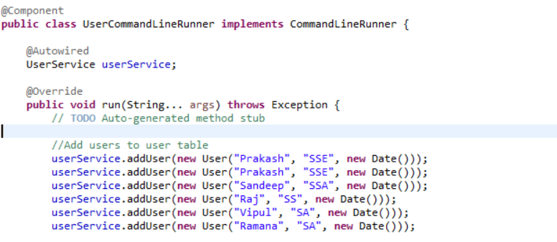

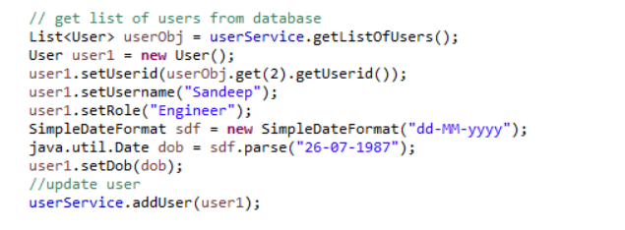

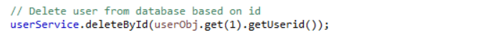

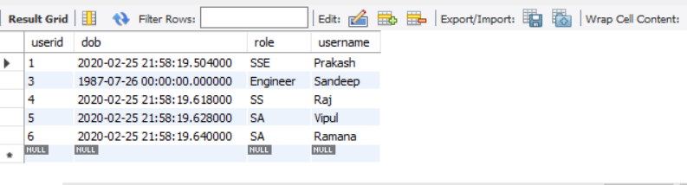

**2. Develop a simple application for integrating the Rest API and perform the Http CRUD operations through postman.**

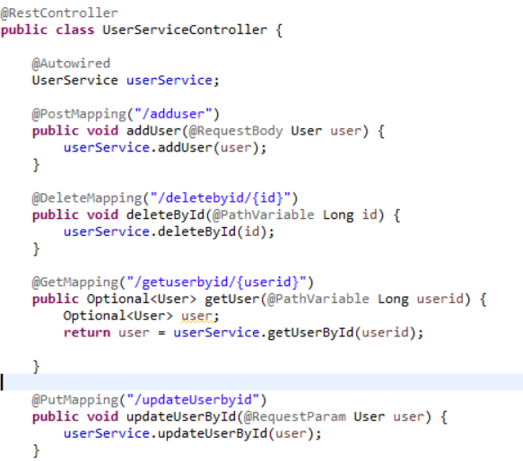

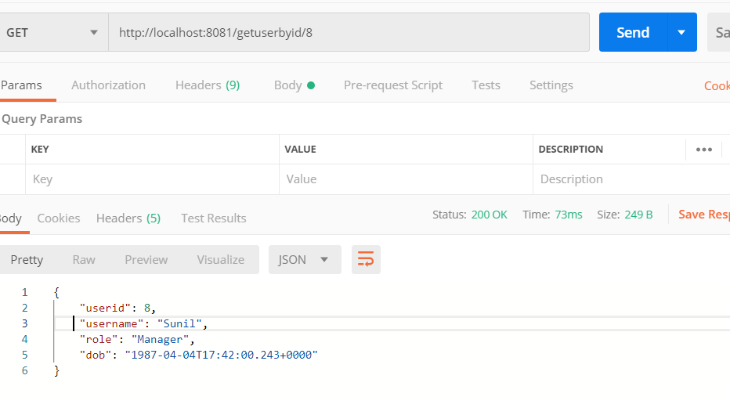

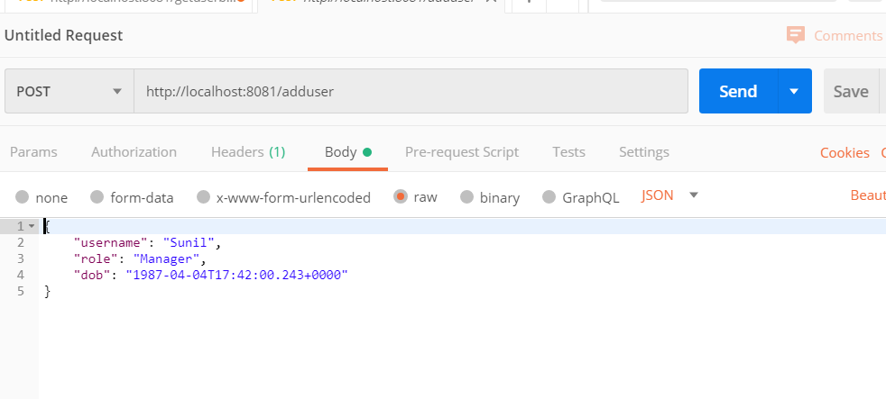

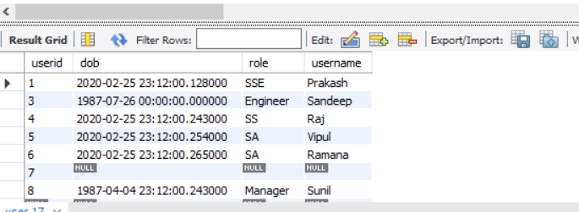

**3. Create a simple project with the implementation mockito**

