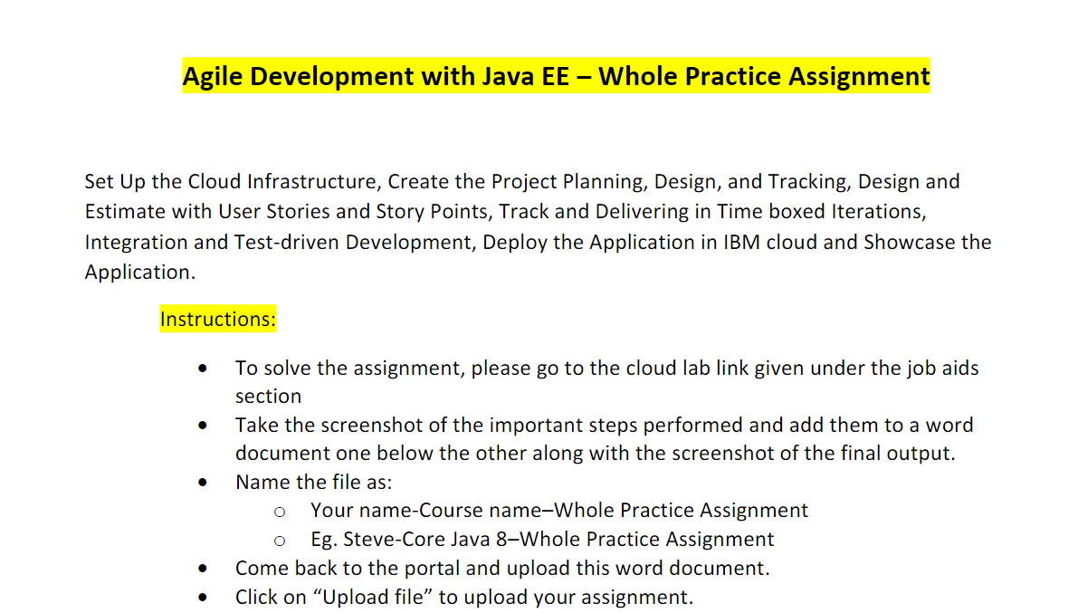

* Register into IBM Cloud application.

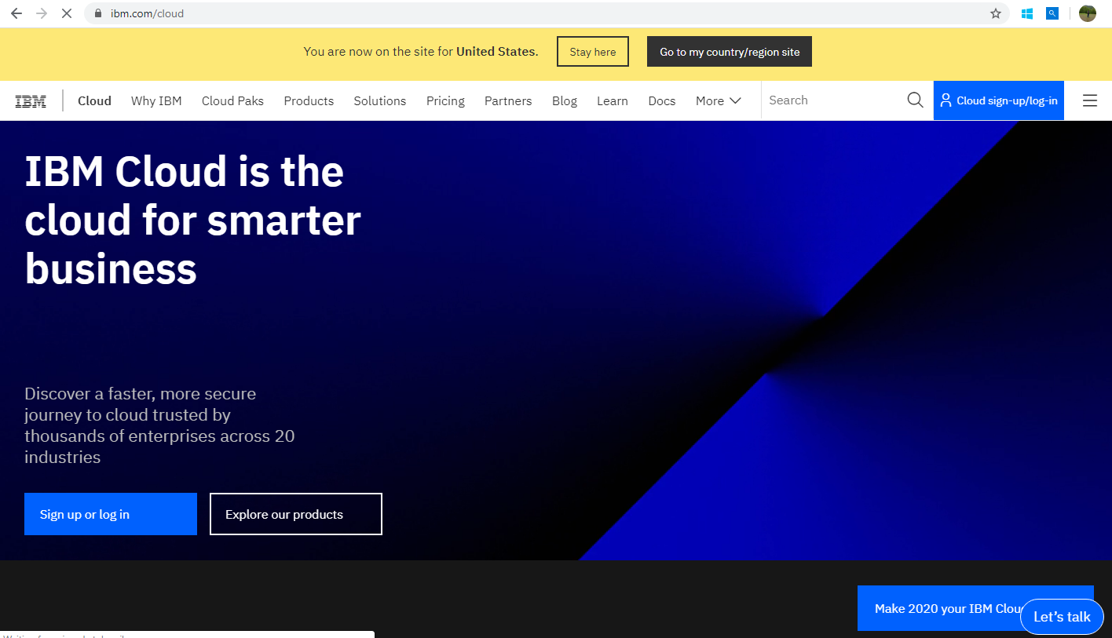

* After Successful login, Dashboard will be displayed like below.

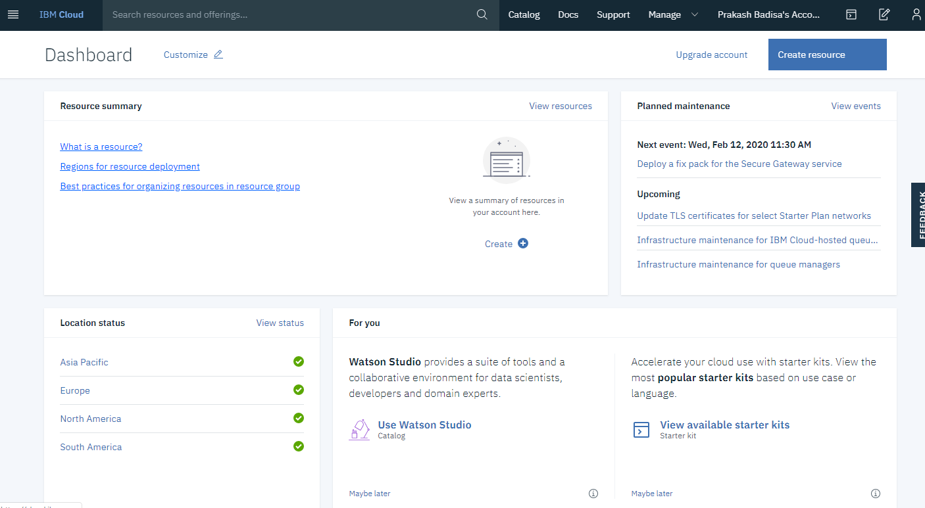

* Created resource as JavaLibertyApp-Agile

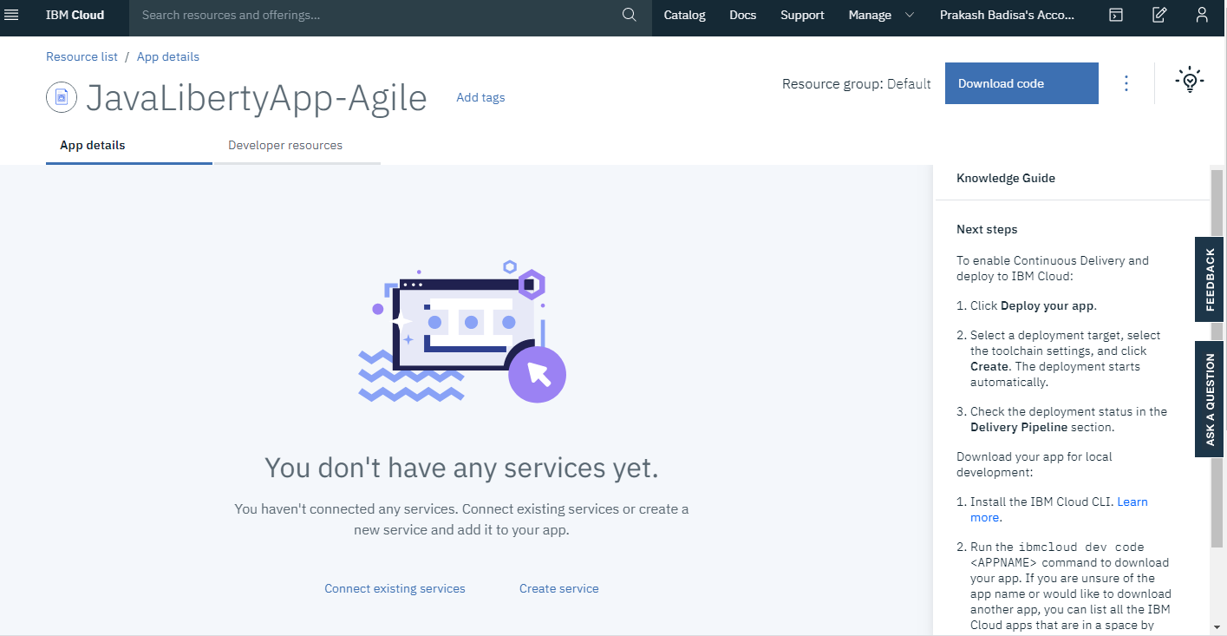

* To Configure continues delivery, we need to deploy application by using Deploy your app section from below.

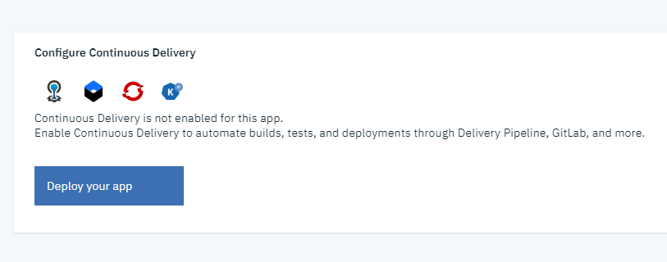

* Choose the Deployment target as IBM Cloud Foundry.

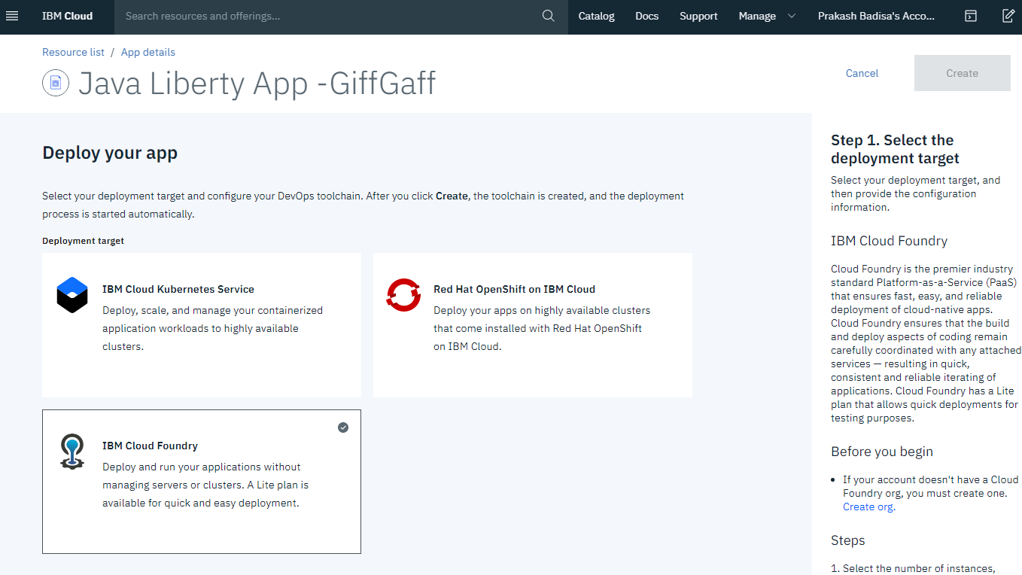

* Select the tool chain settings.

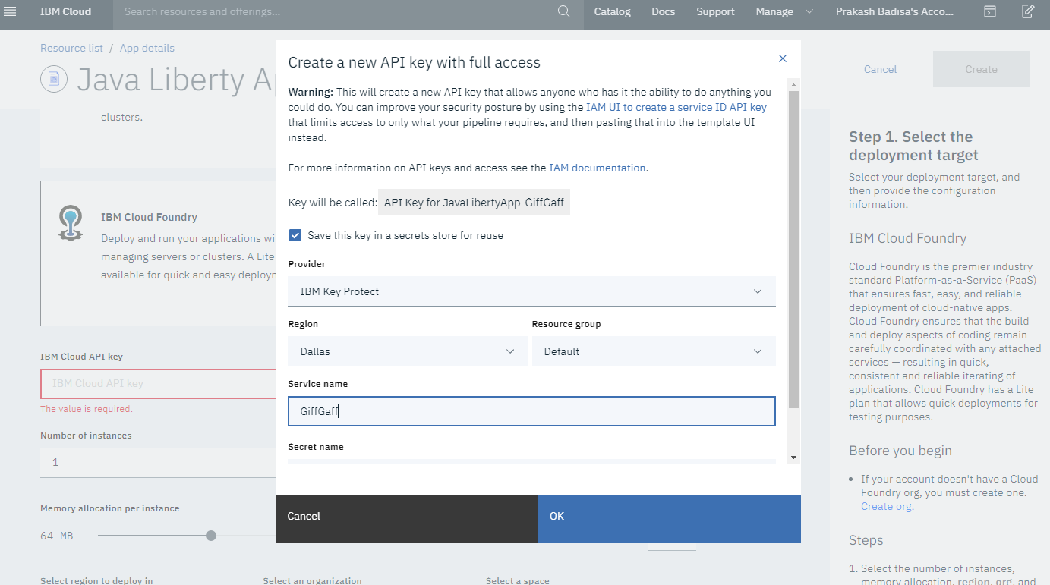

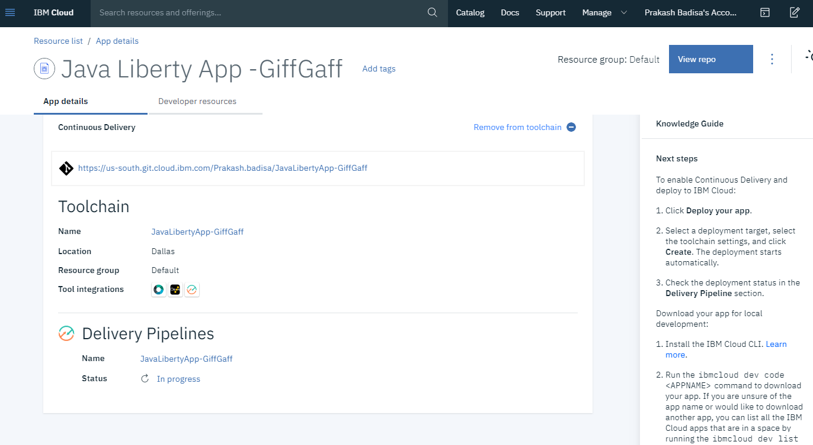

-Using IBM Cloud Foundry to deploy Application. However API key is billable Service. We can’t use this service with a lite account(IBM Cloud Foundry).

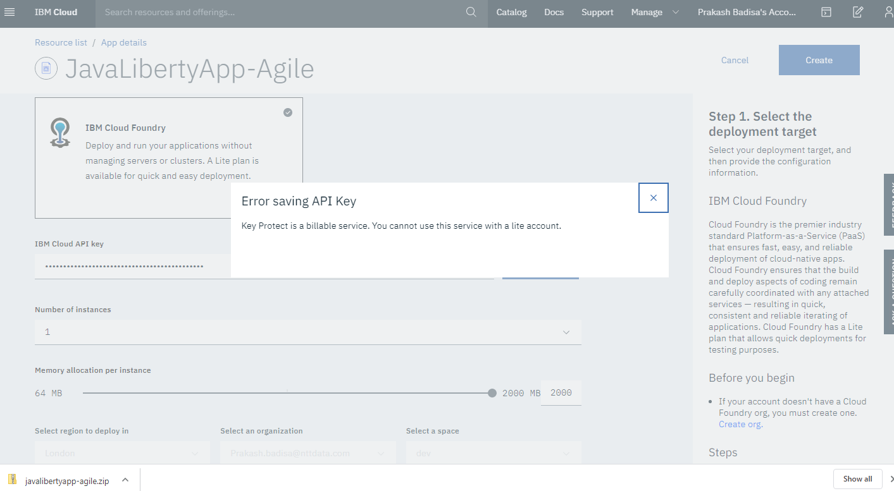

* Getting stage failed error message in deliver section.

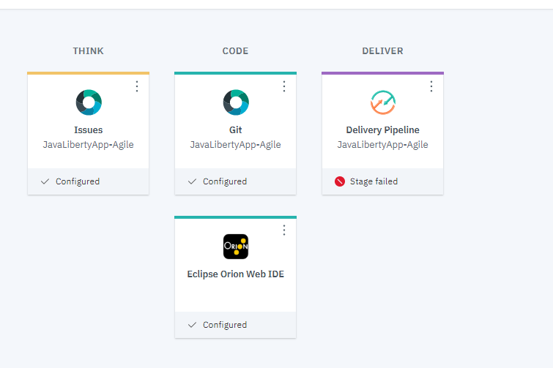

* Create a new issue by clicking New issue button.

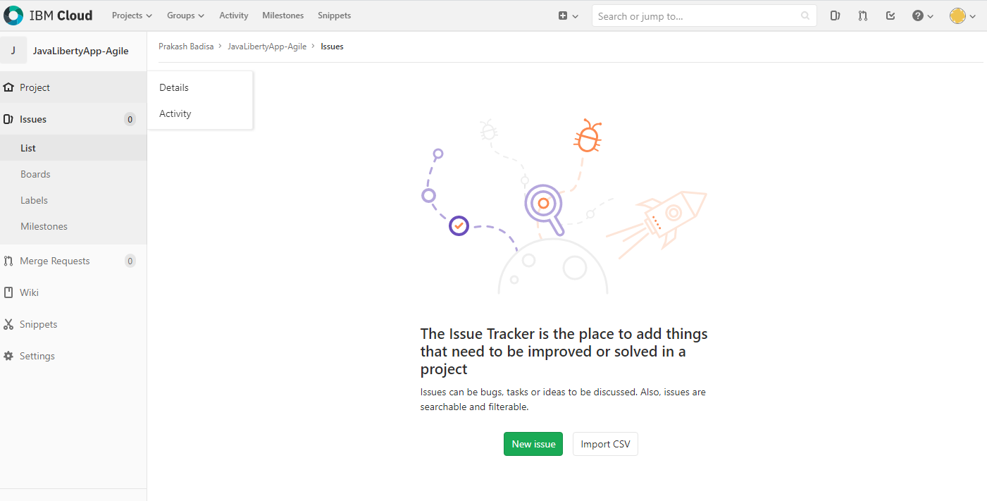

* Created New issue in the below screen

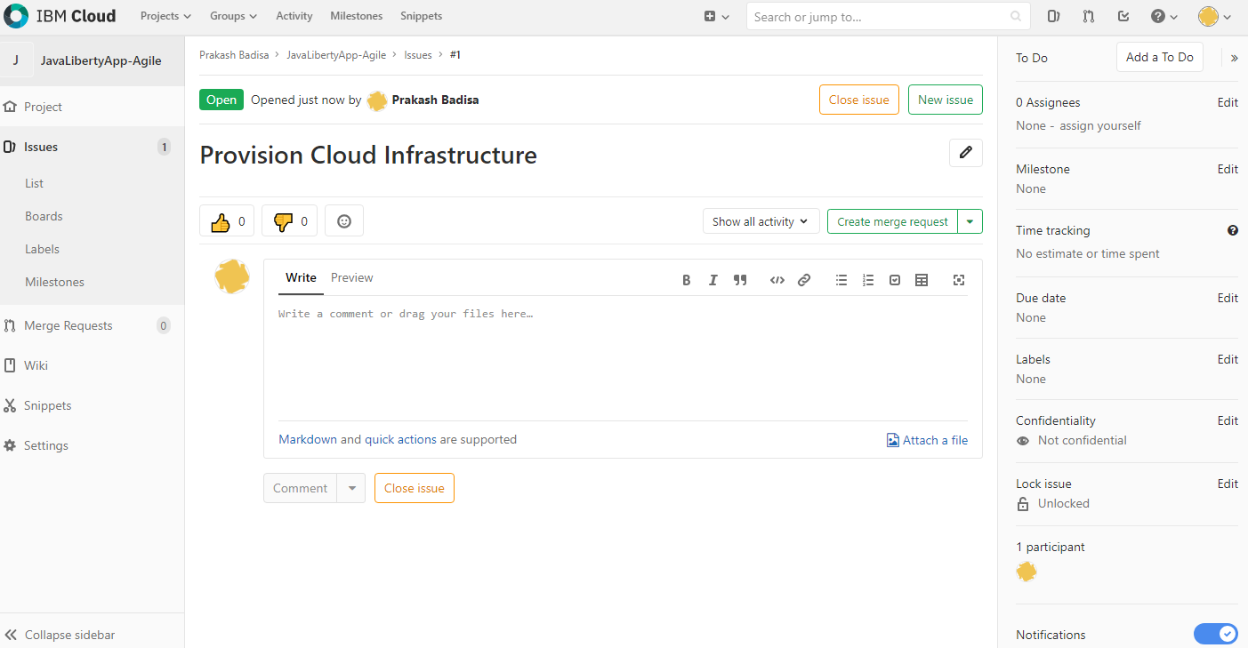

* Create another issue.

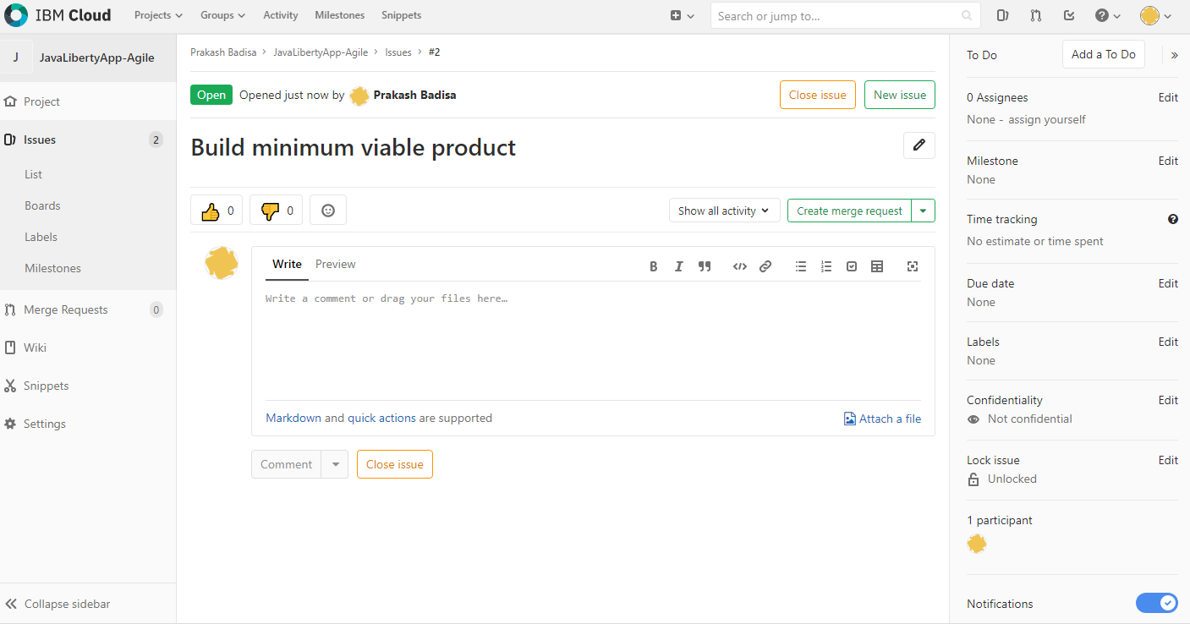

* Now we can see the list of our issues in story board.

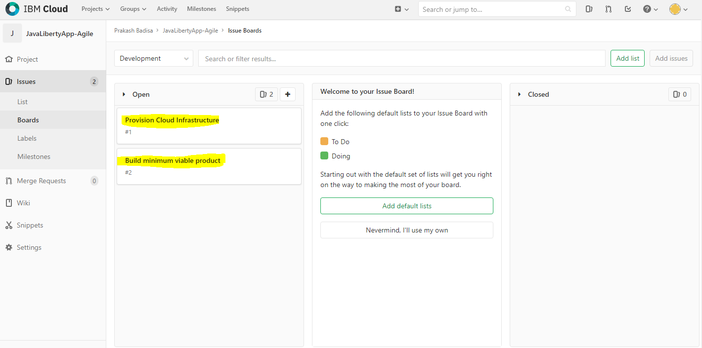

* To prioritize the issues, we simply drag the positions. See the position of issues in the below screen.

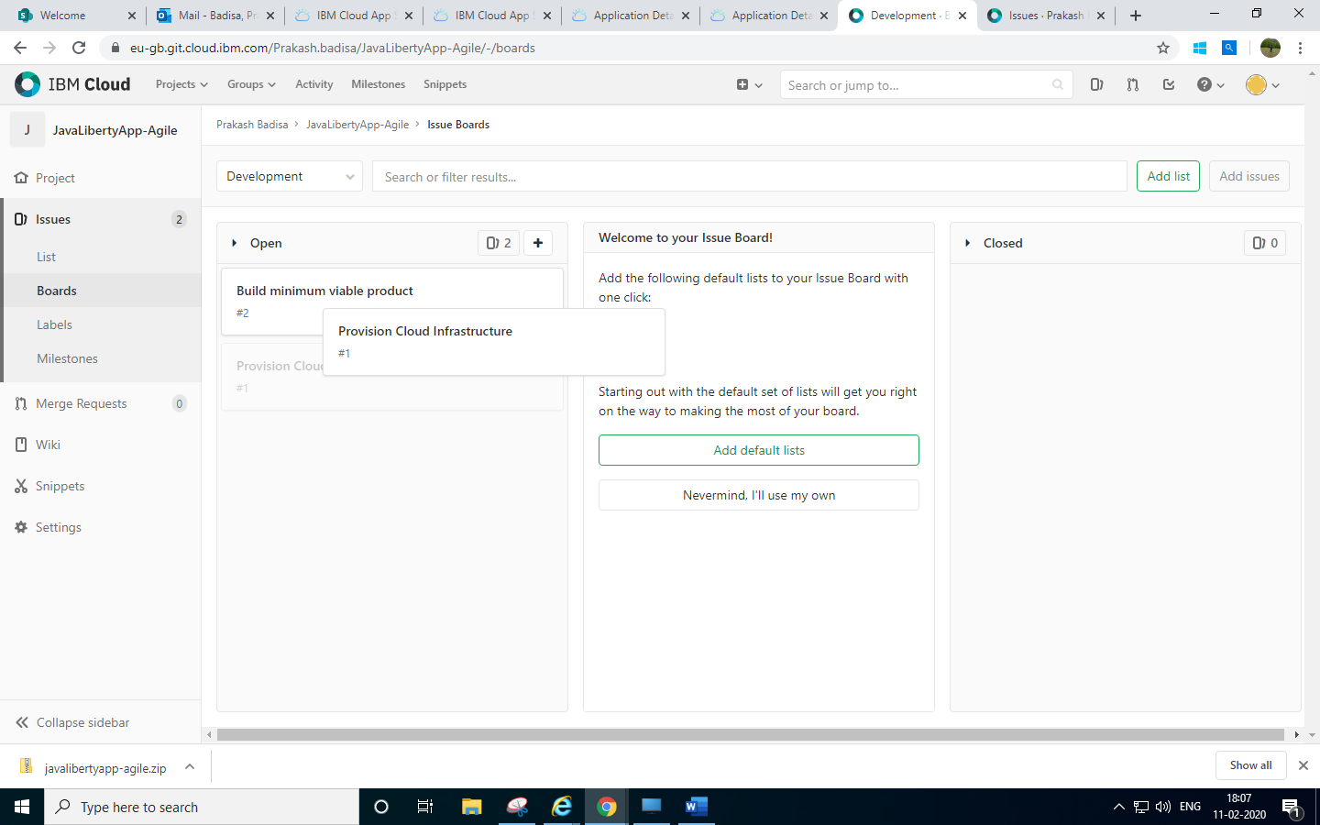

* Update Issue description for both issues.

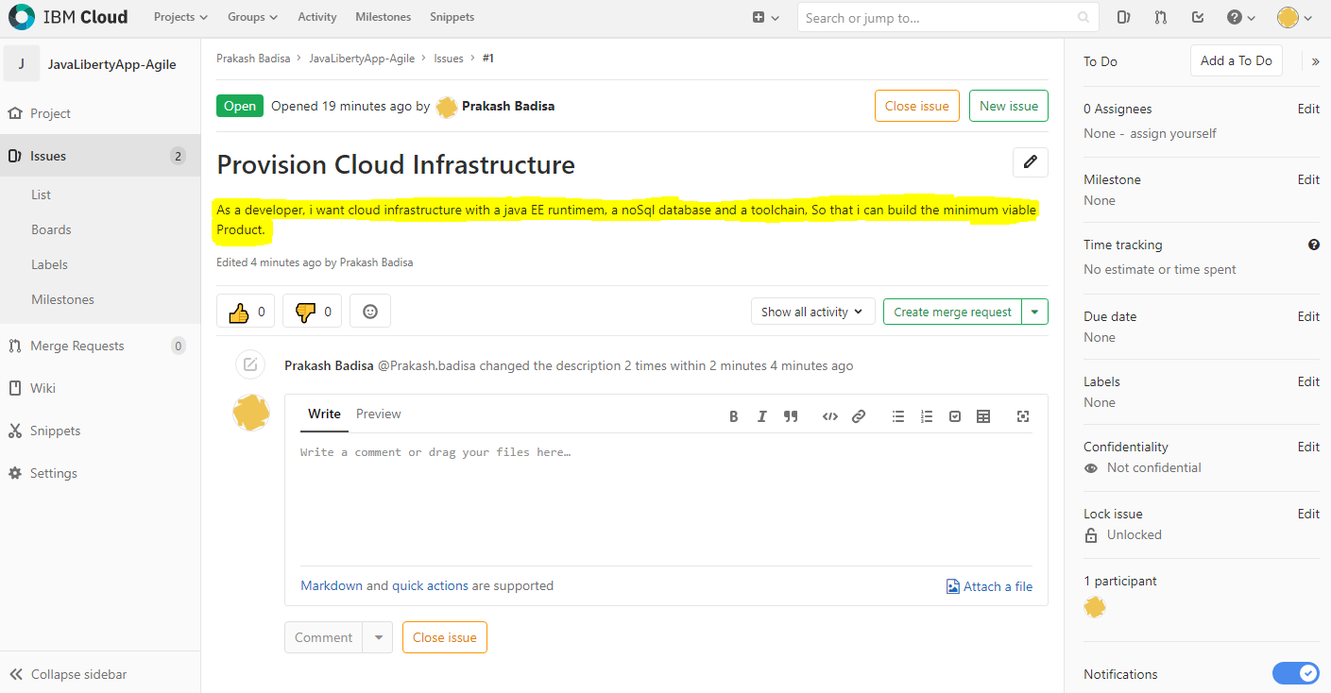

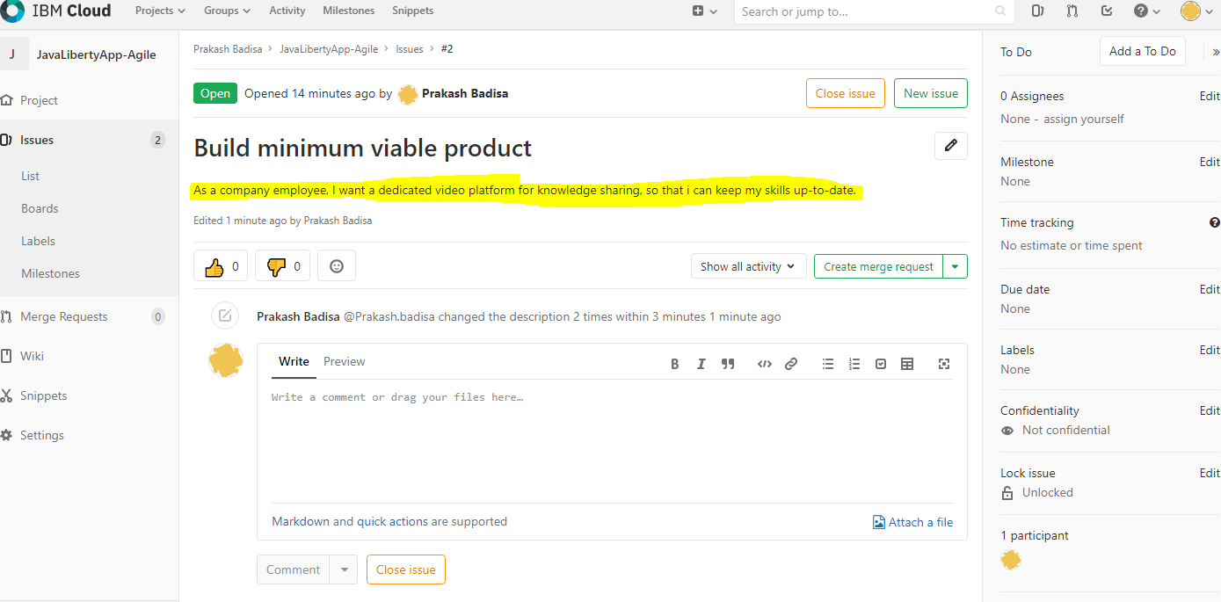

* Create story points.

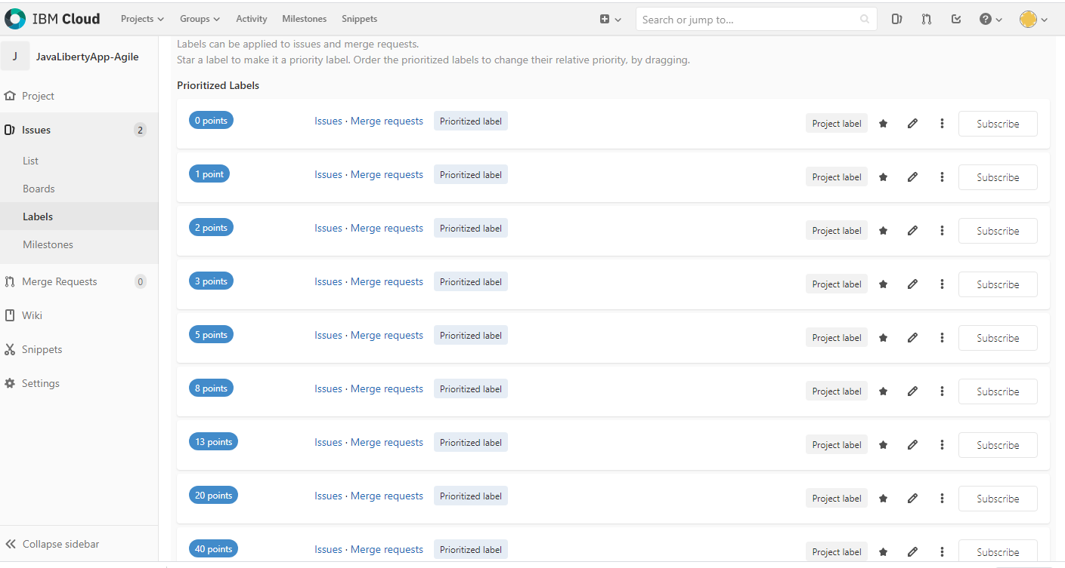

* Allocate story points to the issue.

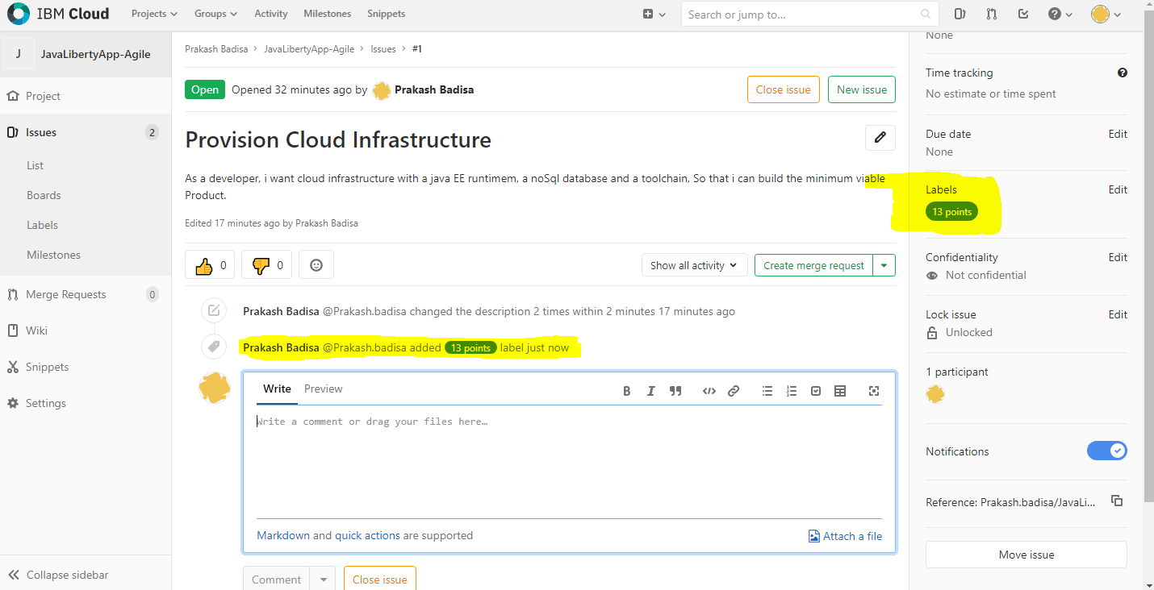

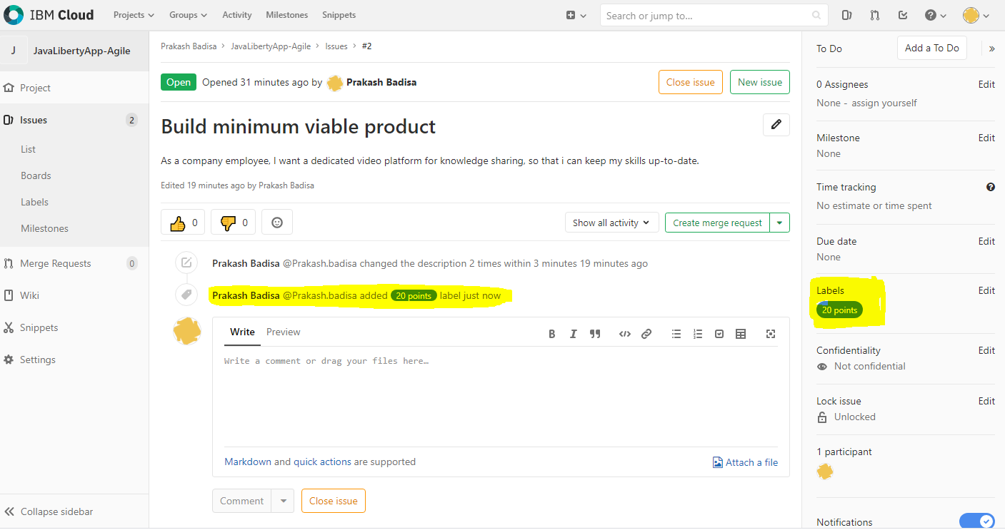

**Tracking and Timeboxing iterations:**

* Created iteration as Sprint-1 and assigned issues to iterations.

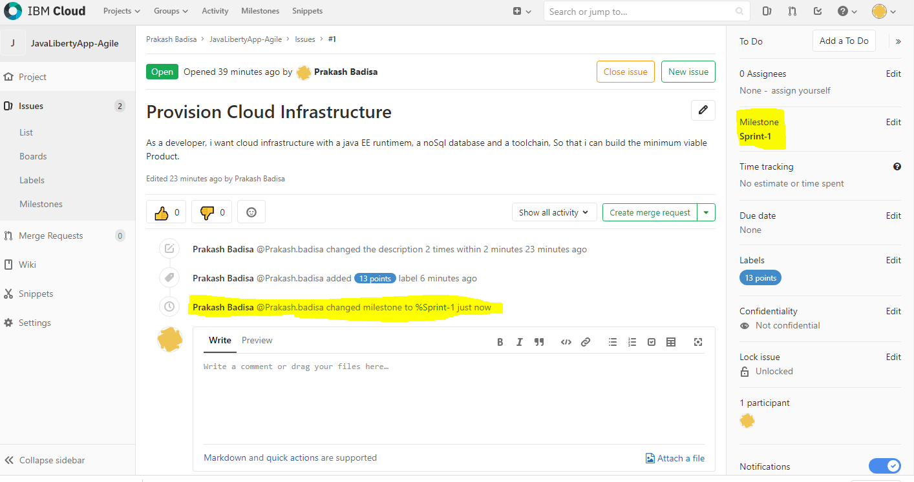

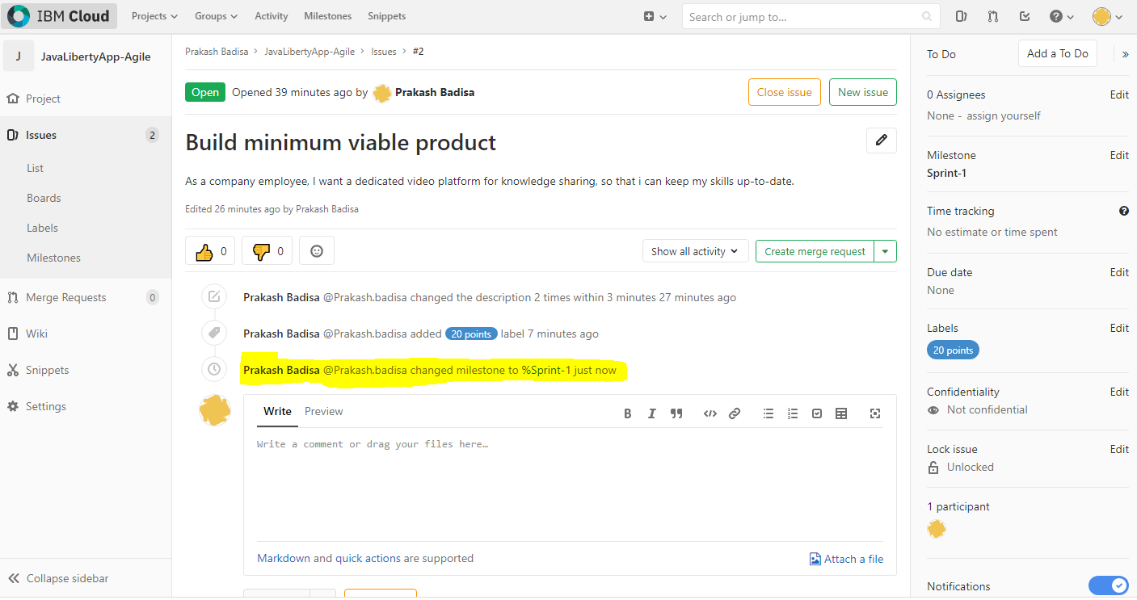

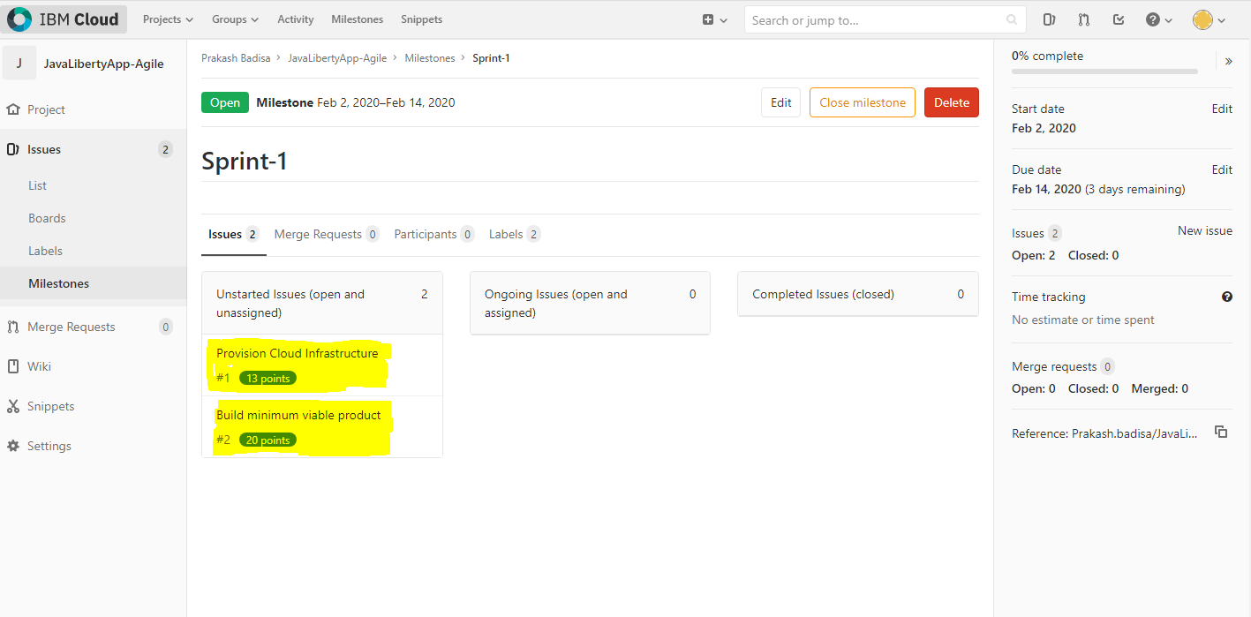

- Assigned Issue/Userstory to myself.

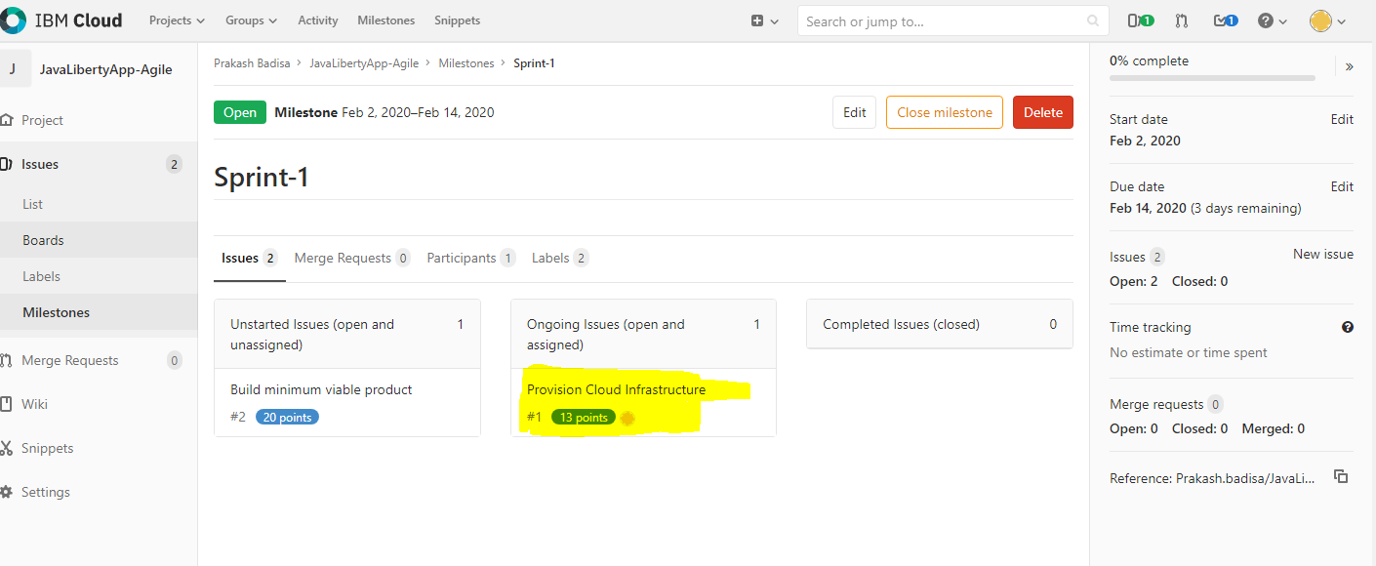

* Issue/Userstory masrk as completed.

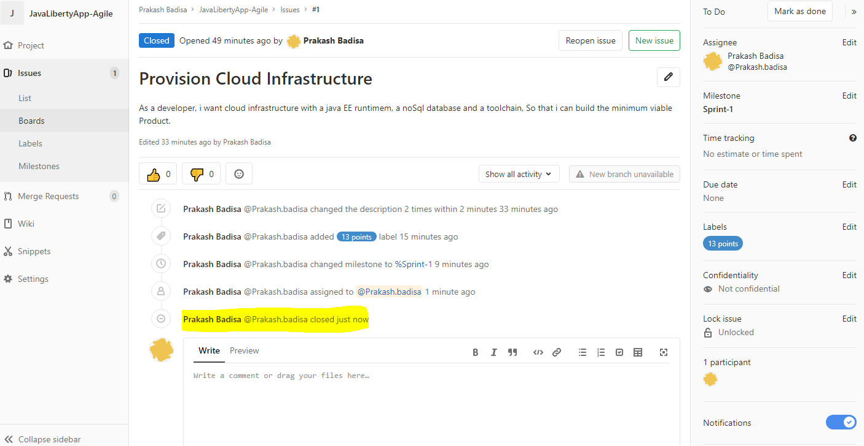 - -

- Status has been changed to completed status.

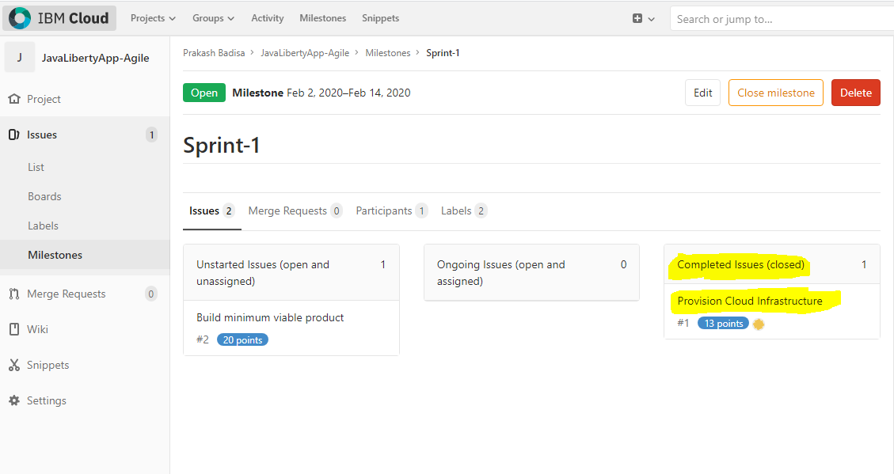

Test Driven Development:

