Mysql Assignment

Write the query to create the table and insert the data into the table.

Fetch the data from the table using order by and group by and find minimum and maximum value in the table

Write the query based on the datatypes in MySQL database and use functions Date and Times and Write the query to fetch the data from two or more tables using joins and use primary and foreign key in MYSQL database.

1. Create schema/database in a local Mysql instance.

**CREATE** **database** network; (or create schema network)

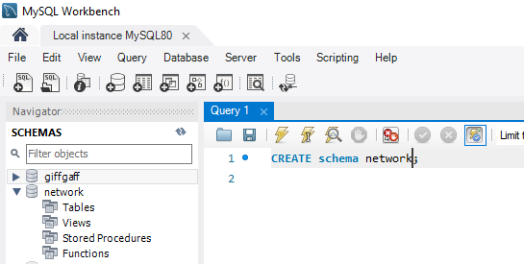

1. Connect to the database/schema

**use** network

1. Create TABLE

CREATE TABLE `network`.`**product**` (

`productid` INT NOT NULL AUTO_INCREMENT,

`product_desc` VARCHAR(100) NULL,

`price` FLOAT(10) NULL,

`variant` VARCHAR(45) NULL,

PRIMARY KEY (`productid`)

);

CREATE TABLE purchases (

`idpurchases` INT UNSIGNED NOT NULL AUTO_INCREMENT,

`productid` INT NOT NULL,

PRIMARY KEY (`idpurchases`),

FOREIGN KEY (productid) REFERENCES product(productid)

);

1. **Show tables**

To list the tables created

1. Insert data in to purchases table

insert into product(product_desc,price,variant) values("Falcon9", 60000000, "5kton");

insert into product(product_desc,price,variant) values("FHeavy", 100000000, "10Kton");

insert into product(product_desc,price,variant) values("soyuz", 100000000, "3seater");

insert into product(product_desc,price,variant) values("change", 100000000, "moon");

insert into purchases(productid) values(1);

insert into purchases(productid) values(1);

insert into purchases(productid) values(3);

insert into purchases(productid) values(4);

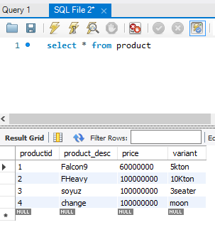

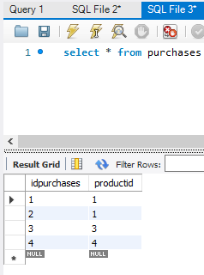

1. **Fetch the matching data from two tables.**

EQUI JOIN

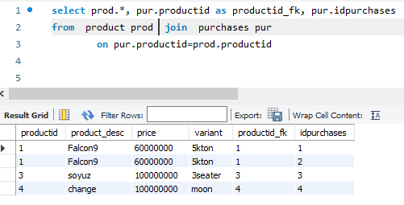

Left Join

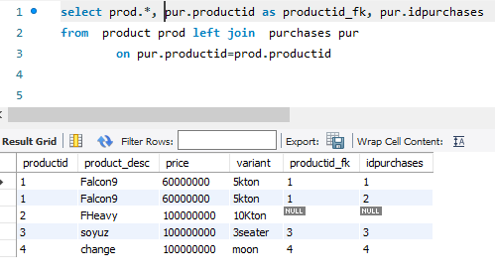

1. alter table purchases add purchase_date **datetime** DEFAULT CURRENT_TIMESTAMP ON UPDATE CURRENT_TIMESTAMP;

alter table purchases add quantity double;

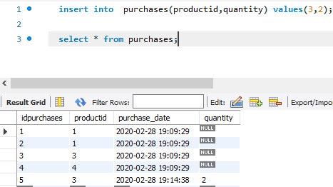

1. **date function**

