**1. Create a ReSTful service in Spring 5 to retrieve Product Details. Configure the API to work with all the Http Verbs by mapping CRUD Operations Get, Put, Post and Delete.**

**2. Populate the Product class with the appropriate properties.**

**3. Configure for appropriate Error handling**

**Create a ReSTful service in Spring 5 to retrieve Product Details. Configure the API to work with all the Http Verbs by mapping CRUD Operations Get, Put, Post and Delete.**

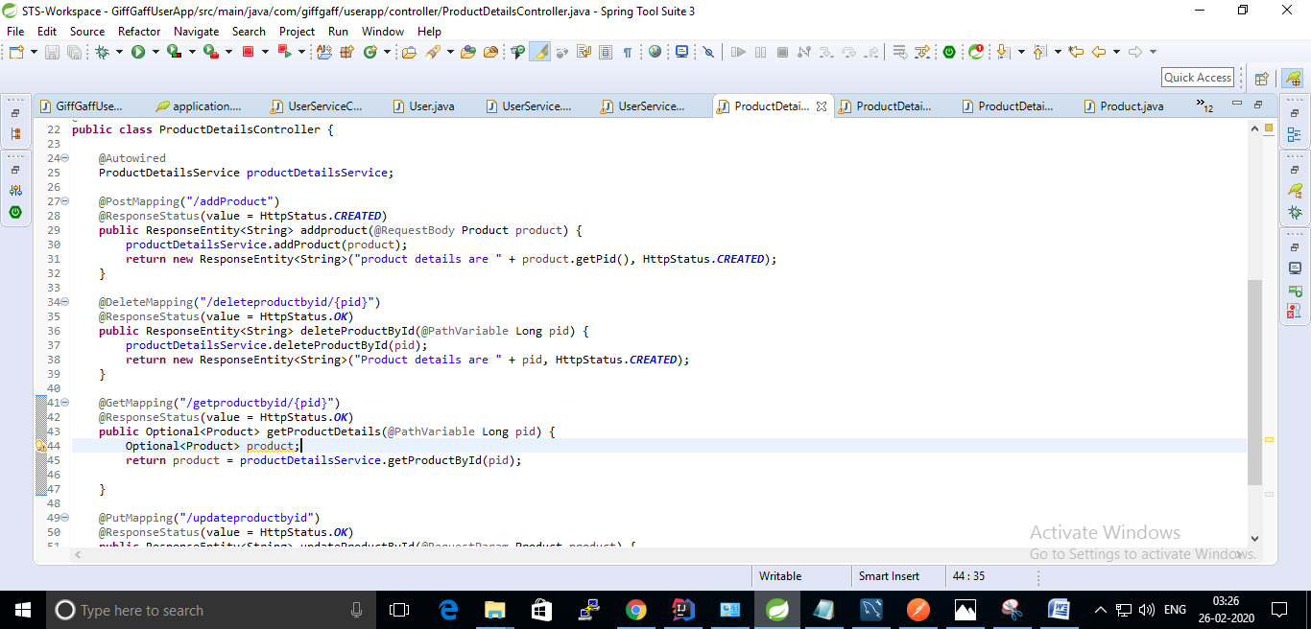

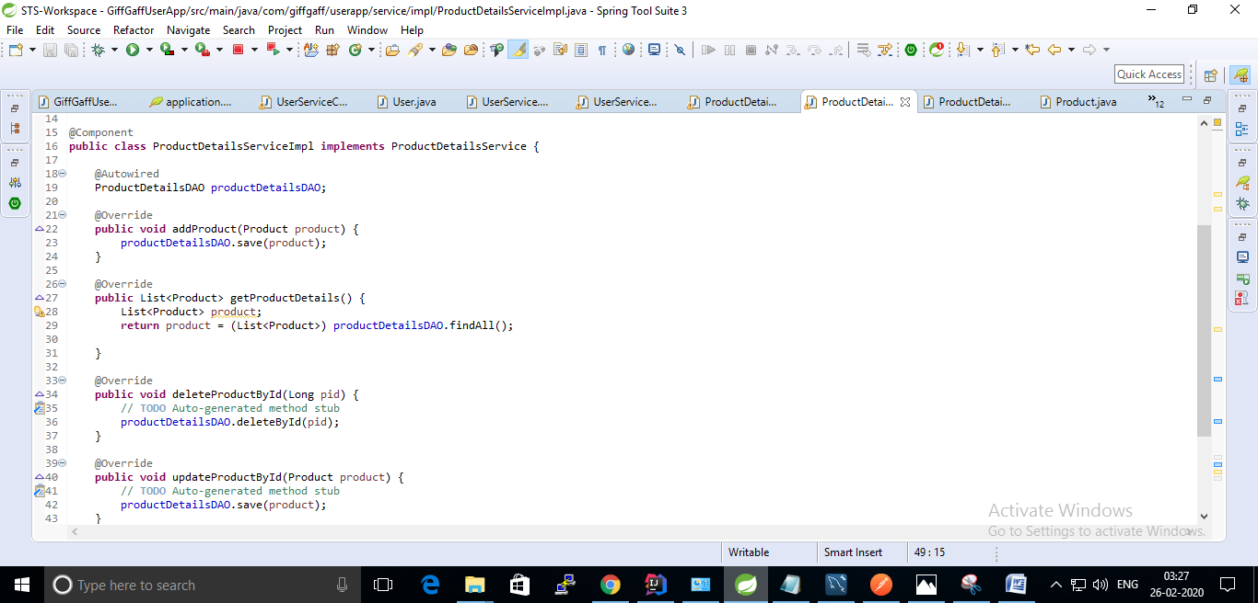

**2. Populate the Product class with the appropriate properties.**

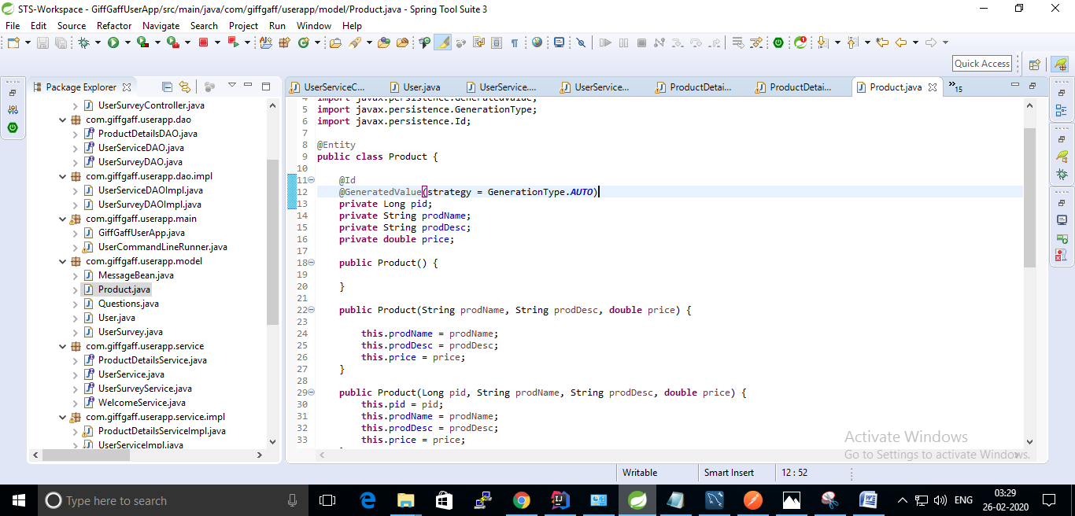

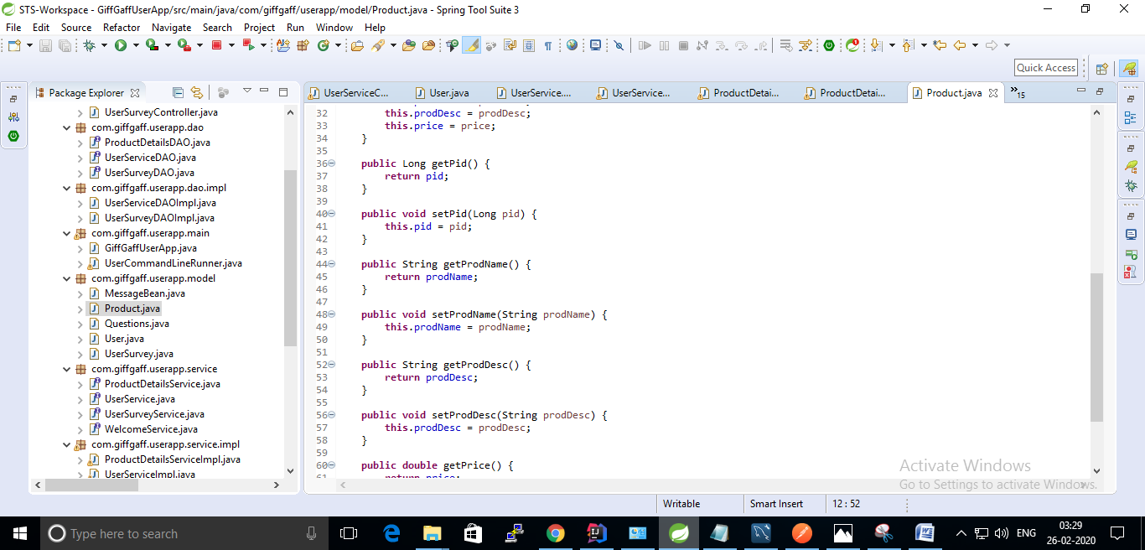

**3. Configure for appropriate Error handling**

