SQL Assignment

1. Write the query to create the table and insert the data into the table.
2. Fetch the data from the table using order by and group by and find minimum and maximum value in the table
3. Write the query based on the datatypes in MySQL database and use functions Date and Times
4. Write the query to fetch the data from two or more tables using joins and use primary and foreign key in MYSQL database.
5. Display the COUNT, SUM, MIN, MAX of any numeric column in a table.
6. Display the Sum of a column using GROUP BY.
7. Restrict the GROUPs using HAVING so that only the TOP most group is displayed.
8. Create schema/database in a local Mysql instance.

**CREATE** **database** network; (or create schema network)

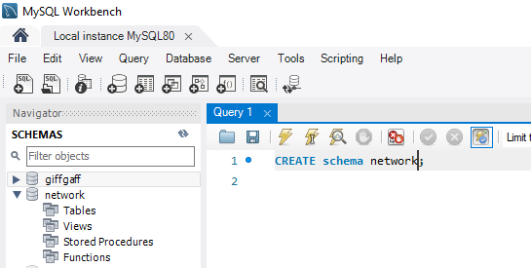

1. Connect to the database/schema

**use** network

1. Create TABLE

CREATE TABLE `network`.`**product**` (

`productid` INT NOT NULL AUTO_INCREMENT,

`product_desc` VARCHAR(100) NULL,

`price` FLOAT(10) NULL,

`variant` VARCHAR(45) NULL,

PRIMARY KEY (`productid`)

);

CREATE TABLE purchases (

`idpurchases` INT UNSIGNED NOT NULL AUTO_INCREMENT,

`productid` INT NOT NULL,

PRIMARY KEY (`idpurchases`),

FOREIGN KEY (productid) REFERENCES product(productid)

);

1. **Show tables**

To list the tables created

1. Insert data in to purchases table

insert into product(product_desc,price,variant) values("Falcon9", 60000000, "5kton");

insert into product(product_desc,price,variant) values("FHeavy", 100000000, "10Kton");

insert into product(product_desc,price,variant) values("soyuz", 100000000, "3seater");

insert into product(product_desc,price,variant) values("change", 100000000, "moon");

insert into purchases(productid) values(1);

insert into purchases(productid) values(1);

insert into purchases(productid) values(3);

insert into purchases(productid) values(4);

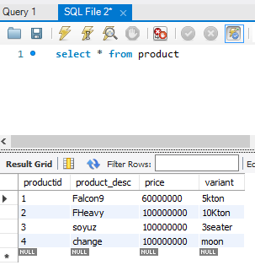

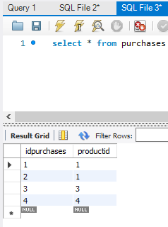

1. **Fetch the matching data from two tables.**

EQUI JOIN

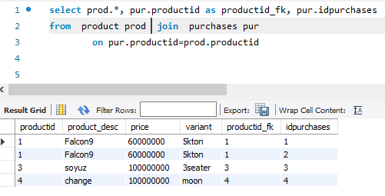

Left Join

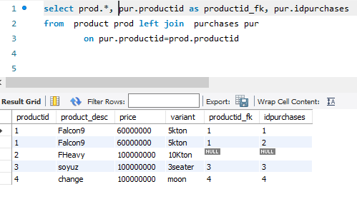

1. alter table purchases add purchase_date **datetime** DEFAULT CURRENT_TIMESTAMP ON UPDATE CURRENT_TIMESTAMP;

alter table purchases add quantity double;

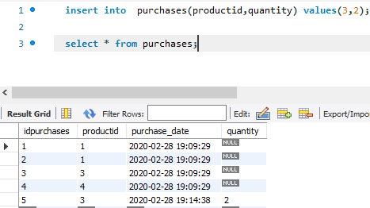

CREATE TABLE `network`.`employee` (

`idemployee` INT UNSIGNED NOT NULL AUTO_INCREMENT,

`name` VARCHAR(45) NOT NULL,

`salary` FLOAT NOT NULL,

`department` VARCHAR(45) NOT NULL,

PRIMARY KEY (`idemployee`));

insert into employee(name,salary, department) values ("suresh",2000,"service");

insert into employee(name,salary, department) values ("helen",4000,"admin");

insert into employee(name,salary, department) values ("allen",10670.12,"customercare");

insert into employee(name,salary, department) values ("mahesh",9999,"service");

insert into employee(name,salary, department) values ("joe",7000,"infra");

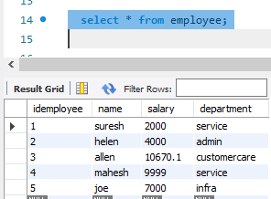

Get total employee count

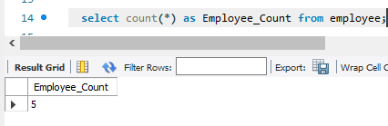

Get sum of salary by department.

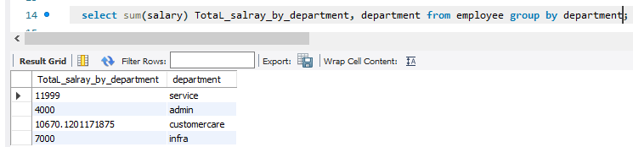

**Get department where total employee salary exceeds 4000**

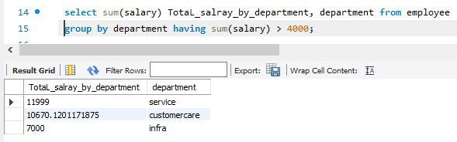

Department with greatest sum of salary

