Empirical Exercise

This exercise is to reproduce regression results Branstetter and Feenstra (2002). To complete the exercise, the file “china_fdi.dta” should be stored in: c:\Empirical_Exercise\Chapter_9\.
Then do:

8.1 Run the program “share_reg.do” to reproduce the regression results in Table 9.1. Notice that apparent consumption (“appcon3”) is included as a control variables in these regressions. What happens if this variable is dropped?

8.2 Open the excel file “standard_errors.xls” to see how the results in Table 9.2 are computed. What formula is used for α, and for its variance and standard error? Justify these formulas.
Hint: Consider the easier case of taking the difference between α and β. Then:

var(α – β) = E[(α – β) – 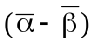]² = E f(α,β),

where f(α,β) is the quadratic function indicated. To compute this expected value, we take a
second-order Taylor series expansion:

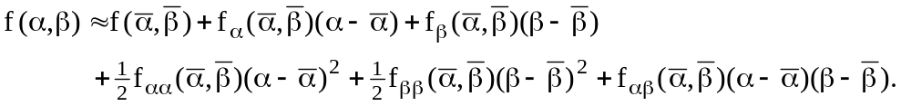
It follows that,
So computing the derivatives of the quadratic function f(α,β), we obtain,
var(α – β) = E[(α – β) – ]² 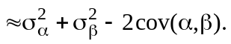
Now given the formula for α, use the same approach to justify its variance.

