Chapter 4: Empirical Exercises

4.1 Download the NBER productivity dataset at http://www.nber.org/nberces/nbprod96.htm, compute the relative wage and relative employment for 1958 – 1996, and reconstruct Figure 4.1 and 4.2. Note: Given this data, you need to first compute the wage rates in production and nonproduction sectors using the following formula:

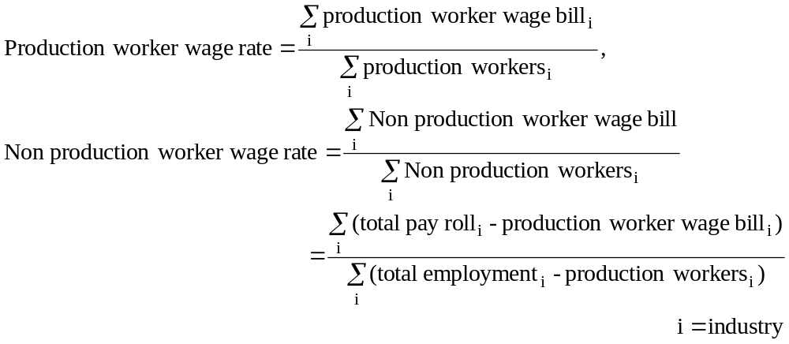

4.2 Run the STATA program “Problem_4_2.do” to reproduce the regressions in Table 4.4 (which is simplified from Table III in Feenstra and Hanson, 1999). Then answer:
(a) What weights are used in these regressions?
(b) How are the results affected if these weights are not used?

4.3 Run the STATA program “Problem_4_3a.do” to reproduce the regressions in Table 4.5 (i.e. Table I in Feenstra and Hansen, 1999). Then run “Problem_4_3b.do” to perform the two-step regression, Table IV and Table V in Feenstra and Hanson (1999). Note that Table V is obtained using the coefficients in the first column of Table IV.

