Data Description for Feenstra (1989)

There are five data sets in excel format: cars.csv, trucks.csv, cycon.csv, cypool.csv, cyship.csv. All of the variables in the data sets are fitted values from instrumental variables regression.

iprice Import price
usprice US price
gprice German price
tariff Tariff rate
income Expenditure on product class
lag0 –lag2 This is what Feenstra called a second order polynomial lag on betas. (See below)
y Import price transformed, y = iprice – income
x1 US price transformed, usprice – income
x2 German price transformed, gprice – income
z0 – z2 lag0-lag2 transformed

Note: all the transformations are done to reflect their restrictions. So some are restricted
to homogeneity, where others are restricted to symmetry and homogeneity.

Explanation of lag0, lag1 and lag2

With a second-order polynomial, 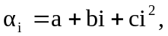 it follows that
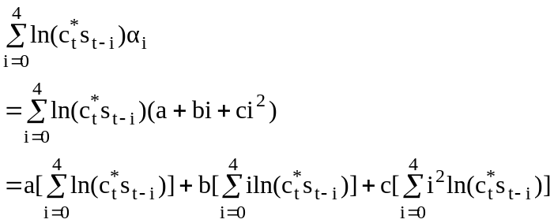

Letting 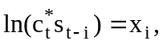 we can define the three lags appearing in this formula as,

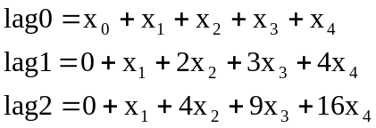

Then to compute the total pass-through of the exchange rate, it follow that,

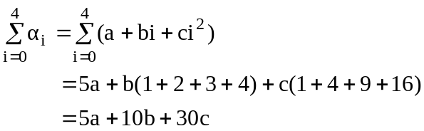

When estimating the equation using lag0, lag1, and lag2, the coefficient estimates that you obtain are a, b, and c, respectively. Using this, you can recover the coefficient estimate and standard error for each individual exchange rate term reported in the Table 7.2. You can always do this by hand, but STATA does offer a command to calculate the linear combination of the estimated coefficients. The syntax for this is,

lincom lag0 + lag1 + lag2

This will calculate the coefficient estimates for the ln(c*_{t} s_{t-1}). This is much in a same way as the syntax for test. Lag0 in above command does not refer to the data, but the coefficient estimate associated with lag0.

