Dear Editor,

I do not know how to track changes in LaTeX, so I added a Git diff.

Header: I merged my name into one line, and this also avoids hiding Jonathan.
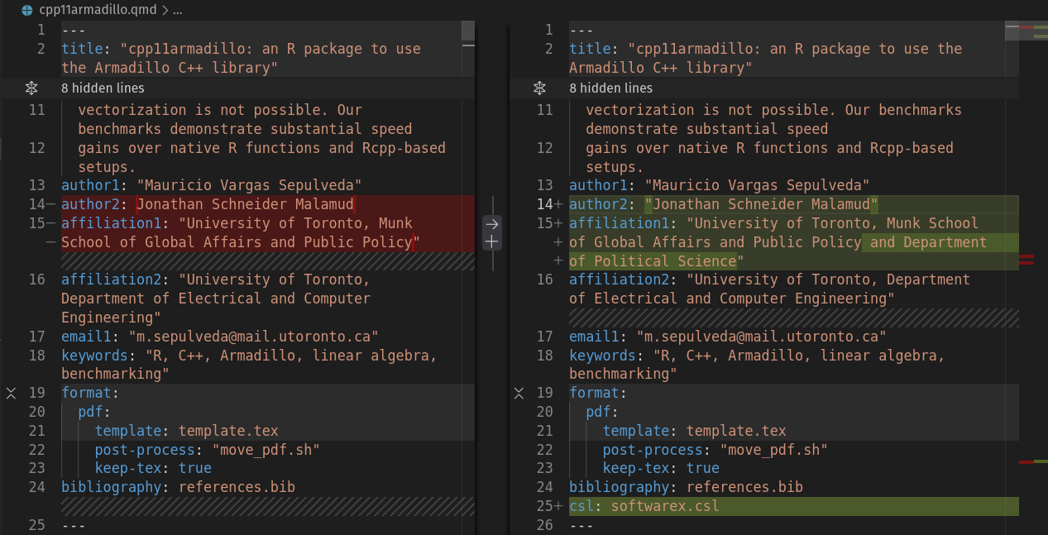

Body: I removed the bold text that reads “CHANGE: ...”. This was just to indicate that the paragraph next had changes.
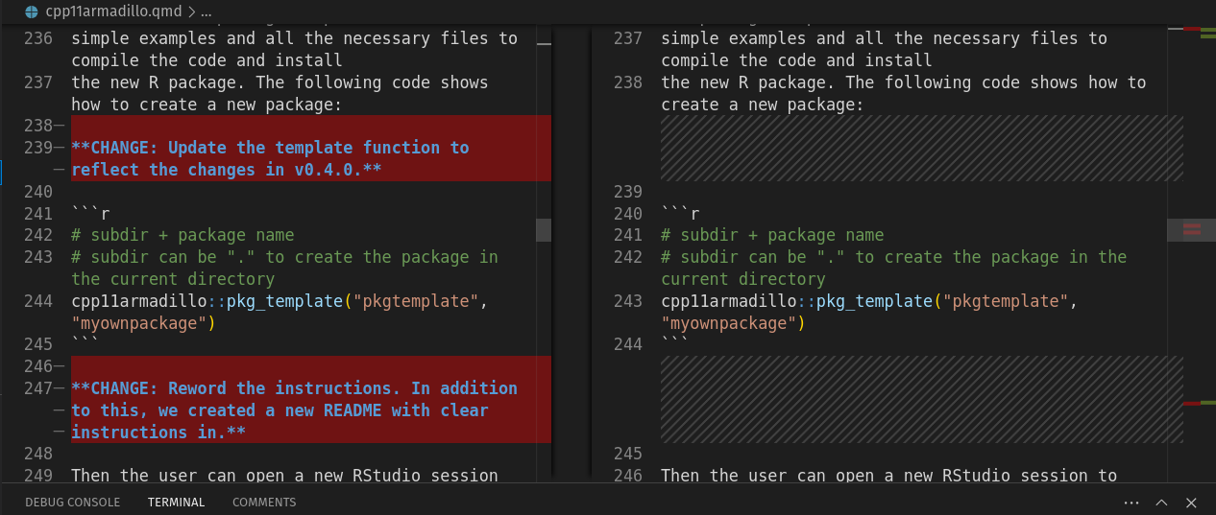

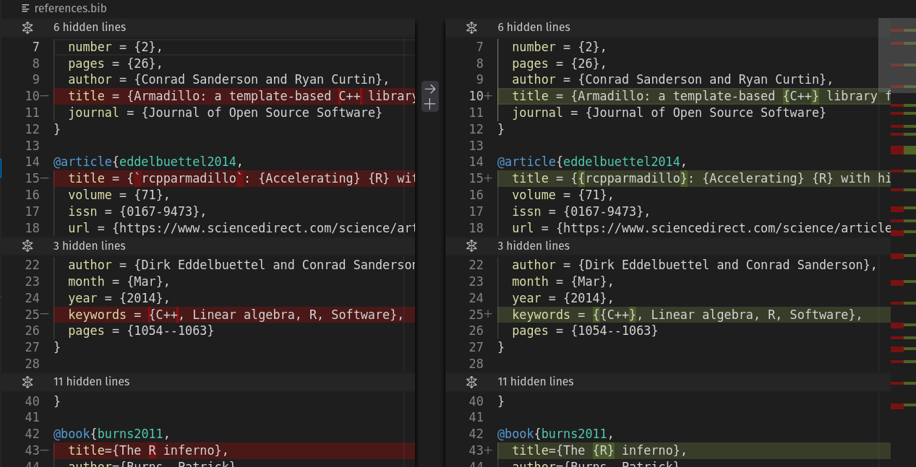
Citations: I added a CSL file to the template, and made several changes to my Quarto template. I create a TeX file from Quarto using Markdown syntax.

Overall, I had a good experience with the reviewers, so I decided to make my template public for authors that write about R or that use Quarto (which also supports Python and others).

Template here: https://github.com/pachadotdev/softwarex-quarto-template

