

* Own Use Provision of Services

ILO add-on module for *own use provision of*

*services* in national labour force surveys

**ILO Department of Statistics**

July 2023

Copyright © International Labour Organization 2023.

**Forthcoming. Not for circulation or citation.**

### Table of contents

* + 1. Introduction 4
  + 2. Key concepts 5
  1. Work 5
  2. Own use provision of services 7
  + 3. Data sources 10
  1. Available measurement approaches, key features 10
  + 4. Statistical Indicators 12
  + 5. Labour force survey add-on module 14
  1. LFS add-on modules for measurement of OPS key features 14
  2. LFS add-on module: Pre-coded activity listing 15
  3. LFS add-on module: Alignment to ICATUS 2016 16
  4. LFS add-on module: Conditional context items 17
  5. LFS add-on module: Schematic of the CAPI design (hybrid light diary module) 18
  6. LFS add-on module: Schematic of the CAPI design (recovery of passive / supervisory care) 19
  7. LFS add-on OPS modules 20

# 1. Introduction

“Own use provision of services” (OPS) encompasses a wide range of activities and responsibilities. It includes routine housework, household management, and ‘direct’ care for children and adults. A defining feature of OPS is that it is undertaken *for own final use.* That is, it is performed for oneself and/or for one’s household or family members, without (expectation of) remuneration1.

OPS was first brought within the reference scope for official labour statistics in October 2013, following the endorsement of new international statistical standards2 by the 19th International Conference of Labour Statisticians (ICLS)3. These standards set out a comprehensive conceptual framework and attendant reference definitions to underpin the production of statistics on OPS – alongside other “forms of work” – in national labour force surveys (LFS).

This document presents the ILO’s newly developed LFS ‘add-on’ modules for the measurement of OPS. Accompanying guidance for national adaptation and implementation is currently in draft.

The model LFS tools are aligned to the 19th ICLS standards, and to other relevant international standards, including the System of National Accounts (SNA) 2008 and the International Classification of Activities for Time Use Statistics (ICATUS) 2016. The modules are also consistent with the UN Statistical Division’s (UNSD’s) updated guidance for the production of time use statistics4.

In developing these modules, the ILO partnered with National Statistical Organisations (NSOs) and independent research institutes to conduct pilot tests. Piloting took place in three countries, between 2021 – 2023, and combined qualitative and quantitative phases to target key evidence gaps. This resulted in refinements to the module content and design and to the guidance on survey administration / fielding (currently being finalised).

The OPS modules have been developed for implementation in low- and middle-income countries (LMICs). They are designed to support NSOs to produce statistics on OPS when resource constraints or other considerations impede an independent time-use survey. The modules may also be appropriate when there is demand for interim statistics between decennial or quinquennial independent time-use survey rounds.

1ILO (2013) “Resolution I: Resolution concerning statistics of work, employment and labour underutilization” ICLS- Resolution-I-[STATI-131114-1]

2ILO (2013) ICLS-Resolution-I-[STATI-131114-1]

3The International Conference of Labour Statisticians (ICLS) is the recognized standard-setting body in labour statistics. The ICLS makes recommendations on selected topics of labour statistics, articulated in resolutions and guidelines. Once approved by the Governing Body of the International Labour Organisation (ILO), a specialized agency of the United Nations, these become part of the set of international standards on labour statistics.

4The [*United Nations Expert Group on Innovative and Effective Ways to Collect Time-Use Statistics (EG-TUS)*](https://unstats.un.org/unsd/demographic-social/meetings/?Topic=time-use%20statistics)is preparing updated international guidance on the production of time use statistics, for publication in 2024. The ILO is a member of the UN EG-TUS. The LFS OPS add-on module integrates provisional updates to the UN Guidance.

# 2. Key concepts

The 19th ICLS standards provide the underpinning concepts and attendant reference definitions for the production of statistics on OPS in national labour force surveys. This section briefly summarises the concepts of “work” and OPS, as set out in those standards.

## Work

In October 2013, the 19th ICLS adopted a new resolution on international standards “concerning statistics of work, employment, and labour under-utilisation”5. These standards superseded those adopted under the 13th ICLS Resolution “*concerning statistics of the economically active population, employment, unemployment and underemployment*”, which had set the scope for labour statistics for over 30 years.

The 19th ICLS standards introduced an internationally agreed statistical definition of “work” as a reference concept. Under this definition, work “*comprises any activity performed by persons of any sex and age to produce goods or to provide services for use by others or for own use*” 6. This definition encompasses all paid and unpaid productive activities and applies regardless of the (in)formality or (il)legality of the sector and status of the work, or the economic unit in/for, which it is performed.

These standards are especially notable for extending the remit of labour statistics to encompass work activities that fall outside of the system of national accounts’ (SNA) “production boundary” but within the broader SNA “general production boundary”7.

All work (i.e., all production of goods or provision of services) falls within the SNA general production boundary. This means that, in macro-economic terms, all work is recognised as economically productive. All non-work (i.e., all activities that do not involve production of goods or provision of services) fall outside of the SNA general production boundary. In the case of non-market-oriented activities, this dividing line centres the market- mediated delegability of the activity in question. Activities that fail to meet this “third- party criterion” 8 (activities that cannot be performed by another person on one’s own behalf, e.g., sleeping, learning, recreation) fall outside of the general production boundary9.

While the SNA general production boundary recognises all work as economically productive, a narrower, “production boundary” determines which economically

5ILO (2013) ICLS-Resolution-I-[STATI-131114-1]

6ILO (2013) ICLS-Resolution-I-[STATI-131114-1], 3: 7

7The 19th ICLS concept of work is aligned to the General production boundary as defined in the System of National Accounts 2008 and its concept of economic unit that distinguishes i. market units (i.e., corporations, quasi- corporations, and household unincorporated market enterprises); ii. non-market units (i.e., government and non- profit institutions serving households), iii. households that produce goods or services for own final use.

8The “third person criterion” was originally developed by Margaret Reid (1934) “Economics of household production”. New York, NY, John Wiley.

9Certain activities are excluded from the general production boundary on grounds other than the third person

criterion. These include begging and stealing, and “self-care” activities (e.g., personal grooming, health, hygiene).

productive activities are included – and which excluded – in estimates of core macro- economic indicators, including gross domestic product (GDP)10. Such indicators occupy a central role in public policy, planning, and budget decisions, focussing attention and resources on a sub-set of economically productive activities.

Prior to the 19th ICLS standards, labour statistics’ coverage of work activities was identical with the narrower of the two SNA production boundaries. This covers all work performed for pay or profit, as well as selected unpaid work activities (unpaid traineeships / apprenticeships, organisation-based volunteer work, direct volunteer work to produce goods, and own-use production of goods), depicted in figure one.

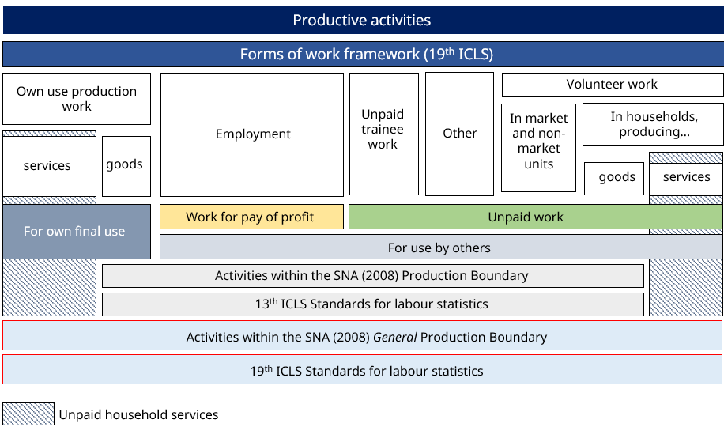

Figure 1

19th ICLS forms of work framework, alignment to the system of national accounts (SNA)

*Source: Adapted from* [*19th ICLS Resolution I: Resolution on work, employment and labour underutilization*](https://www.ilo.org/wcmsp5/groups/public/---dgreports/---stat/documents/normativeinstrument/wcms_230304.pdf)

With the introduction of the 19th ICLS, the remit of labour statistics was extended to recognise all *forms of work* as eligible for coverage in labour statistics. This resulted in a realignment of labour statistics to the SNA general production boundary, meaning unpaid household services was now within scope for labour statistics. In expanding the scope of labour statistics to recognise all work, the 19th ICLS standards also narrowed the concept of “employment” for the purpose of labour force statistics (to encompass only “work performed for pay of profit”). Under the previous (13th ICLS) standards, the concept

10While highly stable, the boundary is not immutable – some previously excluded economically productive activities have been admitted within the production boundary in the past. Most notably, in the 1970’s, the scope of subsistence production work (own use production of goods) admitted within the production boundary (and, by extension, labour statistics) was expanded beyond subsistence farming, fishing, and forestry, to include a wider range of activities [(Beneria, Lourdes (1999))](https://library.fes.de/libalt/journals/swetsfulltext/17160677.pdf)

of employment was expansive, collapsing all activities within the SNA (2008) production boundary in a single “employment” category.

These twin changes11 resulted in a dual measurement framework for labour statistics, integrating statistics on labour market engagement alongside participation in – and trade-offs between – different paid and unpaid productive activities. At a conceptual level, this entails parity in the treatment of different forms of work for the purposes of statistical measurement.

## Own use provision of services

The 19th ICLS recognises five separate and mutually exclusive “forms of work”12, with persons potentially occupying multiple work situations within a given reference period:

1. Own-use production work comprising production of goods and services for own final use
2. Employment work comprising work performed for others in exchange for pay or profit
3. Unpaid trainee work comprising work performed for others without pay to acquire workplace experience or skills
4. Volunteer work comprising non-compulsory work performed for others without pay
5. Other work activities (not defined in the resolution, but encompassing activities such as court mandated unpaid work)

OPS forms one of two sub-categories under (a), own use production work. Own use production work refers to productive activities for own final use. That is, production of goods or provision of services for “where the intended destination of the output is mainly for final use by the producer…or final consumption by household members, or by family members living in other households”13. Four separate “activity clusters”14 are distinguished within the sub-category of OPS:

* 1. household accounting and management, purchasing and/or transporting goods
  2. preparing and/or serving meals, household waste disposal and recycling
  3. cleaning, decorating, and maintaining one’s own dwelling or premises, durables and other goods, and gardening
  4. childcare and instruction, transporting and caring for elderly, dependent or other household members…, etc.

11A third, related, change ushered in by the 19th ICLS standards relates to the treatment of unemployment, refined to permit a wider range of labour under-utilisation indicators, covering *time-related unemployment* and *potential labour force,* as supplements to the unemployment rate (which remains a key indicator for labour force statistics)*.* 12ILO (2013) ICLS-Resolution-I-[STATI-131114-1], 3: 7

13ILO (2013) ICLS-Resolution-I-[STATI-131114-1], 5: 22D.

14ILO (2013) ICLS-Resolution-I-[STATI-131114-1], 15: 22C. The term “activity cluster” is not defined in 19th ICLS Resolution I, but clarification is provided in a separate report.

At a general level, this categorisation maps well onto multi-dimensional concepts of social reproduction and unpaid domestic and care work. It permits domestic work and “indirect care” work (activity clusters i – iii) to be distinguished from “direct care” work (activity cluster iv) in statistical outputs and indicators. In this, it is consistent with reporting requirements for SDG indicator 5.4.1, which mandates countries to report on the “proportion of time spent on unpaid domestic and care work, by sex, age, location”15.

Figure 2

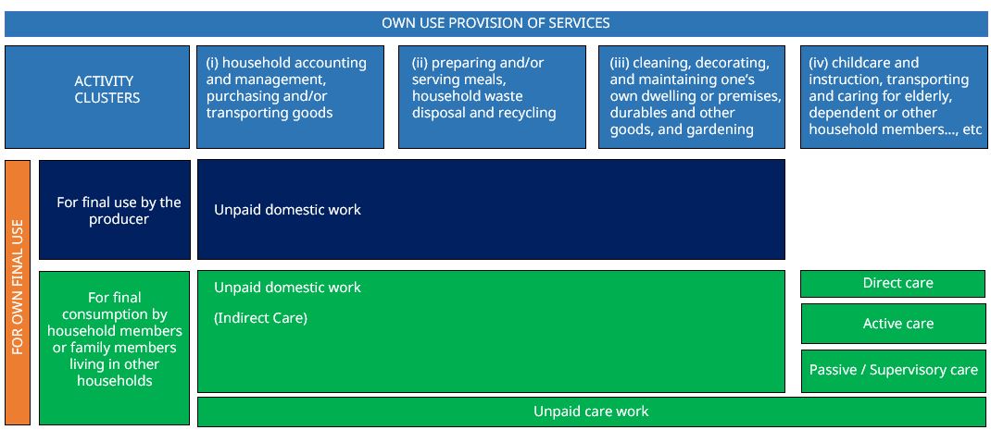

Own-use provision of services, mapped to multi-dimensional concept of care work

While only implicit in the 19th ICLS standards, the direct / indirect care distinction provides a useful organising framework for the development of measurement tools. “Indirect” care work refers to the provision of services which underpin daily life (such as cooking, cleaning, laundry, household maintenance and management), and form the pre- conditions for direct care16. “Direct” care work refers to relational care activities and responsibilities between care-provider(s) and care-recipient(s)17.

The category of direct care may be further sub-divided to distinguish “active” dimensions of caregiving (such as feeding, bathing, dressing, providing medical care, accompanying places), and “passive” or “supervisory” dimensions, expressed in caregiver presence, availability, and readiness to respond to the care recipient’s needs. This multi- dimensional concept of caregiving has several, important implications for the operationalisation of activity cluster (iv). “Passive” or “supervisory” dimensions of caregiving have been shown to be highly prone to under-reporting. Often taken-for- granted by respondents as a background constant, passive care corresponds to a

15UNSD (2023) [Harmonized SDG metadata - format version 1.1](https://unstats.un.org/sdgs/metadata/files/Metadata-05-04-01.pdf)

16International Labour Organisation (2018:6), [*Care work and care jobs for the future of decent work*](https://www.ilo.org/global/publications/books/WCMS_633135/lang--en/index.htm), ILO, Geneva

17International Labour Organisation (2018:6), [*Care work and care jobs for the future of decent work*](https://www.ilo.org/global/publications/books/WCMS_633135/lang--en/index.htm), ILO, Geneva

particular “state of mind”18, expressed in being present, attentive, available, watchful19. Understood as a “state of being”, rather than of “doing”, time spent on passive care is especially prone to omission or misrepresentation when measurement tools operationalise caregiving as a series of discrete, isolated activities20. Adequate measurement of passive dimensions of caregiving requires additional survey items, increasing the interview duration. While minimising respondent burden is a motivating factor in the development of the OPS modules, the inclusion of items to record passive care dimensions is justified by the scope for exclusion to deflate estimates of overall time allocations to care-giving. The ILO OPS module’s treatment of passive / supervisory care is aligned to the UN provisional definition of supervisory care.

**Box one: Provisional statistical reference concept for supervisory care**

The UNSD Expert Group on Time Use Statistics21 has developed a provisional reference concept for the statistical measurement of supervisory care, as follows:

“Unpaid supervisory care refers to the time the caregiver is in hearing or visual proximity to a dependent household or family member to provide unpaid caregiving services, should such need arise. The provision of supervisory care does not require the active involvement implied in the provision of those caregiving services where an interaction between the caregiver and dependent household or family member is needed. Supervisory care may occur at any location where the dependent household or family member is present and in close proximity with the caregiver. There is no requirement for bodily proximity of the caregiver with the dependent household and family member, such as being in the same room. More specifically, the provision of unpaid supervisory care includes:

* Time when the caregiver care engages in other activities in parallel, including remunerated activities listed in ICATUS-2016 Major Division 1, provided the caregiver remains accessible and in proximity should the need to provide caregiving services arise.
* Time when the dependent household or family member is engaged in activities alone, including sleeping.
* Time when the caregiver is not necessarily interacting with the dependent household or family member- but is ‘on-call’ should unpaid caregiving services be needed. This includes personal activities, such as sleeping.
* Unpaid supervisory care comprises hours related to being *on call* for the direct provision of unpaid caregiving services. It is classified as an activity under Group 416 (minding children) and 425 (passive care for dependent adults) …it excludes time spent on [other] productive activities falling under ICATUS 2016 Major Division 4, including help to non- dependent household and family members (Division 43)”.

18Budig M, Folbre N. “Activity, Proximity or Responsibility? Measuring Parental Childcare Time”. In Folbre, N and

Bittman, M, eds. Family Time: The Social Organization of Care. New York: Routledge; 2004. p. 51–68 19Folbre, Nancy. 2006. “Measuring Care: Gender, Empowerment, and the Care Economy.”. *Journal of Human Development*, 7(2): 183–99.

20Carrasco and Serrano (2011) draw attention to the parallels with certain occupations, where a part –sometimes the major part – of employment time is acknowledged to involve a state of being “on call”, and is recognised, recorded, and remunerated indivisibly from more “active” aspects of the work. Cristina Carrasco & Mònica Serrano (2011) “Lights and Shadows of Household Satellite Accounts: The case of Catalonia, Spain”. Feminist Economics, 17:2, 63-85, DOI: [10.1080/13545701.2011.573483](https://doi.org/10.1080/13545701.2011.573483)

21Provisional definition developed by the [*United Nations Expert Group on Innovative and Effective Ways to Collect Time-*](https://unstats.un.org/unsd/demographic-social/meetings/?Topic=time-use%20statistics)[*Use Statistics (EG-TUS)*](https://unstats.un.org/unsd/demographic-social/meetings/?Topic=time-use%20statistics)sub-group on the measurement of supervisory care.

# 3. Data sources

The 19th ICLS standards recognise time use surveys (TUS) as the main measurement approach for OPS statistics22, noting that LFS add-on modules can be a useful source when the objective is “to capture general patterns of participation of the population in different forms of work”23.

## Available measurement approaches, key features

Two main time-use measurement approaches are available to inform the development of LFS add-on modules, termed “diary” and “stylised”24. A variety of different formats are available within each broad approach. In recent years, ‘hybrid’ diary instruments, which combine aspects of each, have been the subject of growing interest.

Diary measurement formats are characterised by the chronological reporting of time use over the 24 hours of a day, sometimes for multiple days. The respondent records (if self- administered) or reports (if interviewer-administered) how they spend (if contemporaneous) / spent (if retrospective) their time, from a designated moment, conventionally 4am or 12midnight, or from the moment that they wake/woke up. The exercise is sometimes repeated for multiple days.

Within this broad approach, several diary formats have been developed. Formats vary in important ways. Episode timings may be open-ended or pre-defined. In the former, the respondent records (or reports) the start and end times of each activity. In the latter, the 24 hours of the day are divided into, usually equal25, intervals of between five minutes and 60 minutes, ready to be populated with the respondents’ activity/ies.

Formats also vary according to whether activities are open-coded or pre-defined. In the former, activities are recorded verbatim, in the respondents’ own words, subject to coding at the data entry stage. In the latter, the respondent (if self-administered) or interviewer (if interviewer-administered) selects the code that most closely corresponds to each activity from a pre-specified list. The convention is to refer to diaries with pre- designated activity codes as “light” / “lite” diaries and to open-code diaries as “full” diaries.

Further variations, applicable to both light and full diaries, include the presence of fields to record “multi-tasking”, i.e., activities undertaken simultaneously or over-lapping, and/or contextual information such as location, presence of others, ‘beneficiary’, remuneration, use of ICT, and/or affect.

22ILO (2013) ICLS-Resolution-I-[STATI-131114-1], 13-14: 67B.

23ILO (2013) ICLS-Resolution-I-[STATI-131114-1],13-14: 67A.

24Approaches used outside of survey contexts, such as immersive observation, experience sampling methods (ESM), and deployment of wearable technologies, are omitted from discussion as beyond scope.

25In some cases, longer intervals are assigned to night-time hours, during which most respondents are presumed to be sleeping, to condense the diary exercise.

In a stylised format, respondents report participation in, and total, summed, time dedicated to, an activity or activity-class over a specified reference period, usually either a seven-day week or a 24-hour day. While diary formats record the timing, sequencing, and duration of activities, stylised formats provide participation and total duration. Stylised questions may be framed in terms of a specific reference period, e.g., “Yesterday (or last week), how much time did you spend doing (activity X)?” Alternatively, questions may be phrased more generally in terms of usual or typical practices, e.g., “How many hours a day (or a week) do you usually spend doing (activity X)?”26. The term “stylised” originated in this latter framing. The resulting time use estimates were “stylised” in that they referred to a hypothetical construct – the “typical” day, week, month, or other reference period – rather than a concrete, actual, reference period27. Contemporary usage of the term “stylised” has expanded to incorporate “actual” and “usual” framings. The distinctiveness of the approach is instead defined in opposition to the diary format28.

Stylised approaches vary in breadth of coverage. At one end of this spectrum are “stylised analogues of time diaries”29. The scope of activities covered in such “stylised analogues” is deliberately comprehensive, the goal being to capture – at varying levels of detail – all activities the respondent performed for a given reference period30. The comprehensive list of activities included in stylised analogues permit a level of activity coverage comparable to diary approaches. At the other end of the spectrum are short question series’, which forego a \full accounting of respondents’ time use, to restrict investigation to a limited number of activity classes.

Hybrid diary instruments include direct question items, familiar from the “stylised” approach, alongside a ‘core’ diary. Such combined approaches have developed in response to a range of different measurement, operational, and statistical considerations. The inclusion of targeted direct probe(s) can address under-identification of activity/ies omitted from spontaneous diary reports. Targeted stylised probes are included in the LFS add-on light diary modules to recover “supervisory” or “passive” caregiving responsibilities. The direct probes are sequenced after initial diary completion, with newly recalled / reported activities flagged as recovered items in the diary record.

26There is broad consensus that “typical” period questions place greater cognitive demands on respondents than do specific period questions (where the specific period is sufficiently short and recent).

27Juster, F. Thomas., Ono, Hiromi., and Stafford Frank P. (2003) “An Assessment of Alternative Measures of Time Use”, Sociological Methodology, 2003;33: pp. 19-54, Available from: https://[www.jstor.org/stable/1519852](http://www.jstor.org/stable/1519852) 28Terminology relating to time-use measurement instruments remains somewhat unstandardised. Within the peer-review literature, stylised approaches are sometimes restricted to investigations of “usual” or “typical”

time use and sometimes applied expansively. Practice varies considerably. The most recent published international

guidelines (UN 2005: 15) applies the expansive definition (i.e., encompassing “actual” and “usual”).

29See [UN 2005:15](https://unstats.un.org/unsd/publication/seriesf/seriesf_93e.pdf), Guide to Producing Statistics on Time Use: Measuring Paid and Unpaid Work, Department of Economic and Social Affairs, Statistics Division, ST/ESA/STAT/SER/93, United Nations, New York

30See [UN 2005:16](https://unstats.un.org/unsd/publication/seriesf/seriesf_93e.pdf), Guide to Producing Statistics on Time Use: Measuring Paid and Unpaid Work, Department of Economic and Social Affairs, Statistics Division, ST/ESA/STAT/SER/93, United Nations, New York

# 4. Statistical Indicators

The 19th ICLS standards specify the production of three statistical indicators, headcounts, participation rates, and volume measures *by activity cluster* of own-use providers of services31. This is consistent with indicators specified in the 19th ICLS for other forms of unpaid work (i.e., own-use producers of goods, unpaid trainees, and volunteer workers (the latter disaggregated by type of economic unit)32.

The specified indicators for participation rates and volume measures (with headcounts calculated as an input) are consistent with headline indicators for time use data:

* + Participation rate (proportion of population participating) by activity domain
  + Volume measures:
* Mean time spent (minutes per day or hours per week) on activity/ies of interest, for the population (or sub-groups of interest) as a whole (sometimes termed ‘social time’)
* Mean participant time spent (minutes per day or hours per week) by activity/ies, of interest for the participating population (or sub-groups thereof) only (sometimes termed ‘participant time’)

Volume measures for time use data are calculated in one of two ways (and sometimes both), with the difference based on the denominator of interest. These are *mean time spent,* or *social time* (where the denominator includes all observations)33 and *mean participant time spent* or *participant time* (where the denominator is restricted to observations for the activity of interest)*.*

The principal advantage of a *mean time spent,* or *social time,* indicator is its greater sensitivity to changes over time, which may originate in the amount of time allocated to an activity domain by participants, the proportion of the total population (or population sub-group) participating in the activity class, or a combination of the two. In contrast, *mean participant time spent* or *participant time* indicators capture only the former source of change over time (changes in time allocations for the participating population). The

31ILO (2013) ICLS-Resolution-I-[STATI-131114-1], 15: 74B.

32ILO (2013) ICLS-Resolution-I-[STATI-131114-1],15: 74A, 74C, 74D

33The 19th ICLS Standards (ILO (2013) ICLS-Resolution-I-[STATI-131114-1],5: 22A, 22B) impose a one-hour criterion for the calculation of OPS indicators. This means that headcounts, participation rates, and volume rates are calculated only for participants reporting 60 minutes or more activity in OPS (as a whole). The same one-hour criterion is imposed for all “forms of work” (with the appropriate reference period varying for the different forms of work). However, in the case of OPS is it likely to be overly restrictive – and ultimately problematic, skewing overall estimates downwards (particularly in the case of men), exaggerating gender-based differences, and undermining monitoring of change over time. Such a constraint also impedes comparative analysis, including comparability of estimates for SDG indicator 5.4.1 (which imposes no such minimum floor). For that reason, the interim recommendation (pending formal revision by the ICLS) is that the one-hour criterion is not imposed for the calculation of OPS indicators.

social time volume indicator is consistent with SDG Indicator 5.4.1 (“the proportion of time spent [in a day34] on unpaid domestic and care work by sex, age35, and location36”).

While the *mean participant time spent*, or *participant time,* indicator is less sensitive to change over time, it is sometimes favoured, owing to the ‘user-friendliness’ of the output. Since only participant’s time allocations are included, the average time recorded for each activity more closely aligns with intuitive expectations (e.g., an average of ∼8 hours spent in employment).

While intuitively appealing, participant time indicators are vulnerable to misinterpretation as the sum of different (primary) activity domains exceeds 24 hours (or 168 hours for a 7-day week). This is because the cohort of participants differs across activity classes. The extent to which ‘social time’ and ‘participant time’ diverge is a function of the participation rate. For activities with universal, or very comprehensive, rates of participation, e.g., sleeping, the two indicators will closely align. For activities with highly skewed participation rates, divergence will be greater. For these reasons, volume measures should generally be calculated based on *mean time spent,* or *social time* approach. This allows for greater sensitivity to variations over time.

For each activity cluster, disaggregation is specified according to the following characteristics:

*Indicators should be computed for the population as a whole and disaggregated by sex, specified age groups (including separate categories for youth)37, level of educational attainment, geographic region, urban and rural areas, and other relevant characteristics taking account of the statistical precision of the estimates38*

In the case of own use provision of services, other relevant characteristics may include:

* + Labour force status
  + Marital status
  + Parenthood status

The 19th ICLS standards specify different reference periods appropriate to each form of work, “based on the intensity of participation and working time arrangements”*39*. For own use provision of services, the reference period is specified as “one or more 24-hour days within a seven-day or one-week period*”40*.

34The reference period – in square brackets – is specified in the UNSD definition [(UNSD 2019)](https://unstats.un.org/sdgs/metadata/files/Metadata-05-04-01.pdf)

35Age: 15+, 15-24, 25-44, 45-54, 55-64 and 65+ [(UNSD 2018)](https://unstats.un.org/sdgs/metadata/files/Metadata-05-04-01.pdf)

36Location: Urban/rural (according to national definitions in the absence of a standardised international definition [(UNSD 2019)](https://unstats.un.org/sdgs/metadata/files/Metadata-05-04-01.pdf)

37The relevant guidance on disaggregation by age-band states: *Five-year age bands should be used for the main aggregates, where the lowest age bracket refers to persons aged 15–19 years and the highest age bracket to persons aged 75 years and above. Where concerns regarding the precision of the estimates impede disaggregation by five-year age bands, broader bands may be used; in all cases these should include 15–24 years, 25–34 years, 35–54 years, 55–64 years, 65–74 years and 75 years and above* (ILO (2013) ICLS-Resolution-I-[STATI-131114-1] 18:93)

38ILO (2013) ICLS-Resolution-I-[STATI-131114-1], 14: 71.

39ILO (2013) ICLS-Resolution-I-[STATI-131114-1], 4: 19.

40ILO (2013) “Resolution I: Resolution concerning statistics of work, employment and labour underutilization” ICLS- Resolution-I-[STATI-131114-1], 5: 19.

# 5. Labour force survey add-on module

## LFS add-on modules for measurement of OPS key features

Table 1: Key features of the LFS OPS add-on module

|  |  |
| --- | --- |
| **Feature** | **Summary details** |
| Format | Hybrid light diary |
| Target population | Identical with population for labour force survey (working age population, 15 years old and above), no limitations imposed on  labour force status or other characteristics |
| Mode | Face-to-face interviewer administered |
| Administration | CAPI, CS Pro |
| Reference period | One 24-hour day, “yesterday” 04:00 to 04:00 |
| Reference day assignment | Probabilistic assignment of sampled  households to days of week in advance |
| Pending recovery strategy | Postponement and substitution (pre- specified substitution day) protocols developed as part of allied implementation  guidance |
| Respondent sampling (within household) | A minimum of one eligible household member (probabilistically sampled) Countries may adopt other intra-household sample designs, e.g., couple dyad / all  eligible members. |
| Activity timing | Fixed episodes (96 x 15-minute episodes) |
| Activity coding | Respondent narrates diary day verbatim. Interviewer selects from 40 pre-coded activities + “other, specify”. Codes aligned to the UN International Classification of Activities for Time Use Statistics 2016  (ICATUS-16) coding scheme. |
| Contextual items | Four *conditionally activated* contextual items (location, co-presence, beneficiary, market orientation) to support assignment to forms  of work / ICATUS-16 major divisions |
| Treatment of supervisory / passive care | Dedicated recovery series activated on completion of the diary day. Separate items target supervision / passive care of children  and adults |
| Treatment of simultaneity / multi-tasking | Optional fields to record multiple activities  as occurring simultaneously (i.e., during one or more of the same 15-minute episodes). |

## LFS add-on module: pre-coded activity listing

|  |  |
| --- | --- |
| OWN USE PROVISION OF SERVICES, HYBRID LIGHT DIARY (LDB_): ACTIVITY CODES | |
| **IMPLEMENTATION NOTES**   * 40 activity codes have been developed as response codes for items:   + LDB_1, LDB_1B | |
| **LDB**  1 | **_1 & LDB_1B**  Sleeping or napping [OMIT FOR LDB_1B, SIMULTANEOUS ACTIVITIES] |
| 2 | Personal hygiene and health |
| 3 | Eating or drinking |
| 4 | Cooking / baking / preparing / serving meals, snacks, beverages + related tasks (cleaning dishes, storing food and drinks…) |
| 5 | Manufacturing / processing foods, beverages, herbs, medicines, tobacco |
| 6 | Cleaning and tidying indoors |
| 7 | Outdoor cleaning and upkeep |
| 8 | Pet care (includes feeding, exercising, cleaning, grooming, taking to vet) |
| 9 | Decorating or minor repairs, maintenance of buildings, durable goods, vehicles, machinery |
| 10 | Laundry / repair or maintenance of clothes, textiles, shoes |
| 11 | Shopping for/purchasing goods |
| 12 | Paying bills, budgeting, administration, planning, organising |
| 13 | Providing physical care or comforting children (feeding, cleaning, bathing, giving medical care, soothing…) |
| 14 | Teaching, training, helping, talking with, or reading to children |
| 15 | Playing games and sports with children |
| 16 | Attending children’s sports or games match, play, dance, or talent show, or similar (includes training, practice, rehearsals) |
| 17 | [Supervising / minding / watching over / keeping an eye on] children |
| 18 | Providing physical care, practical assistance, or emotional support to adults |
| 19 | [Supervising / minding / watching over / keeping an eye on] ill, injured, frail, or disabled adults who require assistance |
| 20 | Waged or salaried employment / self-employment / paid traineeship |
| 21 | Helping without pay in a farm or business enterprise |
| 22 | Looking for paid work or setting up a new business |
| 23 | Unpaid traineeship or internship |
| 24 | Volunteering / community or social organising/ environmental / nature conservation / protection of wild or street animals |
| 25 | Studying, learning |
| 26 | Growing crops, including kitchen garden, (clearing, planting, fertilising, irrigating, weeding, picking / harvesting) |
| 27 | Tending to livestock (accompanying while grazing, milking, gathering wool / eggs / dung / other animal products) |
| 28 | Gathering / processing firewood, straw |
| 29 | Fetching water from natural and other source |
| 30 | Fishing / Aquaculture / Forestry / Logging / Gathering wild products / [hunting or trapping animals] |
| 31 | Mining, quarrying / construction, major renovations, or major repairs |
| 32 | Weaving, knitting, sewing, embroidering, tanning, bead work, textile- / leather- / metal-, wood- / stone- / brickwork |
| 33 | Socializing, visiting with, talking to friends / family / neighbours |
| 34 | Religious practice (individual or collective) |
| 35 | Participating in community festivals, celebrations |
| 36 | Attending cultural / entertainment / sports events |
| 37 | Playing sports or doing exercise |
| 38 | Watching tv shows, movies, online visual media / Reading for leisure / Listening to music, radio, podcasts, online audio media |
| 39 | Hobbies, games, pass-times (includes resting / relaxing, “doing nothing”) |
| 40 | Travelling or commuting / Transporting or accompanying people or goods [OMIT FOR LDB_1B, SIMULTANEOUS ACTIVITIES] |
| 41 | Other: Specify |
| 42 | NOTHING ELSE [OMIT FOR LDB_1, ACTIVITY ONE] |
| 97 | DON’T KNOW |

## LFS add-on module: Alignment to ICATUS 2016

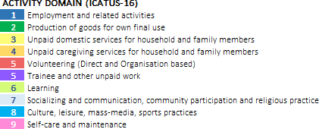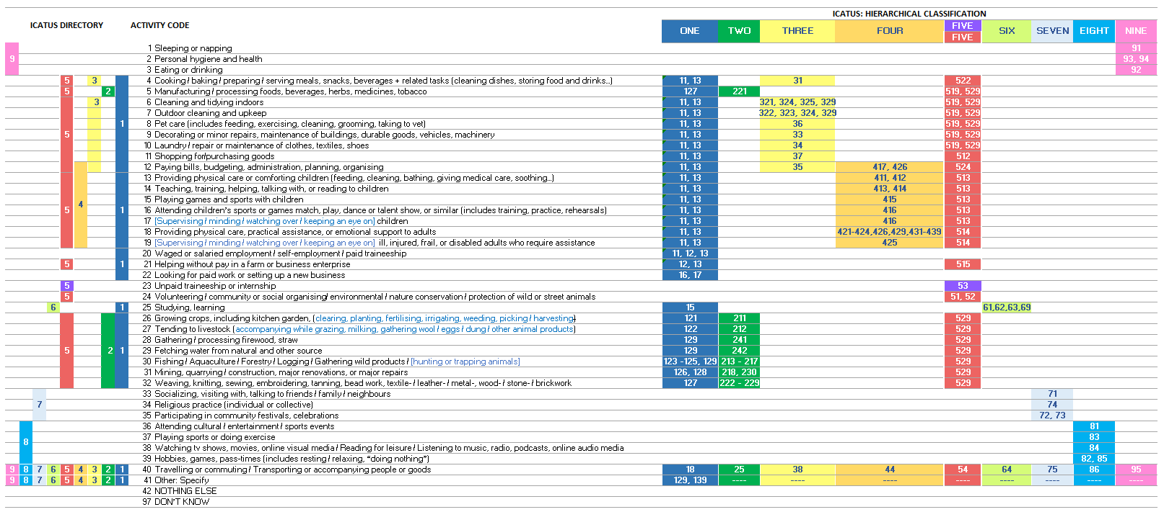

## LFS add-on module: Conditional context items

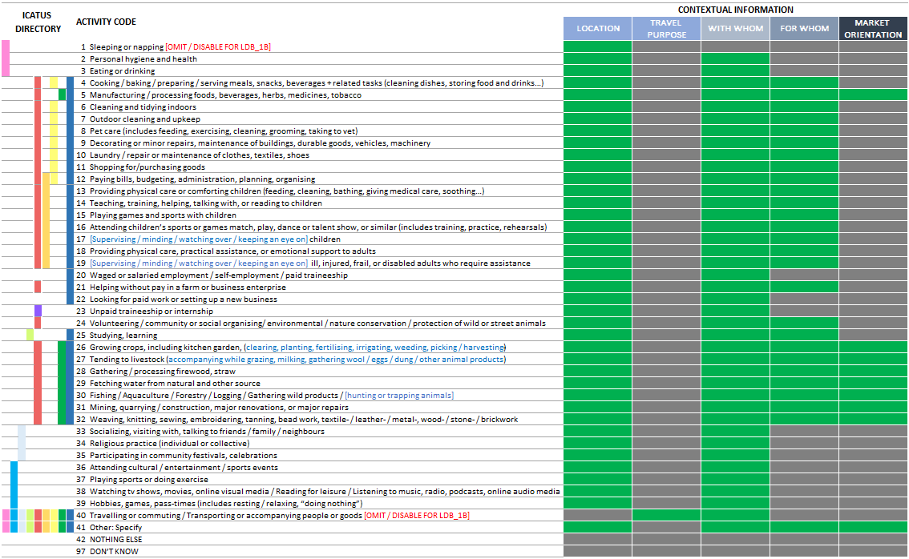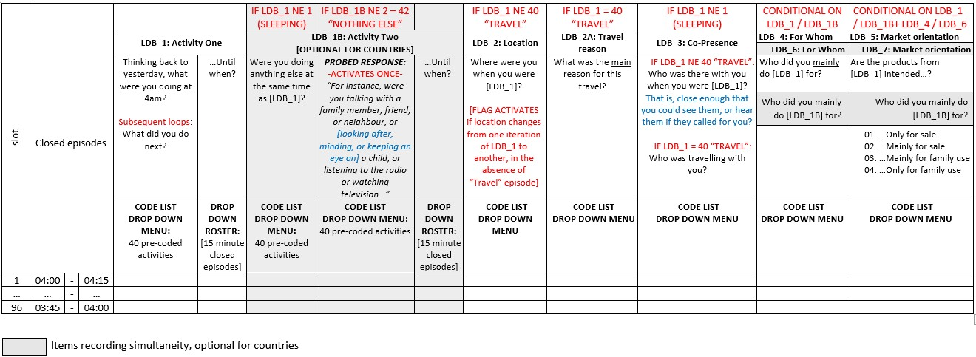

**5.5 LFS add-on module: Schematic of the CAPI design (hybrid light diary module)**

## LFS add-on module: Schematic of the CAPI design (recovery of passive / supervisory care)

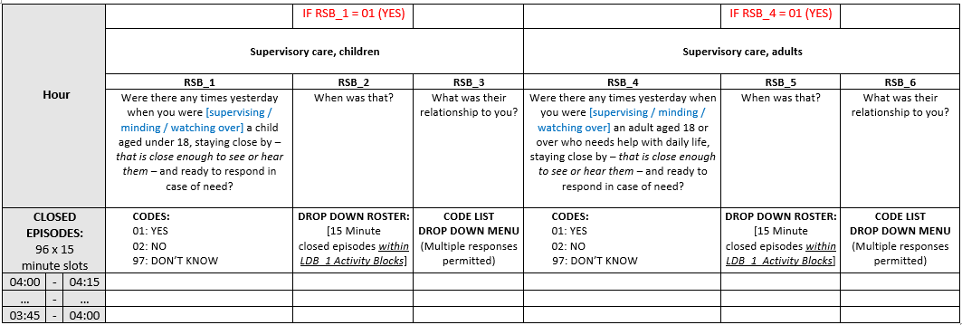

## LFS add-on OPS modules

#### Conventions used in the ILO model LFS questionnaires for CAPI

* + - Regular text: Indicates text to be read by the interviewer
    - *Italics: Indicates interviewer instructions or aids, not to be read aloud*
    - CAPS: INDICATES RESPONSE CATEGORIES AND FILTERS NOT TO BE READ OUT LOUD
    - (Parenthesis): Indicates that a choice or a substitution must be made
    - Red text: Indicates overall filter groups to be asked a question/set of questions, related instructions, or other guidance to the developer
    - [Blue text within square brackets]: Indicates text to be adapted as per national circumstances
    - Bold text: Indicates question numbers, section headings, skips, other structural items

|  |
| --- |
| REPUBLIC OF MALAWI  NATIONAL STATISTICAL OFFICE |
| 2023 LABOUR FOUR SURVEY  TIME USE QUESTIONNAIRE, 15+ YEARS OLD |
| |  |  |  | | --- | --- | --- | |  |  |  |   CLUSTER:  REGION: ________________________________________________________________  DISTRICT: ________________________________________________________________  TA/STA: ________________________________________________________________   |  |  |  | | --- | --- | --- | |  |  |  |   ENUMERATION NUMBER:   |  |  | | --- | --- | |  |  |   HOUSEHOLD NUMBER:  HOUSEHOLD HEAD: _________________________________________________________  INTERVIEWER NAME:  ________________________________________________________  SUPERVISOR NAME: _________________________________________________________   |  |  |  | | --- | --- | --- | |  |  |  |   DATE OF INTERVIEW:  START TIME:   |  |  | | --- | --- | |  |  |  |  |  | | --- | --- | |  |  |   END TME: |

|  |
| --- |
| OWN USE PROVISION OF SERVICES, HYBRID LIGHT DIARY: MODULE LDB_ |
| **OBJECTIVES AND SCOPE**   * To record the timing, duration, and sequencing of all activities undertaken by persons over a 24-hour reference period * To accurately classify and characterise activities undertaken by persons over a 24-hour reference period * The sequence is aligned with the 19th ICLS standards (2013), the UN ICATUS (2016), and the SNA (2008) * This module marks the start of the personal hybrid light diary covering a period of 24 hours from 04:00 on   the day prior to the interview until 04:00 of the day of the interview. |
| **IMPLEMENTATION NOTES**   * To be asked of one probabilistically sampled eligible household member * Proxy reporting is NOT permitted for module LDB_ * The 24-hour reference period is divided into 96 x 15-minute time slots. Start and end times are recorded by selection of the corresponding 15-minute episode. Intervening episodes are filled automatically. * 40 pre-coded activities are listed on page 7. * Additional contextual information fields are automatically activated for selected activities. * Two global variables (LDB_TSS, LDB_TSE) are created as pre-filled variables to direct the interview flow and inform calculation of additional background variables (not shown here for ease of navigation) * **Items LDB_1B, LDB_6, LDB_6A, and LDB_7 record simultaneous activities. These are optional for**   **countries.** |
| **LDB_1**  *INTERVIEWER TO READ INTRO TEXT:*  The purpose of the next section of the survey is to create a snapshot of daily life in [COUNTRY]. That is, how people spend their day – the things they do, the places they go, and the responsibilities they have.  Information about how people spend their time on a day-to-day basis is very important to help plan services needed in the local area, as well as national policies and schemes.  I’m going to ask you about what you did yesterday. We will start with what you were doing at 4am yesterday morning. We begin at 4am because people are often asleep at that time. This allows us to capture the start of the waking day.  Please tell me what you did yesterday in the order that you did it. Try to tell me as much detail as you can about what you were doing, where you were, and who was with you throughout the day.  Thinking about yesterday, what were you doing at [4am…]? [SELECT FROM PRE-CODED ACTIVITIES]  Note for CAPI: Subsequent loops: And what did you do next…?  Until when?  [SELECT FROM DROP-DOWN LIST OF 15-MINUTE TIMESLOTS] |
| **LDB_CHK** Note for CAPI: If respondent was **not** sleeping [LDB_1 NE 01] at 04:00, ask: What time did you wake up yesterday?  HH:MM  9977: DID NOT SLEEP THAT NIGHT (E.G., WORKING NIGHTSHIFT) |
| *ASK IF (LDB_1 IS NOT EQUAL TO 01 [SLEEPING]*  **LDB_1B**  Were you doing anything else at the same time as you were [LDB_1]? Note for CAPI: CONSTRAIN TO ONE ACTIVITY PER 15 MINUTE SLOT [SELECT FROM PRE-CODED ACTIVITIES]  Note for CAPI: ACTIVATE ONCE ONLY [FIRST TIME THAT LDB_1B = 42 or 97]  IF LDB_1B = 42 or 97: Probe: *For instance, were you talking with a family member, friend, or neighbour, or [looking after | minding | keeping an eye on] a child, or eating a snack, or listening to the radio, or watching television…*  Until when did you [LBD_1B]?  *Notes: For CAPI implementation, from second iteration onwards, LDB_TSE updates to start range from value of*  *LDB_TSS + 1* |
| IF LDB_1 NE 40 “TRAVEL” & IF LDB_1 NE 97 “DON’T KNOW”  Note for CAPI: LDB_2 SHOULD BE AUTO-FILLED AS 08 “IN TRANSIT” IF LDB_1 = CODE 40 “TRAVEL” |

|  |
| --- |
| **LDB_2**  Where were you when you were [LDB_1]?  [FOR SECOND LOOP OF LDB_1 ONWARDS: 99. NO CHANGE IN LOCATION SINCE PRIOR ACTIVITY]   1. OWN HOME (DWELLING OR IMMEDIATE SURROUNDS) 2. OTHER PERSONS' HOME (DWELLING OR IMMEDIATE SURROUNDS) 3. WORKPLACE 4. SCHOOL OR OTHER EDUCATIONAL ESTABLISHMENT 5. RELIGIOUS SITE / PLACE OF WORSHIP (CHURCH, MOSQUE, TEMPLE, SPIRIT HOUSE…) 6. OTHER OUTDOOR PUBLIC OR COMMERCIAL SITE (STREET, MARKET, PARK, FIELD, FOREST, POND, LAKE…) 7. OTHER INDOOR PUBLIC OR COMMERCIAL SITE (SHOP, BANK, RESTAURANT, CINEMA, MUSEUM, HOSPITAL…) 8. IN TRANSIT 9. OTHER (SPECIFY)   Note for CAPI: If location changes between iterations of LDB_1, without intervening “Travel” [LBD_1 = CODE 40]  or “in transit” [LDB_2 = CODE 08], activate script: “Warning: Change in location without intervening travel time.  Please enter a valid value” |
| IF LDB_1 = 40 “TRAVEL”  **LDB_2A**  What was the main reason for this travel?   1. COMMUTING FOR WAGED OR SALARIED JOB, OWN/HOUSEHOLD BUSINESS, TRAINEESHIP, VOLUNTEER WORK, STUDIES 2. OTHER TRAVEL FOR WAGED OR SALARIED JOB, OWN/HOUSEHOLD BUSINESS, TRAINEESHIP, VOLUNTEER WORK, STUDIES 3. PRODUCTION OF GOODS (GROWING CROPS/RAISING ANIMALS/GATHERING FIREWOOD/FETCHING WATER…) 4. PROVISION OF SERVICES (SHOPPING, DOING LAUNDRY, PAYING BILLS, RUNNING ERRANDS…) 5. SOCIALISING / COMMUNITY PARTICIPATION / RELIGIOUS PRACTICE 6. CULTURE / LEISURE / SPORTS OR EXERCISE 7. SELF-CARE & MAINTENANCE (MEDICAL APPOINTMENTS, HAIRDRESSER / SALON VISITS, SPA TREATMENT…) 8. DROPPING OFF / COLLECTING / ACCOMPANYING HOUSEHOLD OR FAMILY CHILDREN 9. DROPPING OFF / COLLECTING / ACCOMPANYING ADULT HOUSEHOLD OR FAMILY MEMBERS 10. DROPPING OFF / COLLECTING / ACCOMPANYING OTHER CHILDREN OR ADULTS 11. OTHER |
| **LDB_3**  ASK IF (LDB_1 NE 1) & (LDB_1 NE 97) & (LDB_1 NE 40) & (LDB_2 NE 08)  Who was there with you when you were [LDB_1]? That is, close enough that you could see them, or hear them if they called for you?  ASK IF (LDB_1 NE 1) & (LDB_1 NE 97) & (LDB_1 = 40) OR (LDB_2 = 08)  Who was travelling with you?  [FOR SECOND LOOP OF LDB_1 ONWARDS: 99. NO CHANGE IN PERSONS PRESENT SINCE PRIOR ACTIVITY]   1. ALONE (INCLUDES WITH STRANGERS IN PUBLIC SETTING) ALL THAT APPLY 2. HOUSEHOLD AS A WHOLE (INCLUDES SELF AND ALL HH MEMBERS) 3. SPOUSE 4. OTHER ADULT HOUSEHOLD OR FAMILY MEMBERS 5. OTHER ADULTS KNOWN TO RESPONDENT (E.G., FRIENDS / NEIGHBOURS / COLLEAGUES) 6. OWN CHILD(REN) 7. GRANDCHILD(REN) 8. OTHER FAMILY CHILDREN 9. OTHER CHILDREN |
| ASK IF LDB_3 = 06 – 08  **LDB_3A**  How old [is/are] [she / he / they]? ALL THAT APPLY   1. UNDER 3 YEARS OLD 2. 3 YEARS OLD TO 6 YEARS OLD 3. 7 YEARS OLD TO 12 YEARS OLD 4. 13 YEARS OLD TO 17 YEARS OLD 5. 18 YEARS OR OLDER |

|  |
| --- |
| ASK IF LDB_1 = 4–19, 21, 24–32, 41 OR LDB_2A = 3, 4, 8,9  **LDB_4**  Who did you mainly do [LDB_1] for?  CONSTRAIN: SELECT ONE ONLY (MAIN BENEFICIARY)  [FOR SECOND LOOP OF LDB_1 ONWARDS: 99. NO CHANGE SINCE PRIOR ACTIVITY]   1. SELF 2. HOUSEHOLD AS A WHOLE (INCLUDES SELF AND ALL HH MEMBERS) 3. SPOUSE 4. OTHER ADULT HOUSEHOLD OR FAMILY MEMBER 5. OTHER ADULTS (E.G., FRIENDS / NEIGHBOURS / COLLEAGUES / STRANGERS) 6. OWN CHILD(REN) 7. GRANDCHILD(REN) 8. OTHER FAMILY CHILDREN 9. OTHER CHILDREN 10. WAGED OR SALARIED JOB 11. OWN-BUSINESS OR HOUSEHOLD/FAMILY BUSINESS OR OTHER INCOME GENERATION 12. FOR A CHARITY, COMMUNITY GROUP, OR ORGANISATION 13. HOUSEHOLD OR FAMILY LIVESTOCK 14. HOUSEHOLD OR FAMILY PET 15. WILD OR STREET ANIMALS / NATURAL ENVIRONMENT 16. OTHER: SPECIFY |
| ASK IF LDB_4 = 06 – 08  **LDB_4A**  How old [is/are] [she / he / they]?   1. UNDER 3 YEARS OLD 2. 3 YEARS OLD TO 6 YEARS OLD 3. 7 YEARS OLD TO 12 YEARS OLD 4. 13 YEARS OLD TO 17 YEARS OLD 5. 18 YEARS OR OLDER |
| ASK IF LDB_1 = 5, 26–32, 41 AND LDB_4 NE 10 - 12  **LDB_5**  Are the products from [LDB_1] intended…?   1. …Only for sale 2. …Mainly for sale 3. …Mainly for family use 4. …Only for family use |
| ASK IF LDB_1B = 4–19, 21, 24–32, 41  **LDB_6**  Who did you mainly do [LDB_1B] for?  CONSTRAIN: SELECT ONE ONLY (MAIN BENEFICIARY)  [FOR SECOND LOOP OF LDB_1B ONWARDS: 99. NO CHANGE SINCE PRIOR ACTIVITY]   1. SELF 2. HOUSEHOLD AS A WHOLE (INCLUDES SELF AND ALL HH MEMBERS) 3. SPOUSE 4. OTHER ADULT HOUSEHOLD OR FAMILY MEMBER 5. OTHER ADULTS (E.G., FRIENDS / NEIGHBOURS / COLLEAGUES / STRANGERS) 6. OWN CHILD(REN) 7. GRANDCHILD(REN) 8. OTHER FAMILY CHILDREN 9. OTHER CHILDREN 10. WAGED OR SALARIED JOB 11. OWN-BUSINESS OR HOUSEHOLD/FAMILY BUSINESS OR OTHER INCOME GENERATION 12. FOR A CHARITY, COMMUNITY GROUP, OR ORGANISATION 13. HOUSEHOLD OR FAMILY LIVESTOCK 14. HOUSEHOLD OR FAMILY PET 15. WILD OR STREET ANIMALS / NATURAL ENVIRONMENT 16. OTHER: SPECIFY |

|  |  |
| --- | --- |
| ASK IF LDB_6 = 06 – 08  **LBB_6A**  How old [is/are] [she / he / they]?   1. UNDER 3 YEARS OLD 2. 3 YEARS OLD TO 6 YEARS OLD 3. 7 YEARS OLD TO 12 YEARS OLD 4. 13 YEARS OLD T0 17 YEARS OLD 5. 18 YEARS OR OLDER |  |
| ASK IF LDB_1B = 5, 26–32, 41  **LBB_7**  Are the products from [LDB_1B] intended…?   1. …only for sale 2. …mainly for sale 3. …mainly for family use 4. …only for family use |
| END OF MODULE LDB_ |
|  | |
| OWN USE PROVISION OF SERVICES, HYBRID LIGHT DIARY: MODULE RSB_ (RECOVERY OF SUPERVISORY CARE) | |
| **OBJECTIVES AND SCOPE**   * To record persons’ background supervisory and on-call care responsibilities over the 24-hour reference period | |
| **IMPLEMENTATION NOTES**   * To be asked of all household members of working age. Proxy reporting is NOT permitted for module LDB_ * Administered on completion of module LDB_ | |
| **RSB_1**  Were there any times yesterday when you were [supervising / minding / watching over] a child aged under 18, staying close by *– that is close enough to see or hear them –* and ready to respond in case of need?   1. YES 2. NO | |
| *ASK IF RSB_1 = 1*  **RSB_2**  When was that? ALL THAT APPLY   * Drop down menu: Activities reported under LSB_1   *Note: For CAPI implementation (drop-down with each activity reported as separate category – allow for multi-select)* | |
| *ASK IF RSB_2 <> notappl*  **RSB_2A**  When during [LDB_1] was that? ALL THAT APPLY  [Select from drop-down list of 15-minute timeslots]  CONSTRAIN TO ONE RESPONSE ONLY IF CODE 97 “CONTINUOUS”  97. Continuously  *Note: For CAPI implementation,* constrain time range based on [LDB_TSS] to [LDB_TSE] for LDB_1  *Note: For CAPI implementation, separate roster to collect estimated time for RSB_2a)* | |
| **RSB_3**  What is their relationship to you? ALL THAT APPLY   1. OWN CHILD(REN) 2. GRANDCHILD(REN) 3. OTHER FAMILY CHILDREN 4. OTHER CHILDREN | |
| **RSB_3A**  How old [is/are] they? ALL THAT APPLY   1. UNDER 3 YEARS OLD 2. 3 YEARS OLD TO 6 YEARS OLD 3. 7 YEARS OLD TO 12 YEARS OLD 4. 13 YEARS OLD TO 17 YEARS OLD | |

|  |
| --- |
| **RSB_4**  Were there any times yesterday when you were [supervising / minding / watching over] an adult aged 18 or over who needs help with daily life, staying close by *– that is close enough to see or hear them –* and ready to respond in case of need?   1. YES 2. NO |
| *ASK IF RSB_4 = 1*  **RSB_5**  **When was that…?**  *Note: For CAPI implementation (drop-down with each activity reported as separate category – allow for multi-select)* |
| **RSB_5a**  When during [LDB_1] was that? ALL THAT APPLY  [Select from drop-down list of 15-minute timeslots]  CONSTRAIN TO ONE RESPONSE ONLY IF CODE 97 “CONTINUOUS”  97. Continuously  *Note: For CAPI implementation,* constrain time range based on [LDB_TSS] to [LDB_TSE] for LDB_1  *Note: For CAPI implementation, separate roster to collect estimated time for RSB_5)* |
| **RSB_6**  What is their relationship to you? ALL THAT APPLY   1. HOUSEHOLD MEMBER(S) 2. FAMILY MEMBER(S) LIVING IN A SEPERATE HOUSEHOLD 3. EMPLOYER / LANDLORD 4. OTHER INDIVIDUALS / HOUSEHOLDS (FRIENDS / NEIGHBOURS / ACQUAINTENCES / STRANGERS) |
| END OF MODULE RSB |

|  |
| --- |
| OWN USE PROVISION OF SERVICES: MODULE TPL_ (DEPARTURE FROM TYPICAL DAY) |
| **OBJECTIVES AND SCOPE**   * Identify potential explanations for atypical time use (e.g., excessive day time sleep due to illness) |
| **IMPLEMENTATION NOTES**   * Administered on completion of modules LDB_ and RSB_ and QDB_ |
| **TPL_1A**  Was yesterday unusual in any way, such as…?  ALL THAT APPLY   1. You worked more hours than normal in your paid job(s) 2. You worked fewer hours than normal in your paid job(s) 3. It was a festival day or the day of an event (e.g., public holiday, religious festival, wedding, christening, funeral) 4. It was a leave day / holiday from paid work (day-off / annual leave / other leave entitlement) 5. It was a school holiday for children in your care (EXCLUDE WEEKEND) 6. You were sick / unwell / injured 7. A household or family member was sick / unwell / injured 8. You experienced travel disruptions 9. OTHER: SPECIFY 10. NO |
| IF TPL_1A = 7  **TPL_1B**  You mentioned that yesterday was unusual because a household or family member was *sick / unwell / injured*. Who was that?  ALL THAT APPLY   1. SPOUSE 2. OTHER ADULT HOUSEHOLD OR FAMILY MEMBERS 3. CHILDREN AGED <=5 YEARS OLD 4. CHILDREN AGED 6 - 11 YEARS OLD 5. CHILDREN AGED 12 - 17 YEARS OLD |
| END OF MODULE TPL_ |

|  |
| --- |
| OWN USE PROVISION OF SERVICES: MODULE TAW_ **(**TIME AWARENESS**)** |
| **OBJECTIVES AND SCOPE**   * To track variations in time awareness and availability / strategies for telling time * **Optional for countries** |
| **TAW_1**  Just before we finish, do you know what time it is now? HH:MM  97. DON’T KNOW  *Note: For CAPI implementation, programme time stamp for this item* |
| *ASK IF (TAW_1=97)*  **TAW_2**  Do you know approximately? HH:MM  97. DON’T KNOW  *Note: For CAPI implementation, programme time stamp for this item* |
| *ASK IF (TAW_1 NE 97 OR TAW_2 NE 97)*  **TAW_3**  *DO NOT READ: ENUMERATOR TO OBSERVE & CODE*   1. RESPONDENT CONSULTED WRISTWATCH OR POCKET WATCH 2. RESPONDENT CONSULTED MOBILE PHONE 3. RESPONDENT CONSULTED CLOCK 4. RESPONDENT ASKED SOMEONE 5. RESPONDENT ESTIMATED WITH REFERENCE TO WORK / SCHOOL / TEMPLE / TRANSPORT / RADIO/TV SCHEDULE, ETC., 6. RESPONDENT ESTIMATED BY POSITION OF SUN / DAYLIGHT, ETC., 7. OTHER, SPECIFY |
| END OF MODULE TAW_ |
| END OF SURVEY |